FLIPKART-STYLE E-COMMERCE
CUSTOMER PURCHASE ANALYTICS
Business Decision & Recommendation Report
Senior Business Analyst Perspective
━━━━━━━━━━━━━━━━━━━━━━━━━━━━━━━━━━━━

$29.50M  Revenue | $6.76M  Profit | 22.9%  Profit Margin | 25,000  Orders | 2,000  Customers | $1,180  AOV

Portfolio positioning: This report is based on a synthetic / portfolio e-commerce dataset designed to resemble a large marketplace business. It should not be represented as actual Flipkart customer or transaction data.

Prepared for business decision-making, prioritization, and portfolio presentation

1. Executive Decision Summary
The business is profitable and operationally stable, but the dataset suggests a commercial model that is not translating transaction activity into meaningful growth. The strongest decision opportunity is not “sell more at any cost”; it is to improve the quality of revenue by tightening discount governance, protecting product margins, and using more targeted growth levers.
Observed signal | What it means for the business | Decision implication
2025 revenue growth: 0.43% | Revenue is effectively flat year over year. | Shift focus from reporting growth to identifying controllable growth levers.
2025 profit growth: 0.17% | Profit is also flat and grew more slowly than revenue. | Protect margin while testing growth initiatives.
57.9% of orders discounted | Discounting is a major part of the current commercial model. | Promotion rules should be measured by incremental profit, not only sales.
15% discount: 12.5% loss-order rate; 20% discount: 33.6% | Deep discounts are strongly associated with negative-profit transactions. | Introduce margin floors and approval rules for deep discounts.
2.3% of all orders are loss-making | Value leakage is material enough to warrant direct management. | Create a weekly loss-order exception review.
Returns: 0.06% of orders | Observed return volume is very low, but return logic is only a negative-quantity proxy. | Do not make strong return-policy decisions until return status/reason is captured.

Recommended decision: Prioritize a Margin Protection Program first, followed by Product Profitability Optimization and controlled growth experiments. Treat customer-retention and return conclusions as secondary until the data model is enriched.

Decision priorities
- Implement discount guardrails and a minimum post-discount margin rule.
- Review high-revenue / low-margin SKUs and redesign price, vendor cost, or promotion strategy.
- Use category and regional growth experiments to break the current flat-growth pattern.
- Improve customer, basket, return, and marketing data before making lifecycle or attribution decisions.
- Create a recurring commercial performance review using profit, margin, loss-order rate, and promotion effectiveness as primary metrics.

2. Current Business Performance
$29.50M  Revenue | $6.76M  Profit | $22.76M  Cost | 22.9%  Margin | 48,064  Net Units | 585  Loss Orders

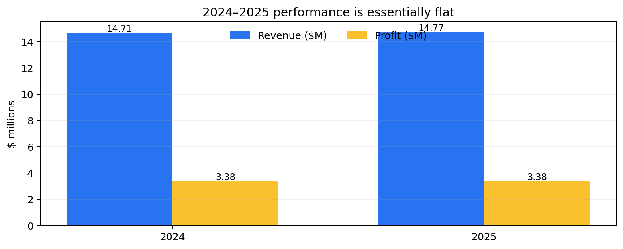
Interpretation: Revenue increased only 0.43% from 2024 to 2025; profit increased 0.17% and order count 0.37%. This is best treated as a flat-growth business rather than a meaningful growth trajectory.

Business problem 1 — Growth without momentum
A business can remain profitable while still losing strategic momentum. Flat revenue, profit, and order growth means future performance will depend on either higher customer value, better product mix, stronger demand generation, or improved unit economics.
Possible cause (hypothesis) | How to validate | Potential business response
Mature demand / limited new-customer acquisition | Add acquisition channel and new-vs-existing customer fields; compare cohort growth. | Run channel-specific acquisition pilots and measure CAC-to-contribution economics.
Product mix is stable but not expanding demand | Track category/product growth rate, availability, and conversion. | Prioritize high-margin growth categories and new product bundles.
Promotions drive transactions but not incremental value | Measure incremental units and contribution margin versus non-promo baseline. | Replace blanket discounting with targeted offers and eligibility rules.

3. Problem Analysis — Discount and Profit Leakage
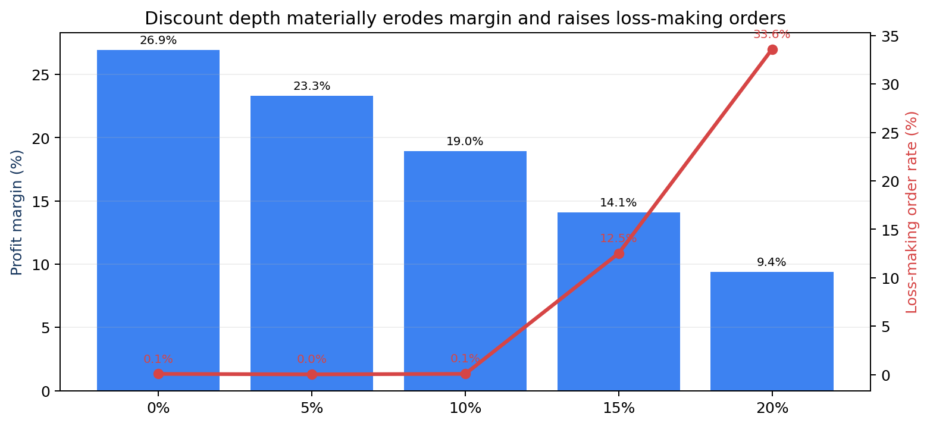
Discount | Revenue | Profit margin | Loss-order rate | Orders
0% | $13.10M | 26.9% | 0.1% | 10,521
5% | $7.45M | 23.3% | 0.0% | 6,222
10% | $5.55M | 19.0% | 0.1% | 5,005
15% | $2.61M | 14.1% | 12.5% | 2,475
20% | $0.79M | 9.4% | 33.6% | 777

Observed risk: Margin falls from 26.9% with no discount to 9.4% at a 20% discount. The loss-making order rate rises sharply to 12.5% at 15% discount and 33.6% at 20%.

Hypothetical commercial explanation
- Promotion depth may be too broad. Discounts could be applied without considering product-specific margin headroom.
- Revenue may be prioritized over contribution profit. Teams may be optimizing for GMV / sales rather than unit economics.
- Discount eligibility may not be differentiated. High-margin and low-margin products may be receiving similar promotional treatment.
- Volume response may not justify margin loss. The current dataset does not prove that 15–20% discounts create enough incremental demand to offset lower margins.

Recommended business decision
Action | Rule / design | Expected benefit | Decision caution
Introduce discount tiers | 0–10% = standard; >10% requires margin validation; >15% requires approval or campaign rationale. | Protect contribution margin and reduce loss-making orders. | Do not assume demand is unchanged; run controlled tests.
Set SKU margin floor | Block promotions that push expected contribution margin below a defined threshold. | Prevents structurally unprofitable offers. | Threshold should vary by category and strategic intent.
Promotion scorecard | Track incremental units, revenue, profit, margin, and post-promo behavior. | Moves promotion decisions from sales-led to profit-led. | Requires a comparable baseline / control group.

Illustrative scenario — not a forecast: If positive-quantity orders currently discounted above 10% had instead been sold at a 10% discount, with unit volume unchanged, full-period profit would be approximately $251,056 higher (+3.7% versus observed profit). This is a sensitivity scenario only; real volume may respond to price.

4. Problem Analysis — Product and Category Profitability
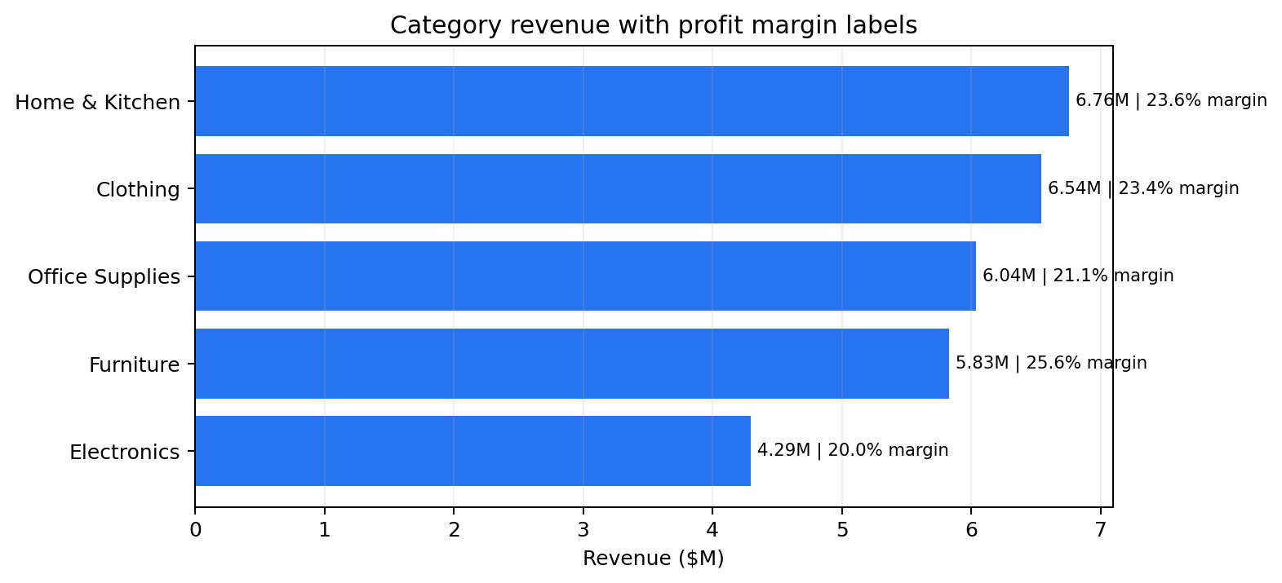
Category | Revenue | Revenue share | Profit | Margin
Home & Kitchen | $6.76M | 22.9% | $1.60M | 23.6%
Clothing | $6.54M | 22.2% | $1.53M | 23.4%
Office Supplies | $6.04M | 20.5% | $1.28M | 21.1%
Furniture | $5.83M | 19.8% | $1.49M | 25.6%
Electronics | $4.29M | 14.6% | $0.86M | 20.0%

Observed opportunity: Home & Kitchen is the largest revenue category. Furniture has the strongest category margin (25.6%). Electronics has the weakest margin (20.0%), while Office Supplies also trails the portfolio average at 21.1%.

High-revenue products with weak margins
Product | Category | Revenue | Margin | Illustrative uplift to 15%
Paper Product 24 | Office Supplies | $344,117 | 7.9% | $24,448
Appliances Product 40 | Home & Kitchen | $328,348 | 8.3% | $22,067
Cookware Product 89 | Home & Kitchen | $500,882 | 9.6% | $27,178
Cookware Product 64 | Home & Kitchen | $404,482 | 10.7% | $17,475
Printers Product 86 | Office Supplies | $377,258 | 10.8% | $15,815
Kids Product 36 | Clothing | $390,398 | 11.4% | $13,906
Accessories Product 9 | Electronics | $302,629 | 12.0% | $8,972
Mobiles Product 66 | Electronics | $416,699 | 12.1% | $12,233
Stationery Product 68 | Office Supplies | $369,416 | 12.2% | $10,180
Men Product 27 | Office Supplies | $316,751 | 12.7% | $7,131

Illustrative portfolio scenario: For high-revenue products currently below 15% margin, lifting those SKUs to a 15% margin at unchanged revenue would add about $195,861 in full-period profit. This overlaps with the discount scenario and should not be added to it as an independent benefit.

Recommended actions
- SKU profitability review. For each low-margin high-revenue SKU, determine whether the issue is list price, supplier cost, discounting, or product mix.
- Vendor / sourcing negotiations. Target cost reduction on high-volume low-margin SKUs before applying customer-facing discounts.
- Price architecture. Define target margin corridors by category and flag products outside the corridor.
- Bundle strategy. Pair low-margin traffic drivers with higher-margin complementary items instead of relying only on deeper discounts.
- Assortment rationalization. Products that are both low-margin and low-growth should be reviewed for strategic relevance.
Category sensitivity examples: A 2 percentage-point margin improvement on Electronics, at unchanged revenue, is worth roughly $85,896 across the observed period. A 1 percentage-point improvement on Office Supplies is worth roughly $60,368. These are sensitivity calculations, not forecasts.

5. Customer and Buying-Behavior Assessment
Finding | Business interpretation | Risk / limitation
2,000 purchasing customers across 25,000 orders | The dataset has enough transaction volume for broad segment and product analysis. | Synthetic structure may not reflect real customer acquisition patterns.
100.0% of customers have >1 order | All identified customers are repeat buyers in the full-period dataset. | This makes “repeat vs one-time” retention analysis uninformative at the full-period level.
66.6% of customers are needed to reach 80% of revenue | Revenue is not heavily concentrated in a tiny VIP group. | This may be a synthetic-data artifact; customer value strategy needs richer behavior fields.
55.0% of products are needed to reach 80% of product revenue | Product revenue is moderately diversified rather than dominated by a handful of SKUs. | Does not reveal basket affinity because order_id does not represent multi-line baskets.

Key analytical limitation: The current data supports spending, frequency, segment, demographic, product, and region analysis. It does not support defensible market-basket analysis, customer acquisition attribution, or true retention/cohort analysis without additional fields.

Recommended customer-data enrichment
Add field / entity | Why it matters | Business decisions enabled
basket_id / order_group_id | Links multiple products purchased in the same checkout. | Cross-sell, basket affinity, bundles, attach-rate optimization.
acquisition_channel / campaign_id | Connects customers to source and campaign. | CAC, ROAS, profitable acquisition, channel budget allocation.
order_status / return_reason | Separates sale, cancellation, refund, return, exchange. | Return-policy decisions and root-cause reduction.
seller / brand | Separates assortment economics and seller quality. | Vendor negotiations, brand strategy, seller performance.
delivery date / SLA | Measures customer experience and fulfillment quality. | Delivery optimization, churn risk, service-level management.
rating / review | Connects commercial performance to customer experience. | Quality interventions, review-driven conversion strategy.

6. Regional Performance and Return Interpretation
Region | Revenue | Share | Margin | States | Revenue / state
North | $7.57M | 25.7% | 22.7% | 5 | $1.51M
South | $7.38M | 25.0% | 23.0% | 5 | $1.48M
East | $7.35M | 24.9% | 23.1% | 5 | $1.47M
West | $5.78M | 19.6% | 23.0% | 4 | $1.44M
Central | $1.42M | 4.8% | 22.3% | 1 | $1.42M

Senior-analyst interpretation: Central contributes only 4.8% of total revenue, but it contains only one state in this synthetic geography. Revenue per state is broadly comparable with other regions. Therefore, Central should not be labeled an underperforming region solely from total revenue.

Returns
There are only 15 return-flagged transactions (0.06% of orders). Because the return flag is derived from negative quantity and there is no explicit return status, reason, or refund lifecycle, this signal is insufficient for strong operational recommendations.
- Do not set return-policy targets from this dataset alone. The event definition is too weak.
- Add return reason and refund fields. Separate damaged, wrong item, quality, buyer remorse, delivery issue, and fraud/abuse cases.
- Measure return rate by product after instrumentation. Use return rate, not only return count, and adjust for sales volume.

7. Decision-Risk Assessment — Data Quality and Model Limitations
Issue | Observed count / condition | Decision risk | Required control
Invalid order dates | 10 | Time-series metrics can be distorted if invalid dates are included. | Exclude invalid dates from time metrics and track exception count.
Missing customer IDs | 60 | Customer-level revenue attribution is incomplete. | Use Unknown Customer bucket or remediate upstream capture.
Missing product IDs | 35 | Product/category analysis misses a small share of transactions. | Use Unknown Product bucket; investigate source system.
Category/sub-category anomalies | 12 product rows flagged | Product hierarchy comparisons may be inconsistent. | Define governed product taxonomy and stewardship process.
Signup chronology conflicts | Many orders predate recorded signup_date | Acquisition/cohort conclusions may be misleading. | Clarify business meaning of signup_date before cohort use.
All customers are repeat in full period | 100% repeat rate | One-time vs repeat segmentation is not useful for this dataset. | Use rolling-window definitions and add first-order / acquisition context.

Decision rule: No strategic KPI should be used in management reporting unless its business definition, source field, exception handling, and ownership are documented.

Recommended analytical governance
- Metric dictionary. Define Revenue, Net Revenue, Profit, Margin, AOV, Return Rate, Discounted Order Rate, Loss-Order Rate, Active Customer, and Repeat Customer.
- Data quality scorecard. Track missing keys, invalid dates, taxonomy anomalies, and unknown dimension attribution every refresh.
- Dimension stewardship. Assign ownership for product hierarchy and regional master data.
- Decision traceability. Record which dashboard metric drove each commercial action and evaluate the result later.

8. Business Recommendation Portfolio
Priority | Recommendation | Business rationale | Primary KPI | Illustrative horizon
P0 | Discount governance & margin floors | Deep discounts correlate with much lower margin and high loss-order rates. | Profit margin; loss-order rate; promo ROI | 0–30 days
P0 | Commercial KPI & data-quality governance | Current limitations can produce misleading customer, return, and cohort decisions. | DQ exceptions; metric adoption | 0–30 days
P1 | High-revenue / low-margin SKU recovery | Several products carry significant revenue but <15% margin. | SKU margin; contribution profit | 30–60 days
P1 | Category margin program | Electronics and Office Supplies trail portfolio margin. | Category margin; profit dollars | 30–90 days
P1 | Growth experiment program | 2025 revenue and order growth are almost flat. | Incremental revenue/profit; conversion | 30–90 days
P2 | Customer lifecycle enrichment | Current customer data is insufficient for true acquisition and retention strategy. | CAC, repeat rate, retention, CLV | 60–120 days
P2 | Return instrumentation | Return signal is too weak for operational policy decisions. | Return rate by reason/product | 60–120 days

What not to do: Do not reduce all discounts indiscriminately, declare Central a weak region based only on total revenue, or claim strong retention/return insights from the current data. Each would overstate what the dataset can support.

9. 90-Day Decision and Execution Roadmap
Phase | Business actions | Analytical actions | Decision gate
Days 0–30: Control | Define margin floors; require approval for deep discounts; identify top 20 margin-leakage SKUs. | Publish KPI dictionary; create discount and loss-order exception report; validate product taxonomy. | Approve pilot rules and measurement design.
Days 31–60: Pilot | Pilot revised discounts on selected low-margin SKUs/categories; begin vendor/cost negotiations. | Create treatment/control comparison; monitor conversion, units, revenue, profit, and margin. | Scale only if contribution profit improves without unacceptable demand loss.
Days 61–90: Scale | Expand successful rules; launch category growth tests and targeted cross-sell/bundling. | Add channel, basket, return, and delivery data to the model; automate commercial scorecard. | Adopt new commercial policy and quarterly optimization cycle.

Illustrative pilot design
- Select 10–20 high-revenue SKUs with margins below 15%, stratified by category.
- Split comparable traffic / periods into current-promotion and revised-promotion groups where operationally feasible.
- Measure conversion, units, revenue, contribution profit, margin, cancellation/return rate, and follow-on purchase behavior.
- Use contribution profit as the primary decision metric, with revenue and conversion as guardrails.
- Scale only when profit improvement is statistically and commercially meaningful.

10. Management KPI and Decision Framework
KPI | Definition / purpose | Current baseline | Illustrative target direction
Profit Margin | Profit / Revenue | 22.9% | Increase without material order decline.
Loss-Making Order Rate | Orders with profit < 0 / orders | 2.3% | Reduce, especially at 15–20% discount tiers.
Discounted Order Rate | Orders with discount > 0 / orders | 57.9% | Optimize; lower only where profit improves.
AOV | Revenue / orders | $1,180 | Maintain or increase while protecting margin.
Revenue Growth | Current period vs prior comparable period | 2025 YoY 0.43% | Move from flat to sustainable positive growth.
Profit Growth | Current period vs prior comparable period | 2025 YoY 0.17% | Grow at least in line with revenue.
Return Rate | Return-flagged orders / orders | 0.06% (proxy) | Do not set target until return instrumentation improves.
Data Quality Exceptions | Invalid/missing analytical keys | 10 invalid dates; 60 missing customer; 35 missing product | Drive toward near-zero critical exceptions.

Illustrative management target: For a pilot, a reasonable decision gate could be +0.5 percentage points of contribution margin with no more than a pre-agreed decline in conversion or units. This target is illustrative and should be calibrated using business tolerance and experimental evidence.

11. Recommendation Risks and Mitigations
Risk | Why it matters | Mitigation
Discount reduction lowers demand | Scenario benefits assume unchanged volume, which may not hold. | Use controlled pilots; set revenue/conversion guardrails.
Margin optimization harms customer perception | Price increases or reduced discounts can reduce perceived value. | Use targeted offers, bundles, loyalty benefits, and personalized incentives.
Supplier-cost negotiations take time | Cost-side improvements may not be immediately available. | Prioritize products by profit-dollar opportunity and supplier leverage.
Synthetic data overstates pattern stability | Portfolio dataset may not reflect real marketplace seasonality or customer behavior. | Treat results as a case-study decision framework, not real Flipkart evidence.
Overfitting to current period | Two years may not capture shocks, campaigns, or longer cycles. | Use rolling comparisons and continuously re-estimate economics.

Assumptions
- Sales_amount, cost_amount, and profit are assumed to be the intended commercial measures for each transaction.
- Negative quantity is treated as a return proxy because that is how the cleaned dataset was designed.
- Scenario calculations assume unchanged volume and cost unless explicitly stated; therefore they are sensitivity analyses, not forecasts.
- Category and region recommendations use the cleaned standardized fields, while known taxonomy anomalies remain a governance concern.
- This report intentionally avoids presenting the portfolio dataset as actual Flipkart operational data.

12. Final Business Recommendation
Primary decision: Move the commercial operating model from revenue-first discounting toward profit-aware growth.
The strongest evidence in this analysis is the discount-to-profit relationship. The business already produces a healthy overall margin, so the immediate opportunity is to preserve and improve contribution economics while testing growth. Deep promotions should become exception-based, not default. High-revenue low-margin products should receive structured pricing and cost interventions. Growth initiatives should then be measured on incremental profit, not only incremental sales.
Decision | Recommended stance
Deep discounts (>10%) | Restrict to validated use cases; require post-discount margin check and campaign rationale.
High-revenue low-margin SKUs | Prioritize for price, cost, supplier, and promotion redesign.
Category strategy | Protect Furniture / Home & Kitchen economics; improve Electronics and Office Supplies margin quality.
Regional strategy | Compare normalized metrics before reallocating investment; avoid judging Central by total revenue alone.
Customer strategy | Use current data for spend/frequency segmentation, but enrich the model before acquisition/retention decisions.
Return strategy | Instrument true return lifecycle before policy optimization.
Management cadence | Review profit, margin, loss-order rate, and promotion ROI weekly; review category and growth strategy monthly.

Expected business outcome: A more disciplined commercial model with fewer loss-making promotions, better SKU-level profitability, clearer growth experiments, and stronger confidence in management decisions. The objective is not simply to maximize revenue; it is to increase sustainable, decision-quality profit.

End of report

