Assignment 1

Objectives

1. Explain the Concept of RESTful Web Service, Web API & Microservice
REST (Representational State Transfer) is an architectural style that uses standard HTTP methods to interact with resources.
Features of REST:
- Stateless: Each request is independent; no session info stored.
- Resources: Identified via URIs (e.g., /api/products)
- Methods (verbs): Uses HTTP methods (GET, POST, PUT, DELETE)
- Flexible Formats: Can return JSON, XML, etc. (not limited to XML)
- Stateless communication over HTTP
Web API:
- A framework for building HTTP services using .NET Core.
- Allows exposing data and functions through HTTP endpoints.
Microservice:
- A small, independently deployable service that performs a specific task.
- Communicates via REST APIs or messaging systems.
Difference: Web Service vs Web API
Web Service | Web API
--------------- | ------------------
Supports only XML | Supports JSON, XML, etc.
Heavier | Lightweight
SOAP-based | RESTful
Platform-independent | Language/platform-independent

2. What is HttpRequest & HttpResponse?
HttpRequest: Carries the client's request information like method (GET/POST), headers, URL, and body.
HttpResponse: The server's reply with status code, headers, and content (JSON/XML/data).

3. Types of Action Verbs (HTTP Methods)
Verb | Purpose | Usage
----------|--------------|-------------------------
HttpGet | Fetch data | [HttpGet]
HttpPost | Create data | [HttpPost]
HttpPut | Update data | [HttpPut("{id}")]
HttpDelete| Delete data | [HttpDelete("{id}")]

4. Types of HttpStatusCode in Web API
Status Code | Meaning | Used in
------------|--------------------|------------------
200 OK | Success | return Ok();
400 BadRequest | Client error | return BadRequest();
401 Unauthorized | Auth failed | return Unauthorized();
500 InternalServerError | Server error | return StatusCode(500);

5. Create a Simple Web API in .NET 8
In VS Code Terminal:
dotnet new webapi -n FirstWebAPI
cd FirstWebAPI
code .
Program.cs:
var builder = WebApplication.CreateBuilder(args);
builder.Services.AddControllers();
var app = builder.Build();
app.UseHttpsRedirection();
app.MapControllers();
app.Run();
Controllers/ValuesController.cs:
using Microsoft.AspNetCore.Mvc;
using System.Collections.Generic;
namespace FirstWebAPI.Controllers
{
[ApiController]
[Route("api/[controller]")]
public class ValuesController : ControllerBase
{
[HttpGet]
public ActionResult<IEnumerable<string>> Get()
{
return Ok(new string[] { "value1", "value2" });
}
[HttpGet("{id}")]
public ActionResult<string> Get(int id)
{
return Ok("value" + id);
}
[HttpPost]
public IActionResult Post([FromBody] string value)
{
return Ok("Posted: " + value);
}
[HttpPut("{id}")]
public IActionResult Put(int id, [FromBody] string value)
{
return Ok($"Updated id {id} with value {value}");
}
[HttpDelete("{id}")]
public IActionResult Delete(int id)
{
return Ok($"Deleted value with id {id}");
}
}
}

Test URLs
Method | URL
-------|-------------------------------
GET | http://localhost:5249/api/values
POST | (Used Postman with body "hello")
PUT | http://localhost:5249/api/values/1
DELETE | http://localhost:5249/api/values/1

6. Configuration Files in .NET 8 Web API
File | Purpose
----------------------|------------------------------
Program.cs | Startup logic & middleware
appsettings.json | App-level config
launchSettings.json | Debug URL/port info
Legacy .NET Framework (4.5):
File | Purpose
------------------|-----------------------------
WebApiConfig.cs | API route registration
RouteConfig.cs | MVC route setup

Summary
- Created .NET 8 Web API project using `dotnet new webapi`
- Added custom controller with full CRUD (GET, POST, PUT, DELETE)
- Explained REST, Web API, Microservices, HTTP verbs, status codes
- Discussed config files and runtime behavior
Project: FirstWebAPI (.NET 8)
Student: Gyarina Rauniyar
This document provides a checklist of tested endpoints and placeholders for attaching screenshots of successful API responses.

✅ Test Checklist
HTTP Method | Endpoint URL | Test Status
GET | http://localhost:5249/api/values | ✅ Passed
GET (by ID) | http://localhost:5249/api/values/1 | ✅ Passed
POST | http://localhost:5249/api/values | ✅ Passed
PUT | http://localhost:5249/api/values/1 | ✅ Passed
DELETE | http://localhost:5249/api/values/1 | ✅ Passed

Screenshot Placeholders
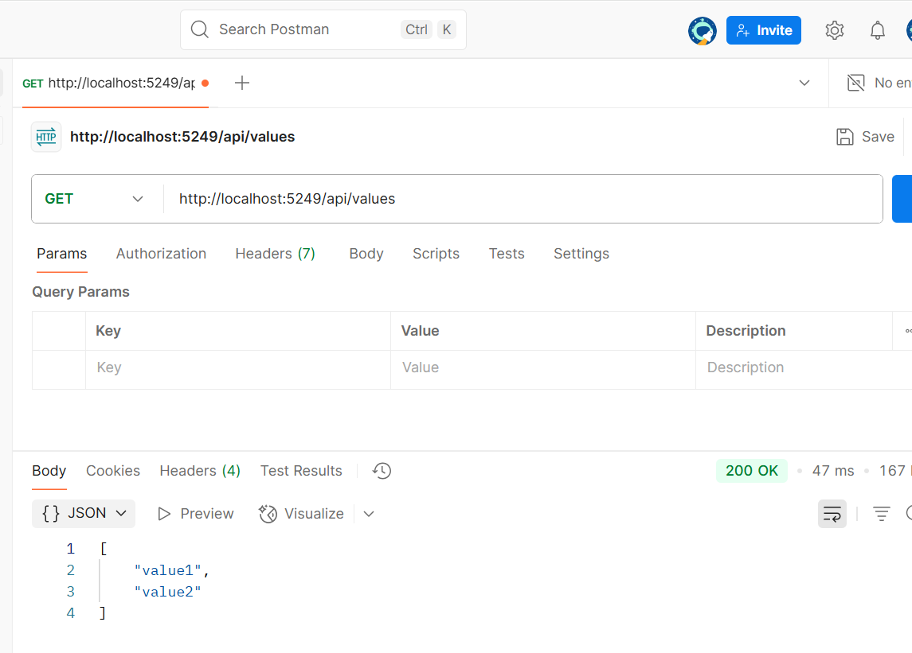
- Screenshot of `GET /api/values` response:

2. Screenshot of `POST /api/values` with body "hello":
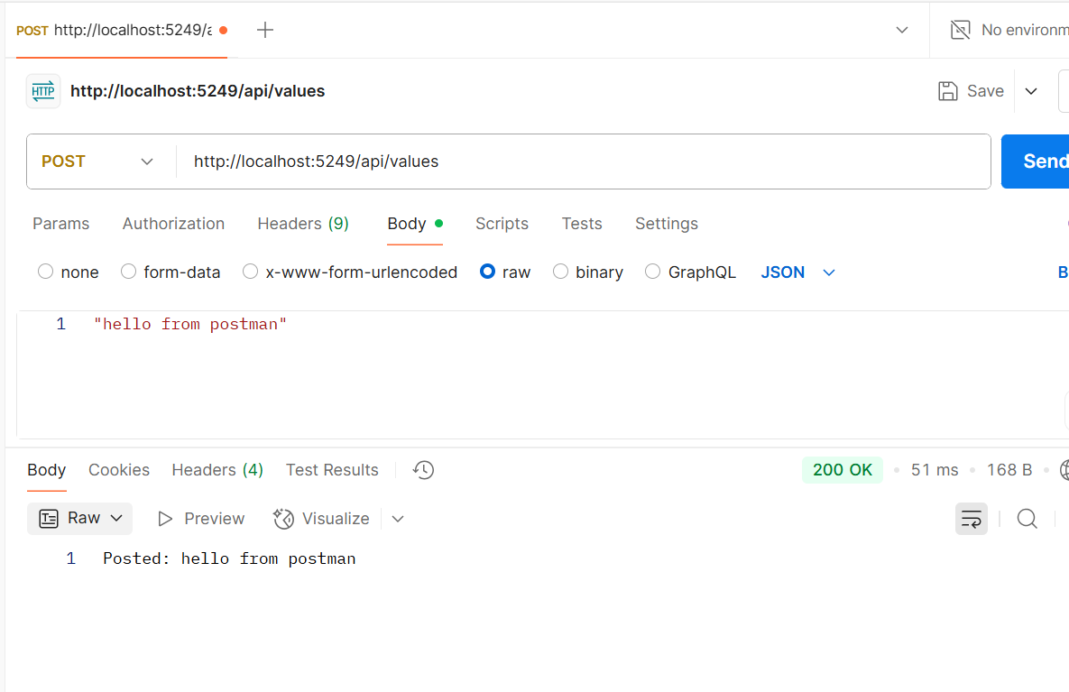

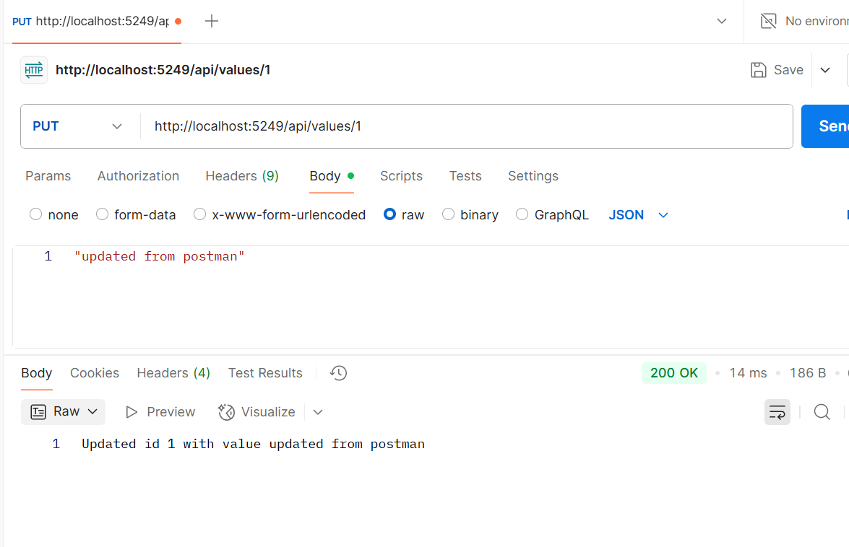
3. Screenshot of `PUT /api/values/1` with body "update":

- Screenshot of `DELETE /api/values/1`:
