EF Core 8.0 Guided Additional_Hands_On Exercises
Submitted By: Gyarina Rauniyar
Lab 6: Updating and Deleting Records using EF Core

Scenario:
The store updates product prices and removes discontinued items.

Objective:
To update and delete records using Entity Framework Core.

Steps and Code Implementation:

Step 1: Setup
Ensured the following namespaces are added at the top of Program.cs:
using System;
using System.Threading.Tasks;
using RetailStoreContextLab;
using Microsoft.EntityFrameworkCore;

Step 2: Main Method Logic for Updating and Deleting Records
The Main method was updated as follows:
class Program
{
static async Task Main(string[] args)
{
using var context = new AppDbContext();
// Update a Product
var product = await context.Products.FirstOrDefaultAsync(p => p.Name == "Laptop");
if (product != null)
{
product.Price = 70000;
await context.SaveChangesAsync();
Console.WriteLine("Product price updated.");
}
else
{
Console.WriteLine("Product not found.");
}
// Delete a Product
var toDelete = await context.Products.FirstOrDefaultAsync(p => p.Name == "Rice Bag");
if (toDelete != null)
{
context.Products.Remove(toDelete);
await context.SaveChangesAsync();
Console.WriteLine("Product deleted.");
}
else
{
Console.WriteLine("Product to delete not found.");
}
}
}

Step 3: Built and Ran the Application
Executed the following commands in the terminal:
dotnet build
dotnet run

OutputScreenshot:
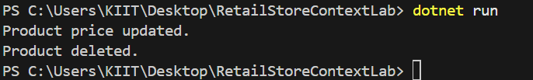

Conclusion:
In this lab, I have successfully learned how to:
- Update an existing product’s price in the database.
- Delete a product from the database.

Lab 7: Writing Queries with LINQ using EF Core

Scenario:
The store wants to filter and sort products for reporting.

Objective:
To use LINQ methods like Where, Select, OrderBy, and project data into DTOs using Entity Framework Core.

Steps and Code Implementation:

Step 1: Setup
Ensured the following namespaces are added at the top of Program.cs:
using System;
using System.Threading.Tasks;
using RetailStoreContextLab;
using Microsoft.EntityFrameworkCore;
using System.Linq;

Step 2: Main Method Logic for Filtering, Sorting, and DTO Projection
class Program
{
static async Task Main(string[] args)
{
using var context = new AppDbContext();
// Filter and Sort Products
var filtered = await context.Products
.Where(p => p.Price > 1000)
.OrderByDescending(p => p.Price)
.ToListAsync();
Console.WriteLine("Filtered & Sorted Products (Price > 1000):");
foreach (var product in filtered)
{
Console.WriteLine($"Name: {product.Name}, Price: {product.Price:F2}");
}
// Project into DTOs
var productDTOs = await context.Products
.Select(p => new { p.Name, p.Price })
.ToListAsync();
Console.WriteLine("\nProduct DTOs:");
foreach (var dto in productDTOs)
{
Console.WriteLine($"Name: {dto.Name}, Price: {dto.Price:F2}");
}
}
}

Step 3: Built and Ran the Application
Executed the following commands in the terminal:
dotnet build
dotnet run

Output Screenshot:
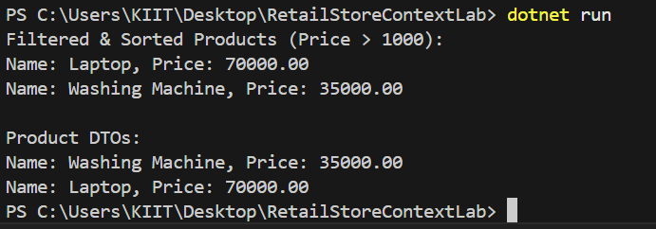

Note:
(We might notice that the product “Rice Bag” was missing from the output, even though its price is 1200 and satisfies the filter condition. That was because during Lab 6, the “Rice Bag” product was deleted from the database. As a result, it no longer appeared in the results for Lab 7.)

Conclusion:
In this lab, I have successfully learned how to:
- Use LINQ to filter and sort records from the database.
- Project selected fields into anonymous DTOs for reporting.
- Understand how data modifications from previous operations (like deletions) affect query results.
Entity Framework Core and LINQ provide powerful and expressive tools to perform complex data queries with minimal code.

