EF Core 8.0 Guided Mandatory_Hands_On Exercises
Submitted By: Gyarina Rauniyar
Lab1: Understanding ORM with a Retail Inventory System

Scenario:
I am building an inventory management system for a retail store. The store wants to track products, categories, and stock levels in a SQL Server database.

Objective:
Understanding what ORM is and how EF Core helps bridge the gap between C# objects and relational tables.

Task Solutions

1. What is ORM?
ORM (Object-Relational Mapping) allows developers to map C# classes to relational database tables. It enables data manipulation using C# code instead of raw SQL queries.
Example Mapping:
public class Product
{
public int Id { get; set; }
public string Name { get; set; }
public int Stock { get; set; }
}
In this example, EF Core will automatically map the Product class to a database table Products.
Benefits:
- Increased productivity
- Better maintainability
- Reduced need for manual SQL
- Database abstraction layer

2. EF Core vs EF Framework
Feature | EF Core 8.0 | EF Framework (EF6)
Platform | Cross-platform | Windows-only
Lightweight | Yes | Heavier, mature
Modern Features | LINQ, Async, Compiled Queries, JSON columns | Limited modern features
Flexibility | High | Less flexible

3. EF Core 8.0 Features
- JSON column mapping
- Compiled models for improved performance
- Interceptors and better bulk operations

4. Create a .NET Console App
Commands used:
dotnet new console -n RetailInventory
cd RetailInventory

5. Install EF Core Packages
Commands used:
dotnet add package Microsoft.EntityFrameworkCore.SqlServer
dotnet add package Microsoft.EntityFrameworkCore.Design

6. C# Code for the Retail Inventory System
Product.cs
namespace RetailInventory
{
public class Product
{
public int Id { get; set; }
public string Name { get; set; }
public int Stock { get; set; }
public int CategoryId { get; set; }
public Category Category { get; set; }
}
}
Category.cs
namespace RetailInventory
{
public class Category
{
public int Id { get; set; }
public string Name { get; set; }
public List<Product> Products { get; set; }
}
}
InventoryContext.cs
using Microsoft.EntityFrameworkCore;
namespace RetailInventory
{
public class InventoryContext : DbContext
{
public DbSet<Product> Products { get; set; }
public DbSet<Category> Categories { get; set; }
protected override void OnConfiguring(DbContextOptionsBuilder optionsBuilder)
{
optionsBuilder.UseSqlServer(@"Server=localhost\\SQLEXPRESS;Database=RetailInventoryDB;Trusted_Connection=True;TrustServerCertificate=True;");
}
}
}
Program.cs
using System;
using System.Linq;
namespace RetailInventory
{
class Program
{
static void Main(string[] args)
{
using (var context = new InventoryContext())
{
// Add Category
var category = new Category { Name = "Electronics" };
context.Categories.Add(category);
context.SaveChanges();
// Add Product
var product = new Product
{
Name = "Laptop",
Stock = 20,
CategoryId = category.Id
};
context.Products.Add(product);
context.SaveChanges();
// Display Products
var products = context.Products.ToList();
foreach (var p in products)
{
Console.WriteLine($"Product: {p.Name}, Stock: {p.Stock}");
}
}
}
}
}

7. Migration and Database Commands
dotnet ef migrations add InitialCreate
dotnet ef database update
dotnet run

8. Output Screenshot
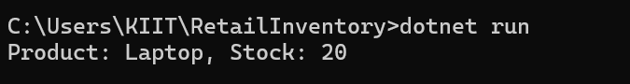
Product: Laptop, Stock: 20

Conclusion
The lab demonstrates how EF Core bridges the gap between C# code and relational databases using ORM principles. I successfully created a console application, mapped C# classes to database tables, performed database operations, and viewed the output.
Lab 2: Setting Up the Database Context for a Retail Store

Scenario:
The retail store wants to store product and category data in a SQL Server database.

Objective:
Configuring DbContext and connecting to SQL Server using C# and EF Core.

Task Solutions

1. Project Setup
Created a new .NET Console project using the following commands:
dotnet new console -n RetailStoreContextLab
cd RetailStoreContextLab
Installed EF Core packages:
dotnet add package Microsoft.EntityFrameworkCore.SqlServer
dotnet add package Microsoft.EntityFrameworkCore.Design

2. C# Model Classes
Category.cs
public class Category
{
public int Id { get; set; }
public string Name { get; set; }
public List<Product> Products { get; set; }
}
Product.cs
public class Product
{
public int Id { get; set; }
public string Name { get; set; }
public decimal Price { get; set; }
public int CategoryId { get; set; }
public Category Category { get; set; }
}

3. Database Context Configuration
AppDbContext.cs
using Microsoft.EntityFrameworkCore;
public class AppDbContext : DbContext
{
public DbSet<Product> Products { get; set; }
public DbSet<Category> Categories { get; set; }
protected override void OnConfiguring(DbContextOptionsBuilder optionsBuilder)
{
optionsBuilder.UseSqlServer(@"Server=localhost\SQLEXPRESS;Database=RetailInventoryDB_Lab2;Trusted_Connection=True;TrustServerCertificate=True;");
}
}
(Note: A different database name RetailInventoryDB_Lab2 was used to avoid conflicts with previous labs.)

4. Testing the Database Context in Program.cs
using System;
using System.Linq;
class Program
{
static void Main(string[] args)
{
using (var context = new AppDbContext())
{
// Add Category
var category = new Category { Name = "Appliances" };
context.Categories.Add(category);
context.SaveChanges();
// Add Product
var product = new Product
{
Name = "Washing Machine",
Price = 35000,
CategoryId = category.Id
};
context.Products.Add(product);
context.SaveChanges();
// Display Products
var products = context.Products.ToList();
foreach (var p in products)
{
Console.WriteLine($"Product: {p.Name}, Price: {p.Price}");
}
}
}
}

5. Migration and Database Creation Commands
dotnet ef migrations add InitialCreate
dotnet ef database update
dotnet run

6. Output Screenshot
Product: Washing Machine, Price: 35000

Conclusion
The lab demonstrates successful creation of model classes, configuration of AppDbContext, and interaction with a SQL Server database using C#. The output confirms that the database is properly set up and working.

Lab 3: Using EF Core CLI to Create and Apply Migrations

Scenario:
The retail store’s database needs to be created based on the models I’ve defined. I’ll use EF Core CLI to generate and apply migrations.

Objective:
Learning how to use EF Core CLI to manage database schema changes.

Task Solutions

1. EF Core CLI Installation
Installed EF Core CLI globally using the following command:
dotnet tool install --global dotnet-ef

2. Created Initial Migration
Navigated to the project folder:
cd RetailStoreContextLab
Created an initial migration named InitialCreateLab3 to avoid conflicts with previous migrations:
dotnet ef migrations add InitialCreateLab3
A Migrations folder was generated containing code that represents the database schema based on the C# models.

3. Applied Migration to Create the Database
Executed the following command to apply the migration and create the database:
dotnet ef database update
The database RetailInventoryDB_Lab2 was successfully created in SQL Server.

4. Verified Database in SQL Server Management Studio (SSMS)
Steps followed:
- Opened SQL Server Management Studio (SSMS)
- Connected to server: localhost\SQLEXPRESS
- Expanded Databases → RetailInventoryDB_Lab2
- Expanded Tables
Confirmed that the following tables were created: ✅ dbo.Categories
✅ dbo.Products
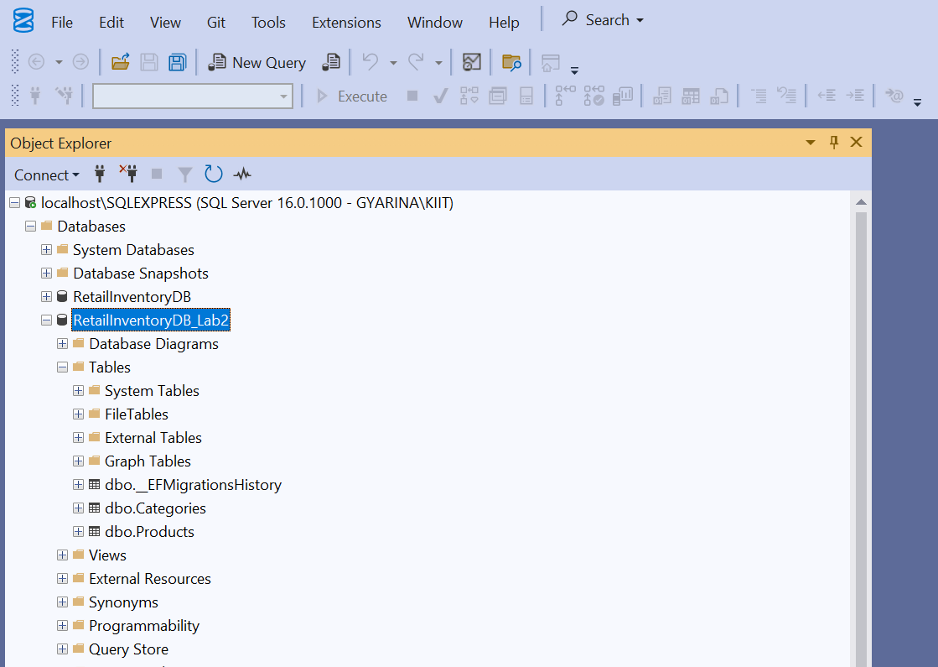

This confirmed that the EF Core migration and database update were successful.

Conclusion
Successfully used EF Core CLI to generate and apply migrations. Verified that the database and tables were created as expected in SQL Server. The process demonstrated how EF Core bridges the gap between C# models and the relational database structure.

Lab 4: Inserting Initial Data into the Database

Scenario:
The store manager wants to add initial product categories and products to the system.

Objective:
Using EF Core to insert records using AddRangeAsync and SaveChangesAsync.

Task Solutions

1. Program.cs Code to Insert Data
The following C# code was written in Program.cs to insert initial data:
using System;
using System.Threading.Tasks;
class Program
{
static async Task Main(string[] args)
{
using var context = new AppDbContext();
// Insert Categories
var electronics = new Category { Name = "Electronics" };
var groceries = new Category { Name = "Groceries" };
await context.Categories.AddRangeAsync(electronics, groceries);
// Insert Products linked to Categories
var product1 = new Product { Name = "Laptop", Price = 75000, Category = electronics };
var product2 = new Product { Name = "Rice Bag", Price = 1200, Category = groceries };
await context.Products.AddRangeAsync(product1, product2);
// Save changes to the database
await context.SaveChangesAsync();
Console.WriteLine("Initial data inserted successfully!");
}
}

2. Ran the Application
Executed the following command in the project directory:
dotnet run
Output:
Initial data inserted successfully!
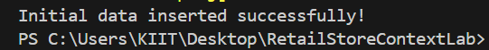

3. Verified Data in SQL Server Management Studio (SSMS)
Steps followed:
- Opened SSMS
- Connected to server: localhost\SQLEXPRESS
- Expanded Databases → RetailInventoryDB_Lab2
- Expanded Tables
- Right-clicked dbo.Categories → Selected Select Top 1000 Rows
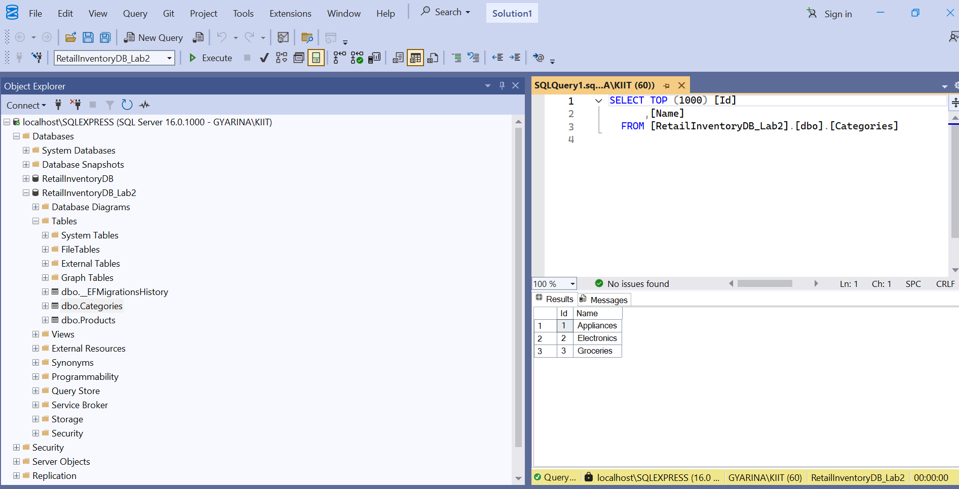

- Right-clicked dbo.Products → Selected Select Top 1000 Rows
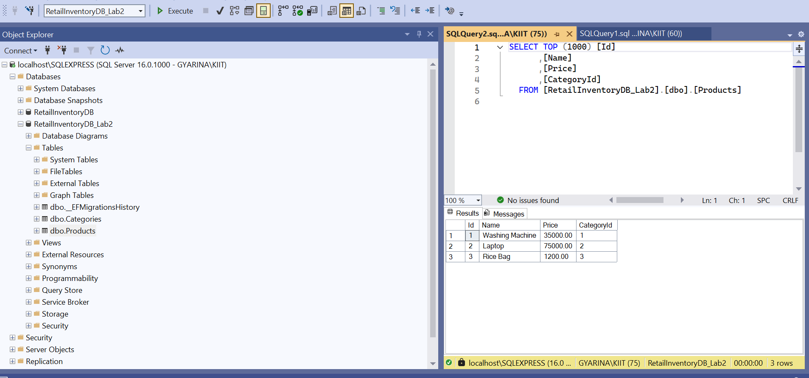

Verified Records:
- Categories:
  - Electronics
  - Groceries
- Products:
  - Laptop (linked to Electronics)
  - Rice Bag (linked to Groceries)

Conclusion
Successfully inserted initial product categories and products into the database using EF Core’s AddRangeAsync and SaveChangesAsync. Verified that the data is present in SQL Server, confirming the lab objective is achieved.

Lab 5: Retrieving Data from the Database

Scenario:
The store wants to display product details on the dashboard.

Objective:
Using FindAsync, FirstOrDefaultAsync, and ToListAsync to retrieve data from the database using EF Core.

Task Solutions

1. Program.cs Code to Retrieve Data
The following C# code was written in Program.cs to retrieve data:
using System;
using System.Linq;
using System.Threading.Tasks;
using Microsoft.EntityFrameworkCore;
class Program
{
static async Task Main(string[] args)
{
using var context = new AppDbContext();
// 1. Retrieve All Products
var products = await context.Products.ToListAsync();
Console.WriteLine("\nAll Products:");
foreach (var p in products)
Console.WriteLine($"{p.Name} - ₹{p.Price:0.00}");
// 2. Find by ID
var product = await context.Products.FindAsync(1);
Console.WriteLine($"\nFound: {product?.Name}");
// 3. FirstOrDefault with Condition
var expensive = await context.Products.FirstOrDefaultAsync(p => p.Price > 50000);
Console.WriteLine($"\nExpensive Product: {expensive?.Name}");
}
}

2. Ran the Application
Executed the following command in the project directory:
dotnet run
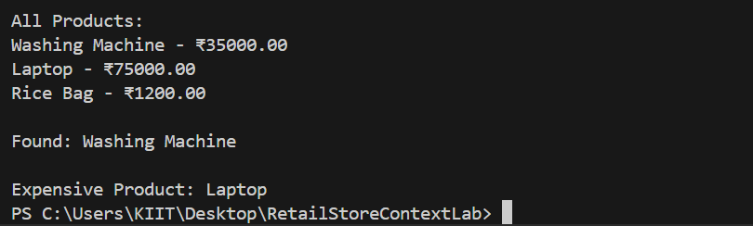
Output Observed:

3. Explanation of Output
- All products from the database were displayed using ToListAsync()
- The product with ID = 1 (Washing Machine) was found using FindAsync(1)
- The first product with price greater than ₹50,000 (Laptop) was found using FirstOrDefaultAsync

Conclusion
Successfully retrieved product details from the database using EF Core’s ToListAsync, FindAsync, and FirstOrDefaultAsync methods. Verified that the correct data was displayed on the console, fulfilling the lab objectives.

