Task on GIT Docx - 1

Link for GitDemo Repository(Final):- https://github.com/gyarinarauniyar/GitDemo.git

KIIT@Gyarina MINGW64 ~
$ git version
git version 2.49.0.windows.1

KIIT@Gyarina MINGW64 ~
$ git config --global --list
user.email=gyarinarauniyar2020@gmail.com
user.name=gyarinarauniyar

KIIT@Gyarina MINGW64 ~
$ notepad++

KIIT@Gyarina MINGW64 ~
$ notepad++.exe bash -profile
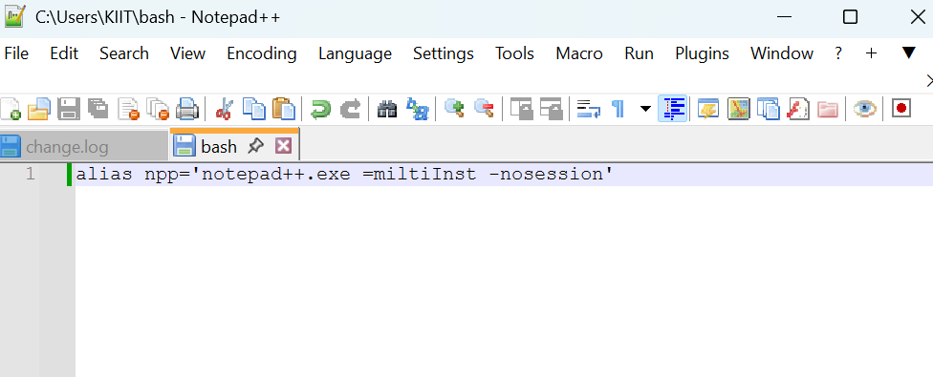

KIIT@Gyarina MINGW64 ~
$ git config --global core.editor "notepad++.exe -multiInst -nosession"

KIIT@Gyarina MINGW64 ~
$ git config --global -e

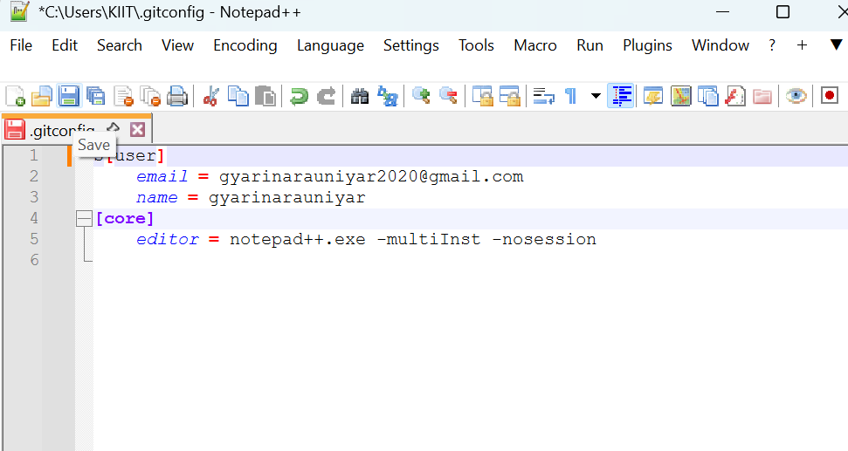

KIIT@Gyarina MINGW64 ~
$ cd downloads

KIIT@Gyarina MINGW64 ~/downloads
$ mkdir GitDemo

KIIT@Gyarina MINGW64 ~/downloads
$ cd GitDemo

KIIT@Gyarina MINGW64 ~/downloads/GitDemo
$ git init
Initialized empty Git repository in C:/Users/KIIT/Downloads/GitDemo/.git/

KIIT@Gyarina MINGW64 ~/downloads/GitDemo (master)
$ ls -a
./ ../ .git/

KIIT@Gyarina MINGW64 ~/downloads/GitDemo (master)
$ ls -al
total 1028
drwxr-xr-x 1 KIIT 197121 0 Aug 10 20:51 ./
drwxr-xr-x 1 KIIT 197121 0 Aug 10 20:47 ../
drwxr-xr-x 1 KIIT 197121 0 Aug 10 20:51 .git/

KIIT@Gyarina MINGW64 ~/downloads/GitDemo (master)
$ echo "Welcome to the version control" >> welcome.txt

KIIT@Gyarina MINGW64 ~/downloads/GitDemo (master)
$ ls -al
total 1029
drwxr-xr-x 1 KIIT 197121 0 Aug 10 20:53 ./
drwxr-xr-x 1 KIIT 197121 0 Aug 10 20:47 ../
drwxr-xr-x 1 KIIT 197121 0 Aug 10 20:51 .git/
-rw-r--r-- 1 KIIT 197121 31 Aug 10 20:53 welcome.txt

KIIT@Gyarina MINGW64 ~/downloads/GitDemo (master)
$ cat welcome.txt
Welcome to the version control

KIIT@Gyarina MINGW64 ~/downloads/GitDemo (master)
$ git status
On branch master

No commits yet

Untracked files:
(use "git add <file>..." to include in what will be committed)
welcome.txt

nothing added to commit but untracked files present (use "git add" to track)

KIIT@Gyarina MINGW64 ~/downloads/GitDemo (master)
$ git add welcome.txt
warning: in the working copy of 'welcome.txt', LF will be replaced by CRLF the next time Git touches it

KIIT@Gyarina MINGW64 ~/downloads/GitDemo (master)
$ git commit
[master (root-commit) 7d1fa01] added welcome.txt
1 file changed, 1 insertion(+)
create mode 100644 welcome.txt

KIIT@Gyarina MINGW64 ~/downloads/GitDemo (master)
$ git status
On branch master
nothing to commit, working tree clean

KIIT@Gyarina MINGW64 ~/downloads/GitDemo (master)
$ git remote add origin https://github.com/gyarinarauniyar/GitDemo.git

KIIT@Gyarina MINGW64 ~/downloads/GitDemo (master)
$ git push -u origin master
Enumerating objects: 3, done.
Counting objects: 100% (3/3), done.
Writing objects: 100% (3/3), 252 bytes | 252.00 KiB/s, done.
Total 3 (delta 0), reused 0 (delta 0), pack-reused 0 (from 0)
To https://github.com/gyarinarauniyar/GitDemo.git
* [new branch] master -> master
branch 'master' set up to track 'origin/master'.

KIIT@Gyarina MINGW64 ~/downloads/GitDemo (master)
$ git pull origin master --allow-unrelated-histories
From https://github.com/gyarinarauniyar/GitDemo
* branch master -> FETCH_HEAD
Already up to date.

KIIT@Gyarina MINGW64 ~/downloads/GitDemo (master)
$ git push -u origin master
branch 'master' set up to track 'origin/master'.
Everything up-to-date

KIIT@Gyarina MINGW64 ~/downloads/GitDemo (master)
$

