Task on GIT Docx - 3

Link for GitDemo Repository(Final):- https://github.com/gyarinarauniyar/GitDemo.git

KIIT@Gyarina MINGW64 ~
$ cd ~/downloads/GitDemo

KIIT@Gyarina MINGW64 ~/downloads/GitDemo (master)
$ git branch GitNewBranch

KIIT@Gyarina MINGW64 ~/downloads/GitDemo (master)
$ git branch -a
GitNewBranch
* master
remotes/origin/master

KIIT@Gyarina MINGW64 ~/downloads/GitDemo (master)
$ git checkout GitNewBranch
Switched to branch 'GitNewBranch'

KIIT@Gyarina MINGW64 ~/downloads/GitDemo (GitNewBranch)
$ echo "This is a new branch file" > branchfile.txt

KIIT@Gyarina MINGW64 ~/downloads/GitDemo (GitNewBranch)
$ git add branchfile.txt
warning: in the working copy of 'branchfile.txt', LF will be replaced by CRLF the next time Git touches it

KIIT@Gyarina MINGW64 ~/downloads/GitDemo (GitNewBranch)
$ git commit -m "Added branchfile.txt in GitNewBranch"
[GitNewBranch 152ac84] Added branchfile.txt in GitNewBranch
1 file changed, 1 insertion(+)
create mode 100644 branchfile.txt

KIIT@Gyarina MINGW64 ~/downloads/GitDemo (GitNewBranch)
$ git status
On branch GitNewBranch
nothing to commit, working tree clean

KIIT@Gyarina MINGW64 ~/downloads/GitDemo (GitNewBranch)
$ git checkout master
Switched to branch 'master'
Your branch is up to date with 'origin/master'.

KIIT@Gyarina MINGW64 ~/downloads/GitDemo (master)
$ git diff GitNewBranch
diff --git a/branchfile.txt b/branchfile.txt
deleted file mode 100644
index 24e7e87..0000000
--- a/branchfile.txt
+++ /dev/null
@@ -1 +0,0 @@
-This is a new branch file

KIIT@Gyarina MINGW64 ~
$ cd ~/downloads/GitDemo

KIIT@Gyarina MINGW64 ~/downloads/GitDemo (master)
$ git config --global merge.tool p4merge

KIIT@Gyarina MINGW64 ~/downloads/GitDemo (master)
$ git config --global mergetool.p4merge.path "C:/Program Files/Perforce/p4merge.exe"

KIIT@Gyarina MINGW64 ~/downloads/GitDemo (master)
$ git mergetool
No files need merging

KIIT@Gyarina MINGW64 ~/downloads/GitDemo (master)
$ ^C

KIIT@Gyarina MINGW64 ~/downloads/GitDemo (master)
$ dir
debug.log log welcome.txt

KIIT@Gyarina MINGW64 ~/downloads/GitDemo (master)
$ git checkout GitNewBranch
Switched to branch 'GitNewBranch'

KIIT@Gyarina MINGW64 ~/downloads/GitDemo (GitNewBranch)
$ dir
branchfile.txt debug.log log welcome.txt

KIIT@Gyarina MINGW64 ~/downloads/GitDemo (GitNewBranch)
$ ^C

KIIT@Gyarina MINGW64 ~/downloads/GitDemo (GitNewBranch)
$ git checkout master
Switched to branch 'master'
Your branch is up to date with 'origin/master'.

KIIT@Gyarina MINGW64 ~/downloads/GitDemo (master)
$ notepad welcome.txt

KIIT@Gyarina MINGW64 ~/downloads/GitDemo (master)
$ git add welcome.txt
warning: in the working copy of 'welcome.txt', LF will be replaced by CRLF the next time Git touches it

KIIT@Gyarina MINGW64 ~/downloads/GitDemo (master)
$ git commit -m "Updated welcome.txt in master branch"
[master 4b265d1] Updated welcome.txt in master branch
1 file changed, 2 insertions(+), 1 deletion(-)

KIIT@Gyarina MINGW64 ~/downloads/GitDemo (master)
$ git checkout GitNewBranch

Switched to branch 'GitNewBranch'

KIIT@Gyarina MINGW64 ~/downloads/GitDemo (GitNewBranch)
$ notepad welcome.txt

KIIT@Gyarina MINGW64 ~/downloads/GitDemo (GitNewBranch)
$ git add welcome.txt

KIIT@Gyarina MINGW64 ~/downloads/GitDemo (GitNewBranch)
$ git commit -m "Updated welcome.txt in GitNewBranch"
[GitNewBranch fa08f91] Updated welcome.txt in GitNewBranch
1 file changed, 1 insertion(+), 1 deletion(-)

KIIT@Gyarina MINGW64 ~/downloads/GitDemo (GitNewBranch)
$ git checkout master

Switched to branch 'master'
Your branch is ahead of 'origin/master' by 1 commit.
(use "git push" to publish your local commits)

KIIT@Gyarina MINGW64 ~/downloads/GitDemo (master)
$ git merge GitNewBranch

Auto-merging welcome.txt
CONFLICT (content): Merge conflict in welcome.txt
Automatic merge failed; fix conflicts and then commit the result.

KIIT@Gyarina MINGW64 ~/downloads/GitDemo (master|MERGING)
$ git mergetool

Merging:
welcome.txt

Normal merge conflict for 'welcome.txt':
{local}: modified file
{remote}: modified file

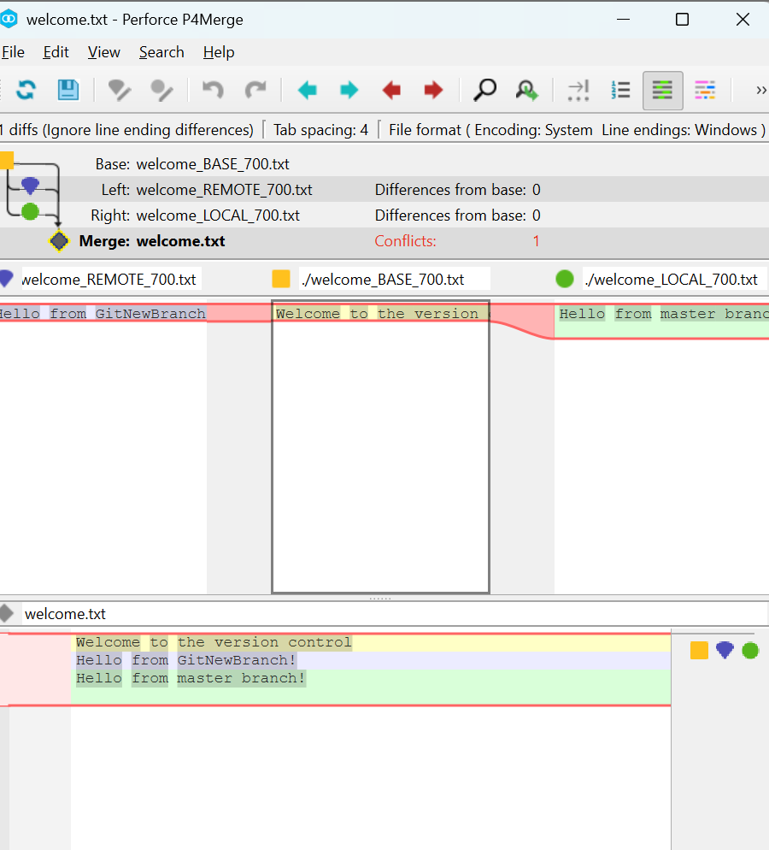

KIIT@Gyarina MINGW64 ~/downloads/GitDemo (master|MERGING)
$ git add welcome.txt

KIIT@Gyarina MINGW64 ~/downloads/GitDemo (master|MERGING)
$ git commit
[master 935b5f1] Merge branch 'GitNewBranch' Resolved merge conflict in welcome.txt

KIIT@Gyarina MINGW64 ~/downloads/GitDemo (master)
$ git log --oneline --graph --decorate

* 935b5f1 (HEAD -> master) Merge branch 'GitNewBranch' Resolved merge conflict in welcome.txt
|\
| * fa08f91 (GitNewBranch) Updated welcome.txt in GitNewBranch
| * 152ac84 Added branchfile.txt in GitNewBranch
* | 4b265d1 Updated welcome.txt in master branch
|/
* 24d3e16 (origin/master) Added .gitignore to ignore .log files and log folder
* 7d1fa01 added welcome.txt

KIIT@Gyarina MINGW64 ~/downloads/GitDemo (master)
$ git branch -d GitNewBranch

Deleted branch GitNewBranch (was fa08f91).

KIIT@Gyarina MINGW64 ~/downloads/GitDemo (master)
$ git status

On branch master
Your branch is ahead of 'origin/master' by 4 commits.
(use "git push" to publish your local commits)

Untracked files:
(use "git add <file>..." to include in what will be committed)
welcome.txt.orig

nothing added to commit but untracked files present (use "git add" to track)

KIIT@Gyarina MINGW64 ~/downloads/GitDemo (master)
$ git push origin master
Enumerating objects: 14, done.
Counting objects: 100% (14/14), done.
Delta compression using up to 8 threads
Compressing objects: 100% (9/9), done.
Writing objects: 100% (12/12), 1.16 KiB | 1.16 MiB/s, done.
Total 12 (delta 3), reused 0 (delta 0), pack-reused 0 (from 0)
remote: Resolving deltas: 100% (3/3), done.
To https://github.com/gyarinarauniyar/GitDemo.git
24d3e16..935b5f1 master -> master

KIIT@Gyarina MINGW64 ~/downloads/GitDemo (master)
$ git status
On branch master
Your branch is up to date with 'origin/master'.

Untracked files:
(use "git add <file>..." to include in what will be committed)
welcome.txt.orig

nothing added to commit but untracked files present (use "git add" to track)

KIIT@Gyarina MINGW64 ~/downloads/GitDemo (master)
$ rm welcome.txt.orig

KIIT@Gyarina MINGW64 ~/downloads/GitDemo (master)
$ git status

On branch master
Your branch is up to date with 'origin/master'.

nothing to commit, working tree clean

KIIT@Gyarina MINGW64 ~/downloads/GitDemo (master)
$

