2 NOT FREE STYLE PROJECT

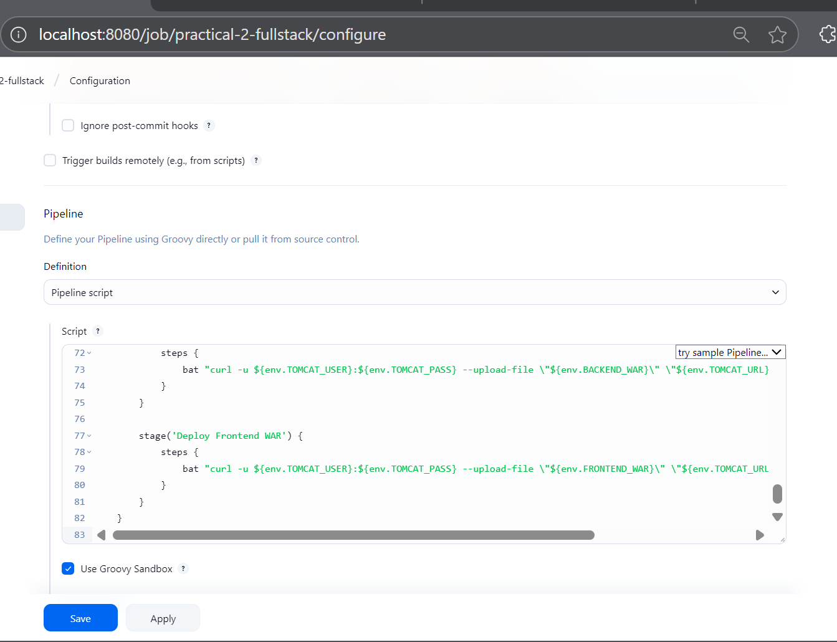

pipeline {

agent any //wbere I want to deploy in jenkins from multiple nodes

tools {

jdk 'JDK_HOME'

maven 'MAVEN_HOME'

}

environment {

TOMCAT_URL = '<http://localhost:9090/manager/text>' // eherer I want to deploy

TOMCAT_USER = 'admin'

TOMCAT_PASS = 'admin'

BACKEND_REPO = '<https://github.com/gyasaswini10/CICD_Practicle_2_Backend.git>

FRONTEND_REPO = '<https://github.com/gyasaswini10/CI_CD_Practicle_2_frontend.git>'

BACKEND_DIR = 'backend'

FRONTEND_DIR = 'frontend'

BACKEND_WAR = 'backend/target/springapp1.war'

FRONTEND_WAR = 'frontend/frontapp1.war'

}

stages {

stage('Clone Repositories') {

steps {

dir("${env.BACKEND_DIR}") {

git branch: 'main', url: "${env.BACKEND_REPO}"

}

dir("${env.FRONTEND_DIR}") {

git branch: 'main', url: "${env.FRONTEND_REPO}"

}

}

}

stage('Build React Frontend') {

steps {

script {

def nodeHome = tool name: 'NODE_HOME', type: 'jenkins.plugins.nodejs.tools.NodeJSInstallation'

env.PATH = "${nodeHome}\\bin;${env.PATH}"

}

dir("${env.FRONTEND_DIR}") {

bat 'npm install'

bat 'npm run build'

}

}

}

stage('Package React as WAR') {

steps {

script {

def warDir = "${env.FRONTEND_DIR}\\war_content"

bat "if exist ${warDir} rmdir /S /Q ${warDir}"

bat "mkdir ${warDir}\\META-INF"

bat "mkdir ${warDir}\\WEB-INF"

bat "xcopy /E /Y /I \"${env.FRONTEND_DIR}\\dist\\*\" \"${warDir}\\\""

bat "jar -cvf ${env.FRONTEND_WAR} -C ${warDir} ."

}

}

}

stage('Build Spring Boot App') {

steps {

dir("${env.BACKEND_DIR}") {

bat 'mvn clean package'

bat 'rename target\\*.war springapp1.war'

}

}

}

stage('Deploy Spring Boot WAR') {

steps {

bat "curl -u ${env.TOMCAT_USER}:${env.TOMCAT_PASS} --upload-file \"${env.BACKEND_WAR}\" \"${env.TOMCAT_URL}/deploy?path=/springapp1&update=true\""

}

}

stage('Deploy Frontend WAR') {

steps {

bat "curl -u ${env.TOMCAT_USER}:${env.TOMCAT_PASS} --upload-file \"${env.FRONTEND_WAR}\" \"${env.TOMCAT_URL}/deploy?path=/frontapp1&update=true\""

}

}

}

}

