**Complaint Management Monthly Report**

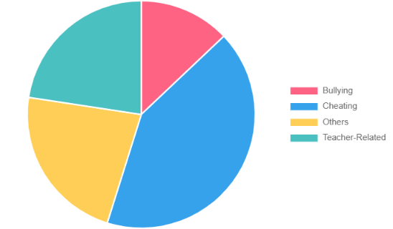

**Complaint Categories Data:**

Bullying: 8

Cheating: 18

Others: 12

Teacher-Related: 9

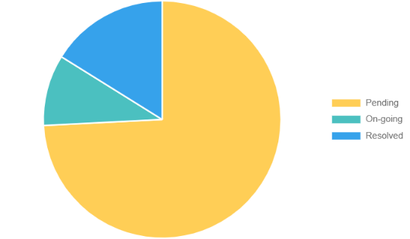

**Complaint Status Data:**

Pending: 39

On-Going: 3

Resolved: 5

**Number of Complaints per Year Level**

First Year

[bar_graph_1.png]

Second Year

[bar_graph_3.png]

Third Year

[bar_graph_4.png]

Fourth Year

[bar_graph_2.png]