**Complaint Management Monthly Report**

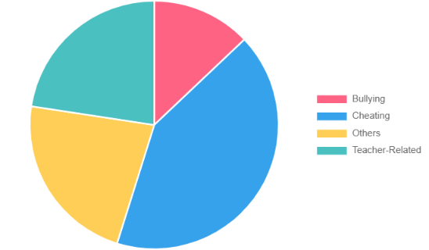

**Complaint Categories Data:**

Bullying: 8

Cheating: 18

Others: 12

Teacher-Related: 9

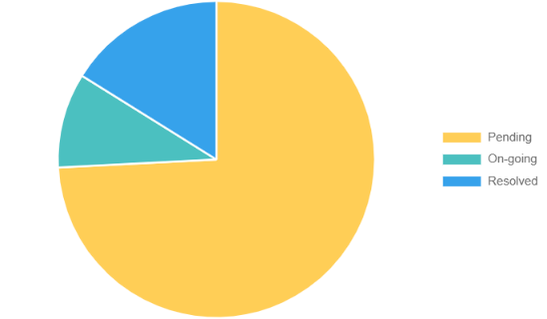

**Complaint Status Data:**

Pending: 39

On-Going: 3

Resolved: 5

**Number of Complaints per Year Level**

First Year

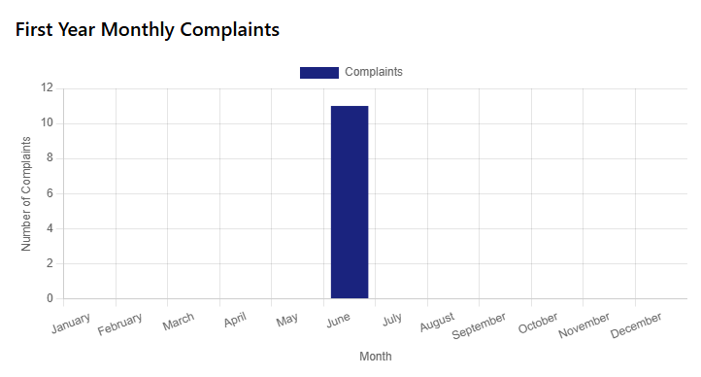

Second Year

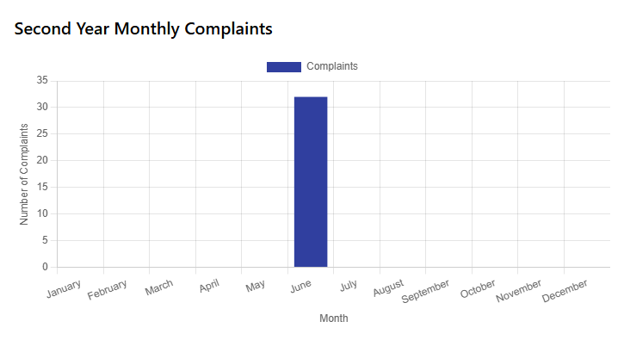

Third Year

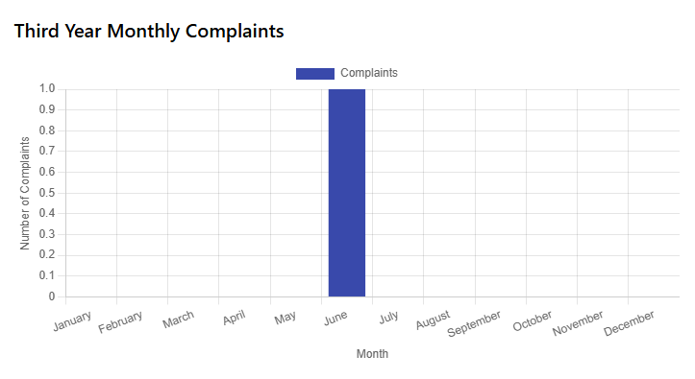

Fourth Year

