**Complaint Management Monthly Report**

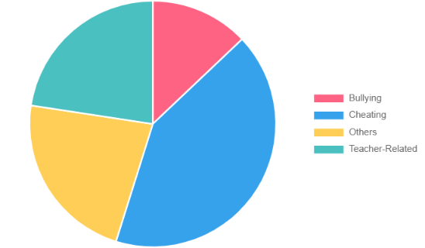

**Complaint Categories Data:**

Bullying: [no. of Bullying complaints]

Cheating: [no. of Cheating complaints]

Others: [no. of Others complaints]

Teacher-Related: [no. of Teacher-Related complaints]

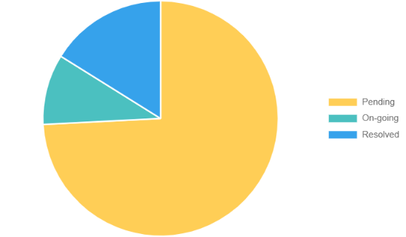

**Complaint Status Data:**

Pending: [no. of Pending complaints]

On-Going: [no. of On-going complaints]

Resolved: [no. of Resolved complaints]

**Number of Complaints per Year Level**

First Year

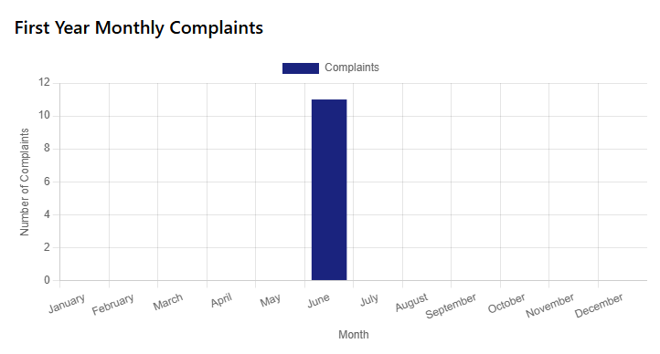

Second Year

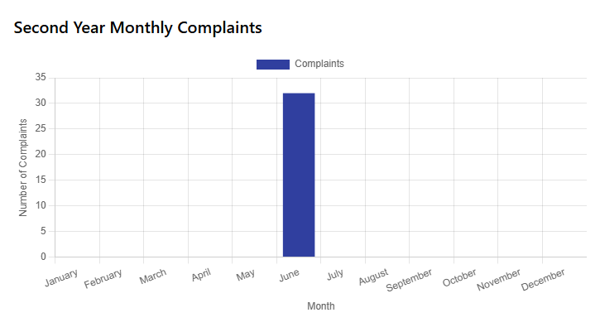

Third Year

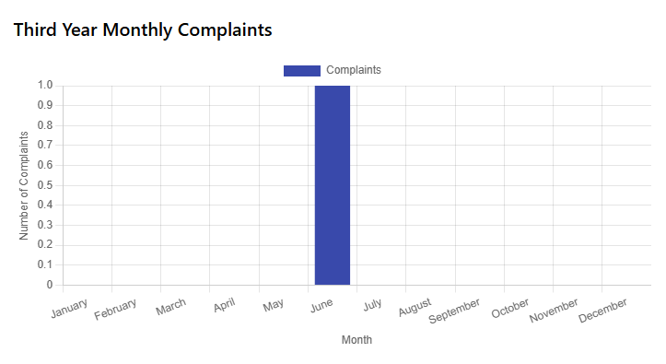

Fourth Year

