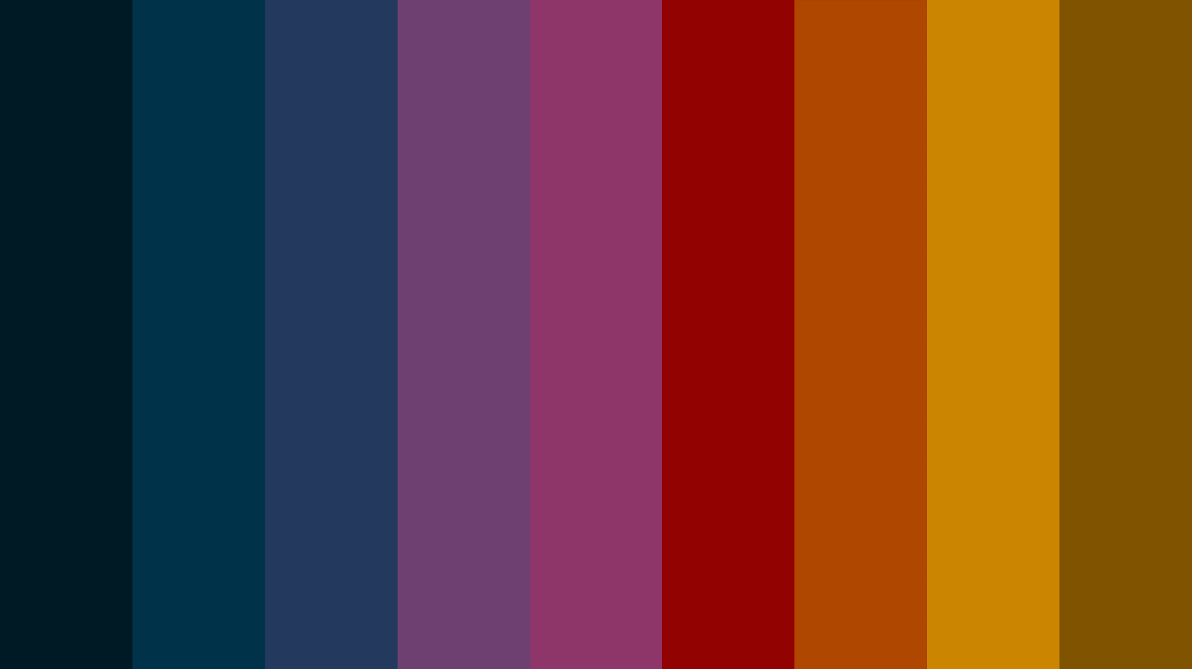



<https://colorkit.co/palette/00202e-003f5c-2c4875-8a508f-bc5090-ff6361-ff8531-ffa600-ffd380>