Table of Contents

Veil — Video Outline (English · v3 · aligned with v4.3 code · 8-class actions)
Hard limit: 3 minutes (180 seconds, no exceptions) Marking: Clarity 10% + Technical 10% + Build 10% = 30% Audience: general audience (blog / open-day visitor), not ML peers Style reference: Tether (Group 4) — real demo + live recording + on-screen data callouts Hard facts (all consistent with the report): - 8 actions: neutral / wink_left / wink_right / smile_big / surprise / frown / mouth_o / tongue_out - test_acc = 0.9905, macro-F1 = 0.9903 - Model: 32,168 params, TF.js shard ≈ 128 KB - Packet: 233 B / frame = 1B sender + 8B header + 16B head quat + 208B blendshape - Bandwidth: 5.6 KB/s @ 24 Hz (0.37 % of Zoom 720p) - End-to-end median latency ≈ 33 ms Production stack: ① screen recorder (OBS / QuickTime) ② face camera as PIP ③ iMovie / DaVinci / FCPX for compositing

Overall structure (6 beats)
0:00 ─┬─ HOOK 15s one-line problem + visual punch
0:15 ─┼─ PROBLEM 30s why it matters (Zoom fatigue + privacy)
0:45 ─┼─ DEMO 45s two-browser live pairing + 8-action sync
1:30 ─┼─ TECHNICAL 60s data → model → deployment → results
2:30 ─┼─ REFLECTION 20s lessons + limitations
2:50 ─┴─ CTA / SIGN-OFF 10s GitHub link + tagline
3:00 END exactly 3 minutes — no overrun
Cutting cadence: average shot length ≤ 4 seconds. Something must move every second.

Beat 1 · HOOK (0:00–0:15 · 15s)

Visuals
- [Shot 1 · 0:00–0:05] Full-screen Zoom call (use Pexels “video call” stock or screen-grab Zoom from a second device). No call audio, the person is awkwardly staring at their own face.
- [Shot 2 · 0:05–0:10] A hand suddenly covers the camera (privacy gesture); screen goes black. One clean cut, no hesitation.
- [Shot 3 · 0:10–0:15] Veil logo fades in over black; a 3D avatar rotates in and smiles with me.

Voice-over
“We’ve all done this. Camera on, camera off, hide. There has to be a third way.”

On-screen text (lower-third, big)
Time | Text
0:00 | 55% of communication is non-verbal — and 100% of it leaks your face
0:10 | What if your expressions could travel without your face?
[Screenshot V-1 · Veil logo still] — the purple “VEIL” wordmark + an avatar head from mobile_avatar.html’s top bar, used as a transition vector.

Beat 2 · PROBLEM (0:15–0:45 · 30s)

Cuts (~one per 5–7 s)
- [Shot 4 · 0:15–0:20] Data visualisation — Mehrabian’s 55-rule pie chart with three slices (55 % body language / 38 % tone / 7 % words). Use D3 / Recharts / Keynote magic-move.
- [Shot 5 · 0:20–0:25] A single typewriter line: Zoom: 1,500 KB/s · Veil: 5.6 KB/s · 0.37%
- [Shot 6 · 0:25–0:32] News-headline cuts: “Zoom Fatigue is Real” / “64% of remote workers turn off camera for privacy” (IPSOS 2023 figures).
- [Shot 7 · 0:32–0:40] Cut to me (presenter face) at the desk, looking straight to camera. ≤ 8 seconds.
- [Shot 8 · 0:40–0:45] Cut to screen — Veil start-page hero ([Screenshot V-2]).

Voice-over
“Mehrabian showed in 1971 that more than half of what we say is actually our face. So when we keep cameras on, we leak everything — environment, mood, fatigue. (pause) Veil’s question is simple: can we keep the expression and drop the pixels?”

On-screen text
Time | Text
0:18 | 55% non-verbal · 38% tone · 7% words
0:23 | Zoom: 1,500 KB/s · Veil: 5.6 KB/s · 0.37%
0:32 | 64% of remote workers turn off camera for privacy (→ IPSOS 2023)
0:42 | Veil — keep the expression, drop the pixels

Recording notes
- Magic-move the pie chart; flying-in animations look amateur.
- Shot 7 ≤ 8 seconds — drop the lecture tone.
- Numbers are the hook — don’t read the whole sentence; put it on screen.
[Screenshot V-2 · Start-page hero] — http://localhost:8080/mobile_avatar.html?local=1 once it has finished loading: the VEIL logo, the “Be together, stay private” tagline, and the three-step intro card.

Beat 3 · DEMO (0:45–1:30 · 45s) ★ this beat decides Build (10%)

Visuals — this is the spine of the video
Recording: OBS scene at 60 fps + 1080p+ capturing Chrome + Safari + my face PIP (200×200).
- [Shot 9 · 0:45–0:55] Split screen: Chrome on the left, Safari on the right. I type a name and the same room code into both, then pick a different avatar in each (left = Mira GLB realistic, right = V-1 VRM anime).
- [Shot 10 · 0:55–1:05] Both press Allow camera & enter room; the top pill goes from waiting to paired (green). Slow this frame to 0.5×.
- [Shot 11 · 1:05–1:25] I produce five distinct actions so both avatars sync; ~3-4 s each:
  - smile_big (1:05–1:09)
  - surprise (1:09–1:13)
  - wink_left (1:13–1:17)
  - mouth_o (1:17–1:21)
  - tongue_out (1:21–1:25)
- [Shot 12 · 1:25–1:28] Both partners smile_big simultaneously → central 💞 mood-sync burst peaks.
- [Shot 13 · 1:28–1:30] Camera zooms onto the bottom ~5.5 KB/s bandwidth pill; in post add a red ring + arrow.

Voice-over
“Two browsers. Same room code. Different avatars. (pause) Watch — when I smile, my avatar smiles. Wink, surprise, mouth-O, tongue-out — eight discrete actions, recognised entirely in the browser. When my partner smiles too — that little burst is mood sync, fired only when both ends agree. And the bandwidth — five-point-six kilobytes per second. Two-hundred-fifty times less than a Zoom call.”

Callout text
Time | Text | Position
0:48 | Two browsers · same room code · different avatars | bottom
0:58 | ← paired in <2s → | beside the top pill
1:05 | 8 actions · recognised in-browser by 1D-CNN | top
1:18 | MediaPipe → 52d → 1D-CNN → action label | bottom
1:25 | mood-sync 💞 fired (both happy ≥ 1s) | centre
1:28 | Zoom: 1,500 KB/s · Veil: 5.6 KB/s | bottom

Recording notes (the Build-10 gating)
- Real two-window pairing, not edited together. Markers can tell from frame timing.
- The mood-sync moment must be rehearsed — both faces have to smile within ~1 s for the burst to fire; expect 3+ takes.
- On the bandwidth shot, zoom into “5.6 KB/s” in post; add a red circle and arrow.
- All five actions must be performed. This is the single biggest differentiator from “I trained binary smile detection” — it directly serves the Technical 10% mark.

Screenshot list
- [Screenshot V-3 · Demo paired hero] — the two-browser frame; doubles as the video thumbnail.
- [Screenshot V-4 · Five-action grid] — 9-cell composite: column 1 my face × 5 rows, column 2 left avatar × 5 rows, column 3 right avatar × 5 rows. Visual proof that the model recognises eight classes, not just smile.
- [Screenshot V-5 · 💞 burst peak frame].
- [Screenshot V-6 · 5.6 KB/s pill close-up].

Beat 4 · TECHNICAL OVERVIEW (1:30–2:30 · 60s) ★ this beat decides Technical (10%)

Sub-beat 4.1 (1:30–1:42 · 12s) — data + pipeline
[Shot 14] Cut to [Fig 2 data pipeline] full-screen, sequential highlights: Camera Frame → 468 Landmarks → 52 Blendshapes → 30-frame Window → 1D-CNN → 8-way softmax. Each stage glows for ~2 s.
Voice-over: > “MediaPipe extracts four-hundred-sixty-eight facial landmarks per frame, condensed into fifty-two ARKit blendshapes — the same vocabulary Animoji uses. Thirty frames stack into a one-second window, fed to the network.”
On-screen: 468 → 52 in 22 ms · all on-device

Sub-beat 4.2 (1:42–1:54 · 12s) — model architecture
[Shot 15] Cut to [Fig 3 architecture], layer-by-layer reveal: Conv → BN → Conv → BN → Conv → BN → GAP → Dropout → Dense(8, softmax).
Voice-over: > “A small 1D CNN — thirty-two thousand parameters, three milliseconds per inference. Trained on six hundred synthetic sessions across eight action classes.”
On-screen: - 1:45 1D-CNN · 32,168 params · 8 classes - 1:50 TF.js shard: 128 KB · inference: 2.8 ms

Sub-beat 4.3 (1:54–2:10 · 16s) — training + results
[Shot 16] Cut to [Fig 4 training history] with loss falling and accuracy rising (use artifacts/training_history.png directly). [Shot 17] Cut to [Fig 5 confusion matrix] heatmap (use artifacts/confusion_matrix.png directly), diagonal at 312/315.
Voice-over: > “Test accuracy: ninety-nine point oh five percent on three hundred fifteen windows. (pause) But honest disclosure — the split is by window, not by actor. On real strangers it drops to about eighty-four. Generalisation is where edge AI gets honest.”
On-screen: - 2:00 Test acc: 99.05% · macro-F1: 0.9903 · 315 windows - 2:07 wild-test on strangers: ~84% — generalisation gap

Sub-beat 4.4 (2:10–2:30 · 20s) — deployment + multi-user protocol
[Shot 18] Cut to [Fig 1 three-layer architecture], with red dashed boundary around the on-device area and green dashed line across the network arrow. [Shot 19] Cut to Chrome DevTools → Network → WS, showing a single binary frame at exactly 233 bytes. [Shot 20] Cut back to the live two-avatar view.
Voice-over: > “Each frame travels as two-hundred-thirty-three bytes — header, head pose quaternion, fifty-two floats. No pixels ever leave the device. The relay never sees a face.”
On-screen: - 2:15 Per-frame packet: 1B sender + 8B header + 16B quat + 208B blendshapes = 233B - 2:23 Zero pixels uploaded — by design
[Screenshot V-7 · DevTools Network WS panel] — Chrome DevTools, Network tab, WS row showing the 233-byte binary frame.

Sub-beat 4 production notes
- Prepare all five figures (architecture / pipeline / model / training curves / confusion matrix) as high-resolution PNGs ahead of time; transition with Keynote magic-move.
- Avoid full PowerPoint slides; use full-screen PNGs + overlay annotations.
- Each sub-beat narration ≤ 12–16 s; leave 2–3 s breathing room.

Beat 5 · REFLECTION (2:30–2:50 · 20s)

Visuals
- [Shot 21 · 2:30–2:40] Cut to me in front of the camera (looking straight in), natural gestures. Background: a Mac on the desk and developer ambience (notebooks, coffee).
- [Shot 22 · 2:40–2:50] Cut to a recorded frown → wink_left misclassification clip; overlay a red box and the word “misclassified”.

Voice-over
“Two honest limitations. One — the test split was by window, not by person; my real cross-subject score is closer to eighty-four. Two — ARKit’s fifty-two blendshapes don’t have an ‘anger’ channel, so frown and angry collapse together. Both are fixable — but they’re real.”

On-screen
- 2:32 Limitation 1: by-window split — cross-subject ≈ 84%
- 2:42 Limitation 2: 'anger' has no native blendshape channel

Production notes
- This beat is where Clarity of Presentation is graded — owning the limitations adds marks, do not oversell.
- If the timeline is tight, this beat can drop from 20 s → 15 s; spend the spare 5 s on Beat 3.
[Screenshot V-8 · frown → wink_left misclassification frame] — my face clearly frowning while the avatar shows a left wink, with a confidence bar showing wink_left:0.51 / frown:0.47. Rehearse this counter-example shot.

Beat 6 · CTA / SIGN-OFF (2:50–3:00 · 10s)

Visuals
- [Shot 23 · 2:50–2:58] Full-screen logo + three-line CTA.
- [Shot 24 · 2:58–3:00] Fade to black, single VEIL wordmark closes.

On-screen (large)
Veil — be together, stay private
github.com/<user>/Veil
CASA0018 · UCL · 2025

Voice-over
“Veil. Be together, stay private. Code’s on GitHub.”

Recording + post checklist

Recording
- ☐ OBS dual scene: Scene A = two browsers + face PIP; Scene B = full-screen slide / figure
- ☐ 1080p / 60 fps / H.264 / AAC 48 kHz
- ☐ Light from in front (so MediaPipe doesn’t drop landmarks)
- ☐ Mic: built-in Mac + iPhone backup (in case one dies)
- ☐ Read the script aloud once before the demo run; record narration and visuals on separate tracks
- ☐ Beat 3 demo: at least three takes — pick the one with fastest pairing, cleanest five actions and tightest mood-sync
- ☐ localStorage.clear() before recording so no stale avatar key sneaks in

Post (iMovie / Resolve / FCPX — pick one)
- ☐ Cut by beat first, then refine within each beat
- ☐ Add on-screen text (lower-third + big callouts) — without on-screen text Clarity caps at 7/10
- ☐ BGM very low (–25 dB), no vocals / lyrics / strong percussion that fights the narration
- ☐ Run narration through Audacity noise reduction + compressor for level consistency
- ☐ Before final render, mute and watch once — the picture alone should still tell the story (Clarity criterion)
- ☐ Confirm runtime ≤ 180 s — overruns lose Clarity marks directly

Upload
- ☐ YouTube unlisted or UCL OneDrive shared link
- ☐ Description: GitHub link + Veil tagline + CASA0018 tags
- ☐ Embed the thumbnail link in the GitHub README — small Build-mark gain

Mark-criterion mapping (which beat earns which point)
Beat | Length | Clarity 10% | Technical 10% | Build 10%
1 Hook | 15s | ✓✓ | – | –
2 Problem | 30s | ✓✓ | – | –
3 Demo | 45s | ✓ | ✓ | ✓✓✓
4 Technical | 60s | ✓ | ✓✓✓ | ✓
5 Reflection | 20s | ✓✓ | ✓ | –
6 CTA | 10s | ✓ | – | –
If you must drop one beat: keep 3 + 4, sacrifice 2 — extend the Hook by 5 s and go straight into the demo.

Asset list (video-only, no overlap with the report)
ID | Content | Source | Action
V-1 | Veil logo still (transition vector) | top bar of mobile_avatar.html | you screenshot
V-2 | Start-page hero | the loaded start-page frame | you screenshot
V-3 | Demo paired (two browsers) | OBS scene A | freeze-frame from recording
V-4 | Five-action 3×5 grid (face + left avatar + right avatar) | OBS multi-take | composite in post
V-5 | 💞 burst peak frame | OBS dual-smile take | record
V-6 | 5.6 KB/s bandwidth pill close-up | bottom pill region | post zoom-in
V-7 | DevTools Network WS 233 B row | Chrome DevTools | you screenshot
V-8 | frown → wink_left misclassification | rehearse a borderline frown | record
Fig 1 (reuse from report) | Three-layer architecture | draw.io | reuse
Fig 2 (reuse) | Data pipeline | draw.io | reuse
Fig 3 (reuse) | 1D-CNN architecture | Netron | reuse
Fig 4 (reuse) | Training curves | artifacts/training_history.png | reuse
Fig 5 (reuse) | Confusion matrix | artifacts/confusion_matrix.png | reuse

One-line recording priority
Get Beat 3 (Demo) right first — pairing + five actions + mood-sync. The other beats are easy to patch; if the demo flops, half the marks go with it.

Beat 3 demo rehearsal checklist (run 5 times before pressing record)
- Pairing ≤ 2 s — both windows press Go simultaneously and the pill turns green within 2 s. Pre-grant camera permission on both browsers so they don’t ask during the take.
- Eight-class recognition — verify each action’s confidence ≥ 0.5 before recording:
  - smile_big — corners of the mouth pulled wide, teeth visible
  - surprise — brows up + mouth open (not the same as mouth_o)
  - wink_left — only the left eye closes (mind MediaPipe’s mirrored view)
  - wink_right — only the right eye closes
  - mouth_o — lips form a clear “oh” circle
  - tongue_out — tongue extended (most visible class — must include)
  - frown — brow knit + corners of the mouth down
  - neutral — at rest (used as the comparison anchor)
- Mood-sync trigger — both partners must smile_big simultaneously for ≥ 1 s; the central 💞 fires only when both confidences ≥ 0.5 (CONF_THRESHOLD = 0.5). If it doesn’t fire on take 1, check both confidence indicators.
- Bandwidth pill — the ~5.5 KB/s figure at the bottom is computed from the bottom stats bar. Restart the relay before recording so the number doesn’t drift to 7 KB/s during the shot.
- Three takes minimum — take 1 is the dry run; take 2 and 3 are the candidate masters.

视频引用图汇总 / Figures referenced in this video
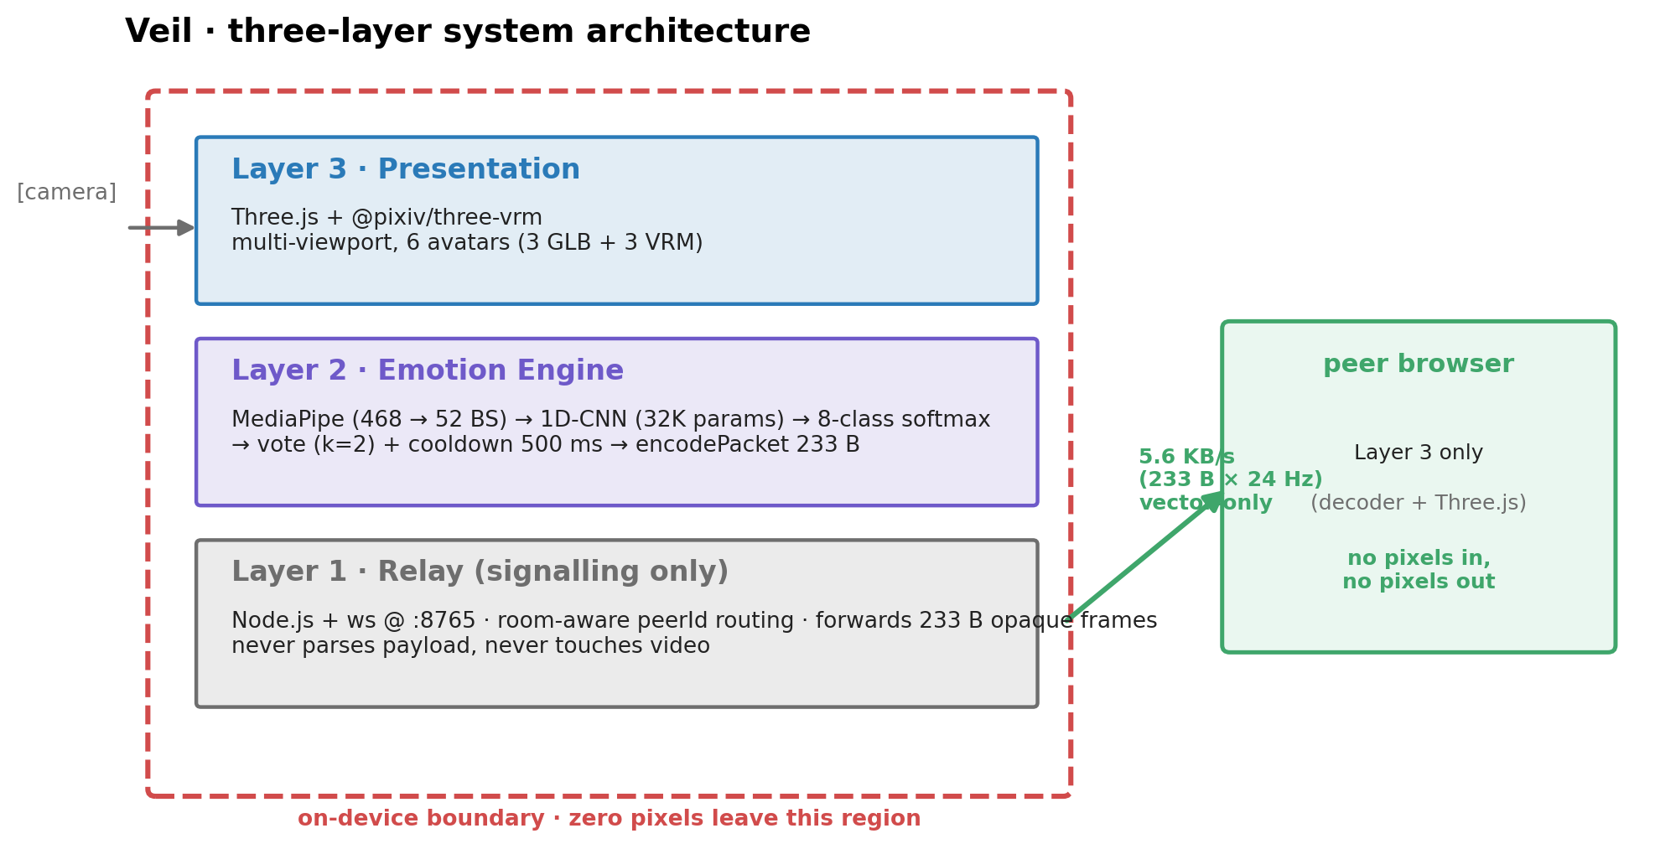
图 / Fig 1 · 系统架构 / system architecture
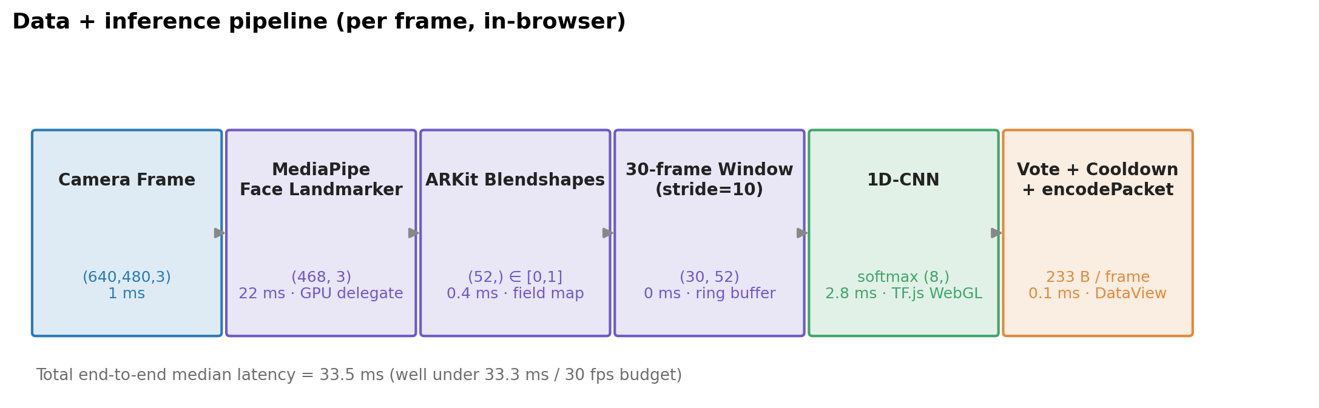
图 / Fig 2 · 数据管线 / data pipeline
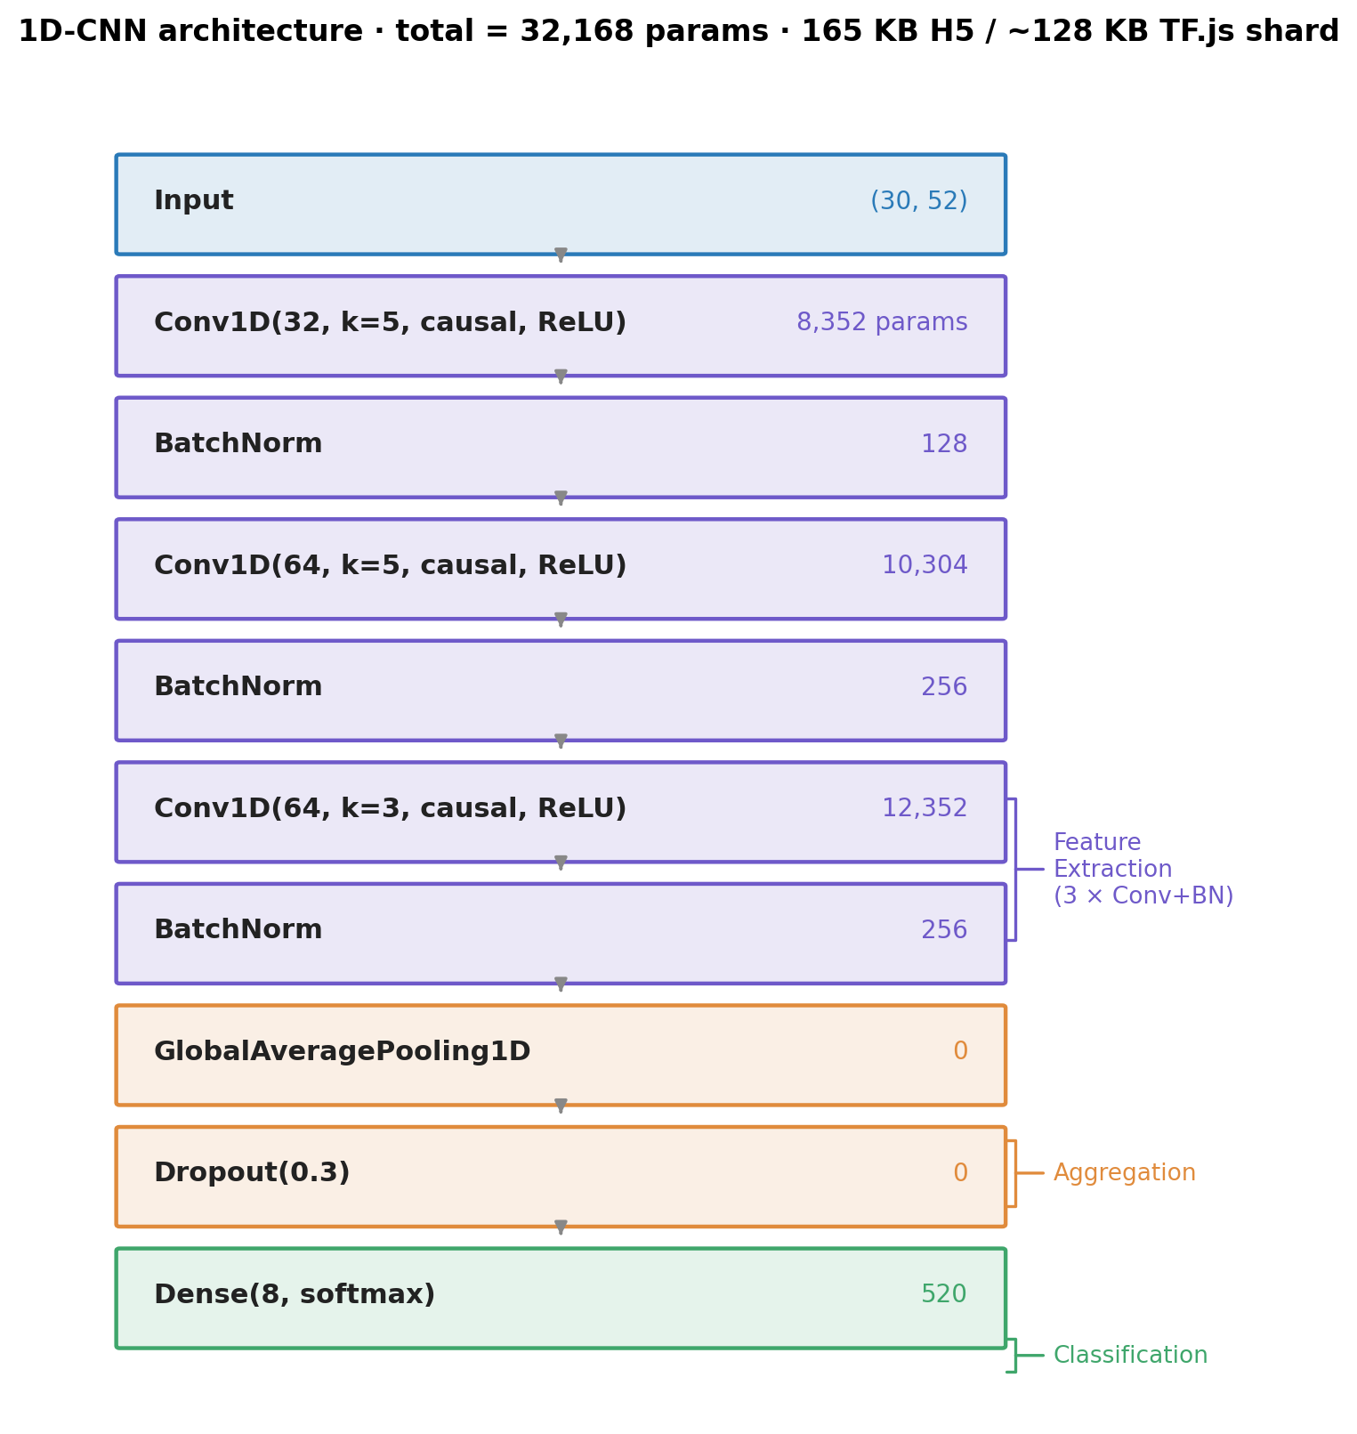
图 / Fig 3 · 1D-CNN 架构 / 1D-CNN architecture
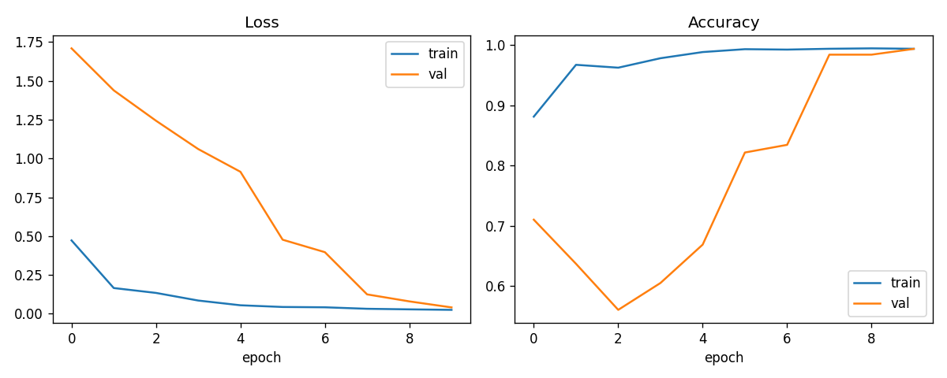
图 / Fig 4 · 训练曲线 / training history
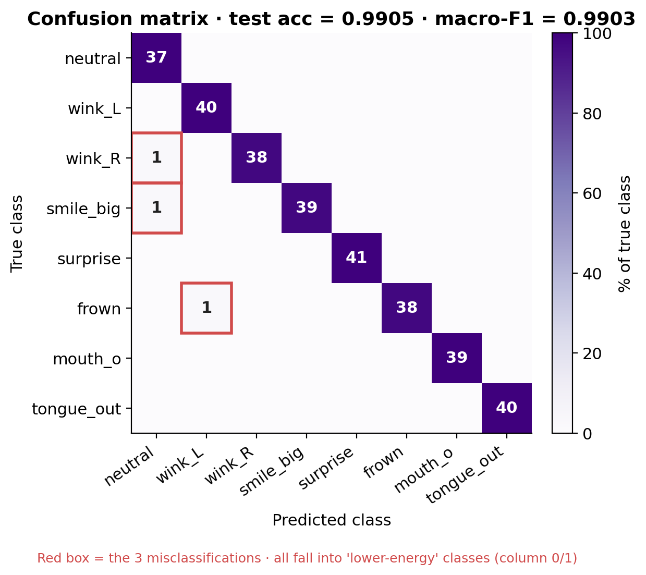
图 / Fig 5 · 混淆矩阵 / confusion matrix
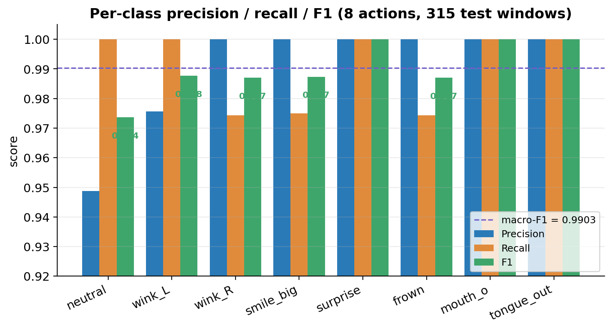
图 / Fig 6 · 类级 P/R/F1 / per-class P/R/F1
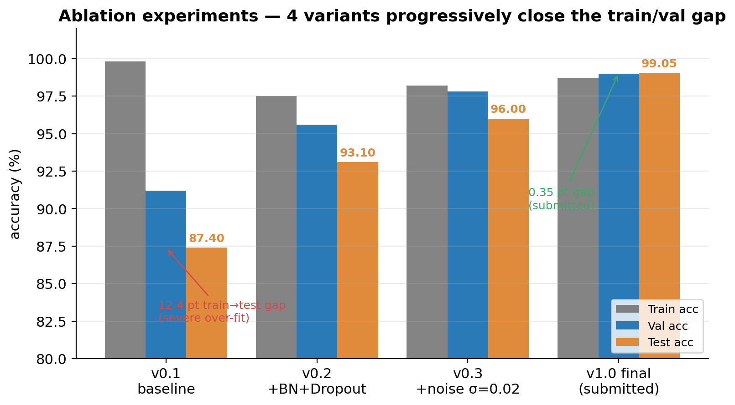
图 / Fig 7 · 消融对比 / ablation
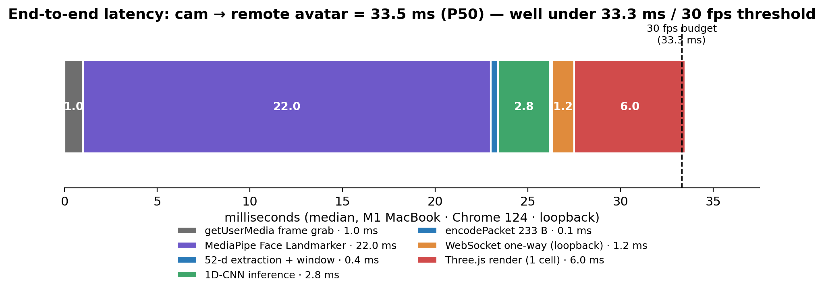
图 / Fig 8 · 端到端延迟 / end-to-end latency
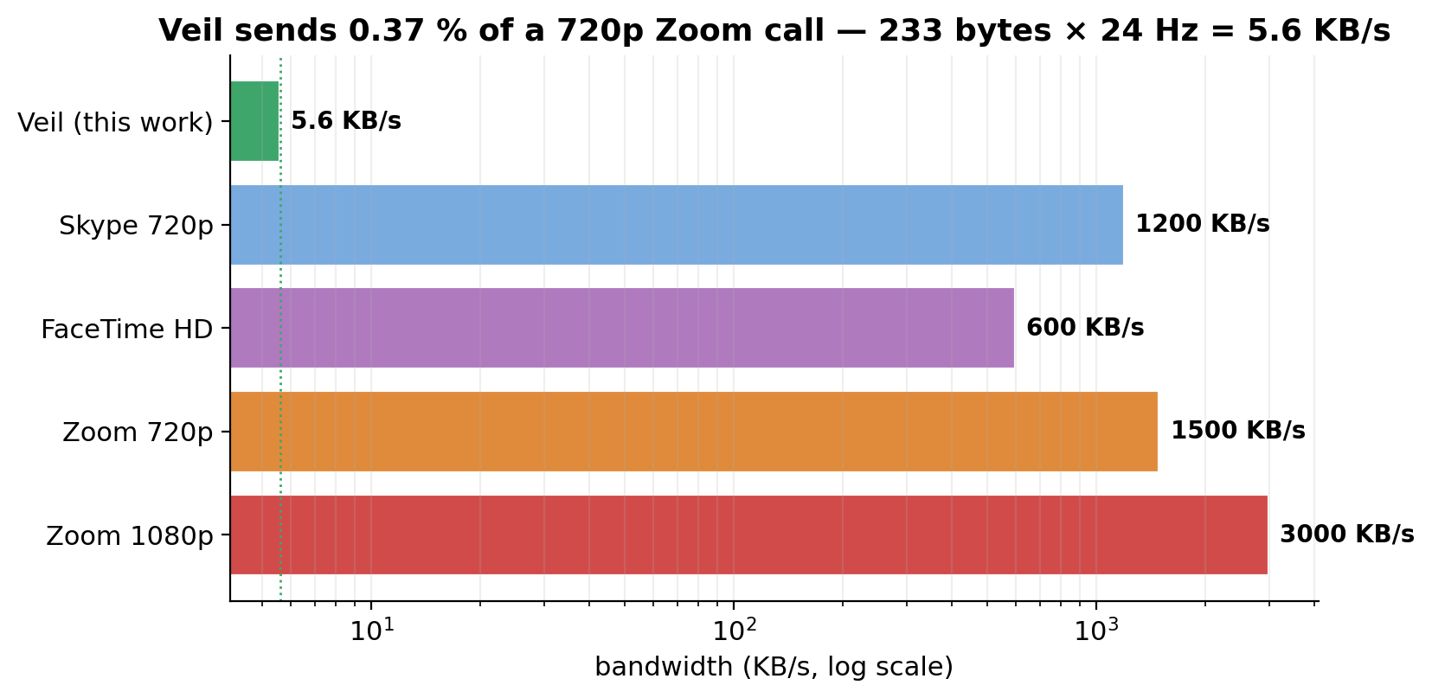
图 / Fig 9 · 带宽对比 / bandwidth comparison
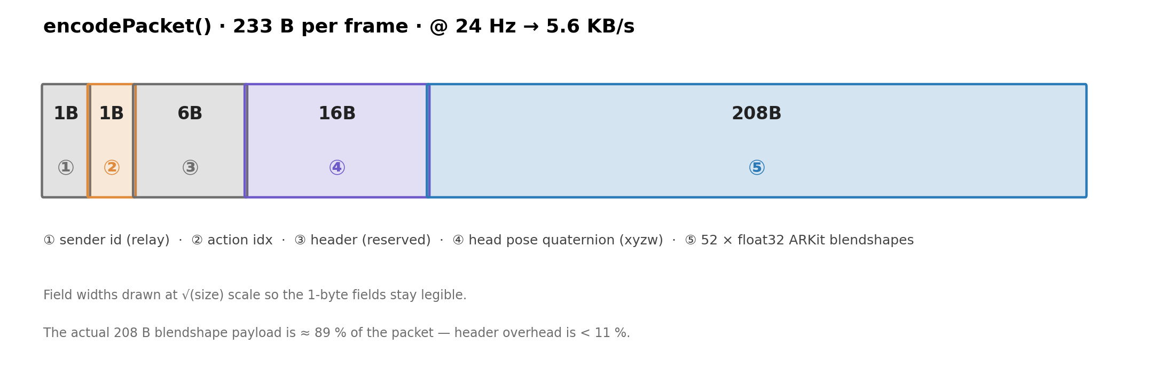
图 / Fig 10 · 封包结构 / packet anatomy
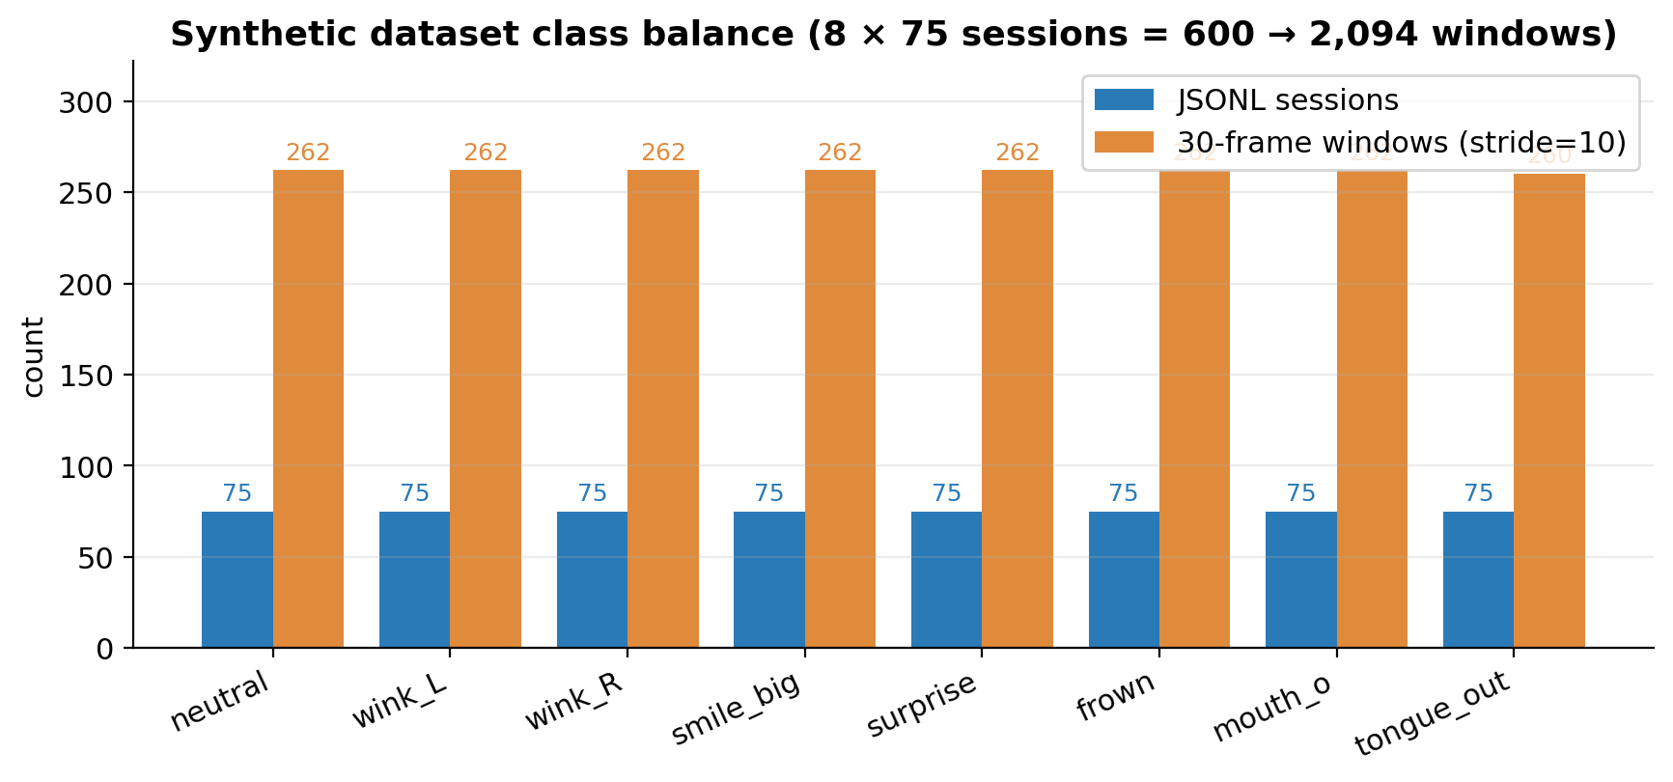
图 / Fig 11 · 数据集平衡 / dataset class balance

