**Gabriel Yeager**

**SYSE 5050**

**HW8**

Exercise 3 from chapter 4.

Develop a WBS for a project in which you are going to build a bicycle. Try to identify all of the major components and provide three levels of detail.

Excercise 5 from chapter 6.

Draw a project network from the following information. What activity(ies) is a burst activity? What activity(ies) is a merge activity?

ID Description Predecessor

A Order review None

B Order standard parts A

C Produce standard parts A

D Design custom parts A

E Software development A

F Manufacture custom parts C, D

G Assemble B, F

H Test E, G

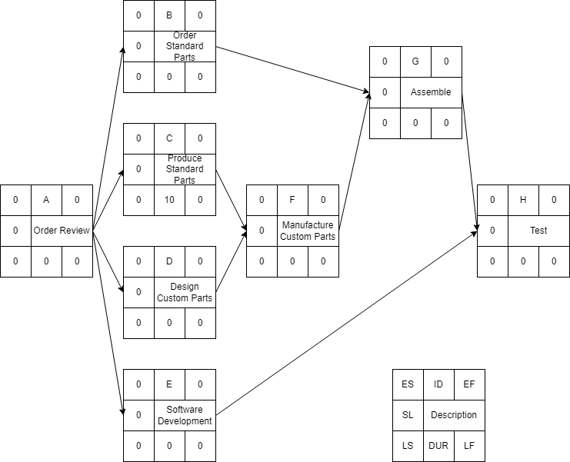

**Activity A is a burst activity.**

**Activities F, G, and H are merge activities.**

Excercise 6 from chapter 6.

From the following information, develop an AON project network. Complete the forward and backward pass, compute activity slack, and identify the critical path. How many days will the project take?

ID Description Predecessor Time

A Survey site None 2

B Excavate site A 4

C Install power lines B 3

D Install drainage B 5

E Pour foundation C, D 3

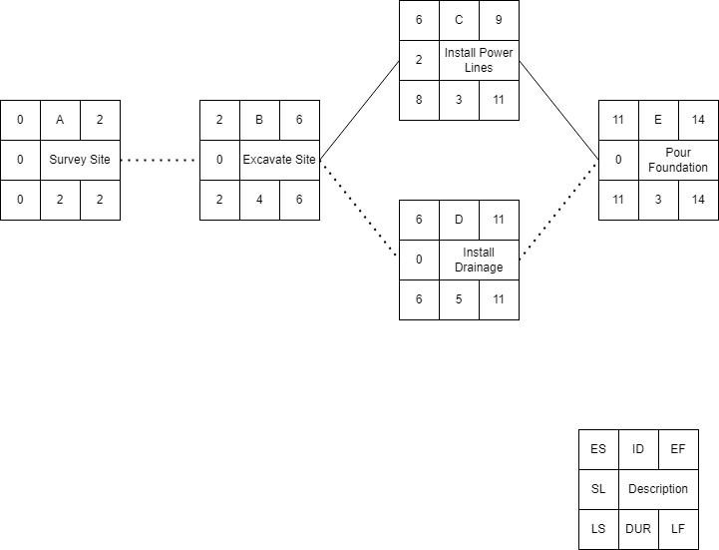

**The critical path is A,B,D,E**

**The project will take 14 days**

Excercise 7 from chapter 6.

The project information for the custom order project of the Air Control Company is presented here. Draw a project network for this project. Compute the early and late activity times and slack times. Identify the critical path.

ID Description Predecessor Time

A Order review None 2

B Order standard parts A 3

C Produce standard parts A 10

D Design custom parts A 13

E Software development A 18

F Manufacture custom hardware C, D 15

G Assemble B, F 10

H Test E, G 5

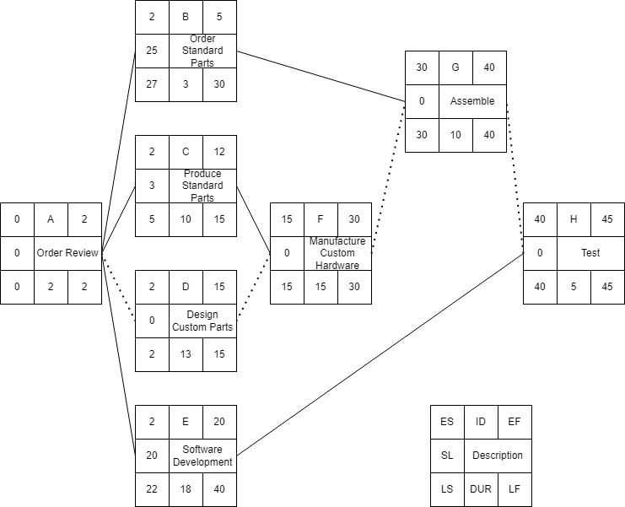

**The critical path is A,D,F,G,H.**