**Gabriel Yeager**

**SYSE 5110**

**Analysis Problem Set**

1). (Lesson 6: Decisions Under Uncertainty) The design of a 12-year life system is to be examined from one of two competing alternatives. Each alternative has a life-cycle cost associated with an expected future. The costs for the futures (optimistic, expected, pessimistic) are given in the table below (millions of $). Assume the probabilities of occurrence of the futures are 30%, 50%, and 20%, respectively.

|  |  |  |  |  |  |  |
| --- | --- | --- | --- | --- | --- | --- |
| Design 1 |  |  |  | Years |  |  |
| Future | 1 | 2 | 3 | 4 | 5 | 6 thru 12 |
| Optimistic | 0.4 | 0.6 | 5.0 | 7.0 | 0.8 | 0.8 |
| Expected | 0.6 | 0.8 | 1.0 | 5.0 | 10.0 | 1.0 |
| Pessimistic | 0.8 | 0.9 | 1.0 | 7.0 | 10.0 | 1.2 |
| Design 2 |  |  |  | Years |  |  |
| Future | 1 | 2 | 3 | 4 | 5 | 6 thru 12 |
| Optimistic | 0.4 | 0.4 | 0.4 | 1.0 | 3.0 | 2.5 |
| Expected | 0.6 | 0.8 | 0.8 | 3.0 | 6.0 | 3.0 |
| Pessimistic | 0.6 | 0.8 | 0.8 | 5.0 | 6.0 | 3.1 |

a). Which design alternative is most desirable from an expected value cost viewpoint using an interest rate of 10%?

Design 1

Optimistic NPV = (0.4/1.1) + (0.6/1.1^2) + (5.0/1.1^3) + (7.0/1.1^4) + (0.8/1.1^5) + (0.8/1.1^6) + (0.8/1.1^7) + (0.8/1.1^8) + (0.8/1.1^9)+ (0.8/1.1^10) + (0.8/1.1^11)+ (0.8/1.1^12)

= 12.31

Expected NPV = (0.6/1.1) + (0.8/1.1^2) + (1.0/1.1^3) + (5.0/1.1^4) + (10.0/1.1^5) + (1.0/1.1^6) + (1.0/1.1^7) + (1.0/1.1^8) + (1.0/1.1^9)+ (1.0/1.1^10) + (1.0/1.1^11)+ (1.0/1.1^12)

= 14.61

Pessemistic NPV = (0.8/1.1) + (0.9/1.1^2) + (1.0/1.1^3) + (7.0/1.1^4) + (10.0/1.1^5) + (1.2/1.1^6) + (1.2/1.1^7) + (1.2/1.1^8) + (1.2/1.1^9)+ (1.2/1.1^10) + (1.2/1.1^11)+ (1.2/1.1^12)

= 16.84

Expected value = (12.31 * 0.30) + (14.61 * 0.5) + (16.84 * 0.2) = **14.37**

Design 2

Optimistic NPV = (0.4/1.1) + (0.4/1.1^2) + (0.4/1.1^3) + (1.0/1.1^4) + (3.0/1.1^5) + (2.5/1.1^6) + (2.5/1.1^7) + (2.5/1.1^8) + (2.5/1.1^9)+ (2.5/1.1^10) + (2.5/1.1^11)+ (2.5/1.1^12)

= 11.10

Expected NPV = (0.6/1.1) + (0.8/1.1^2) + (0.8/1.1^3) + (3.0/1.1^4) + (6.0/1.1^5) + (3.0/1.1^6) + (3.0/1.1^7) + (3.0/1.1^8) + (3.0/1.1^9)+ (3.0/1.1^10) + (3.0/1.1^11)+ (3.0/1.1^12)

= 16.65

Pessemistic NPV = (0.6/1.1) + (0.8/1.1^2) + (0.8/1.1^3) + (5.0/1.1^4) + (6.0/1.1^5) + (3.1/1.1^6) + (3.1/1.1^7) + (3.1/1.1^8) + (3.1/1.1^9)+ (3.1/1.1^10) + (3.1/1.1^11)+ (3.1 1.1^12)

= 27.06

Expected value = (11.10 * 0.30) + (16.65 * 0.5) + (27.06 * 0.2) = **17.07**

**Design 1 is most desirable because it has a lower life-cycle cost according to expected value.**

b). Prepare a decision evaluation matrix for the design alternatives and choose the alternative that is best under the following decision rules:

Optimistic Expected Pessimimistic

Design 1 12.31 14.61 16.84

Design 2 11.10 16.65 27.06

1. Laplace

Design 1: (12.31/3) + (14.61/3) + (16.84/3) = **14.59**

Design 2: (11.10/3) + (16.65/3) + (27.06/3) = **18.27**

**Design 1 is the best alternative according to the laplace principle**

1. Maximax

The minimum cost has the maximum payoff so, I will use the lowest cost as the maximum.

Design 1: 12.31, 14.61, 16.84 = **12.31**

Design 2: 11.10, 16.65, 27.06 = **11.10**

**Design 2 is the best alternative according to under the maximax rule.**

1. Maximin

The maximum cost has the minimum payoff so, I will use the highest cost as the minimum.

Design 1: 12.31, 14.61, 16.84 = **16.84**

Design 2: 11.10, 16.65, 27.06 = **27.06**

**Design 1 is the best alternative according to under the maximin rule.**

1. Hurwicz with  = 0.6

*Hint: The example from the lecture is seeking to maximize a desirable value (profit), this problem is asking you to minimize an undesirable value (cost). Turning your optimistic, expected, and pessimistic values into negative numbers may make this analysis easier.

Design 1: 0.6(12.31) + 0.4(16.84) = **14.122**

Design 2: 0.6(11.10) + 0.4(27.06) = **17.484**

**Design 1 is the best alternative according to under the Hurwicz rule.**

c). Which design would you recommend to management? Justify your response.

**I would recommend design 1 to management. All but one analysis indicated that design 1 had the lowest life-cycle cost. Additionally, design 2 has a very high pessimistic cost, therefore; persuing design 2 may cost a great deal more than design 1 and increase risk significantly.**

2). (Lesson 7 – System Economics) A manufacturing firm has the capacity to produce 650,000 units of an electronic product per year. At present, it is operating at 65% of capacity yielding the firm’s estimated annual income of $416,000. Annual fixed costs are $192,000 and the variable costs are $0.38 per unit of product.

1. What is the firm’s annual profit or loss?

Units = 650000 * 0.65 = 422500

Cost of units sold = 422500 * 0.38 = $160,550

Profit = 416000 - 192000 – 160550 = **$63,450**

1. At what volume of sales does the firm break even?

Constant income per unit = 416000/422500 = 0.98462

Let x be the number of units

192000 = 0.98462x – 0.38x

**The break even volume is 317,555 units.**

1. What will be the profit or loss at 70%, 80%, and 90% of capacity on the basis of constant income per unit and constant variable cost per unit?

70% of capacity

650000 * .7 = 455000

Profit or loss = 0.98462(455000) – 0.38(455000) -192000 = 83102.1

**Profit of $83,102.10**

80% of capacity

650000 * .8 = 520000

Profit or loss = 0.98462(520000) – 0.38(520000) -192000 = 122402.4

**Profit of $122,402.40**

90% of capacity

650000 * .9 = 585000

Profit or loss = 0.98462(585000) – 0.38(585000) -192000 = 161702.7

**Profit of $161,702.70**

3). (Lesson 9 – Design for Reliability) Assume there is a requirement for a new system with a specified performance capability and reliability of 70%. In response to an “invitation to bid”, three supplier configurations have been proposed and are reflected in the figures below. The component reliability factors are given in the table below.

|  |  |  |  |  |  |
| --- | --- | --- | --- | --- | --- |
| Component | Reliability | Component | Reliability | Component | Reliability |
| A | 0.84 | G | 0.87 | M | 0.83 |
| B | 0.86 | H | 0.88 | N | 0.85 |
| C | 0.89 | I | 0.89 | O | 0.84 |
| D | 0.86 | J | 0.86 | P | 0.89 |
| E | 0.87 | K | 0.85 | Q | 0.89 |
| F | 0.82 | L | 0.86 |  |  |

Configuration A:

B

C

G

I

F

D

E

H

O

A

K

J

M

N

P

L

Q

Configuration B:

N

O

C

K

F

G

A

B

D

L

H

E

I

M

J

Configuration C:

H

B

C

M

I

L

D

E

N

A

J

F

K

G

The overall cost associated with each of the supplier proposals is $57,000 for Configuration A, $39,000 for Configuration B, and $42,000 for Configuration C.

1. Determine the system reliability for each of the three configurations.

Configuration A:

BC = 0.86 * 0.89 = 0.7654

DE = 0.86 * 0.87 = 0.7482

K L = 1 – ((1-0.85)(1-0.86)) = 0.979

G H = 1 – ((1-0.87)(1-0.88)) = 0.9844

O P Q = 1 – ((1-0.84)(1-0.89)(1-0.89)) = 0.998064

BC DE = 1 – ((1-0.7654)(1-0.7482)) = 0.94092772

BC DE F GH I = 0.94092772 * 0.82 * 0.9844 * 0.89 = 0.6759767008751264

J KL M N OPQ = 0.86 * 0.979 * 0.83 * 0.85 * 0.998064 = 0.59283870793488

BCDEFGHI JKLMNOPQ = 1 – ((1 – 0.6759767008751264)(1 – 0.59283870793488)

= 0.8680702548691135984482970311680

A BCDEFGHIJKLMNOPQ = 0.84 * 0.8680702548691135984482970311680

= **0.72917901409005542269656950618112**

Configuration B:

CD = 1 – ((1 - 0.89)( 1 – 0.86)) = 0.9846

N O = 0.85 * 0.84 = 0.714

HIJ = 1 – ((1 - 0.88)( 1 – 0.89)(1 – 0.86)) = 0.998152

KLM = 1 – ((1 - 0.85)( 1 – 0.86)(1 – 0.83)) = 0.99643

CD F G = 0.9846 * 0.82 * 0.87 = 0.70241364

E HIJ = 0.87 * 0.998152 = 0.86839224

CDFGEHIJ = 1 – ((1 - 0.70241364)(1 – 0.86839224)) = 0.9608353257538464

CDFGEHIJKLM = 0.9608353257538464 * 0.99643 = 0.957405143640905168352

CDFGEHIJKLM NO = 1 – ((1 - 0.957405143640905168352)(1 – 0.714)) = 0.987817871081298878148672

ABCDFGEHIJKLMNO = 0.84 * 0.86 * 0.987817871081298878148672

= **0.7135996300691303095746006528**

Configuration C:

BC = 0.86 * 0.89 = 0.7654

DE = 0.86 * 0.87 = 0.7482

H I J = 1 – ((1 – 0.88)(1 – 0.89)(1 – 0.86)) = 0.998152

M N = 1 – ((1 – 0.83)(1 - 0.85)) = 0.9745

GK = 0.87 * 0.85 = 0.7395

BC DE F = 1 – ((1 - 0.7654)(1 - 0.7482)(1 – 0.82)) = 0.9893669896

BCDEF HIJ = 0.9893669896 * 0.998152 = 0.9875386394032192

BCDEFHIJ GK = 1 – ((1 - 0.9875386394032192)(1 – 0.7395)) = 0.9967538155645386016

ABCDEFHIJGKLMN = 0.84 * 0.9967538155645386016 * 0.86 * 0.9745

= **0.70169355497654520730804608**

1. In evaluating the three alternatives, using cost-effectiveness criteria, which configuration would you select and why?

Reliability Cost Reliability per dollar

Configuration A 0.72917901409005542269656951 $57,000 0.00001279

Configuration B 0.71359963006913030957460065 $39,000 0.00001830

Configuration C 0.70169355497654520730804608 $42,000 0.00001671

**I would choose configuration B because it meets the 70% reliability requirement and it obtains the most reliabiltity per dollar. It also happens to be the least costly alternative overall.**

4). (Lesson 8 – Control Concepts) Eight maintenance activities, their normal durations in weeks, and the crew sizes for the normal condition are as follows:

|  |  |  |
| --- | --- | --- |
| Activity | Duration in Weeks | Crew size |
| AC | 6 | 8 |
| BC | 6 | 7 |
| BE | 2 | 6 |
| CD | 3 | 2 |
| CE | 4 | 1 |
| DF | 7 | 4 |
| EF | 4 | 6 |
| FG | 5 | 10 |

1. Represent the maintenance project in the form of a PERT chart.

*Hint: there are 2 starting points

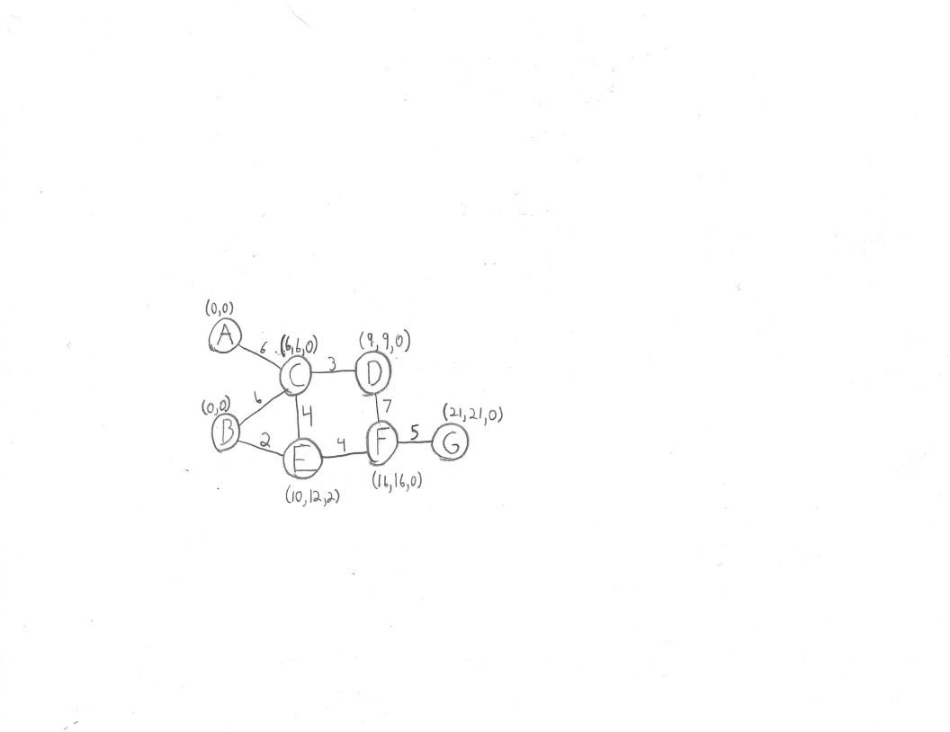

1. Identify the critical path and find the minimum time for project completion.

**The critical path is A-C, C-D, D-F, F-G.**

**6 + 3 + 7 + 5 = 21 weeks is the shortest possible time for project completion.**

1. Extra crew members can be used to expedite activities BC, CE, DF, and EF at a cost given below:

|  |  |  |
| --- | --- | --- |
| Extra Crew | Weeks Saved | Crash cost per week |
| 1 | 1 | $100 |
| 2 | 2 | $120 |
| 3 | 2 | $200 |
| 4 | 3 | $250 |

If there is a penalty cost of $1,250 per week beyond the minimum maintenance time of 20 weeks, recommend the minimum cost schedule.

**We only need to reduce the project completion time by one week and there is no benefit to reducing the completion time less the minimum of 20 weeks. The $100 expendeture on 1 extra crew and saving the 1 week is all that is necessary and is the least expensive option. D-F should be chosen for expiditing. Expiditing activities B-C, C-E, and E-F do not result in a reduction in the completion time.**

1. (Independent of part c) The table below, based on historical completion times, gives three estimates for each activity completion time. Determine the mean and variance of the expected project completion time and calculate the probability that the project is completed within the 20-week minimum maintenance time.

|  |  |  |  |
| --- | --- | --- | --- |
| Activity | Optimistic | Most Likely | Pessimistic |
| AC | 5 | 6 | 8 |
| BC | 4 | 6 | 10 |
| BE | 2 | 2 | 2 |
| CD | 2 | 3 | 7 |
| CE | 2 | 4 | 9 |
| DF | 5 | 7 | 13 |
| EF | 3 | 4 | 6 |
| FG | 4 | 5 | 16 |

Expected time (mean)

AC (5 + 4(6) + 8) / 6 = 6.17

BC (4 + 4(6) + 10) / 6 = 6.33

BE (2 + 4(2) + 2) / 6 = 2

CD (2 + 4(3) + 7) / 6 = 3.5

CE (2+ 4(4) + 9) / 6 = 4.5

DF (5 + 4(7) + 13) / 6 = 7.67

EF (3 + 4(4) + 6) / 6 = 4.17

FG (4 + 4(5) + 16) / 6 = 6.67

The critical path is A-C, C-D, D-F, F-G.

6.33 + 3.5 + 7.67 + 6.67 = **24.01 is the mean project completion time.**

Variance

((8 - 5) / 6)^2 = 0.25

((7 - 2) / 6)^2 = 0.69

((13 – 5) / 6)^2 = 1.78

((16 – 4) / 6)^2 = 4

Z = (20 – 24.01) / sqrt(0.25 + 0.69 + 1.78 + 4) = -1.54689

From Z table: **0.0618 or 6.18% probability of completing the project in 20 weeks or less.**

5). (Lesson 10 – Design for Maintainability) Corrective maintenance task times were observed and tabulated in the table below.

|  |  |  |  |
| --- | --- | --- | --- |
| Task Time (min) | Frequency | Task Time (min) | Frequency |
| 41 | 2 | 37 | 4 |
| 39 | 3 | 25 | 10 |
| 47 | 2 | 36 | 5 |
| 35 | 5 | 31 | 7 |
| 23 | 13 | 13 | 3 |
| 27 | 10 | 11 | 2 |
| 33 | 6 | 15 | 8 |
| 17 | 12 | 29 | 8 |
| 19 | 12 | 21 | 14 |

1. What is the range of observations?

47 – 11 = **36**

1. Using a class interval width of 4, determine the number of class intervals. Plot the data and construct a curve. What type of distribution is indicated by the curve?

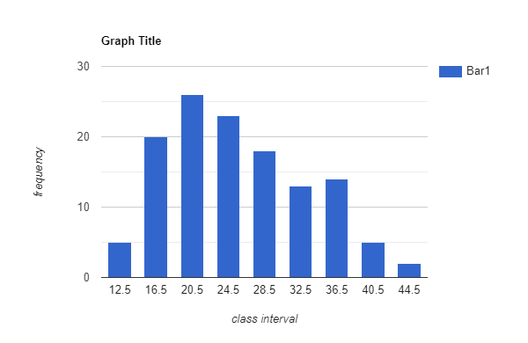

**It appears to be a normal distribution with some skewness toward the lower task time class intervals.**

12.5 16.5 20.5 24.5 28.5 32.5 36.5 40.5 44.5

5 20 26 23 18 13 14 5 2

1. What is the mean of the task times?

((41*2)+(39*3)+(47*2)+(35*5)+(23*13)+(27*10)+(33*6)+(17*12)+(19*12)+(37*4)+(25*10)+(36*5)+(31*7)+(13*3)+(11*2)+(15*8)+(29*8)+(21*14)) / 126 = **25.1508 minutes**

1. What is the standard deviation of the sample data?

( 2((41) - (25.1508))**2+3((39) - (25.1508))**2 +2((47) - (25.1508))**2 +5((35) - (25.1508))**2 +13((23) - (25.1508))**2 +10((27) - (25.1508))**2 +6((33) - (25.1508))**2 +12((17) - (25.1508))**2 +12((19) - (25.1508))**2 +4((37) - (25.1508))**2 +10((25) - (25.1508))**2 +5((36) - (25.1508))**2 +7((31) - (25.1508))**2 +3((13) - (25.1508))**2 +2((11) - (25.1508))**2 +8((15) - (25.1508))**2 +8((29) - (25.1508))**2 +14((21) - (25.1508))**2 ) / 125 =

( 2*((41) - (25.1508))**2 + 3*((39) - (25.1508))**2 + 2*((47) - (25.1508))**2 + 5*((35) - (25.1508))**2 + 13*((23) - (25.1508))**2 + 10*((27) - (25.1508))**2 + 6*((33) - (25.1508))**2 + 12*((17) - (25.1508))**2 + 12*((19) - (25.1508))**2 + 4*((37) - (25.1508))**2 + 10*((25) - (25.1508))**2 + 5*((36) - (25.1508))**2 + 7*((31) - (25.1508))**2 +3 *((13) - (25.1508))**2 +2 *((11) - (25.1508))**2 + 8*((15) - (25.1508))**2 + 8*((29) - (25.1508))**2 + 14*((21) - (25.1508))**2 ) / 125 ))

**standard deviation = 7.823111872210444**

1. What is the Mmax value? Assume 90% confidence level.

Log Mct total = ( 2*(math.log10(41) )+ 3*math.log10((39)) + 2*math.log10((47)) + 5*math.log10((35)) + 13*math.log10((23)) + 10*math.log10((27)) + 6*math.log10((33)) + 12*math.log10((17)) + 12*math.log10((19)) + 4*math.log10((37) ) + 10*math.log10((25)) + 5*math.log10((36)) + 7*math.log10((31)) +3 *math.log10((13)) +2 *math.log10((11)) + 8*math.log10((15)) + 8*math.log10((29)) + 14*math.log10((21)) ) )

= 173.81776184201456

(Log Mct)^2 = ( 2*(math.log10(41)**2) + 3*math.log10((39))**2 + 2*math.log10((47))**2 + 5*math.log10((35))**2 + 13*math.log10((23))**2 + 10*math.log10((27))**2 + 6*math.log10((33))**2 + 12*math.log10((17))**2 + 12*math.log10((19))**2 + 4*math.log10((37) )**2 + 10*math.log10((25))**2 + 5*math.log10((36))**2 + 7*math.log10((31))**2 +3 *math.log10((13))**2 + 2 *math.log10((11))**2 + 8*math.log10((15))**2 + 8*math.log10((29))**2 + 14*math.log10((21))**2 ) )

= 242.129589003407

std dev log mct = sqrt( ((242.129589003407 – (173.81776184201456)**2 ) / 126) / 125 )

= 1.902888

Antilog (log avgMct + 1.28(1.903)

antilog (1.401 + (1.28*1.903))

= **6868.15** **minutes** ?????????????????????????????????????????

pg421

Mmax = 25.1508 + 1.28(7.823111872210444) = **35.16 minutes**

6). (Lesson 12 – Design for Supportability) A critical piece of operational equipment contains 30 parts of the same type. The equipment operates 24 hours a day and the critical pieces have a predicted failure frequency of 10,000 hours. Two inventory supply policies are under evaluation; one based on operational probability and the second on annual costs.

1. If spares are procured at 90-day intervals, how many spares should be carried in the inventory to ensure a 95% probability of success?

λ = number of failures / total operating hours

MTBF = 1 / λ

λ = 1 / MTBF

λ = 1/10,000 = 0.0001

k λ T = 30 * 0.0001 *24 * 90 = 6.48

From nomograph: **11 spares required to achieve 95% probability of success.**

1. If spares are procured as part of an EOQ policy with: cost per unit of $100, cost of preparation and shipping of $25, an estimated cost of managing an item in inventory of 25% of the inventory value, what is the order quantity and annual costs?.

Average spare parts demanded in a year = 6.48 * (365/90) = 26.28 units

Q = sqrt( 2((25)(26.28) / (.25)(Q)(100)) = **3.74586 units**

CD = 100 * 26.28 = $2,628

CD / Q = (25 * 26.28) / 3.74586 = $175.39

CQ / 2 = ((.25)(3.74586)(100)(3.74586)) / 2 = $175.39

Total cost = **$2,978.79**

11 * (365/90) = 44.61

Q = sqrt( 2((25)(44.61) / (.25)(100)) = 9.44563 = **9 units**

CD = 100 * 44.61 = $4461

CD / Q = (25 * 44.61) / 9 = $123.92

CQ / 2 = ((.25)(9)(100)) / 2 = $112.50

Total cost = **$4697.42**

1. Which policy for ordering spares would you recommend? Fully support your recommendation.

**The operational probability model recommends 11 spares on hand for a 90 day period to achieve 95% success. The average number of spares required for a 90 day period is 6.48 units. If the part is critical, then the machine is inoperable while the part is being procured. The loss of operational time and the associate downtime cost will most likely be substantial. The EOQ policy only recommends 4 units be stored in inventory for the year. This inventory level is insufficient to keep the machine operational. This inventory would be depleted every 56 days on with the average failure rate. The operational probability of success would be far less than 70% according to the nomograph. This is an unacceptable risk; therefore, I would recommend the operational probability model.**

7). (Lesson 8 – Control Concepts) An aerospace company machines parts to be used in satellites. A critical dimension for one of these parts is its thickness: the target value is 1.04 millimeters with lower and upper specifications of 1.00 and 1.08 millimeters, respectively. Given the following data, complete an appropriate control chart and determine if the process appears to be in control.

Date 1/5 1/5 1/5 1/6 1/6 1/6 1/7 1/7 1/7

Time 1000 1400 1800 1000 1400 1800 1000 1400 1800

Obs 1.04 1.05 1.04 1.07 1.04 1.04 1.06 1.07 1.04

1.06 1.05 1.06 1.03 1.05 1.05 1.04 1.06 1.03

1.04 1.06 1.05 1.02 1.01 1.03 1.04 1.06 1.02

1.03 1.07 1.06 1.05 1.03 1.03 1.05 1.05 1.03

Xbar = 1.0425 1.0575 1.0525 1.0425 1.0325 1.0375 1.0475 1.06 1.03

Xdouble bar = 9.4025/9 = 1.04472

R = 0.03 0.02 0.02 0.05 0.04 0.02 0.02 0.02 0.02

Rbar = 0.24/9 = 0.02667

UCLx = X + A2R = 1.04472 + 0.337(0.02667) = 1.05370779

LCLx = X – A2R = 1.04472 – 0.337(0.02667) = 1.03573221

UCLr = D4R = 1.816(0.02667) = 0.04843272

LCLr = D3R = 0.184(0.02667) = 0.00490728

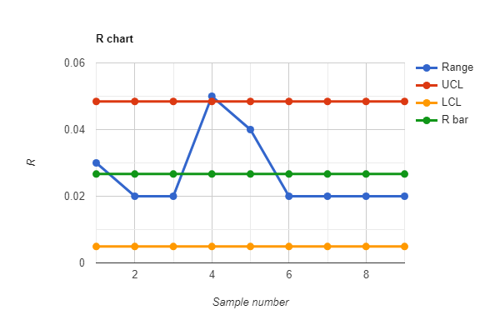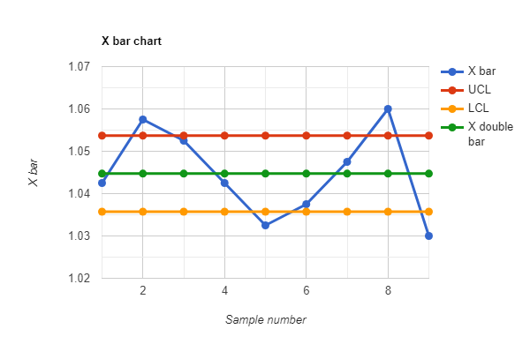

**According to both the R chart and the X bar chart, the process appears to be out of control.**

8). (Lesson 7 – System Economics) A 150 person staff (average salary = $35,000 per year) is scheduled to work on the operations and maintenance (O&M) of a system with a planned 10-year operational lifetime. Pay raises are planned at 1% below the forecasted inflation rate of 6%.

1. What is the labor cost contribution to system O&M LCC?

(35000) + (35000)(1.05) + (35000)(1.05)^2 + (35000)(1.05)^3 + (35000)(1.05)^4 + (35000)(1.05)^5 + (35000)(1.05)^6 + (35000)(1.05)^7 + (35000)(1.05)^8 + (35000)(1.05)^9

= $44,0226.24

$44,0226.24 * 150 = **$66,033,935.81**

1. The Sustaining Engineering group has developed a concept for system modernization which would reduce the O&M staff by 50% beginning in year 6. The concept would require an R&D investment of $2M in year 3, production costs of $5M each in years 4 and 5, with planned operational deployment at the beginning of year 6. What is the LCC for this alternative?

First 5 years salary cost

(((35000) + (35000)(1.05) + (35000)(1.05)^2 + (35000)(1.05)^3 + (35000)(1.05)^4) * 150) = $29,009,564.06

Implementation costs

2000000 + 5000000 + 5000000 = $12,000,000

Last 5 years salary cost

(((35000)(1.05)^5 + (35000)(1.05)^6 + (35000)(1.05)^7 + (35000)(1.05)^8 + (35000) (1.05)^9) * 75) = $18,512,185.87

$29,009,564.06 + $12,000,000 + $18,512,185.87 = **$59,521,749.93**

1. Would you recommend the system modernization to the Program Manager? Fully support your recommendation.

T**hese calculations do not include other considerations such as oppurtunity cost, the potential savings from investing in alternative cost reduction concepts, or investing in an updated system in the future. I am making my recommendation based solely on the information given. The implementation of the system modernization concept would reduce the life-cycle cost by $6,512,185.90. This represents significant savings. I would recommend the system modernization.**

1)

a) Expected value = **14.37**

**Design 1 is most desirable because it has a lower life-cycle cost according to expected value.**

b) Design 1: **14.59**

Design 2: **18.27**

**Design 1 is the best alternative according to the laplace principle**

Design 1: **12.31**

Design 2: **11.10**

**Design 2 is the best alternative according to under the maximax rule.**

Design 1: **6.84**

Design 2: **27.06**

**Design 1 is the best alternative according to under the maximin rule.**

Design 1: **14.122**

Design 2: **17.484**

**Design 1 is the best alternative according to under the Hurwicz rule.**

c)

**I would recommend design 1 to management. All but one analysis indicated that design 1 had the lowest life-cycle cost. Additionally, design 2 has a very high pessimistic cost, therefore; persuing design 2 may cost a great deal more than design 1 and increase risk significantly.**

2)

a) **$63,450**

b) **The break even volume is 317,555 units.**

c) **$83,102.10 $122,402.40 $161,702.70**

3)

a) **0.72917901409005542269656950618112**

**0.7135996300691303095746006528**

**0.70169355497654520730804608**

b) **I would choose configuration B because it meets the 70% reliability requirement and it obtains the most reliabiltity per dollar. It also happens to be the least costly alternative overall.**

4)

a)



b) **The critical path is A-C, C-D, D-F, F-G.**

**6 + 3 + 7 + 5 = 21 weeks is the shortest possible time for project completion.**

c) **We only need to reduce the project completion time by one week and there is no benefit to reducing the completion time less the minimum of 20 weeks. The $100 expendeture on 1 extra crew and saving the 1 week is all that is necessary and is the least expensive option. D-F should be chosen for expiditing. Expiditing activities B-C, C-E, and E-F do not result in a reduction in the completion time.**

d) **24.01 is the mean project completion time.**

**Variances: 0.25, 0.69, 1.78, 4**

**0.3483 or 34.83% probability of completing the project in 20 weeks or less.**

5)

a) 36

b)



**It appears to be a normal distribution with some skewness toward the lower task time class intervals.**

c) **25.1508 minutes**

d) **standard deviation = 7.823111872210444**

e) **6868.15** **minutes**

6)

a) **11 spares required to achieve 95% probability of success.**

b) **3.74586 units Total cost = $2,978.79**

c) **The operational probability model recommends 11 spares on hand for a 90 day period to achieve 95% success. The average number of spares required for a 90 day period is 6.48 units. If the part is critical, then the machine is inoperable while the part is being procured. The loss of operational time and the associate downtime cost will most likely be substantial. The EOQ policy only recommends 4 units be stored in inventory for the year. This inventory level is insufficient to keep the machine operational. This inventory would be depleted every 56 days on with the average failure rate. The operational probability of success would be far less than 70% according to the nomograph. This is an unacceptable risk; therefore, I would recommend the operational probability model.**

7)

**According to both the R chart and the X bar chart, the process appears to be out of control.**





8)

a) **$66,033,935.81**

b) **$59,521,749.93**

c) T**hese calculations do not include other considerations such as oppurtunity cost, the potential savings from investing in alternative cost reduction concepts, or investing in an updated system in the future. I am making my recommendation based solely on the information given. The implementation of the system modernization concept would reduce the life-cycle cost by $6,512,185.90. This represents significant savings. I would recommend the system modernization.**