**Gabriel Yeager**

**SYSE 5110**

**Preliminary Design of Selected System**

**Requirements allocation**

**Power Supply Subsystem**

Convert standard 120v AC power to necessary type for control board and kinematics

Power Minimum: 240W

Utilize circuit breaker

Cost: $30

A0 = 0.9989

MLH/OH: 0.01

**Toolhead Subsystem**

Cost: $150

A0 = 0.9989

MLH/OH: 0.05

Measures distance from bed to Nozzle

Heats and extrudes molten plastic onto build surface and previous cooled layers

Hotend Component

Cold nozzle Swap

Power maximum: 120W

Weight maximum: 40g

Cost: $40

A0 = 0.9989

Nozzle

Melts 1.75mm diameter plastic filament

Melts and flows PLA, PETG, ABS, Nylon, PVA, PC, and composites

Nozzle temperature minimum: 290C

Cold side temperature maximum: 100C

Flow rate minimum (PLA, 0.04mm): 13mm3/s

A0 = 0.9989

Part Cooling Component

Cools layer of extruded plastic in preparation for next layer

Airflow minimum: 2.5CFM

Power maximum: 3W

Cost: $30

A0 = 0.9989

Direct Drive Extruder Component

Pushes solid filament into heated nozzle

Retracts filament according to Gcode commands

Cost: $50

Weight: 100g

A0 = 0.9989

Stepper Motor

Torque minimum: 40Ncm

Power Maximum: 28.8W

A0 = 0.9989

Bed Level Sensor Component

Measures distance from bed to sensor

Accuracy: 0.005mm

Precision: 0.005mm

Power Maximum:0.5W

Cost: $20

A0 = 0.9989

**Bed Subsystem**

Cost: $50

A0 = 0.9989

MLH/OH: 0.02

Bed Heater Component

Heats build surface

Bed temperature minimum: 120C

A0 = 0.9989

Bed Surface

Provides flat area to build FDM model

Bed size: 250mm x 250mm

A0 = 0.9989

**Control Board Subsystem**

Processes user input

Interfaces with MCU

Sends instructions to the printer

Controls cold-side fan

Controls part fan

Controls kinematic subsystem

Controls bed heater

Controls Nozzle heater

Cost: $200

A0 = 0.9989

MLH/OH: 0.01

Micro Controller Unit

Interprets Gcode

Connects to WiFi 2.4Ghz

Cost: $100

A0 = 0.9989

Stepper Drivers

Regulates power to kinematics

Cost: $20

A0 = 0.9989

Display

Displays Data

Cost: $20

A0 = 0.9989

**Kinematics Subsystem**

Positions Toolhead

Adjusts Z tilt

Cost: $120

A0 = 0.9989

MLH/OH: 0.02

Stepper Motors

Torque: 40Ncm

Power Maximum: 28.8W

Cost: $70

A0 = 0.9989

**Frame Subsystem**

Provides structure to mount subsystems and components

Cost: $50

A0 = 0.9989

MLH/OH: 0.02

Store and Dispense Filament

Delivers filament to toolhead

Cost: $5

A0 = 0.9989

Extrusions

Cost: $30

A0 = 0.9989

Fasteners

Cost: $10

A0 = 0.9989

Extrusion Covers

Cost: $5

A0 = 0.9989

**Software Subsystem**

Cost: $10

A0 = 0.9989

MLH/OH: 0.01

Firmware

Cost: $5

A0 = 0.9989

Interprets Gcode

Generates bed mesh

Calculates Z tilt alignment to bed

Software

Cost: $5

A0 = 0.9989

Slices 3d solids

Generates Gcode

**On your alternative systems - you state they all meet the "following" requirements, but are there any that do not meet requirements. Any that meet TPMs better than others? With the systems on different pages, a nice summary comparison between them would be helpful.**

**You have all of these subsystem requirements now, are there any trades that could be made at the subsystem level? I'm sure there are, list a few. Anything plausible is fine.**

**System Synthesis**

**Core XY System Type 1**

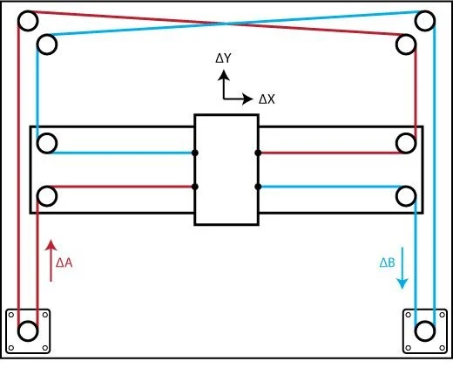

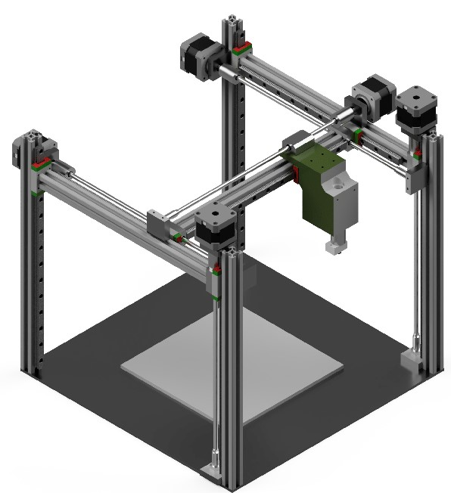

Toolhead movement in xy directions is achieved with belts and stationary motors

Z axis movement is achieved by raising toolhead platform above fixed bed with motor(s) and lead screw(s)

Utilizes cold swap nozzle assembly

Utilizes bed level sensor

Mainboard connects to WiFi

High temperature/high flow nozzle

Uses 1.75mm filament.

Bed size of 250mm x 250mm

**Satisfies the following requirements:**

Build volume: 250mm x 250mm x 250mm

Print speed: 150mm/s

Uses common 1.75mm filament

Prints PLA, PETG, ABS, Nylon, PVA, PC, and composites

WiFi connectivity

Bed level sensing

Cold nozzle change

Interpret Gcode

Positions Toolhead

MLH/OH: 0.02

A0 = 0.9989

**Core XY System Type 2 (Kinematic Bed)** –

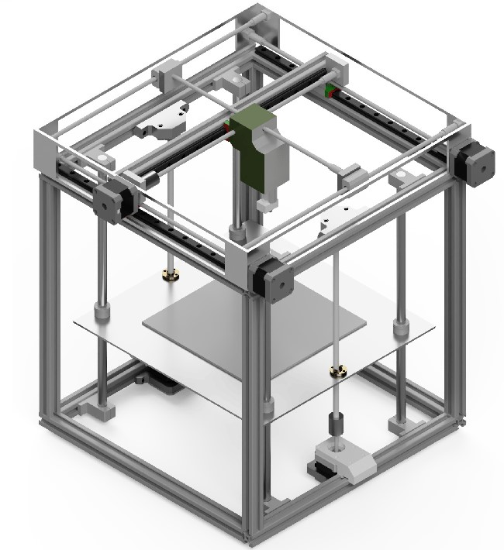

Z axis movement by lowering bed with z screws below fixed toolhead platform

Moves toolhead in xy directions with belts and stationary motors

Z axis movement by lowering bed with z screws below fixed toolhead platform

Utilizes cold swap nozzle assembly

Utilizes bed level sensor

Mainboard connects to WiFi

High temperature/high flow nozzle

Uses 1.75mm filament.

Bed size of 250mm x 250mm

**Satisfies the following requirements:**

Build volume: 250mm x 250mm x 250mm

Print speed: 150mm/s

Uses common 1.75mm filament

Prints PLA, PETG, ABS, Nylon, PVA, PC, and composites

WiFi connectivity

Bed level sensing

Cold nozzle change

Interpret Gcode

Positions Toolhead

MLH/OH: 0.02

A0 = 0.9989

**Cartesian Rectilinear “Bed Slinger” System**

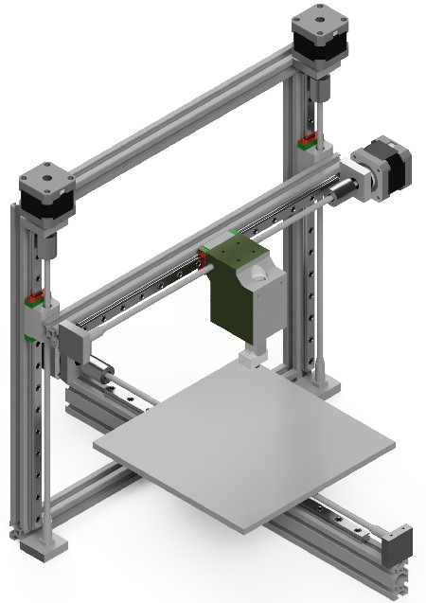

Moves toolhead along X axis on gantry with motor

Moves bed along the Y axis with motor

Moves Z axis by raising X gantry with motor and lead screw(s)

Motor drives belts and pulleys attached to carriage

**Two variations:**

V wheels carriage

Linear rail carriage

Utilizes cold swap nozzle assembly

Utilizes bed level sensor

Mainboard connects to WiFi

High temperature/high flow nozzle

Uses 1.75mm filament

Bed size of 250mm x 250mm

**Satisfies the following requirements:**

Cost maximum: $1000

Build volume: 250mm x 250mm x 250mm

Uses common 1.75mm filament

Prints PLA, PETG, ABS, Nylon, PVA, PC, and composites

WiFi connectivity

Bed level sensing

Cold nozzle change

Interpret Gcode

Positions Toolhead

MLH/OH: 0.02

A0 = 0.9989

**Delta Printer System**

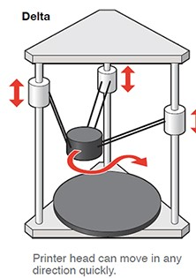

Moves toolhead along X, Y, and Z axes with 3 motors on vertical rails

Toolhead attached to motors with movable arms

Position of toolhead determined by position of the motors on the vertical rails

Utilizes cold swap nozzle assembly

Utilizes bed level sensor

Mainboard connects to WiFi

High temperature/high flow nozzle

Uses 1.75mm filament

Bed size of 250mm x 250mm

**Satisfies the following requirements:**

Cost maximum: $1000

Print speed: 150mm/s

Uses common 1.75mm filament

Prints PLA, PETG, ABS, Nylon, PVA, PC, and composites

WiFi connectivity

Bed level sensing

Cold nozzle change

Interpret Gcode

Positions Toolhead

MLH/OH: 0.02

A0 = 0.9989

**Summary of Alternative Systems**

Core XY Type 1

Print Speed: 250mm/s Meets Requirement

Bed Size: 350mm x 350mm Meets Requirement

Nozzle temperature minimum: 290C Meets Requirement

Cold side temperature maximum: 100C Meets Requirement

Bed temperature minimum: 120C Meets Requirement

MLH/OH: 0.013 Meets Requirement

A0: 0.9993 Meets Requirement

Flowrate: 14mm3/s Meets Requirement

Cost: $1100 Fails to Meet Requirement

Core XY Type 2

Print Speed: 250mm/s Meets Requirement

Bed Size: 350mm x 350mm Meets Requirement

Nozzle temperature minimum: 290C Meets Requirement

Cold side temperature maximum: 100C Meets Requirement

Bed temperature minimum: 130C Meets Requirement

MLH/OH: 0.015 Meets Requirement

A0: 0.9991 Meets Requirement

Flowrate: 14mm3/s Meets Requirement

Cost: $1180 Fails to Meet Requirement

Cartesian Rectilinear “Bed Slinger” System

Print Speed: 180mm/s Meets Requirement

Bed Size: 250mm x 250mm Meets Requirement

Nozzle temperature minimum: 290C Meets Requirement

Cold side temperature maximum: 100C Meets Requirement

Bed temperature minimum: 130C Meets Requirement

MLH/OH: 0.005 Meets Requirement

A0: 0.9995 Meets Requirement

Flowrate: 14mm3/s Meets Requirement

Cost: $700 Meets Requirement

Delta System

Print Speed: 230mm/s Meets Requirement

Bed Size: 150mm, 250mm, and 354mm diameter Fails to Meet Requirement (if cost req. kept)

Nozzle temperature minimum: 290C Meets Requirement

Cold side temperature maximum: 100C Meets Requirement

Bed temperature minimum: 130C Meets Requirement

MLH/OH: 0.017 Meets Requirement

A0: 0.9990 Meets Requirement

Flowrate: 14mm3/s Meets Requirement

Cost: $620, $1800, $2600 Fails to Meet Requirement (if bed req. kept) (If designed to 150mm, 250mm, and 354mm

diameter bed size respectively)

**Trade Studies**

**Cost trade study**

System Estimated Cost

Core XY System Type 1 $1100

Core XY System Type 2 $1180

Cartesian Rectilinear “Bed Slinger” System $700

Delta Printer System $620 (If designed to 150mm bed size)

$1800 (If designed to 250mm bed size)

$2600 (If designed to 354mm bed size)

**System maintenance and availability study**

System MLH/OH A0

Core XY System Type 1 0.013 0.9993

Core XY System Type 2 0.015 0.9991

Cartesian Rectilinear “Bed Slinger” System 0.005 0.9995

Delta Printer System 0.017 0.9990

**Kinematics linear rail/V slot wheel reliability study**

Component MLH/OH A0 Cost

Linear Rail 0.0005 0.9998 $43

V Slot Wheels 0.001 0.9996 $23

**Toolhead direct drive vs bowden tube quality and reliability studies**

Component MLH/OH A0

Direct Drive 0.0015 0.9995

Bowden Tube 0.0018 0.9990

Component Dimensional Accuracy (%) Mass of Stringing (g)

Direct Drive 1.5 0.02

Bowden Tube 5.2 0.83

**Hotend type trade study**

**Kinematic subsystem trade study**

**Mainboard subsytem trade study**

**Delta printer bed size feasibility study**

Note: A 354mm diameter delta bed will be necessary to satisfy the 250mm x 250mm rectangular build surface requirement.

Bed Size (Diameter) Cost

150mm $620

250mm $1800

354mm $2600

**Lead screw trade study**

Component MLH/OH A0 Cost

One lead screw 0.006 0.9992 $20

Two lead screws 0.0012 0.9994 $37

**System Life Cycle Cost**

System Cost Category Estimated Cost

Core XY System Type 1 Research and Development $330

Investment $165

Operating and Support $550

Disposal $55

Core XY System Type 2 Research and Development $354

Investment $177

Operating and Support $590

Disposal $59

Cartesian Rectilinear “Bed Slinger” System Research and Development $210

Investment $105

Operating and Support $350

Disposal $35

Delta Printer System Research and Development $1560

Investment $260

Operating and Support $520

Disposal $260

**Preferred Design**

Cartesian Rectilinear “Bed Slinger” System

**Requirements** **Estimated Attributes/Performance**

Cost maximum: $1000 $700

Build volume: 250mm x 250mm x 250mm 250mm x 250mm x 250mm

Uses common 1.75mm filament Uses 1.75mm filament

Prints PLA, PETG, ABS, Nylon, PVA, PC, and composites Prints PLA, PETG, ABS, Nylon, PVA, PC, and composites

Connects to WiFi Connects to WiFi

Creates bed mesh and adjusts height of nozzle while printing Creates bed mesh and adjusts height of nozzle while printing

Utilizes cold nozzle swap assembly Utilizes cold nozzle swap assembly

Generates Gcode from CAD files Generates Gcode from CAD files

Interprets Gcode Interprets Gcode

Positions Toolhead Positions Toolhead

MLH/OH: 0.02 MLH/OH: 0.005

A0 = 0.9989 A0 = 0.9995

Print speed minimum: 150mm/s Print speed minimum: 180mm/s

Bed temperature minimum: 120C Bed temperature minimum: 130C

The Cartesian rectilinear printer is the only design that satisfies all functional requirements within budget. The low life cycle cost allows for superior alternative components to be incorporated into the design which improves performance. This design will utilize a direct drive extruder which has no drawbacks according to the trade studies. It will feature a linear rail system which improves reliability and maintainability at an increased cost of $20. It will adjust the x gantry with two lead screws at an additional cost of $17.