**Gabriel Yeager**

**SYSE 5150**

**Final Project**

**The Problem**

Drift net fishing is a popular type of commercial fishing that involves leaving nets in the ocean for a period of time to become productive. In an effort to reduce the cost of lost nets, the cost of searching for difficult to find nets, the operational costs of placing nets that become lost, and to minimize the environmental and regulatory concerns of other stakeholders, it is necessary to attach radio beacons to the nets to ensure successful retrieval. We will implement a model that will represent the beacons with a combination of receivers and transmitters known as transceivers. We will then determine the chances of a successful transmission from the furthest beacon (Node 1) to the beacon receiver (Node 10). Additionally, a variation of the model will be created and experimented upon. The variation will examine the chances of successful relay transmission to the beacon receiver while considering the probabilities of the path it took before arriving at each node along the way. The variation will combine the probabilities of the possible paths. This analysis is can be applied to other networks including notably, social networks and disease transmission.

**Design Variables**

The design variables are the edges or arcs between the nodes that represent the path of the signal. The variables are binary in this model. Probabilities of successful signal transmission is assigned to each of the edges between each pair of nodes.

**Objective**

The objective is to maximize the probability of successful transmission of the signal. Two objectives will be compared. The first objective will be the maximizing the sum of the probabilities along the possible paths. The process of calculating this objective is relatively straightforward. All possible paths from Node 1 to Node 10 will be tried and the summation of each unique path will be found. The largest summation will be the maximum optimized solution.

The second objective that will be examined, will be to maximize the probability of successful transmission to the final node. The objective considers the probabilities of the path it took before arriving at each node along the way. The process of calculating this objective will require the multiplication of all of the probabilities in the path. Furthermore, the path taken will change the way the objective is calculated. For example, it is assumed that that the original signal value emitted from Node 1 is 100% or just 1.0. The chance that the signal arrives at the next station is reduced by the value of the probability in the arc. For example, from node 1 to 2 it would be a 60% chance of success so 0.60 is the value for the arc x12. If the path then goes to node 4, then the chances are cut again by 10% (0.60 * 0.90 = 0.54) and the probability that the signal arrives at node 4 is only 54% and so on through the network.

**Constraints**

1. The first constraint will be that the edges that represent the path must be binary in nature. Either the path is taken between two nodes is taken or it is not.

2. The second constraint is that each edge can only be used once. This prevents the model from summing the path repeatedly to obtain a larger value.

3. The third constraint is that the path starts at node one and terminates at node 10.

4. The fourth constraint will be that a node must have an edge or connecting path for it to continue the progression to the next node. A node can only continue the path if the path has already led to it.

The constraints 2, 3, and 4 can be combined during the implementation with excel solver.

**The directed network graph**

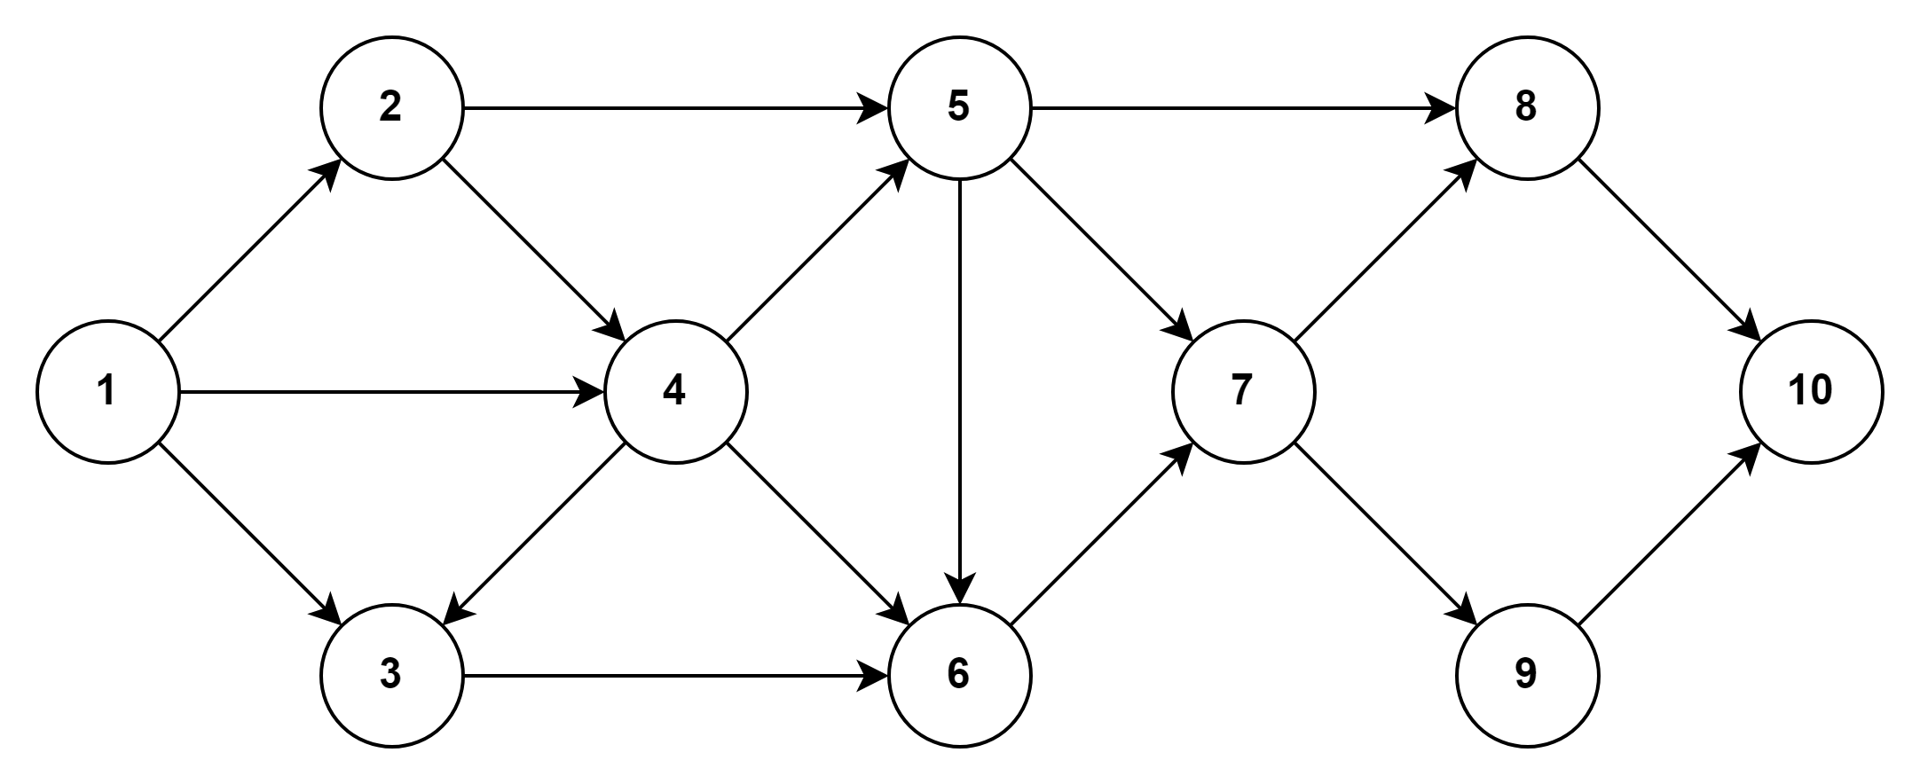

The network graph represents the signal transmission source (Node 1), the transceiver network (Nodes 2-9), and the beacon receiver (Node 10).

**The network graph with standard probabilities assigned**

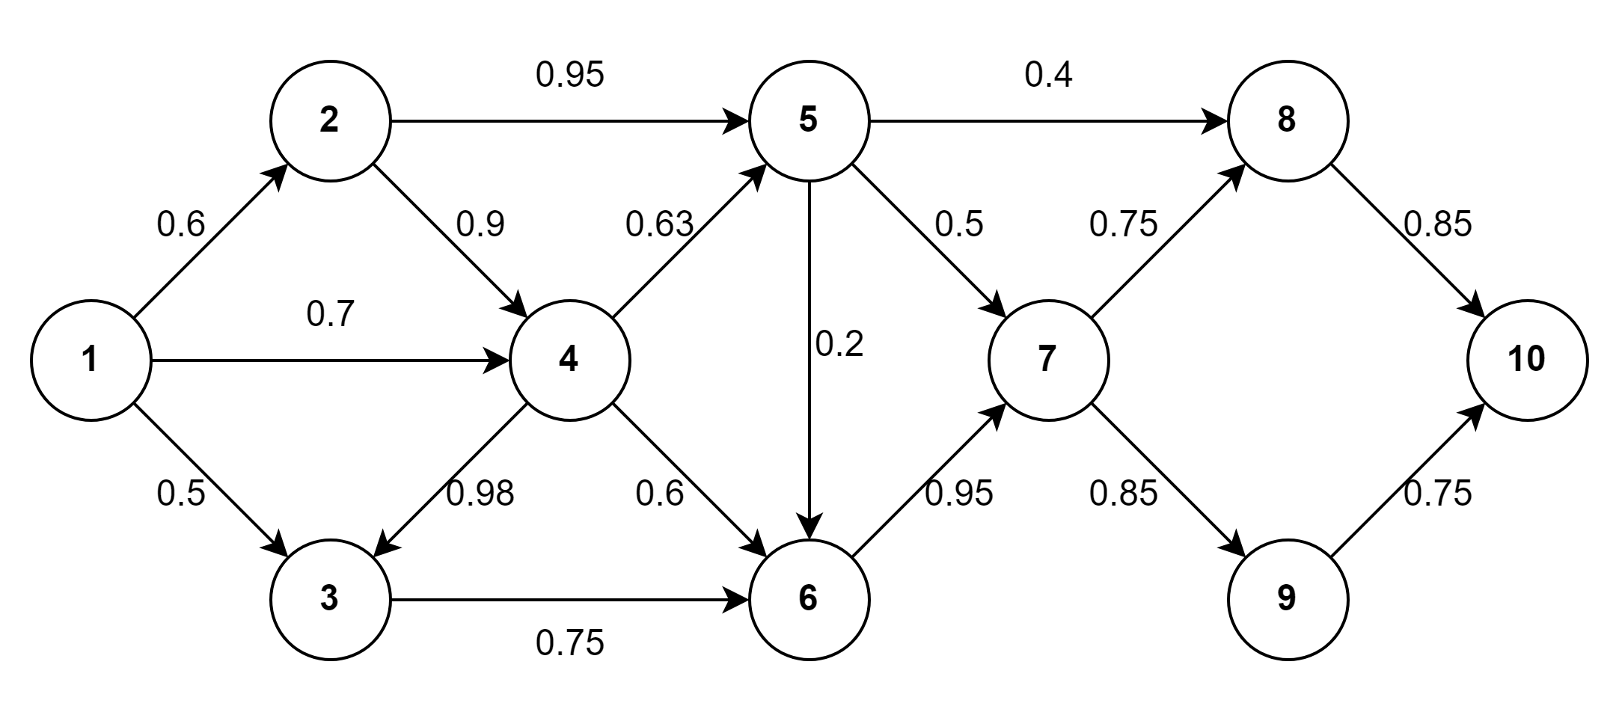

**The optimal path with standard probabilities assigned**

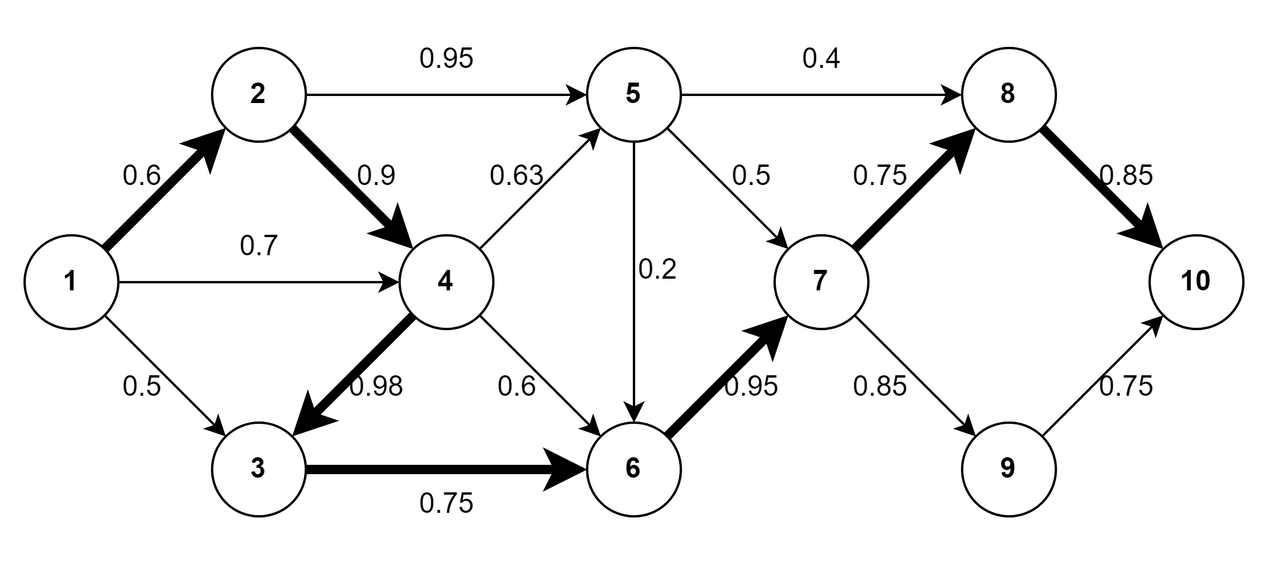



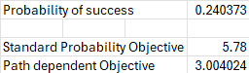

**The probability of successful reception of the signal is 0.2404 with standard probabilities assigned to the model.**

**The network graph with path-dependent probabilities assigned**

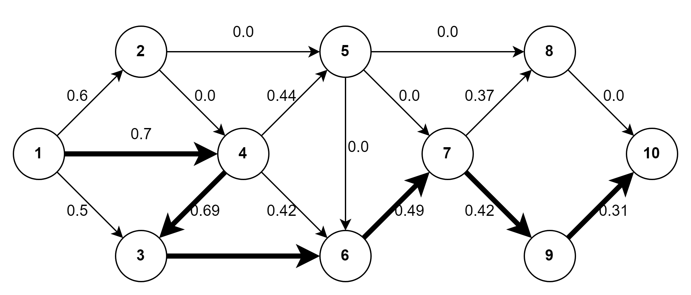



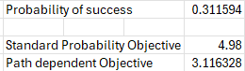

**The probability of successful reception of the signal is 0.3116 with path-dependent probabilities assigned to the model.**

**Conclusion**

Due to the differences between standard summation of probabilities path-dependent combined probabilities and the path-dependent combined probabilities, it is logical that the resulting optimal paths may differ. It is clearly demonstrated that in at least one case considering the probabilities of successful transmission between each pair of nodes in the paths preceding the final transmission to Node 10 results in a different optimal path. Additionally, it may be a more realistic model for the phenomenon of transceiver network reliability.