**Gabriel Yeager**

**SYSE 5150**

**HW2**

**2.5 (a, d, e), 2.11, 2.33, 2.61**

2.5 Determine the feasible space for each of the following independent constraints, given

that x1, x2 ≥ 0.

NOTE: Horizontal line is x1, vertical is x2. Red area on graph is feasible.

(a) -3x1 + x2 ≥ 6

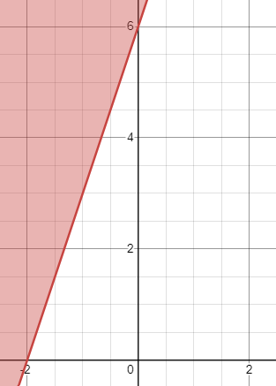

d) x1 - x2 ≤ 0

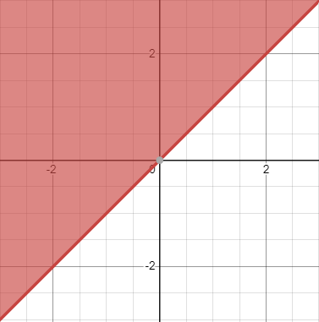

(e) -x1 + x2 ≥ 0



2.11 An individual wishes to invest $5000 over the next year in two types of investment:  
Investment A yields 5%, and investment B yields 8%. Market research recommends  
an allocation of at least 25% in A and at most 50% in B. Moreover, investment in A  
should be at least half the investment in B. How should the fund be allocated to the  
two investments?

x1 = investment A

x2 = investment B

x1 + x2 = 5000

x1 ≥ (1/2)x2

2x1 ≥ x2

x1 ≥ .25(5000)

x2 ≤ .5(5000)

.5(5000) = 2500 which is the maximum investment in x2

5000 – 2500 = 2500, the most amount left to invest in x1

1250 ≤ x1 ≤ 2500

Objective

maximize z = 0.05x1 + 0.08x2

x2 yields more than x1; therefore, the maximum should be invested in x2. The maximum that can be invested in x2 is $2500. $2500 of the $5000 is left to invest in x1. The remainder should be invested in x1. x1 is greater or equal to 1250 and less than or equal to 2500. It is at least 25% of the total invested and at least half of the money invested in x2. The constraints are satisfied for x1. For x2, the amount invested is at most half of the total invested. Thus, all constraints are satisfied.

The optimal allocation is $2500 in each investment. The maximum return is:

z = .05x1 + .08x2

**z = .05(2500) + .08(2500) = $325**

2.33 Day Trader wants to invest a sum of money that would generate an annual yield of at

least $10,000. Two stock groups are available: blue chips and high tech, with average

annual yields of 10% and 25%, respectively. Though high-tech stocks provide higher

yield, they are more risky, and Trader wants to limit the amount invested in these stocks

to no more than 60% of the total investment. What is the minimum amount Trader

should invest in each stock group to accomplish the investment goal?

Let x1 denote blue chips, x2 denote high-tech, and t denote the total amount invested.

Yield ≥ 10000

.1x1 + .25x2 ≥ 10000

t = x1 +x2

x2 ≤ .6t

x2 yields the most so the maximum possible should be invested in x2 subject to the constraint x2 ≤ .6t.

So, x2 = .6t, and x1 = .4t

The objective is to minimize the amount invested z = x1 + x2

.1(.4t) + .25(.6t) =10000

t = $52631.60

The least amount that needs to be invested is a total of $52,631.60 between the two investment types

x1 = .4(52631.6) =$21,052.64

x2 = .6(52631.6) = $31,578.96

**$21,052.64 is the least amount invested in blue chips to achieve the desired yield.**

**$31,578.96 is the least amount invested in high-tech to achieve the desired yield.**

2.61 A realtor is developing a rental housing and retail area. The housing area consists of efficiency apartments, duplexes, and single-family homes. Maximum demand by potential renters is estimated to be 500 efficiency apartments, 300 duplexes, and 250 single-family homes, but the number of duplexes must equal at least 50% of the number of efficiency apartments and single homes. Retail space is proportionate to the number of home units at the rates of at least 12 ft2, 18 ft2, and 20 ft2 for efficiency, duplex, and single family units, respectively. However, land availability limits retail space to no more than 15,000 ft2. The monthly rental income is estimated at $650, $800, and $1500 for efficiency-, duplex-, and single-family units, respectively. The retail space rents for $120/ft2. Develop an LP model to determine the optimal retail space area and the number of family residences, and find the solution using AMPL, Solver, or TORA.

Let x1, x2, and x3 denote the numver of efficiencies, duplexes, and single-families respectively.

Let x4 denote the sqaure feet of retail space.

The following are not treated as contraints in the optimization of this problem: x1 ≤ 500, x2 ≤ 300, x3 ≤ 250.

If they were constraints, then the x1 = 500, x2 = 300, x3 = 250, and x4 = 15000. The maximum income would be $2,740,000.

Constraints

x2 ≤ .5(x1 + x3)

x4 ≤ 15000

x4 ≥ 12x1 + 8x2 + 20x3

Maximize z = 650x1 + 800x2 + 1500x3 + 120x4

The excel solver maximizes the z at $2,987,500 income.

The mix of housing and retail space is 0 efficiency apartments, 312.5 duplexes, 625 single family homes, and 15000 sqft of retail space.

Because a half duplex cannot be built, we add integers as a constraint. This gives us

**Maximum z at $2,986,850 income.**

**The mix of housing and retail space is 3 efficiency apartments, 313 duplexes, 623 single family homes, and 15000 sqft of retail space.**