Assignment 1 (ITP203-Theory)

Question 1

Perform the 2’s complement on Binary Number (01110) and note down the result.

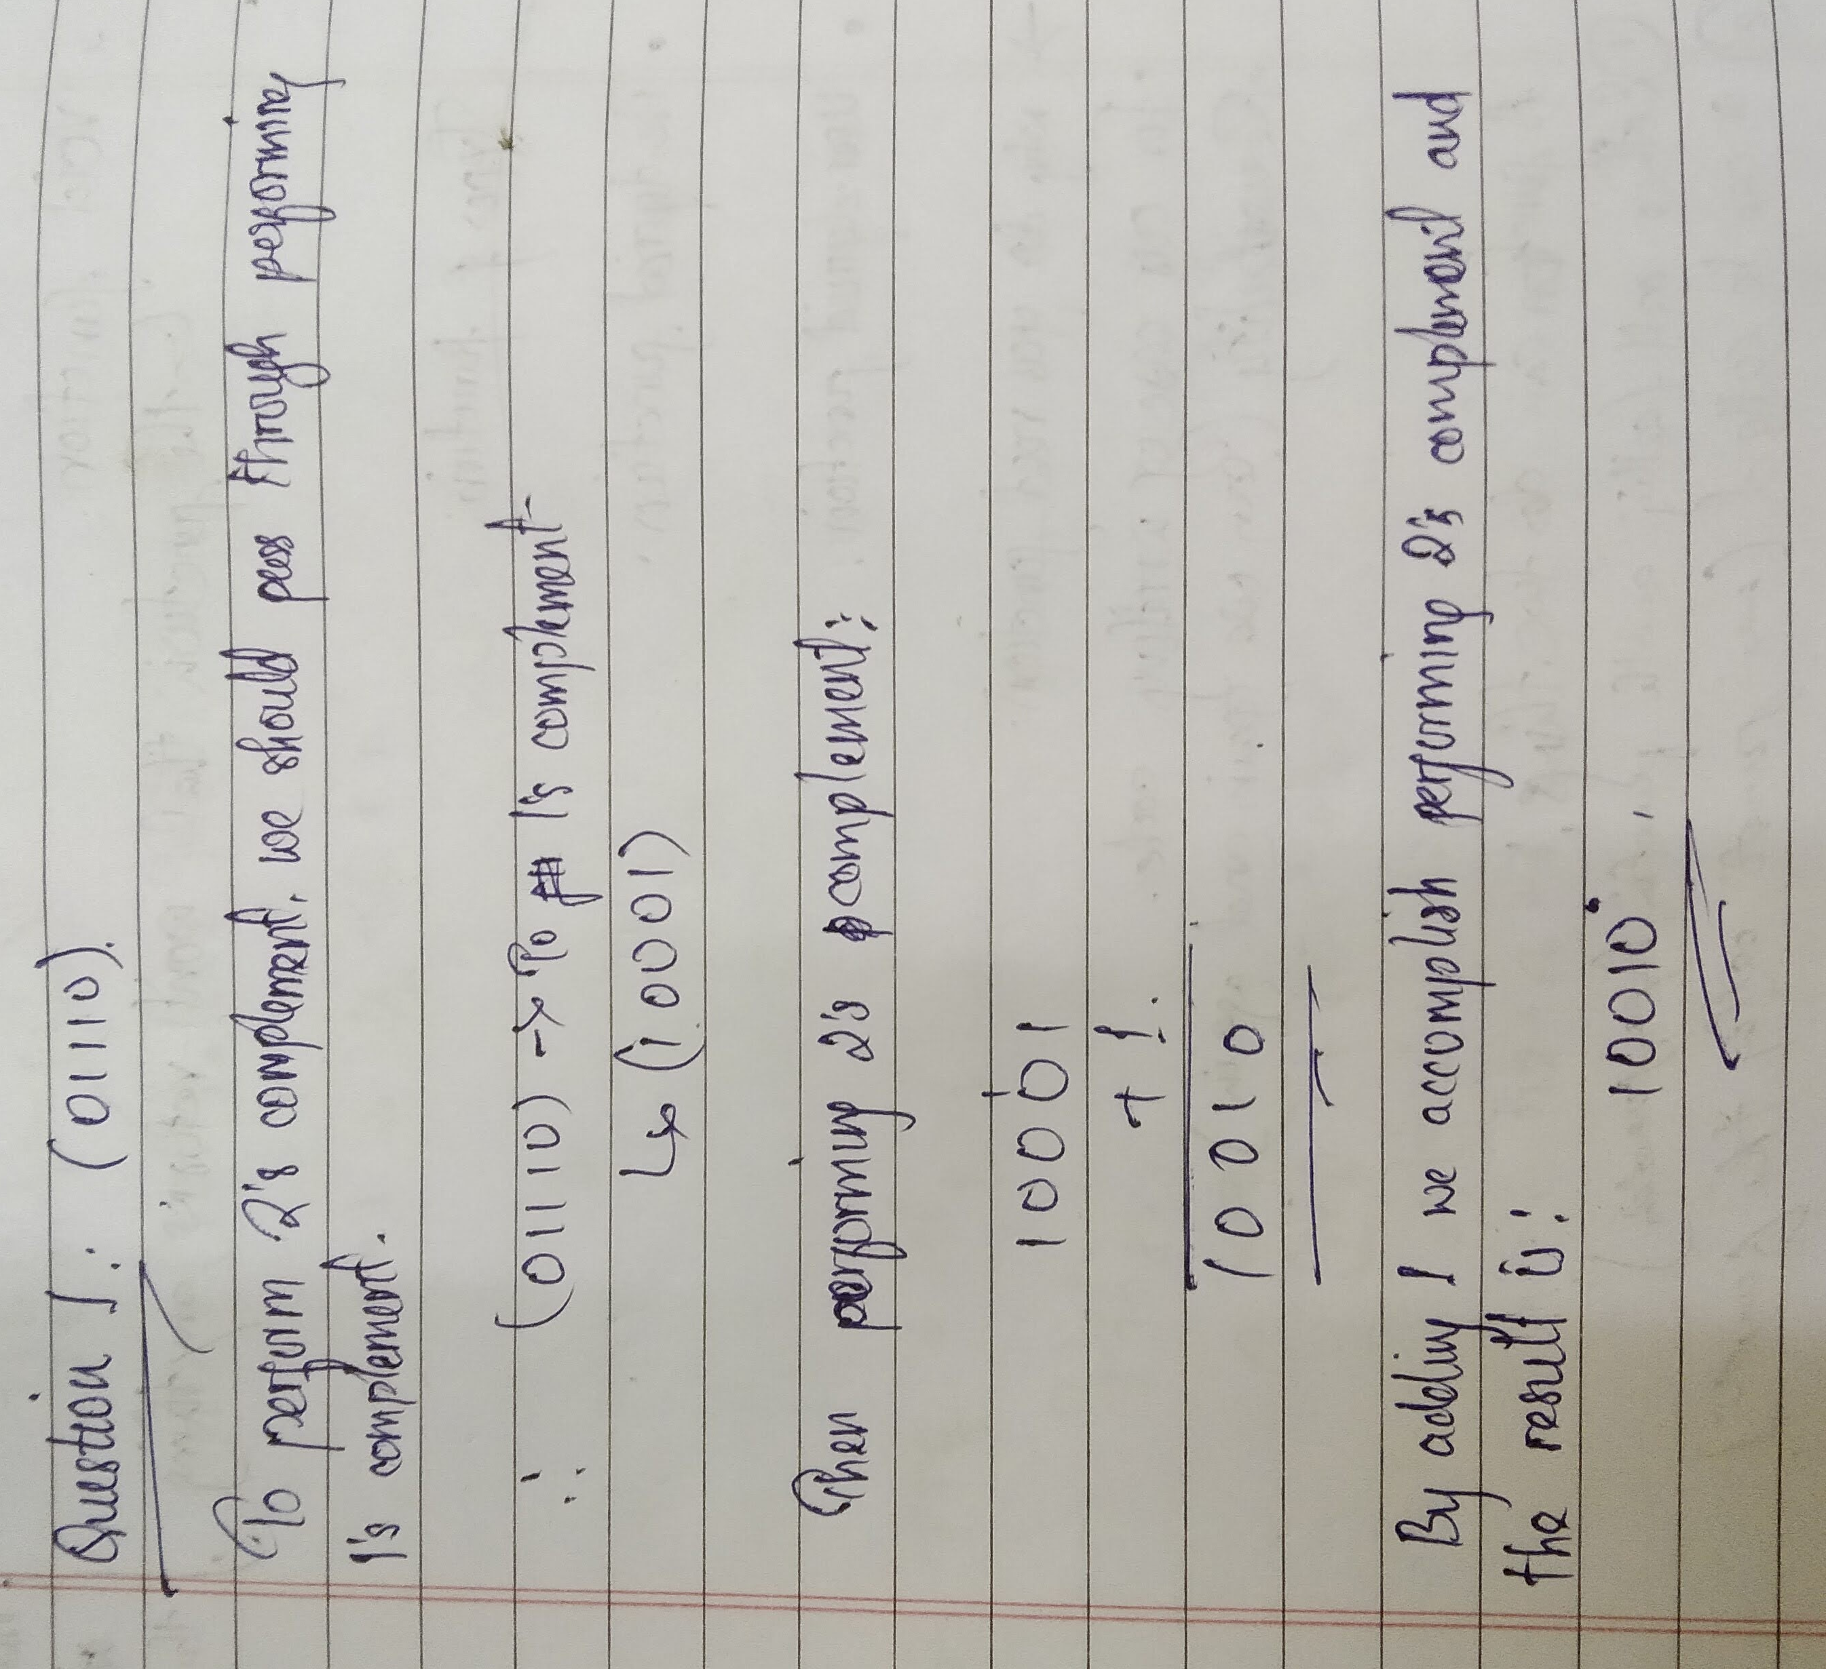

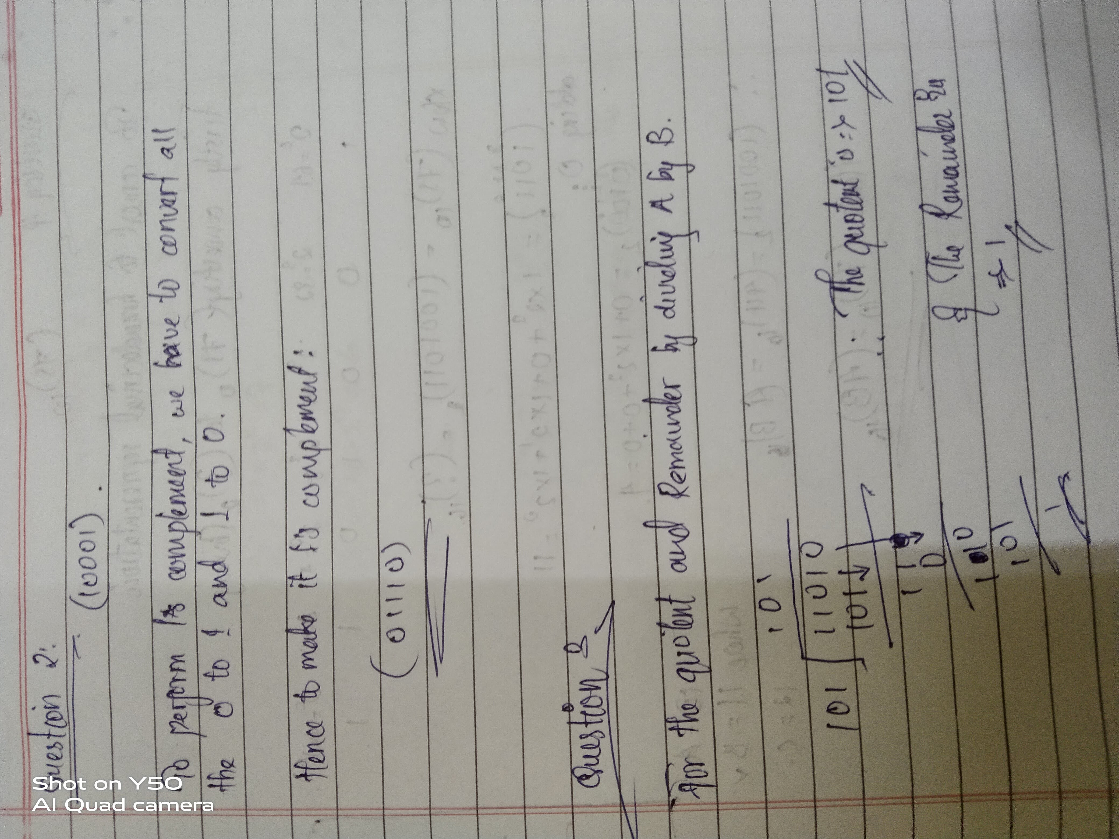
Question 2

Perform the 1’s complement on (10001).

Question 3

You have A = 11010 and B = 101. Divide A by B and find the Quotient and Reminder.

Question 4

Convert (75) 10 into Hexadecimal representation?

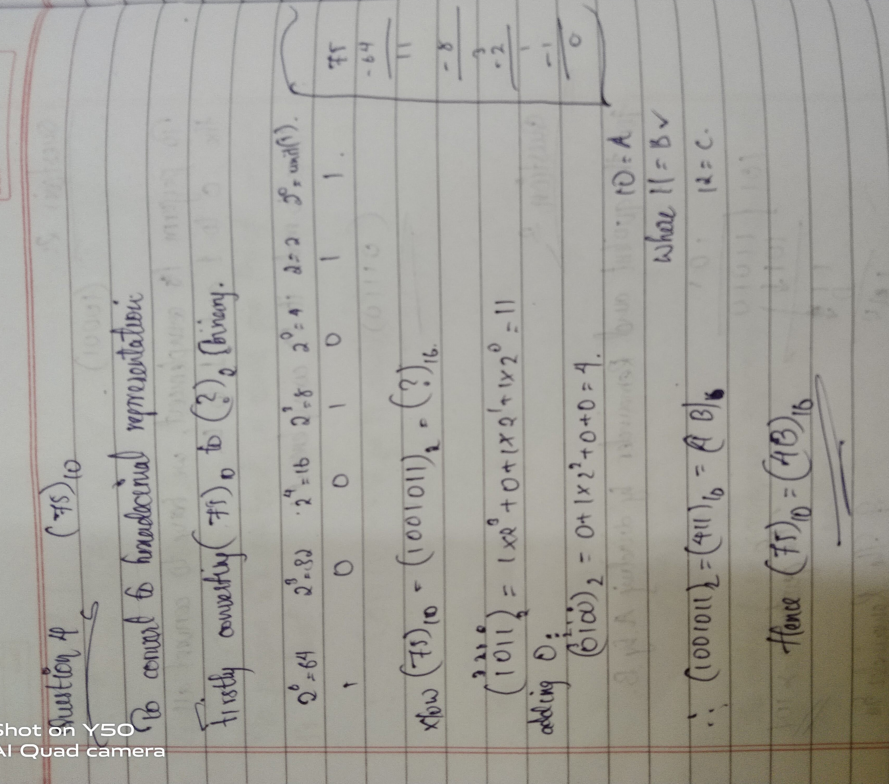

Question 5

(776) 8 + (010110111) 2 = ( ? ) 8.

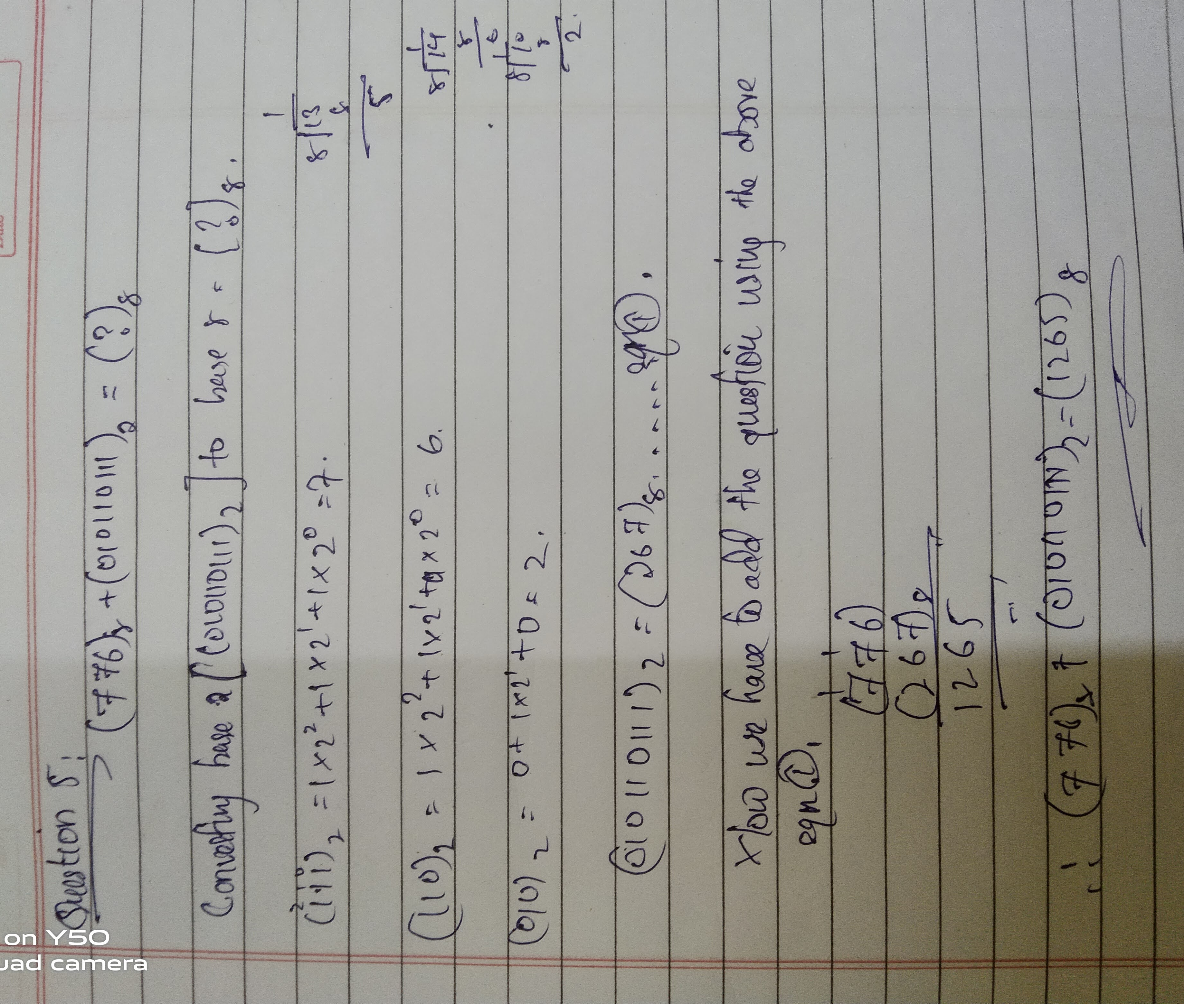

Question 6

WAP in C using While-Loop/Do-While Loop to find a Fibonacci series of “N” number of
terms.

#include <stdio.h>

int main(){
int N, i, a, b, c;
printf("Number for Fibonacci series: ");
scanf("%d", &N);

i=1;
a=0;
b=1;

while(i<=N){
printf("%d\n", a);
c = a + b;
a = b;
b = c;
i++;
}
return 0;
}

Question 7

WAP in C using While-Loop/Do-While Loop to find if a number (any digit) is Armstrong
Number.

#include <stdio.h>
int main()
{
int num, original, rem, sum = 0;

printf("Enter a three-digit Number: ");
scanf("%d", &num);

original = num;

while(original != 0){
rem = original%10;
sum =sum + rem*rem*rem;
original=original/ 10;
}

if(sum == num)
printf("%d is an Armstrong number.",num);

else
printf("%d is not an Armstrong number.",num);
printf("\n");

return 0;
}

