SOFTWARE REQUIREMENT SPECIFICATIONS
Project Topic: Bhutan Ney-Kor

Submitted by:
12190052 Gyeltshen Wangchuk

- Introduction

- Purpose
Aim: To develop an interface to enhance the experience and memories of visiting Bhutan.
Objectives:
- To provide a proper interface to express the beauty of Bhutan to users.
- To interconnect tourist with better understanding of our country.
- To provide proper guide and route to important places around Bhutan

- Scope

System Scope:
This is an android app which will include the following features:

- Welcome: it is the first welcoming page of the app.
- Register: The user have to register in order to access the app with specific requisition.
- Verification: Auto generation of an OTP pin will be sent to the mobile number provided so that to validate the register.
- Login: Using the phone number as the user name and entering password to get in the main page of the app.
- Home: shows the places to visit and have and option to select the dzongkhag that you want to visit.
- Map: The icon is in the home page so that the location of the places can be known.
- Saved: we can take picture of the places we visit and upload it in this page with some added description.
- Profile: detail of the user and some of the in built system management can be seen in this page such as setting, feedback and so on.

User Scope:
This will be applied within Bhutan as a scope.
- Requirements
- Functional Requirements:
Bhutan Ney-Kor will include the following features:
User Feature:
  - Registration: User has to fill up the registration form.
  - Login: User have to login
  - Explore:
  - Share experience:
  - View Profile
  - Logout

- Non-functional Requirements
- Usability: The users will be provided with the direction and naming conventions properly written with icons of the feature so that they will able to use the application easily.
- Security: The application will provide security as it will be for self use and the data are not shared with others, only the direction provided will be general.
- Portability: The application will be portable in different version of android and it is independent of the size of the android phone and tablets.
- The application will be in portrait orientation.

- Software Requirements

For developer:
- Java SE JDK 8 and above: The Java development kit lays the foundation for the Android SDK.
- Android Studio version 4 and above
- Android SDK-25 and above: Included in Android Studio. Provides access to Android libraries and allows you to develop for Android.
- Operating System (OS): Windows and Ubuntu.
- Firebase Realtime Database:
Store and sync data with the NoSQL cloud database. Data is stored as JSON and synchronized in realtime to every connected client.
Version: 19.1.2

- Hardware Requirements

For developer:

- Laptop with minimum 4GB RAM
- 2.00GHz*4 Processor
- 1280 x 800 minimum screen resolution
- Android Smartphone to use as an emulator
For users:
- Android smartphone

3 System designs
a. ERD(Entity Relationship Diagram)

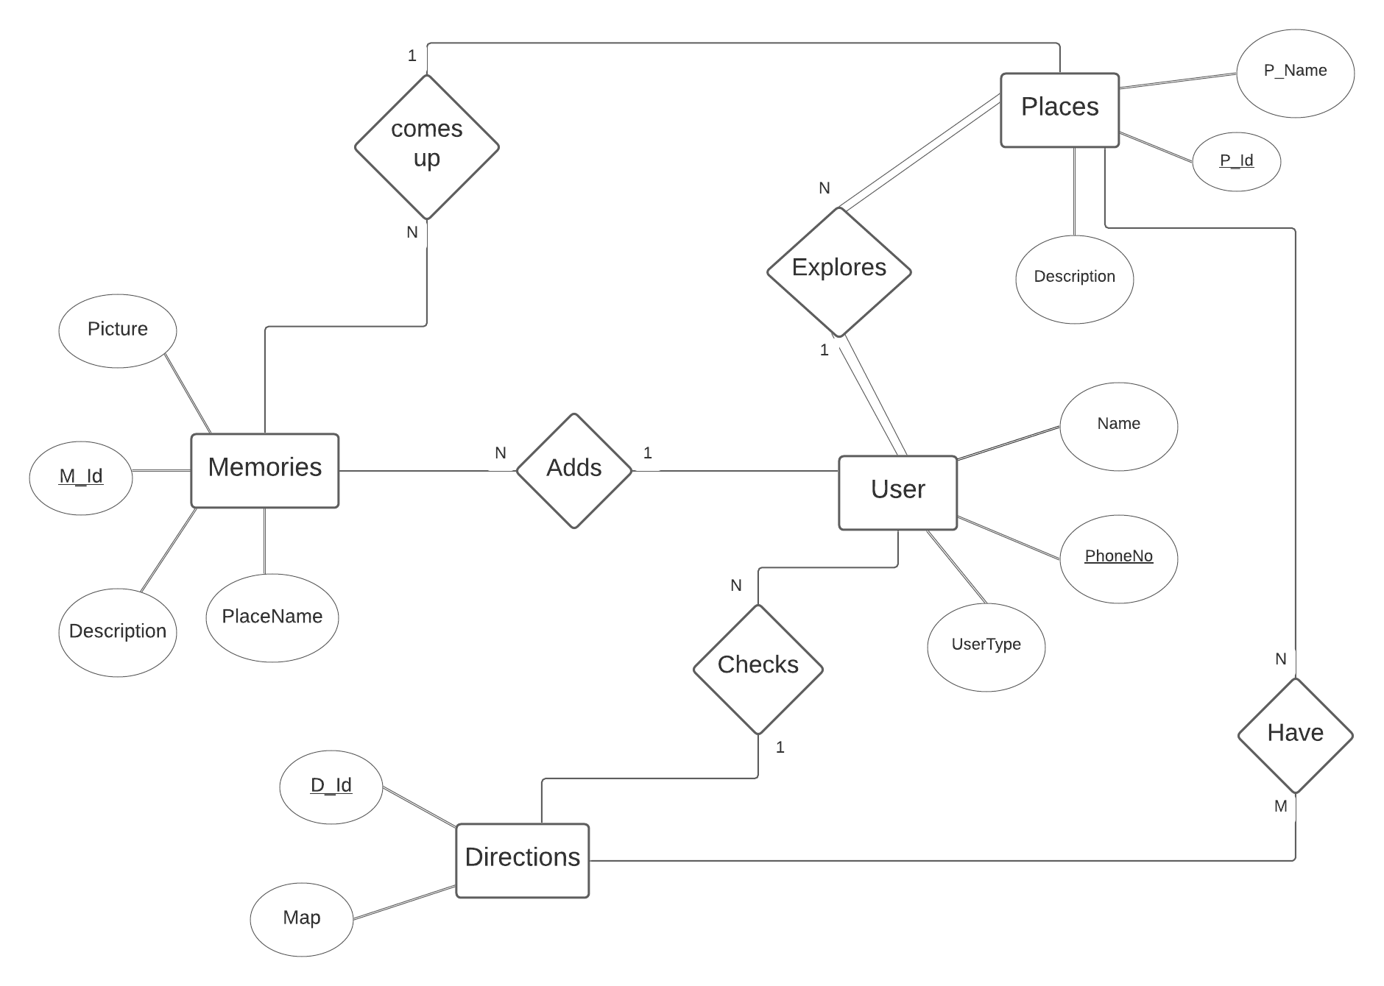

b. Relational Schema
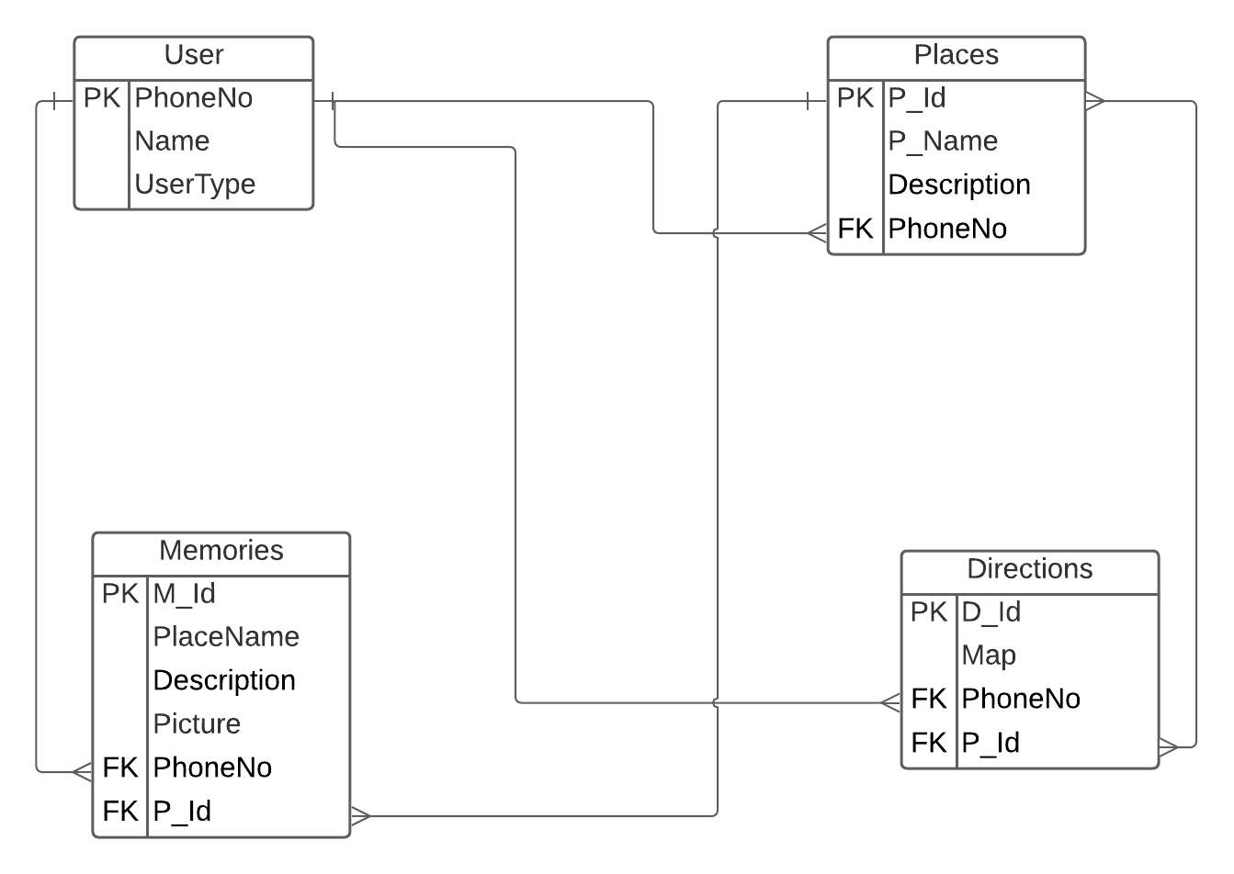

c. Sequence Diagram
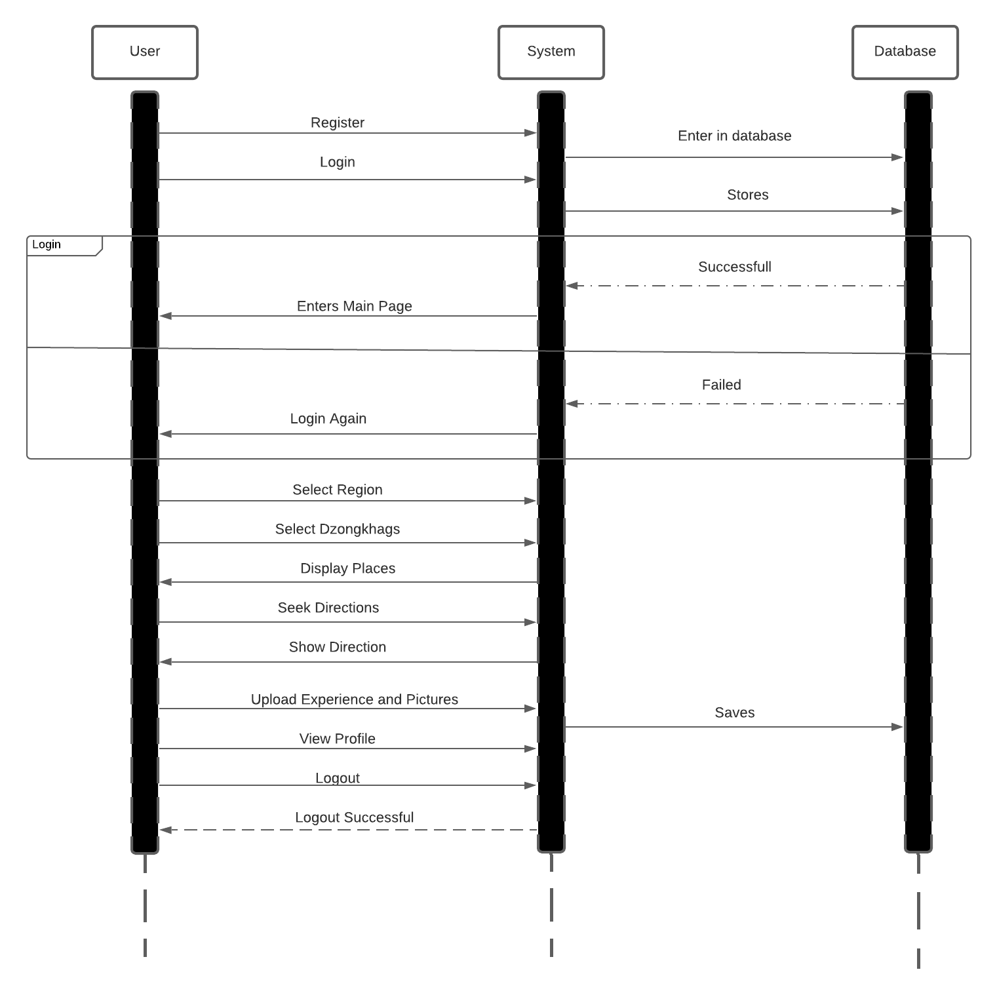

d. Use case Diagram
