Background
Artificial Intelligence (AI) Safety is an emerging field which aims to understand and categorise the risks associated with advanced AI systems while proposing methodologies to combat these issues. This increased focus on AI Safety has largely been fuelled by the success of large deep learning models.
Relatedly, the more mature field of AI Ethics has long tried to address the ethical, societal, economic, etc. risks of real-world AI deployment based on collaborative and interdisciplinary research.
We expect the two fields to share certain topics, but it is unclear to what extent the fields have overlapping interests. To better understand the similarities and differences between the fields, we propose to answer the following questions using a quantitative methodology based on a large corpus of AI Safety and Ethics papers.

Research Questions
- What are the primary sources and origins of AI safety research papers?
- How can we create a visual map of AI ethics and AI safety papers using dimensionality reduction techniques based on their most representative terms?
- What are the common research problems addressed in AI ethics and AI safety?
- What are the non-overlapping, distinct research problems addressed in AI ethics and AI safety?
- What research methodologies are predominantly used in each field, and how do they compare?

Methodology
We collected two corpora of papers one for AI Safety (N=1114) and one for AI Ethics (N=1178). Our goal is to apply quantitative data analysis to extract various patterns about the distribution of topics and methods. To this end, we created several visualisations to aid our understanding. In the following sections, we describe each visualisation, and the method used to generate it.

Term Co-occurance Graph
The term co-occurnace graph shows terms from the titles and abstracts of each paper in a corpus. Each node corresponds to a unique term. Two terms are connected if they co-occur in the same paper.
The algorithm used to generate this graph first extracts every term, then standardises them using morphological stemming, lowercasing, and removing stop words. It then calculates how many times each term occur (N_{t}), using binary or full counting per paper, and removing those words that occur too few times. Following this, a relevance score is calculated for each term (R_{t}) and only the top x% of most relevant terms are kept. Finally, a clustering is performed on the nodes to determine similar nodes.
For the plot below, we used the AI Ethics corpus with N_{t} >= 5, R_{t} >= 66.67%.

Automatic Topic Extraction
Automatic topic extraction uses the BERTopic Python library.
Each document (again we only used titles and abstracts) in the corpus is embedded using SentenceBERT to obtain a high-dimensional numerical representation of each document. The dimensions of the embeddings are then reduced (using UMAP) and clustered (using HDBSCAN) by similarity.
Using the resulting data, we can produce a number of plots.
- Documen and Topic Map: The document and topic map shows each document’s embedding reduced to two dimensions with the topic cluster laid over it in colour. We added descriptive names to each cluster manually.
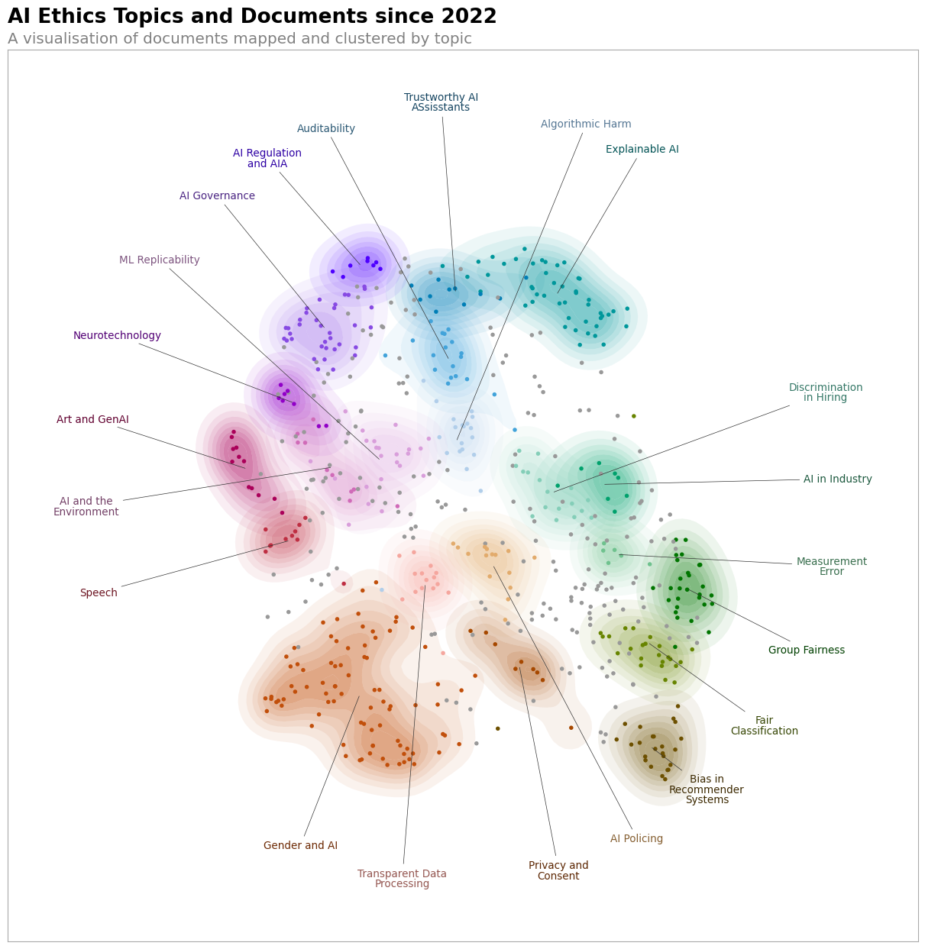
- Topics and Keywords: This shows the top 12 most frequent topics with the most representative keywords (using TF-IDF scoring).
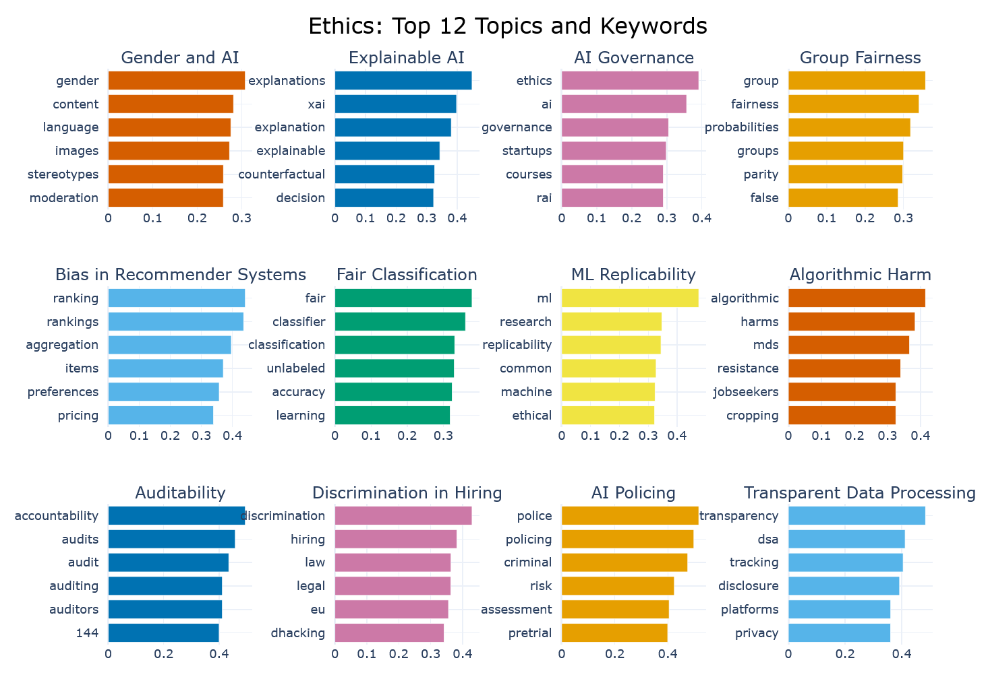
(cont.)

Topic Embedding Comparison
To understand how the two corpora are embedded in comparison to one another, we plot the document and topic embeddings as described in the previous section for both corpora. We lay over this a contour plot that shows which document belongs to which corpus.
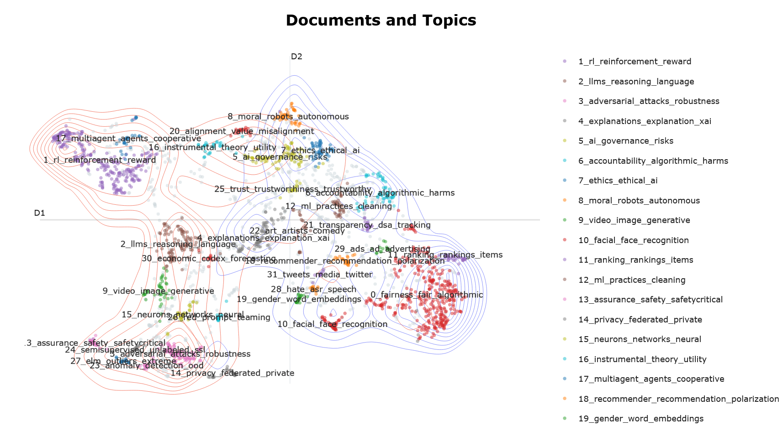

Venues of Publications
To understand where papers get published in AI Safety, we visualise how many times each venue occurs in the corpus on a bar plot.
