**EE382-Visual localization and Perception HW1**

**516021910700 郭远帆**

1. **Abstract**

Histogram Specialization is to transfer the histogram of an image (the original image) to match the histogram of another image (the target image) and remapping the intensity of the original image. This report shows the implementation procedure of Histogram Specialization algorithm in Matlab and the result of 5 pairs of test image.

1. **Procedure**

The program is implemented in such procedure:

1. Transfer the RGB image into gray image
2. Calculate the histogram vector of image1 (original) and image2 (target)
3. Calculate the cumulative histogram vector vector of image1 and image2
4. Build the lookup table using method from PPT page45
5. Map image1 based on lookup table
6. Plot the histogram and cumulative histogram of image1 and image2, histogram of adjusted image1 and lookup table, with these three image showed.
7. **Experimental Result**

The experimental result is shown below:

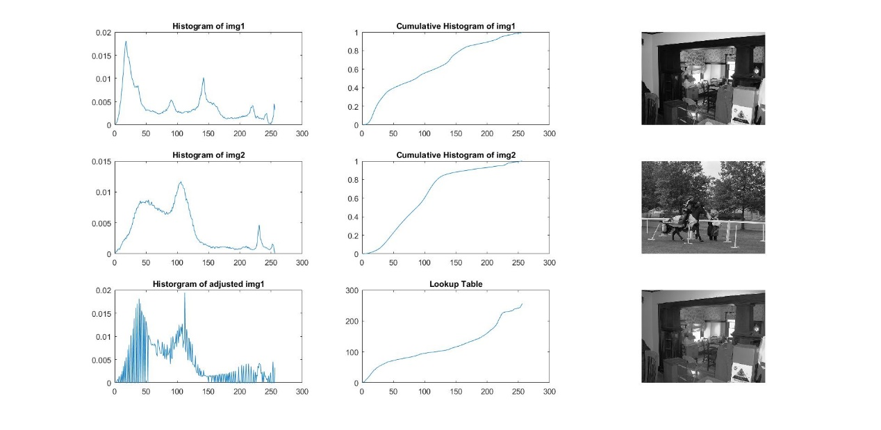

Figure 1

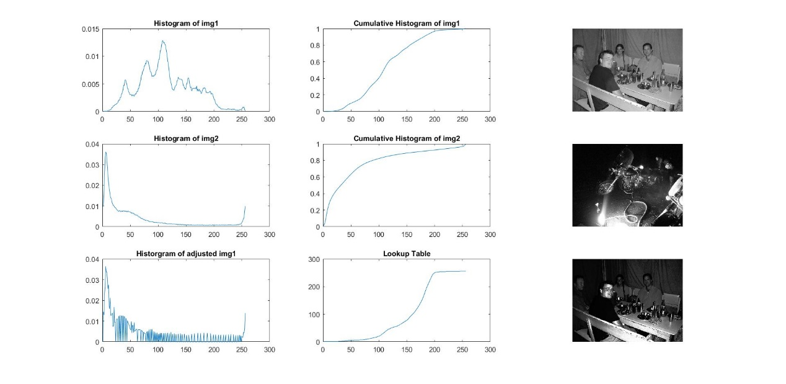

Figure 2

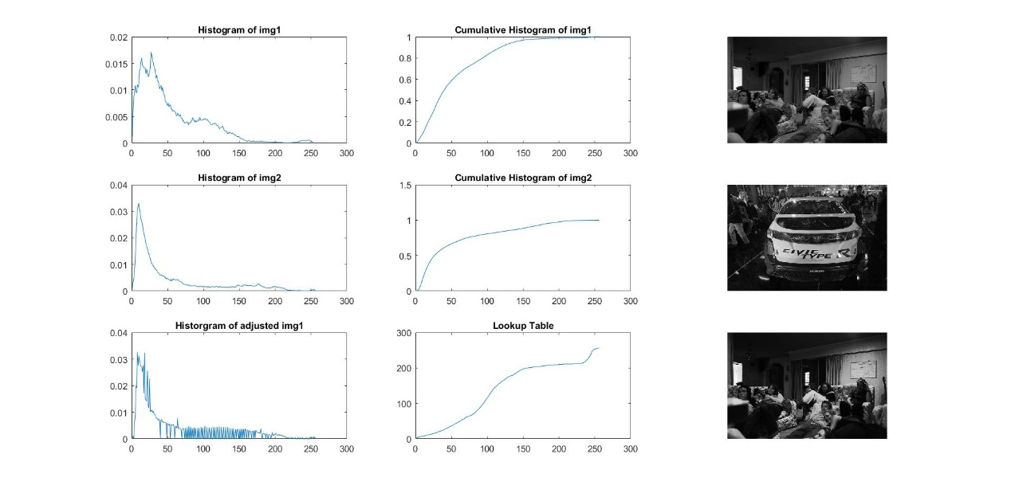

Figure 3

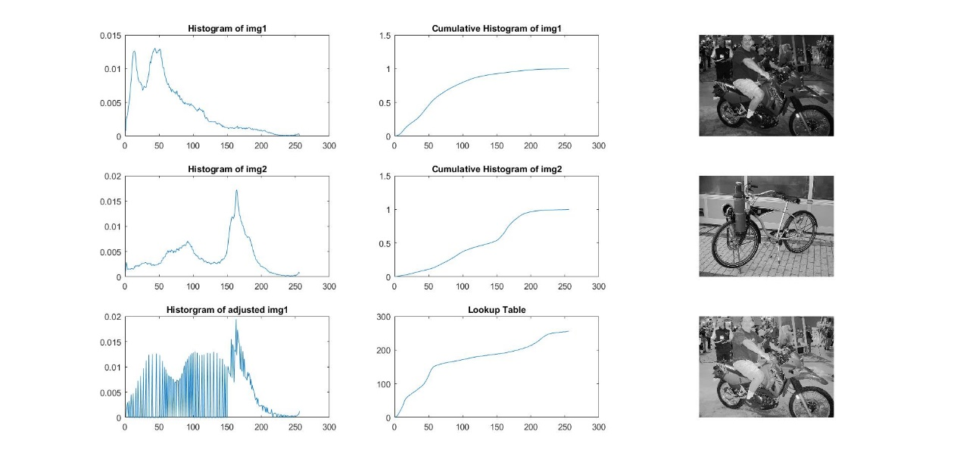

Figure 4

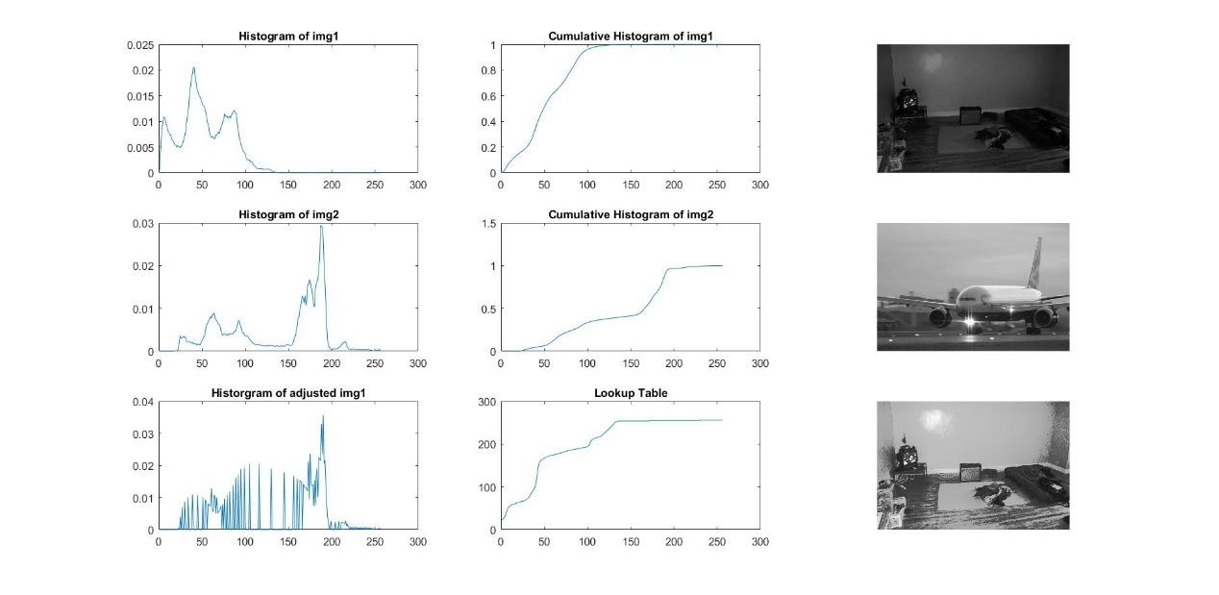

Figure 5

1. **Conclusion**

As shown in Figure1-Figure5 (The label of x-axis is gray level 0-255) the result are correct. At first the program is implemented by Python with python-opencv but with low efficiency. Also, I met a problem when doing matrix operation to build lookup table. Therefore, I chose Matlab. Matlab is more efficient in matrix operation and is easy for me.

1. **Appendix**

**Code list1 – Histogram_specialization.m**

%read image and convert into grey

%img1 is the original image

img1 = imread('./image./9.jpg');

%img2 is the target image

img2 = imread('./image./10.jpg');

img1 = rgb2gray(img1);

img2 = rgb2gray(img2);

im1 = img1;

im2 = img2;

% histogram

hist1 = zeros(1,256);

hist2 = zeros(1,256);

for i = 1:256

hist1(i) = sum(sum(img1==i-1));

hist2(i) = sum(sum(img2==i-1));

end

hist1 = hist1/sum(hist1);

hist2 = hist2/sum(hist2);

%cumulative histogram of img1 and img2

cu_hist1 = cumsum(hist1);

cu_hist2 = cumsum(hist2);

I = zeros(1,256);

%build look up table

for i = 1:256

I(i) = min(find(abs(cu_hist2-cu_hist1(i))==min(abs(cu_hist2-cu_hist1(i)))));

%map img1

img1(find(im1==i-1)) = I(i);

end

%calculate histogram of adjusted image

hist3 = zeros(1,256);

for k = 1:256

hist3(k) = sum(sum(img1==k-1));

end

hist3 = hist3/sum(hist3);

subplot(331);

plot(hist1);

title('Histogram of img1');

subplot(332);

plot(cu_hist1);

title('Cumulative Histogram of img1');

subplot(333);

imshow(im1);

subplot(334);

plot(hist2);

title('Histogram of img2');

subplot(335);

plot(cu_hist2);

title('Cumulative Histogram of img2');

subplot(336);

imshow(im2);

subplot(337);

plot(hist3);

title('Historgram of adjusted img1');

subplot(338);

plot(I);

title('Lookup Table');

subplot(339);

imshow(img1);