**数字信号处理-作业1**

**516021910700 郭远帆**

**2.35**

**(a)**

From Figure P2.35-1 and Figure P2.35-2, we have:

$x\left[n\right]=δ\left[n\right]-δ\left[n-1\right]+δ\left[n-2\right]+δ\left[n-3\right]+δ\left[n-4\right]$

$h\left[n\right]=δ\left[n\right]+δ\left[n-1\right]+δ\left[n-2\right]-δ\left[n-3\right]+δ\left[n-4\right]$

using discrete time convolution sum method $δ\left[n-k_{1}\right]*δ\left[n-k_{2}\right]=δ\left[n-k_{1}-k_{2}\right]$

we have:

$y\left[n\right]=x\left[n\right]*y\left[n\right]=δ\left[n\right]+δ\left[n-2\right]+5δ\left[n-4\right]+δ\left[n-6\right]+δ\left[n-8\right]$

$y[n]$ is shown in Figure 1

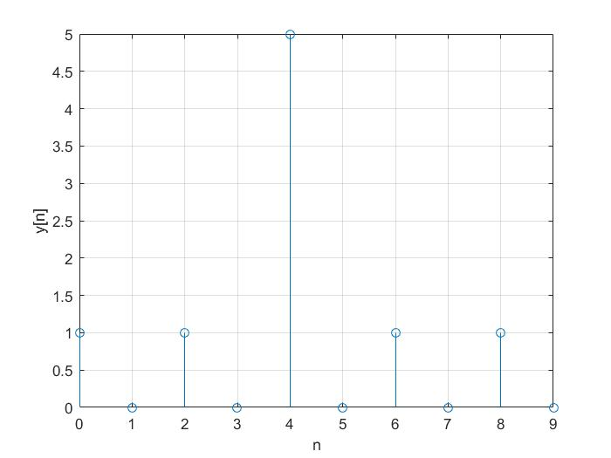

Figure

**(b)**

**(c)**

using shifting property of impulse function, we have: =

$y\left[n\right]=x\left[n\right]*h\left[n\right]=u\left[n+2\right]+u\left[n+1\right]+u\left[n\right]-u\left[n-1\right]+u\left[n-2\right]$

$y\left[n\right]$ is shown in Figure 2

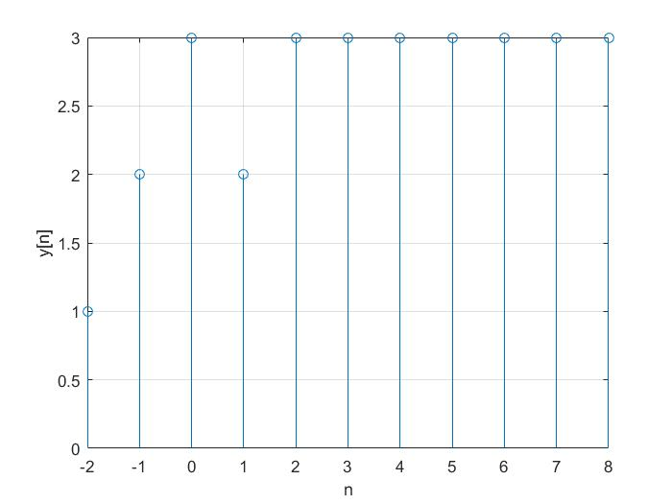

Figure 2