**Report 02: Combining spatial enhancement methods**

**Ge yunhao (116020910017)**

*[Problem 02]*

*Implement the image enhancement task of Section 3.7 (Fig 3.43) (Section 3.8, Fig. 3.46 in our slides). The image to be enhanced is skeleton_orig.tif. You should implement all steps in Figure 3.43. (You are encouraged to implement all functions by yourself, attempting not to directly use Matlab functions such as imfilter or fspecial.)*

[Solve]

Program:

problem2.m.

Input:

skeleton_orig.tif

Output:

Output/Combining spatial enhancement methods.jpg.

middle-output have the middle process

Transformation Function:

(1) Laplace Filter:

$\left[\begin{matrix}-1 & \begin{matrix}-1 & -1\end{matrix} \\ \begin{matrix}-1 \\ -1\end{matrix} & \begin{matrix}\begin{matrix}8 & -1\end{matrix} \\ \begin{matrix}-1 & -1\end{matrix}\end{matrix}\end{matrix}\right]$.

(2) 3×3 Soble Filter X:

$\left[\begin{matrix}-1 & \begin{matrix}-2 & -1\end{matrix} \\ \begin{matrix}0 \\ 1\end{matrix} & \begin{matrix}\begin{matrix}0 & 0\end{matrix} \\ \begin{matrix}2 & 1\end{matrix}\end{matrix}\end{matrix}\right]$.

3×3 Soble Filter Y:

$\left[\begin{matrix}-1 & \begin{matrix}0 & 1\end{matrix} \\ \begin{matrix}-2 \\ -1\end{matrix} & \begin{matrix}\begin{matrix}0 & 2\end{matrix} \\ \begin{matrix}0 & 1\end{matrix}\end{matrix}\end{matrix}\right]$.

(3) Gama Gransformation: $s={cr}^{γ}$.

(4) 5×5 Mean Filter：

$\frac{1}{25}×\left[\begin{matrix}\begin{matrix}1 & 1\end{matrix} & \begin{matrix}1 & 1 & 1\end{matrix} \\ \begin{matrix}\begin{matrix}1 \\ 1 \\ \begin{matrix}1 \\ 1\end{matrix}\end{matrix} & \begin{matrix}1 \\ 1 \\ \begin{matrix}1 \\ 1\end{matrix}\end{matrix}\end{matrix} & \begin{matrix}\begin{matrix}1 \\ 1 \\ \begin{matrix}1 \\ 1\end{matrix}\end{matrix} & \begin{matrix}1 \\ 1 \\ \begin{matrix}1 \\ 1\end{matrix}\end{matrix} & \begin{matrix}1 \\ 1 \\ \begin{matrix}1 \\ 1\end{matrix}\end{matrix}\end{matrix}\end{matrix}\right]$.

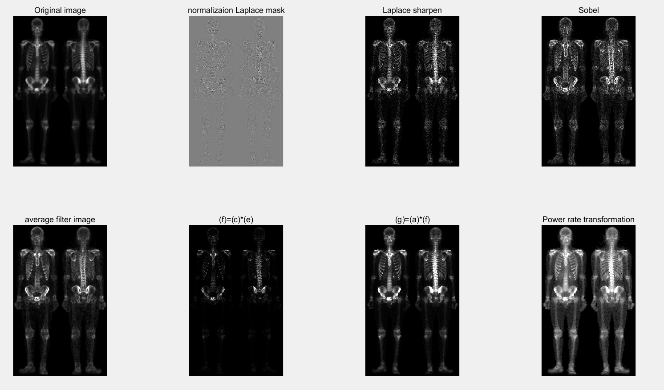

Figure