**Report 03: Filtering in frequency domain**

**Geyunhao （116020710017）**

**[Problem 03]**

Implement the ideal, Butterworth and Gaussian low Pass and high Pass filters and test them under different parameters using characters_test_pattern.tif.

**[Solve]**

**Program:** prob_3.py

**Input:** fig/characters_test_pattern.tif.

**Output:**

(1)Figure3.1. Ideal Low and High Pass Filter with different parameters.

(2) Figure3.2. Butterworthl Low and High Pass Filter with different parameters.

(3) Figure3.3. Gaussian Low and High Pass Filter with different parameters.

For each one in figure 3.1 to 3.3, the first image shows original image, the second fig shows the High pass filter, and the third figure shows High pass filter, Parameter D0 range 5,20,40,100,200.

**Transformation Function:**

For all Filters, define $D(u,v)$

$$D\left(u,v\right)={\left[{\left(u-\frac{M}{2}\right)}^{2}+{\left(v-\frac{N}{2}\right)}^{2}\right]}^{\frac{1}{2}}$$

(1) Ideal Low Pass Filter.

$$H\left(u,v\right)=\left\{\begin{aligned}1, D\left(u,v\right)≤D_{0} \\ 0, D\left(u,v\right)>D_{0}\end{aligned}\right.$$

(2) Ideal High Pass Filter.

$$H\left(u,v\right)=\left\{\begin{aligned}0, D\left(u,v\right)≤D_{0} \\ 1, D\left(u,v\right)>D_{0}\end{aligned}\right.$$

(3) Butterworth Low Pass Filter.

$$H\left(u,v\right)=\frac{1}{1+{\left[\frac{D\left(u,v\right)}{D_{0}}\right]}^{2n}}$$

(4) Butterworth High Pass Filter.

$$H\left(u,v\right)=\frac{1}{1+{\left[\frac{D_{0}}{D(u,v)}\right]}^{2n}}$$

(5) Gaussian Low Pass Filter.

$$H\left(u,v\right)=e^{-\frac{D^{2}\left(u,v\right)}{2D_{0}^{2}}}$$

(6) Gaussian High Pass Filter.

$$H\left(u,v\right)=e^{-\frac{D_{0}^{2}}{2D^{2}\left(u,v\right)}}$$

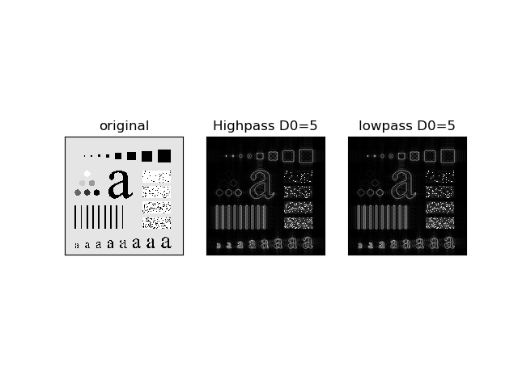 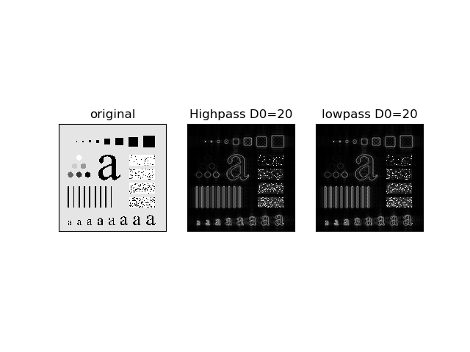

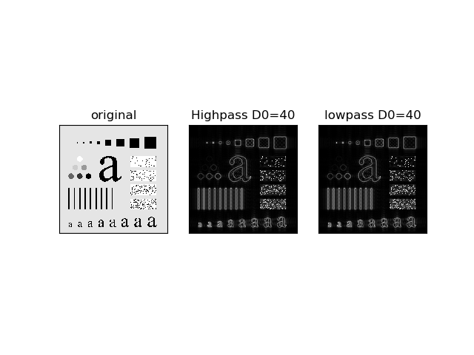 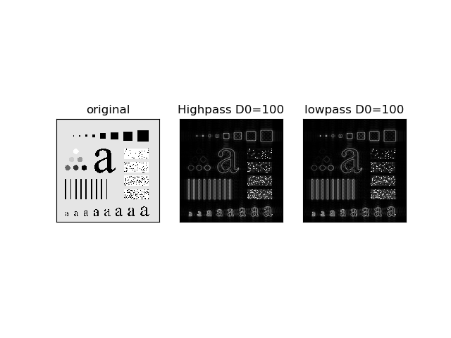

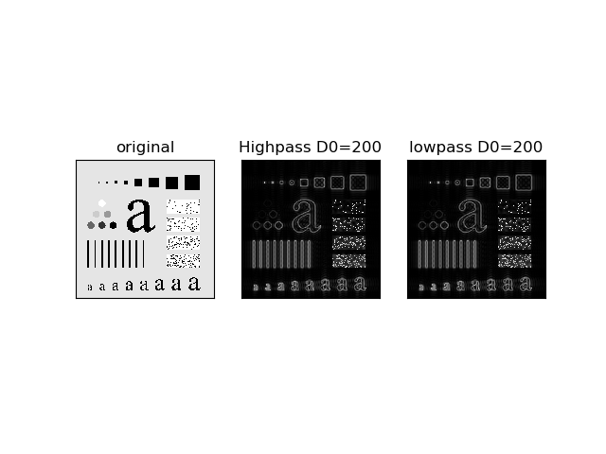

Figure 3.1 Ideal Low and High Pass Filter with different parameters

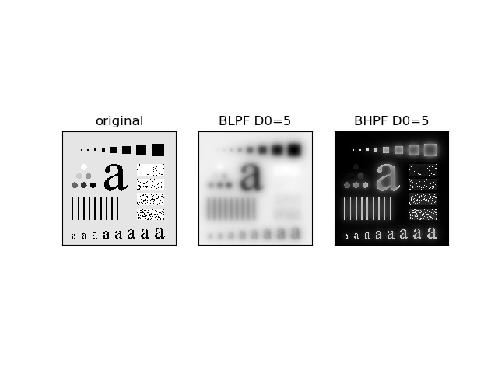 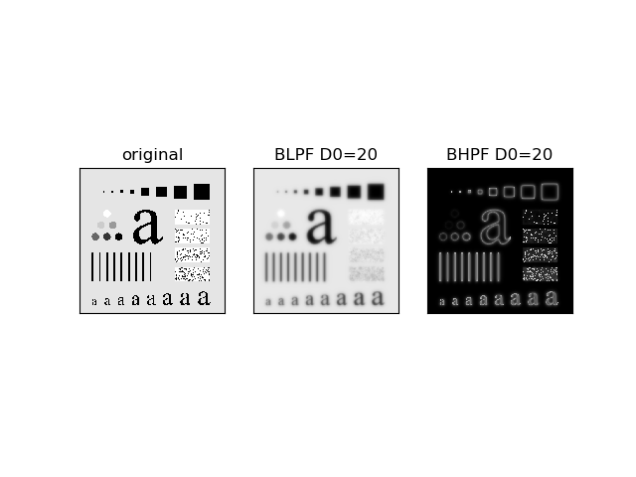

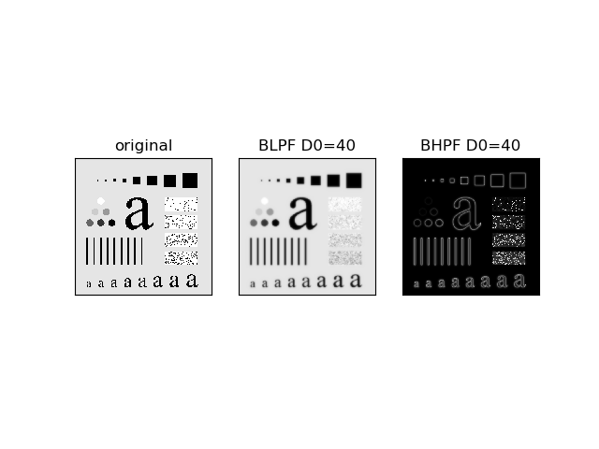 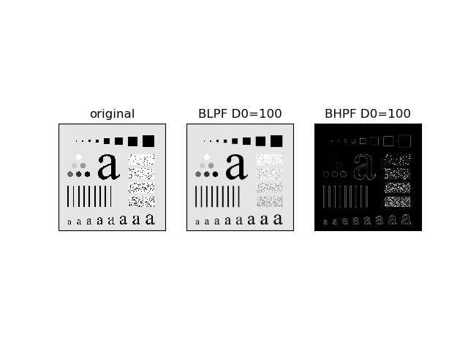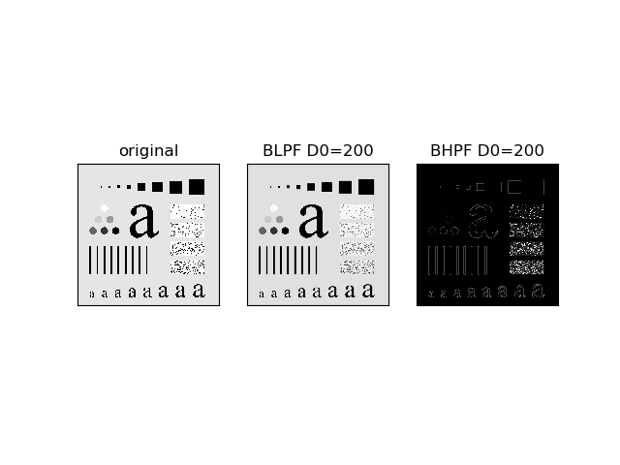

Figure 3.2 Butterworth Low and High Pass Filter with different parameters

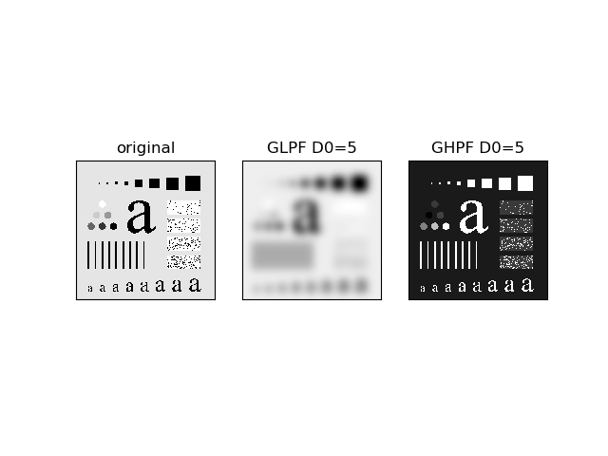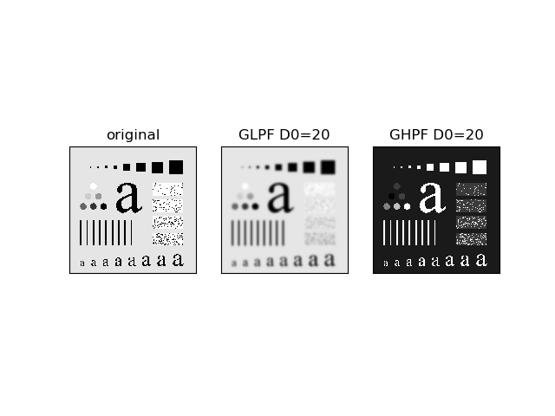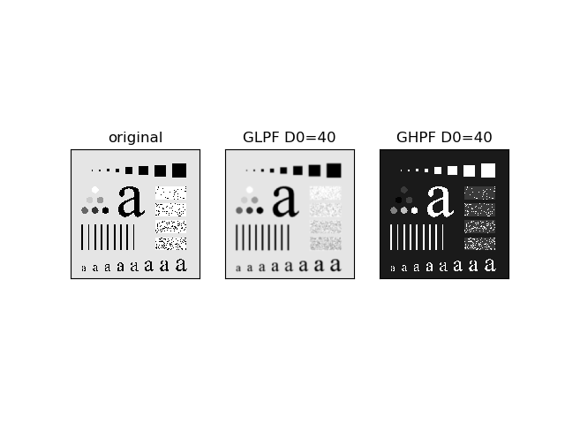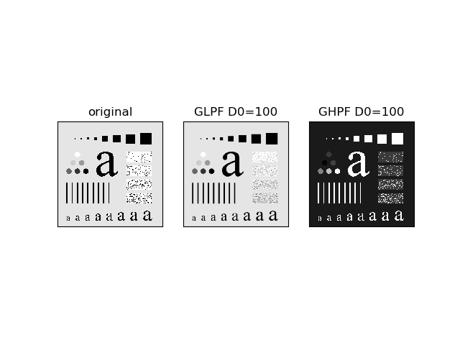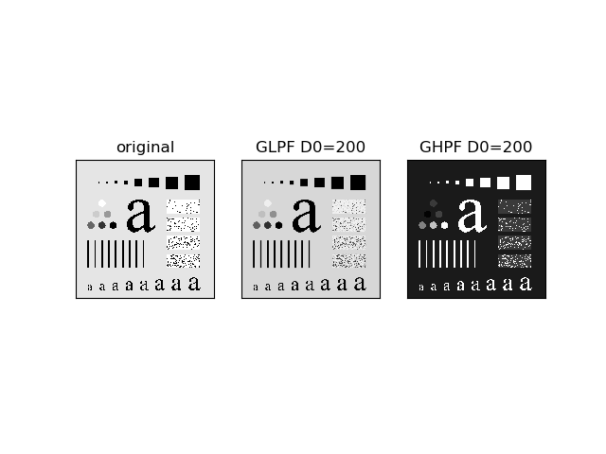

Figure 3.3 Gaussian Low and High Pass Filter with different parameters