**Report 04: Generating different noise and comparing**

**different noise reduction methods**

**Geyunhao （116020910017）**

**[Problem 04]**

In this problem, you are required to write a program to generate different types of random noises started from the Uniform noise and Gaussian noise. (one of the reference may be “Digital image processing using Matlab” PP.143-150. And then add some of these noises to the circuit image (Circuit.tif) and investigate the different mean filters and order statistics as the textbook did at pages 344-352.

**[Solve]**

**Program:** problem4.m.

**Input:**

(1) images\NoiseTestBlack.jpg. An extra image used for testing different Noise Function.

(2) images\Circuit.tif.

**Output:**

(1) Figure4.1. Histogram of None, Uniform, Gaussian, Lognormal Noise in black background.

(2) Figure4.2. Histogram of RayLeigh, Exponential, Erlang, Salt & Pepper Noise in black background.

(3) Figure4.3. Original image, Corrupted by additive Gaussian Noise, 3×3 Arithmetic Mean Filter and 3×3 Geometric Mean Filter.

(4) Figure4.4. Images corrupted by Salt Noise and Pepper Noise, results of 3×3 Contraharmonic Filter with different parameter Q. Q>0 is efficient for Pepper Noise, but it will lose efficacy for Salt Noise. Q<0 has an opposite effect.

(5) Figure4.5. Image corrupted by Salt & Pepper Noise and results of multi-processing with 3×3 Media Filter.

(6) Figure4.6. Processing to images corrupted by Pepper Noise and Salt Noise with Max/Min Order Statistic Filter. Max Order Statistic Filter is efficient for image corrupted by Pepper Noise, and Min Order Statistic Filter is efficient for image corrupted by Salt Noise.

(7) Figure4.7. Image severe corrupted by Uniform Noise and Salt & Pepper Noise, and images processing with 5×5 Arithmetic Mean Filter, 5×5 Geometric Mean Filter, 5×5 Median Order Statistic Filter and α Mean Filter.

**Transformation Function:**

1.Noise

(1) PDF of Uniform Noise.

(2) PDF of Gaussian Noise.

(3) PDF of Lognormal Noise.

(4) PDF of RayLeigh Noise.

(5) PDF of Exponential Noise.

(6) PDF of Erlang Noise.

(7) PDF of Salt & Pepper Noise.

2.Filter

(1) Arithmetic Mean Filter.

(2) Geometric Mean Filter.

(3) Contraharmonic Filter.

(4) Max Order Statistic Filter.

(5) Min Order Statistic Filter.

(6) Median Order Statistic Filter.

(7) α Mean Filter.

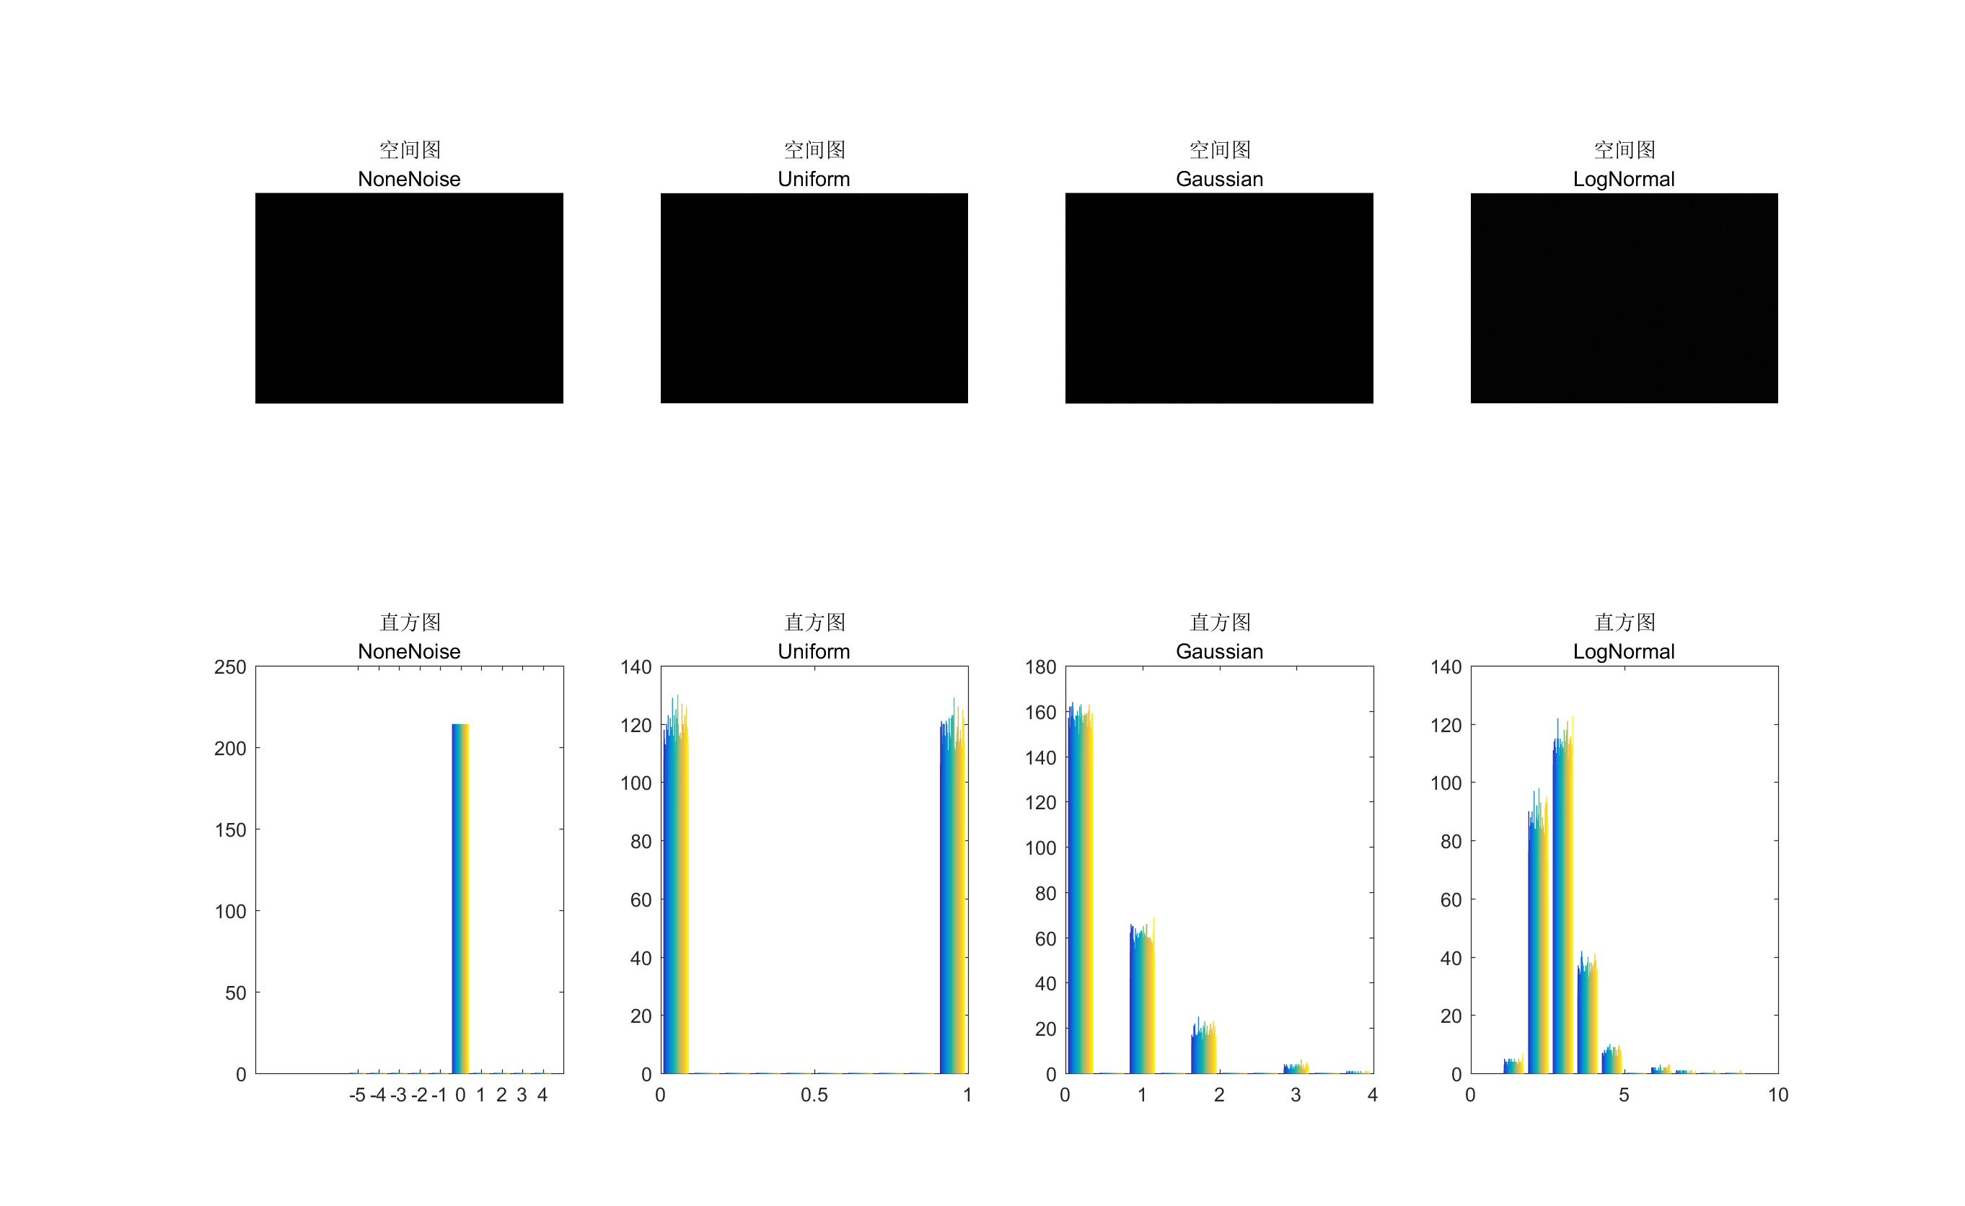

Figure 4.1 Histogram of None, Uniform, Gaussian, Lognormal Noise in black background

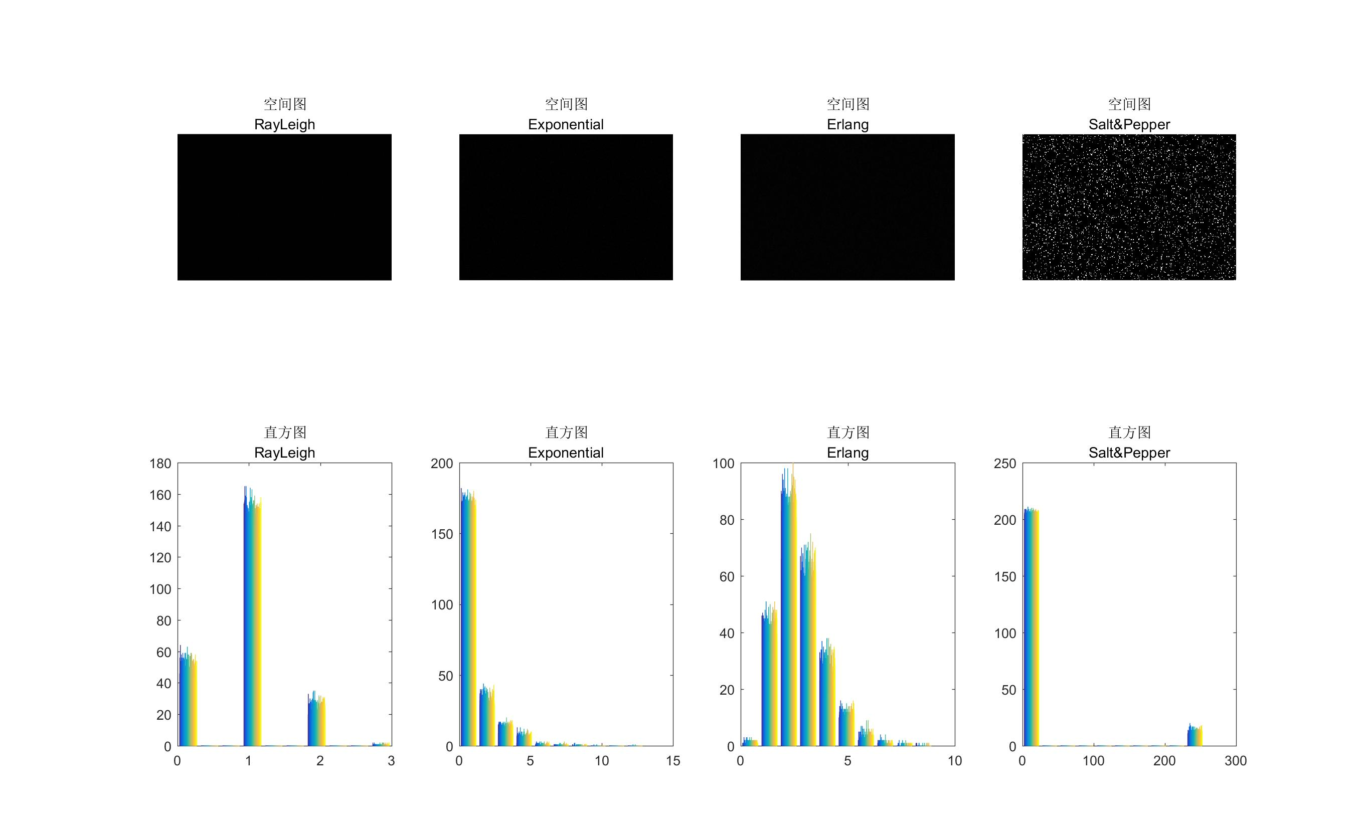

Figure 4.2 Histogram of RayLeigh, Exponential, Erlang, Salt & Pepper Noise in black background

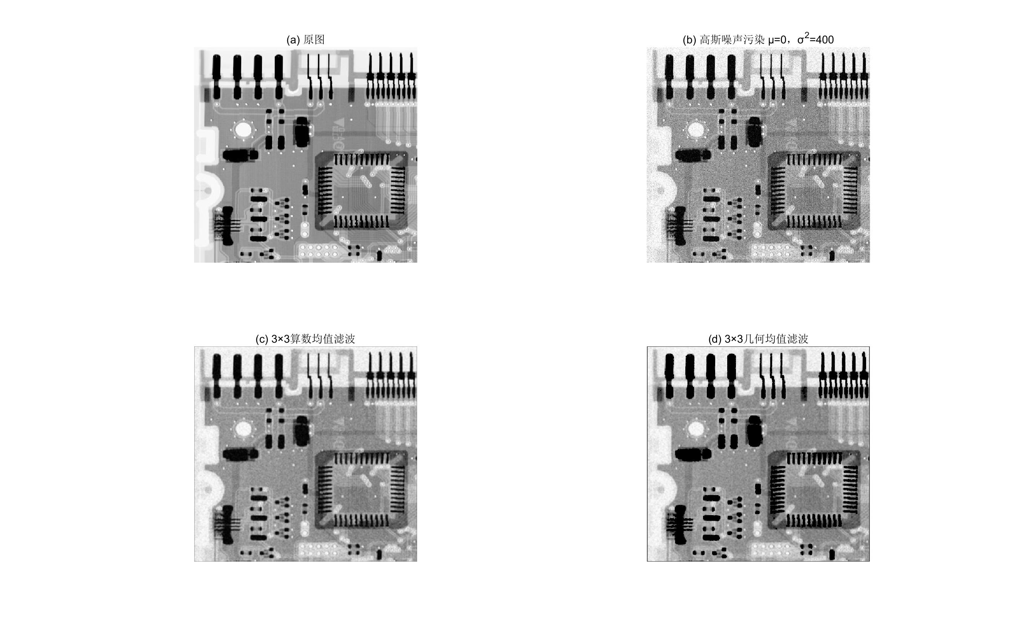

Figure 4.3 Original image, Corrupted by additive Gaussian Noise, 3×3 Arithmetic Mean Filter and 3×3 Geometric Mean Filter

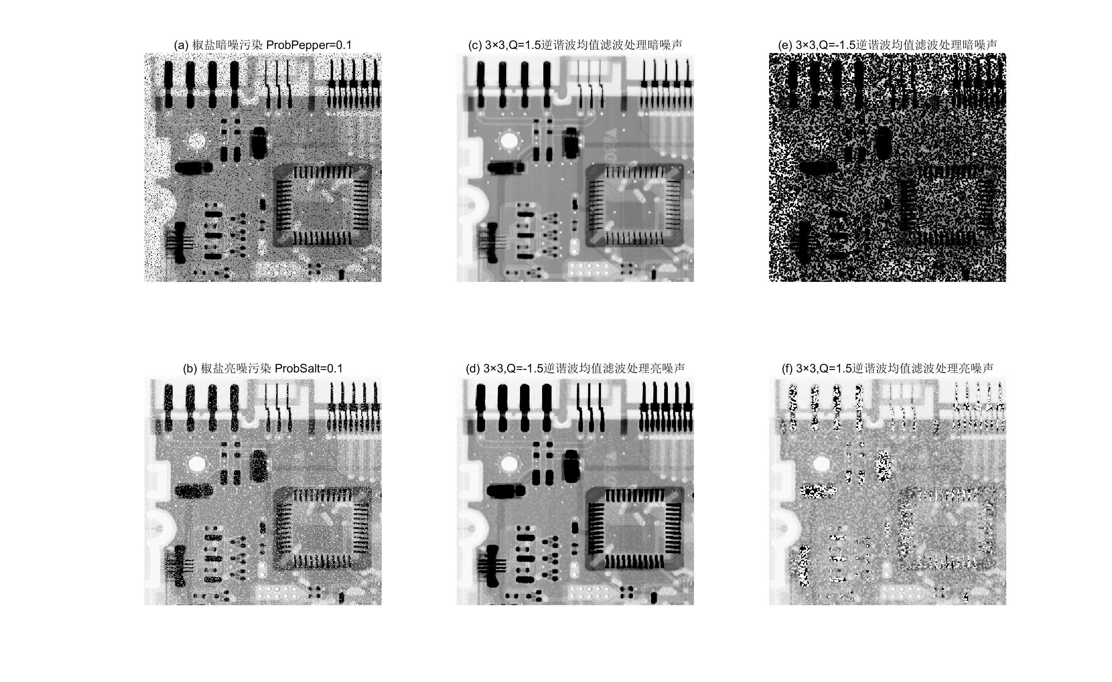

Figure 4.4 Images corrupted by Salt Noise and Pepper Noise, results of 3×3 Contraharmonic Filter with different parameter Q

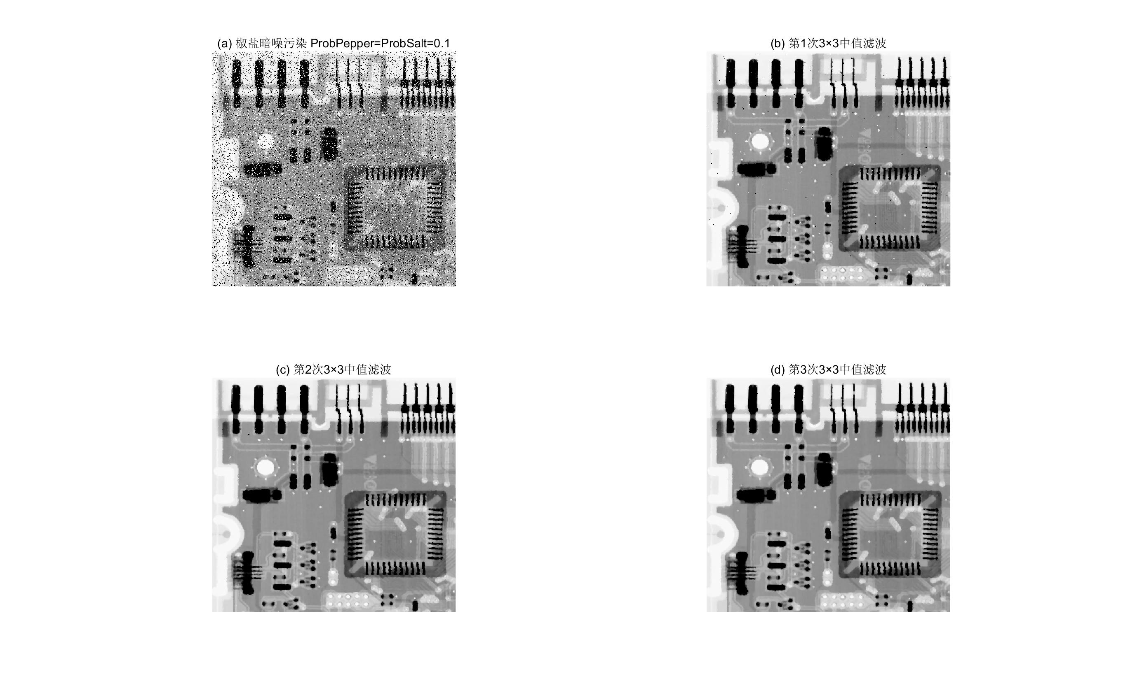

Figure 4.5 Image corrupted by Salt & Pepper Noise and results of multi-processing with 3×3 Media Filter

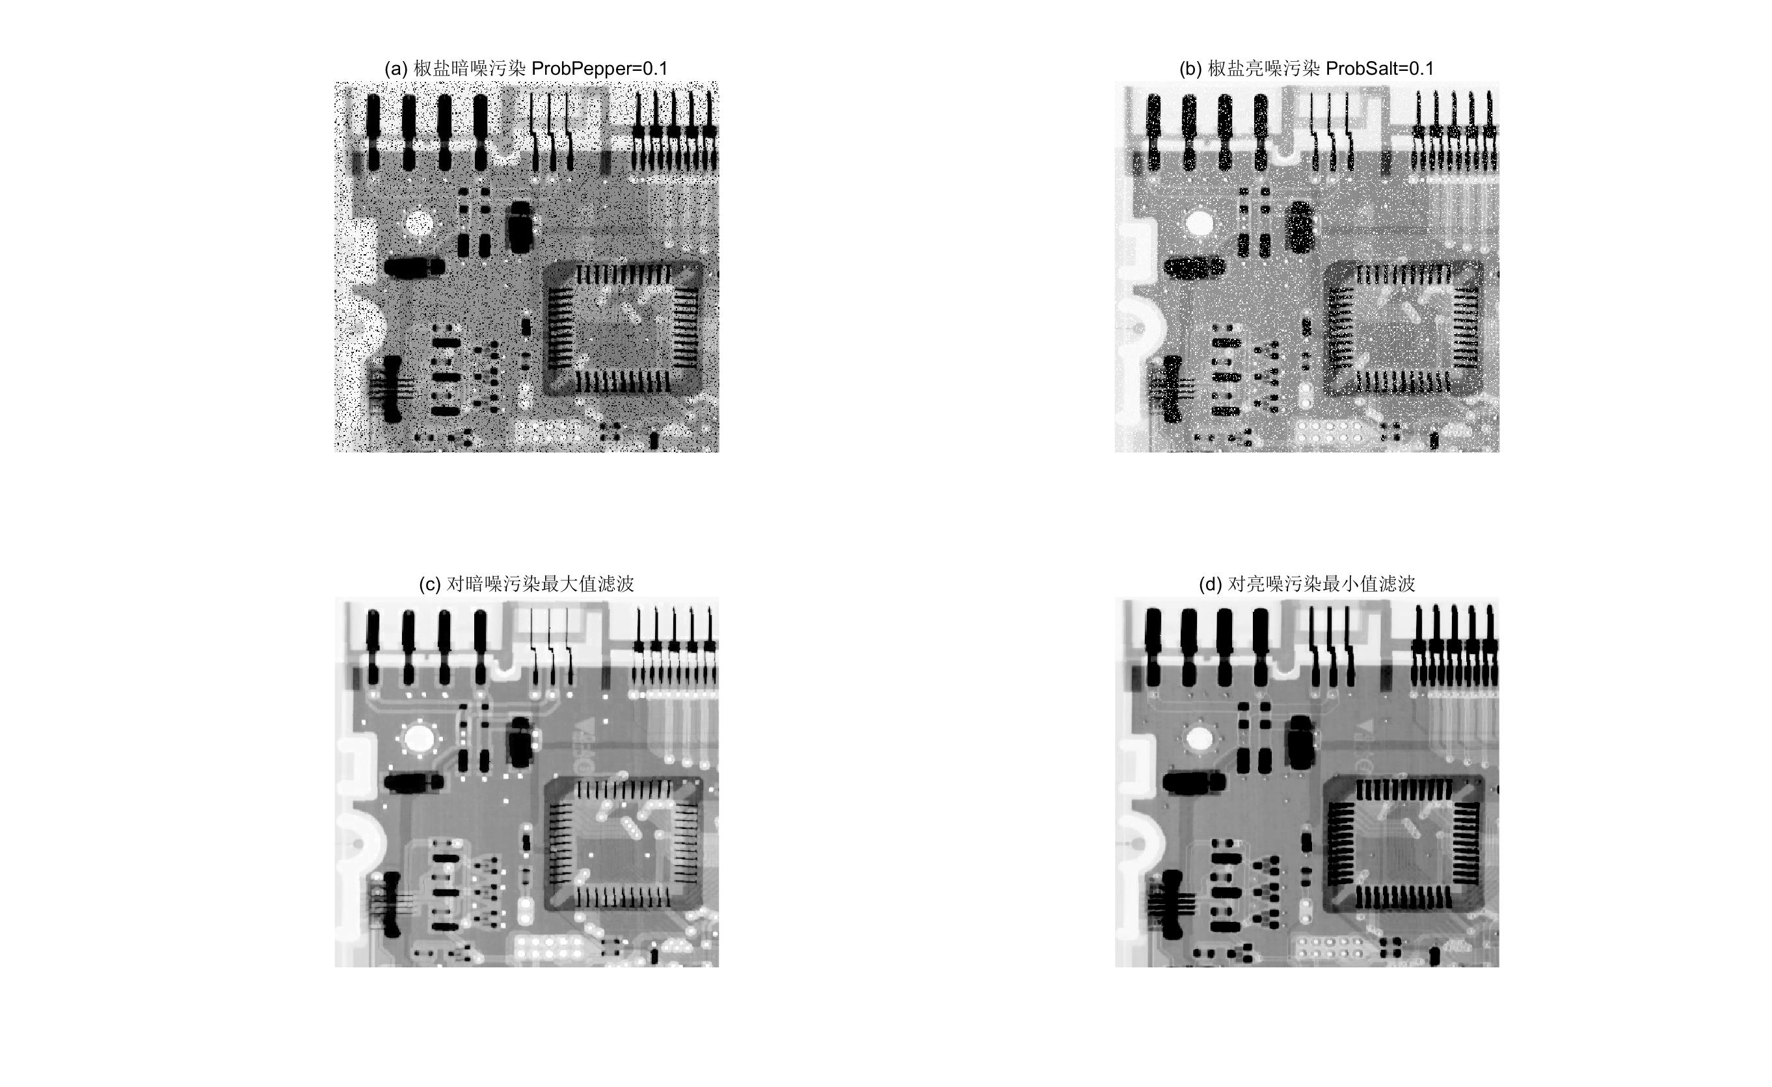

Figure 4.6 Processing to images corrupted by Pepper Noise and Salt Noise with Max/Min Order Statistic Filter

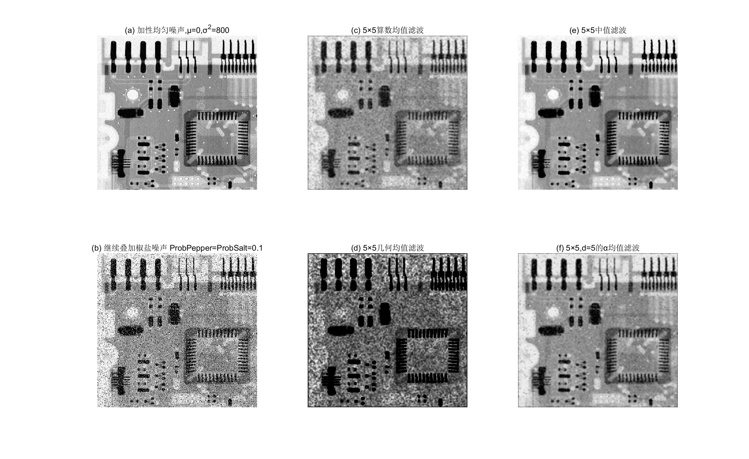

Figure 4.7 Image severe corrupted by Uniform Noise and Salt & Pepper Noise, and images processing with 5×5 Arithmetic Mean Filter, 5×5 Geometric Mean Filter, 5×5 Median Order Statistic Filter and α Mean Filter