**Report 05: Image restoration**

**Ge Yunhao （116020910017）**

**[Problem 05]**

Suppose a blurring degradation function as

(a) Implement a blurring filter using the equation below.

(b) Blur the test image book_cover.jpg using parameters a=b=0.1 and T=1.

(c) Add Gaussian noise of 0 mean and variance of 650 to the blurred image.

(d) Restore the blurred image and the blurred noisy image using the inverse filter, Wiener deconvolution filter, respectively.

(e) Add Gaussian noise of 0 and different variances to the blurred image and repeat (d), investigate the performance of the Wienerdeconvolution filter.

[Solve]

Program:

Main:problem5.m.

Functions: TreatGaussian.m; TreatOut.m

Input: images\book_cover.jpg.

Output:

(1)Figure5.1. Original image, blurred image and blurred image corrupted by Gaussian Noise.

(2) Figure5.2. Inverse Filtering.

(3) Figure5.3. Wiener Filtering ,parameter , when , Filtering looks better.

(4) Figure5.4. Find exact k= 0.0153.

(5) Figure5.5. Filtering effect under different noise conditions.

Transformation Function:

(1) Blur Filtering

(2) Inverse Filtering.

(3) Wiener Filtering.

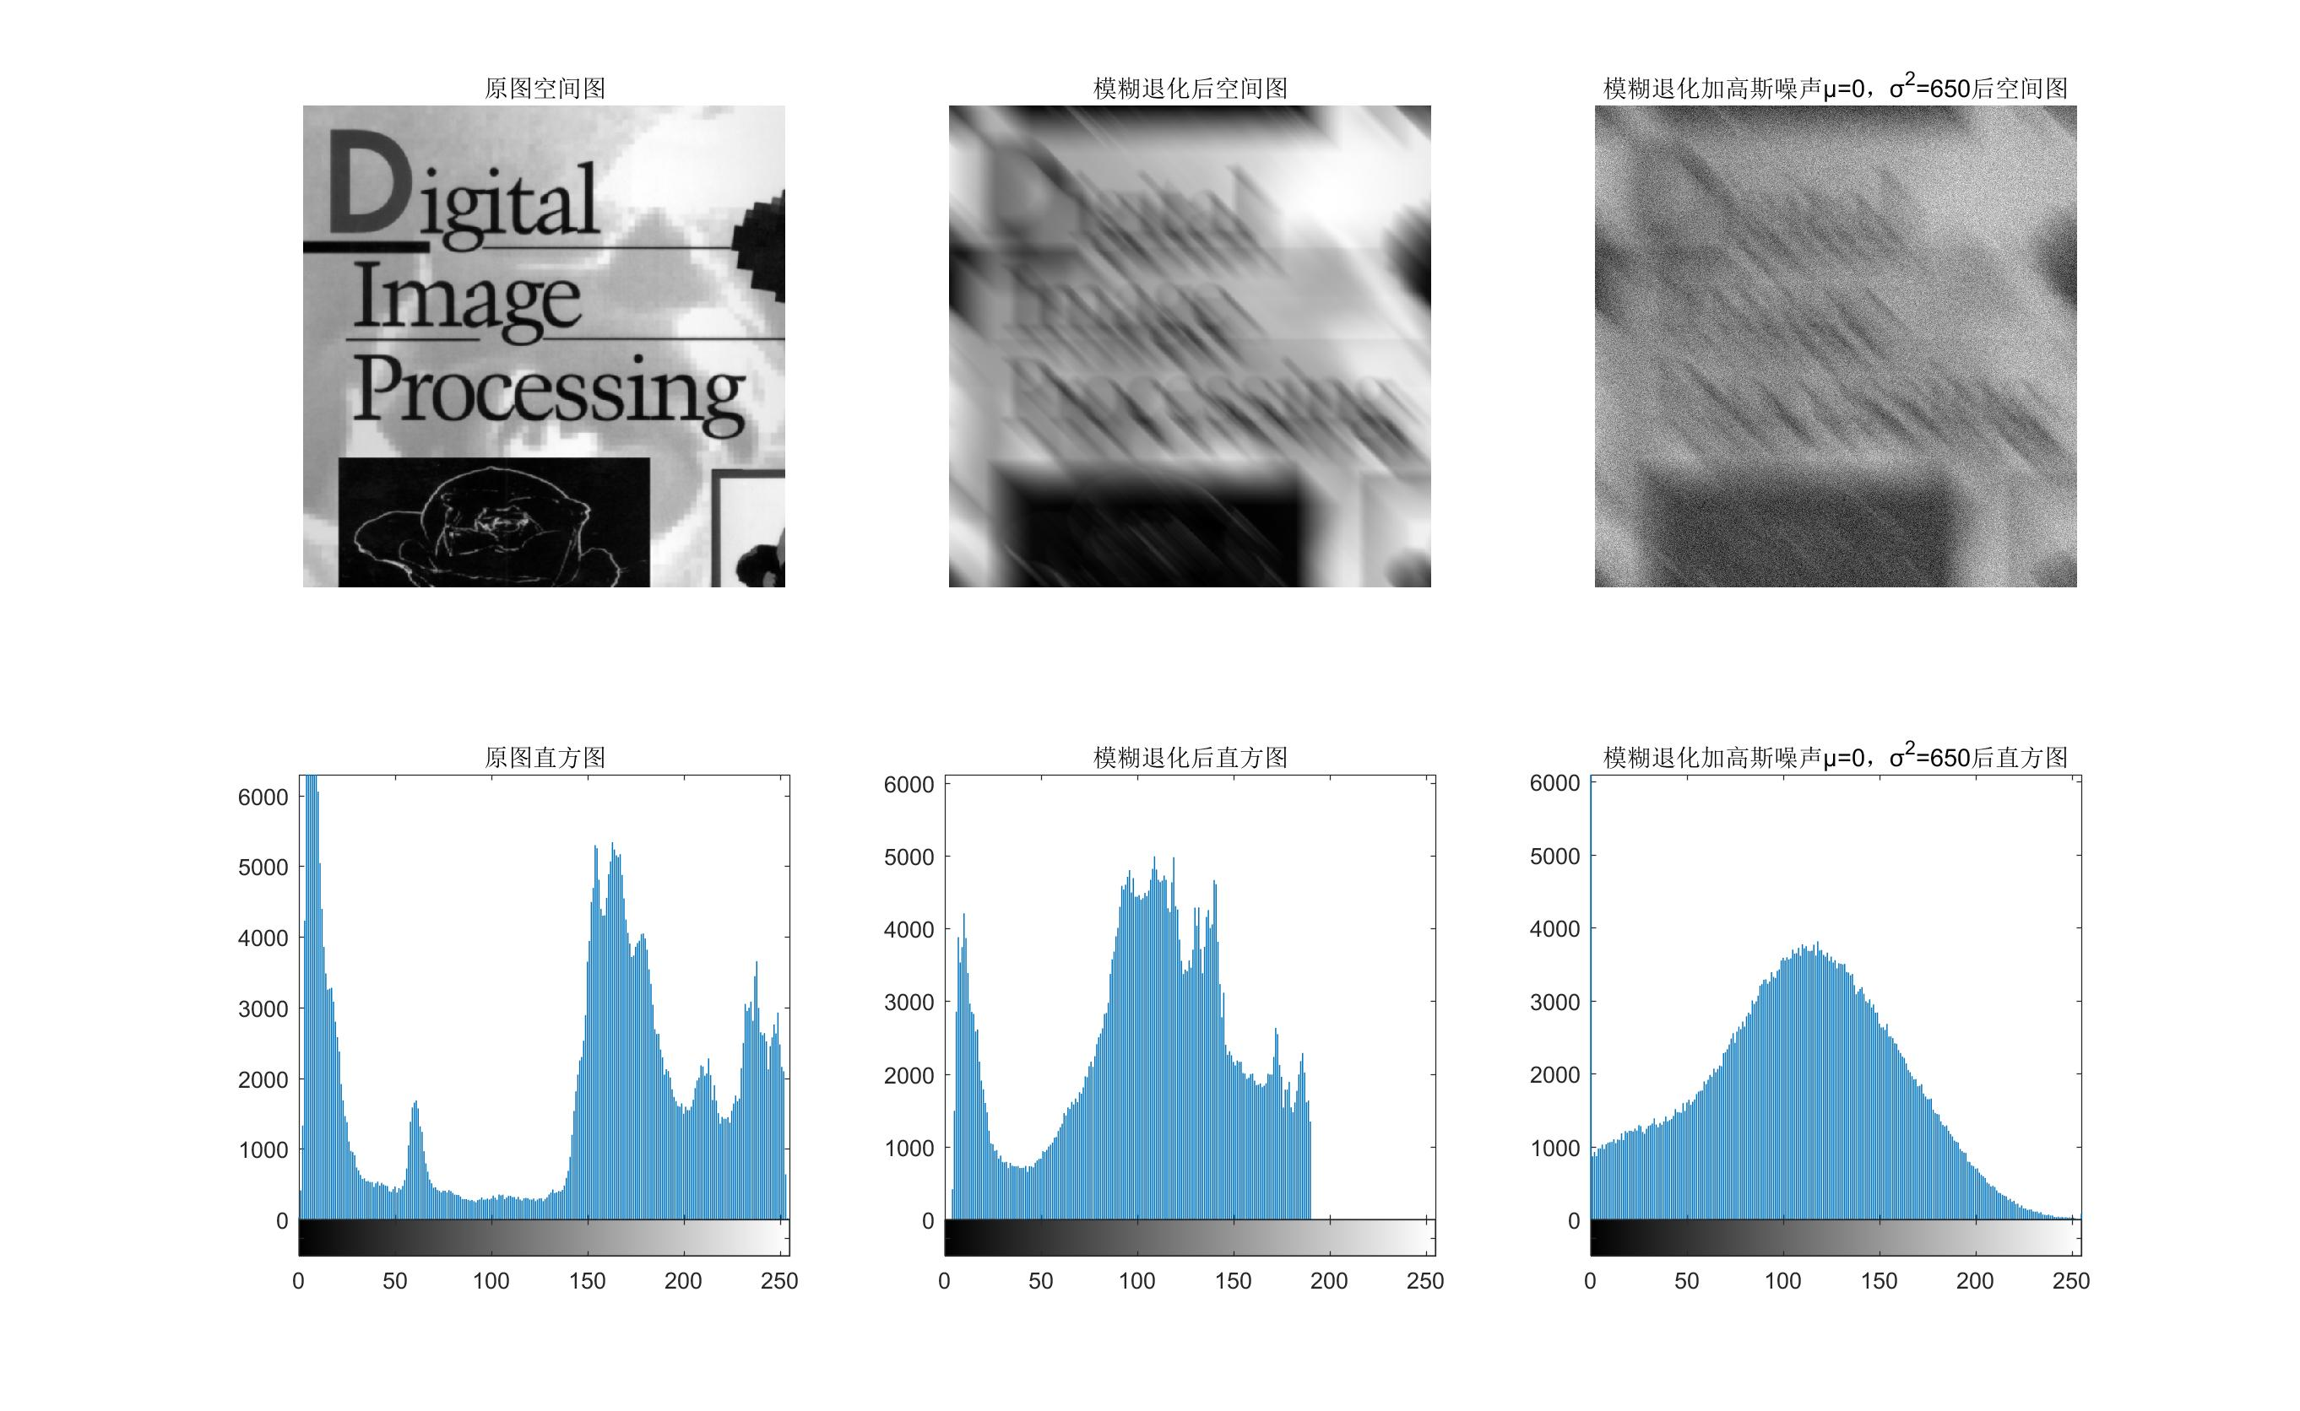

Figure 5.5 Original image, blurred image and blurred image corrupted by Gaussian Noise

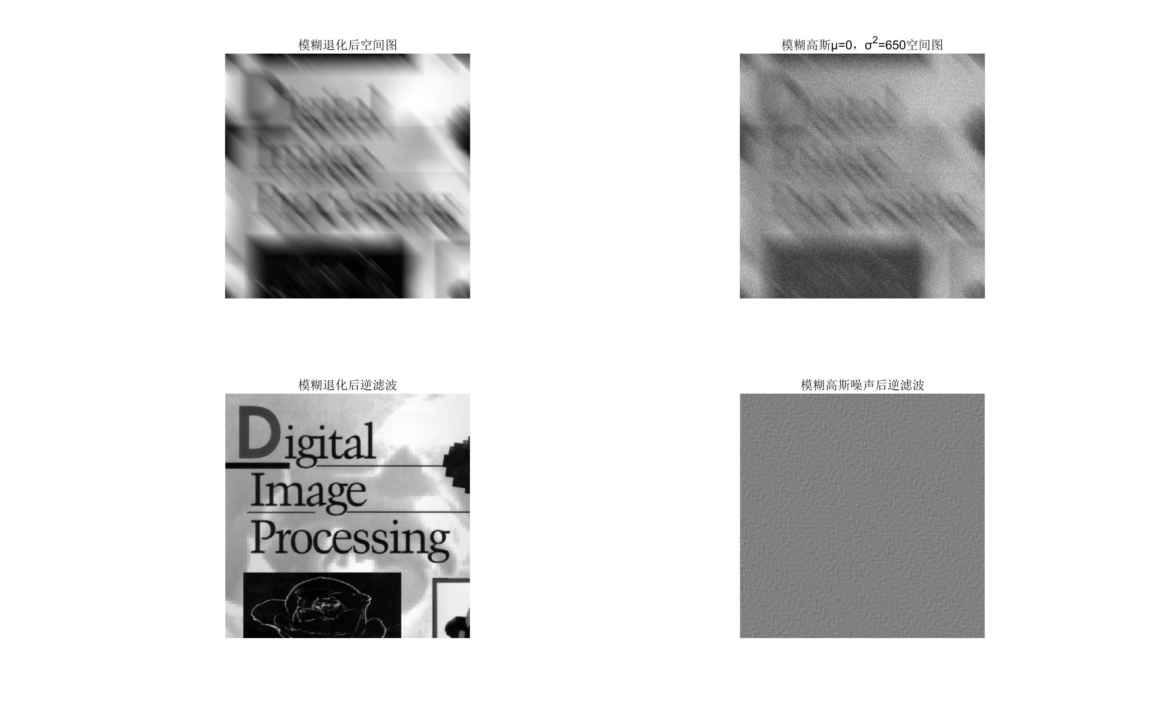

Figure 5.2 Inverse Filtering

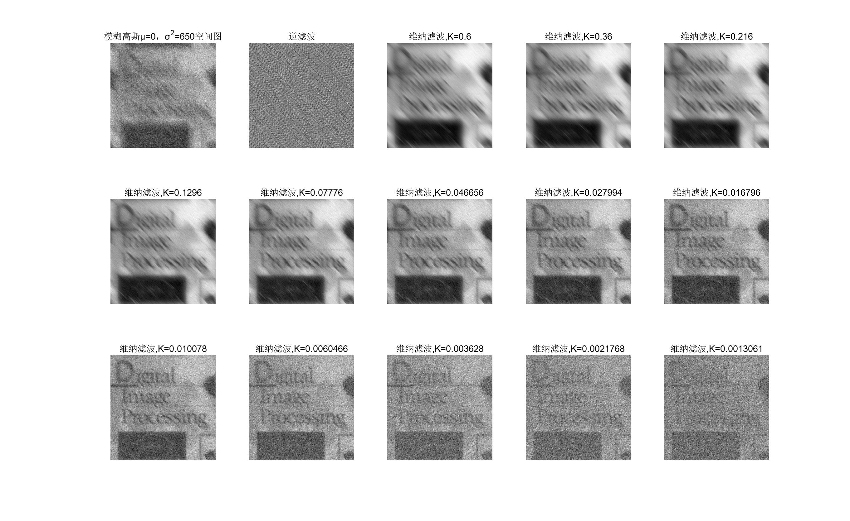

Figure 5.3 Wiener Filtering ,parameter , when , Filtering looks better

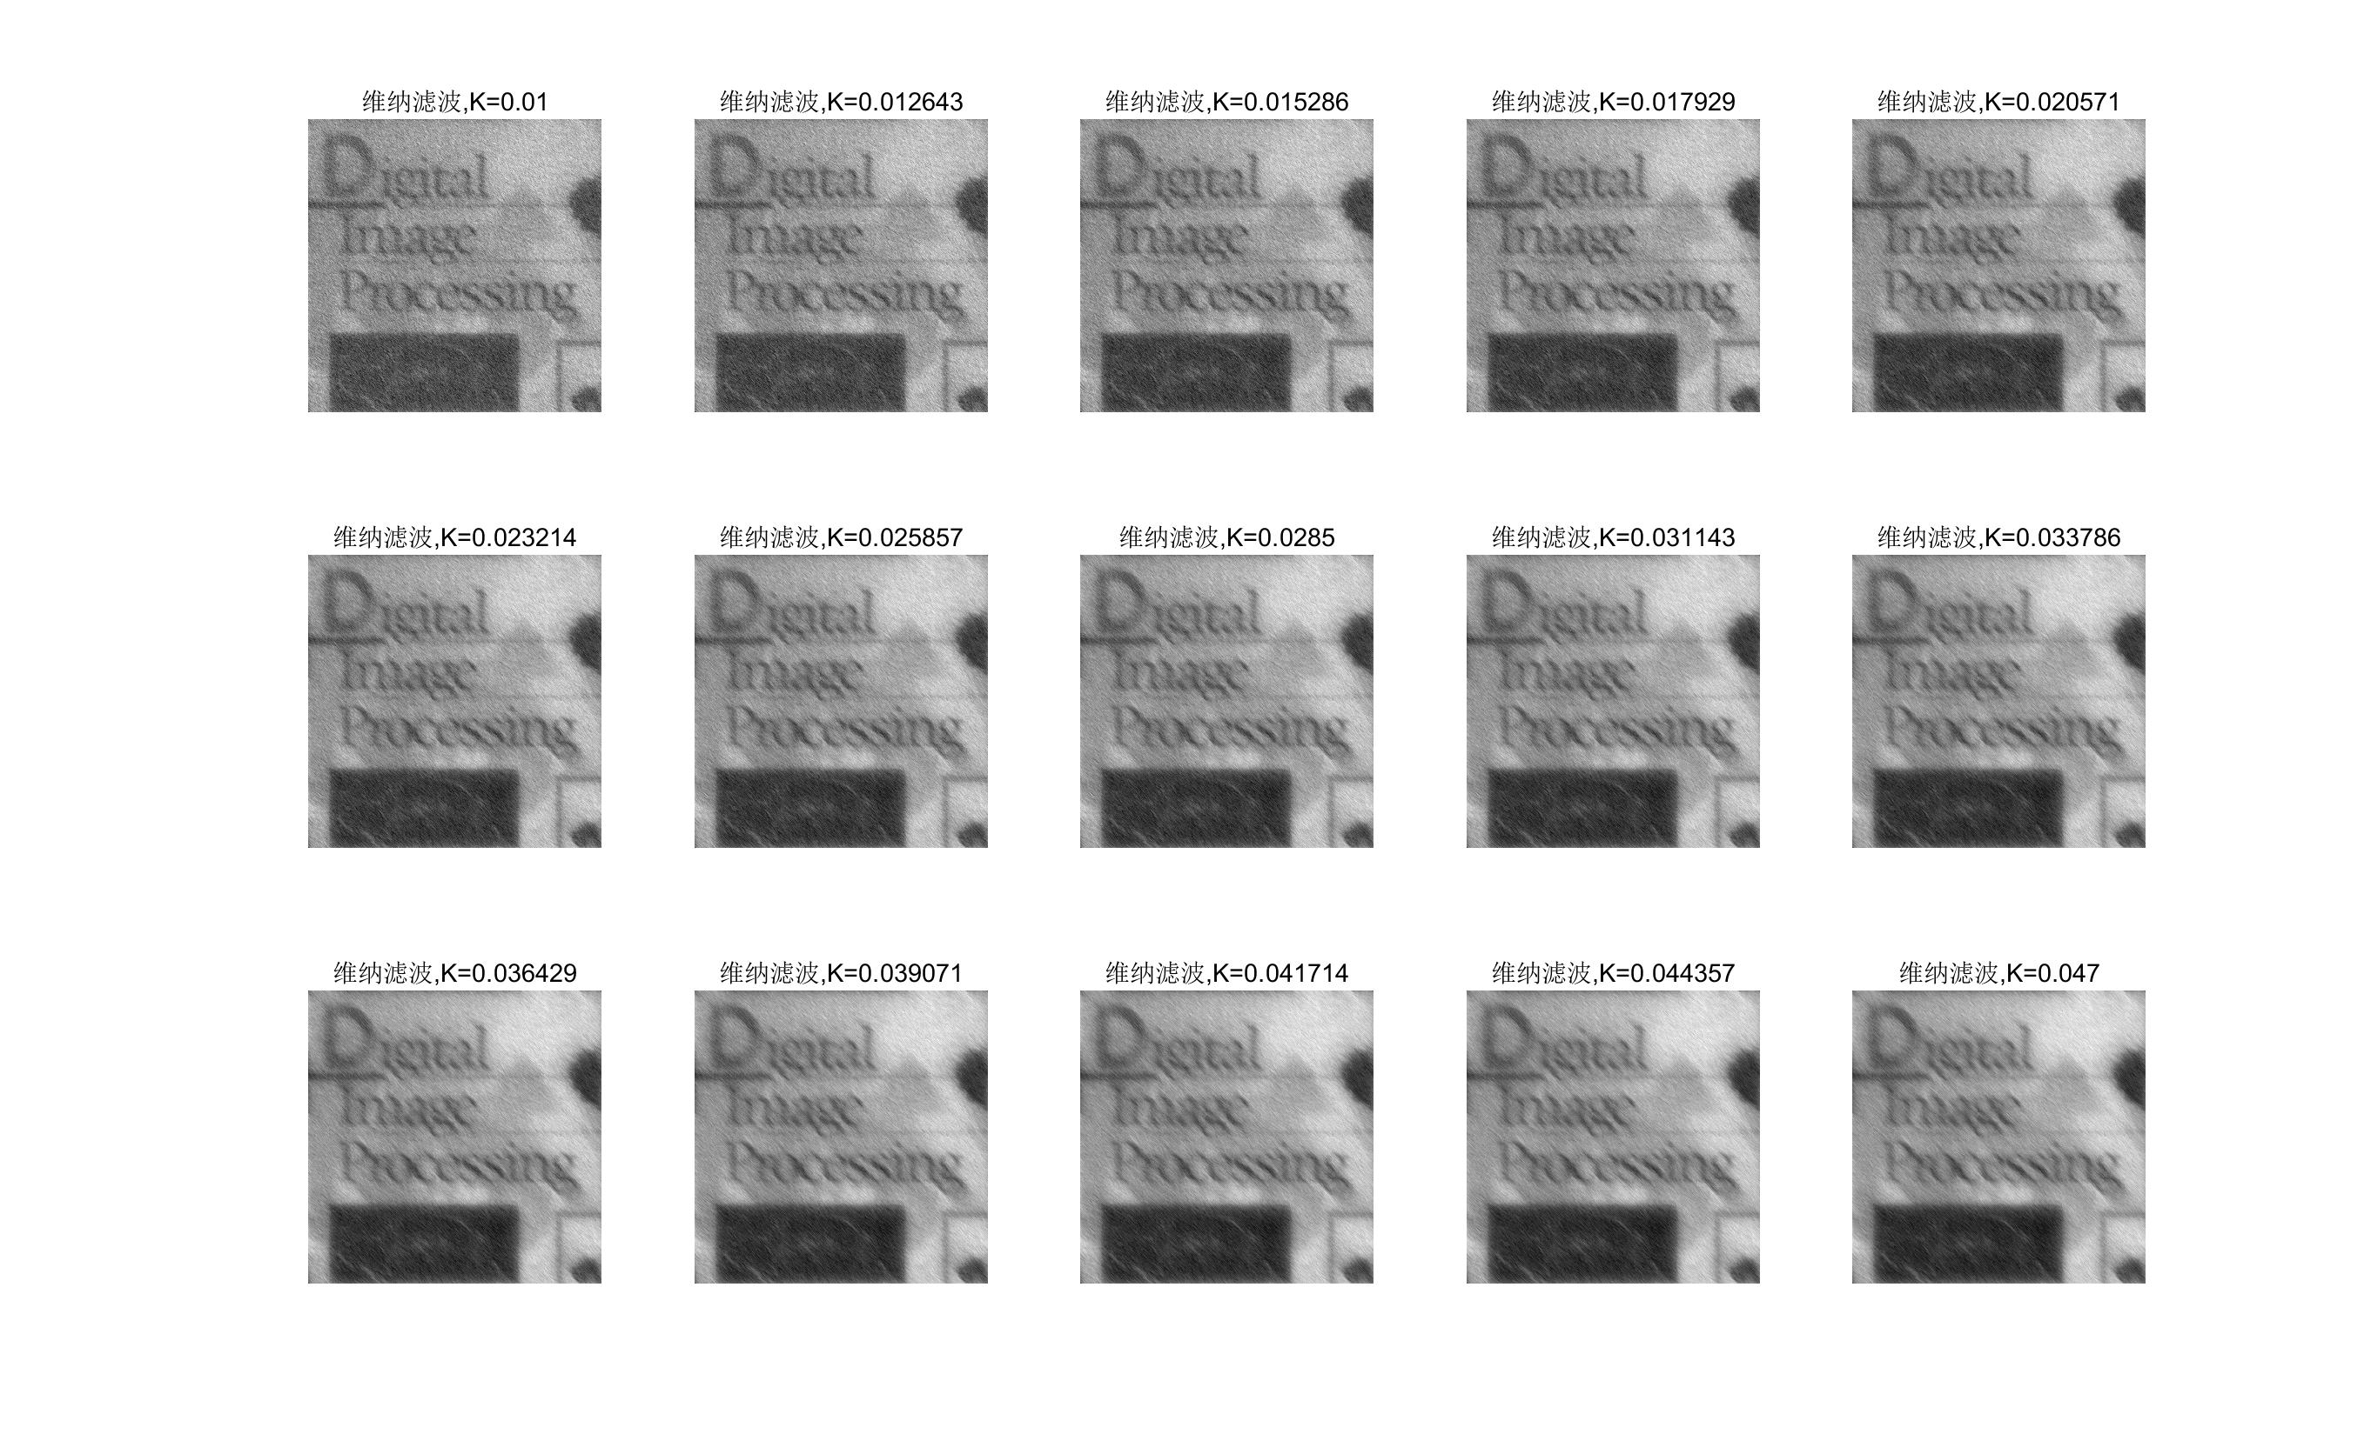

Figure 5.4 Find exact k= 0.0153

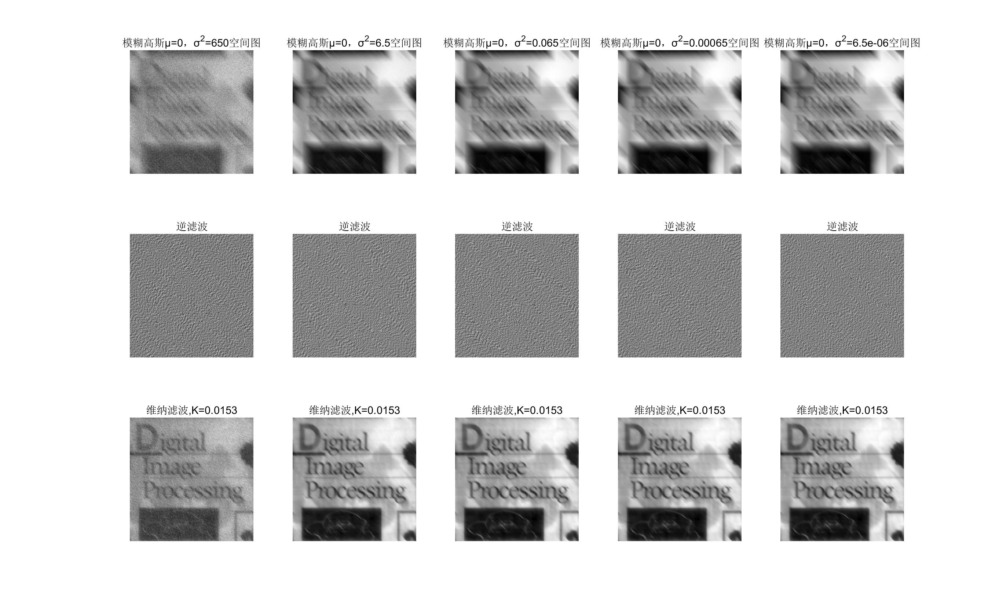

Figure 5.5 Filtering effect under different noise conditions