**Report 06: Geometric transform**

**Ge Yunhao（116020910017）**

**[Problem 06]**

Develop a geometric transform program that will rotate, translate, and scale an image by specified amounts, using the nearest neighbor and bilinear interpolation methods, respectively.

**[Solve]**

**Program:** problem6.m.

**Input:** origin\ray_trace_bottle.tif.

**Output:**

(1)Figure6.1. Image translation were x=170, y=50.

(2) Figure6.2. Image scaling with using the nearest neighbor and bilinear interpolation methods

(3) Figure6.3. Image Ratation using the nearest neighbor and bilinear interpolation methods.

**Transformation Function:**

(1) Bilinear Interpolation

$$f\left(x,y\right)=\left[f\left(1,0\right)-f\left(0,0\right)\right]x+\left[f\left(0,1\right)-f\left(0,0\right)\right]y+\left[f\left(1,1\right)+f\left(0,0\right)-f\left(0,1\right)-f\left(1,0\right)\right]xy+f(0,0)$$

(2) Translation(expressed in affine space)

$$\left[\begin{matrix}a(x,y) \\ b(x,y) \\ 1\end{matrix}\right]=\left[\begin{matrix}1 & 0 & x_{0} \\ 0 & 1 & y_{0} \\ 0 & 0 & 1\end{matrix}\right]\left[\begin{matrix}x \\ y \\ 1\end{matrix}\right]$$

(3)

$$\left[\begin{matrix}a(x,y) \\ b(x,y) \\ 1\end{matrix}\right]=\left[\begin{matrix}\frac{1}{c} & 0 & 0 \\ 0 & \frac{1}{d} & 0 \\ 0 & 0 & 1\end{matrix}\right]\left[\begin{matrix}x \\ y \\ 1\end{matrix}\right]$$

(4)

$$\left[\begin{matrix}a(x,y) \\ b(x,y) \\ 1\end{matrix}\right]=\left[\begin{matrix}cos⁡(θ) & -sin(θ) & 0 \\ sin⁡(θ) & cos⁡(θ) & 0 \\ 0 & 0 & 1\end{matrix}\right]\left[\begin{matrix}x \\ y \\ 1\end{matrix}\right]$$

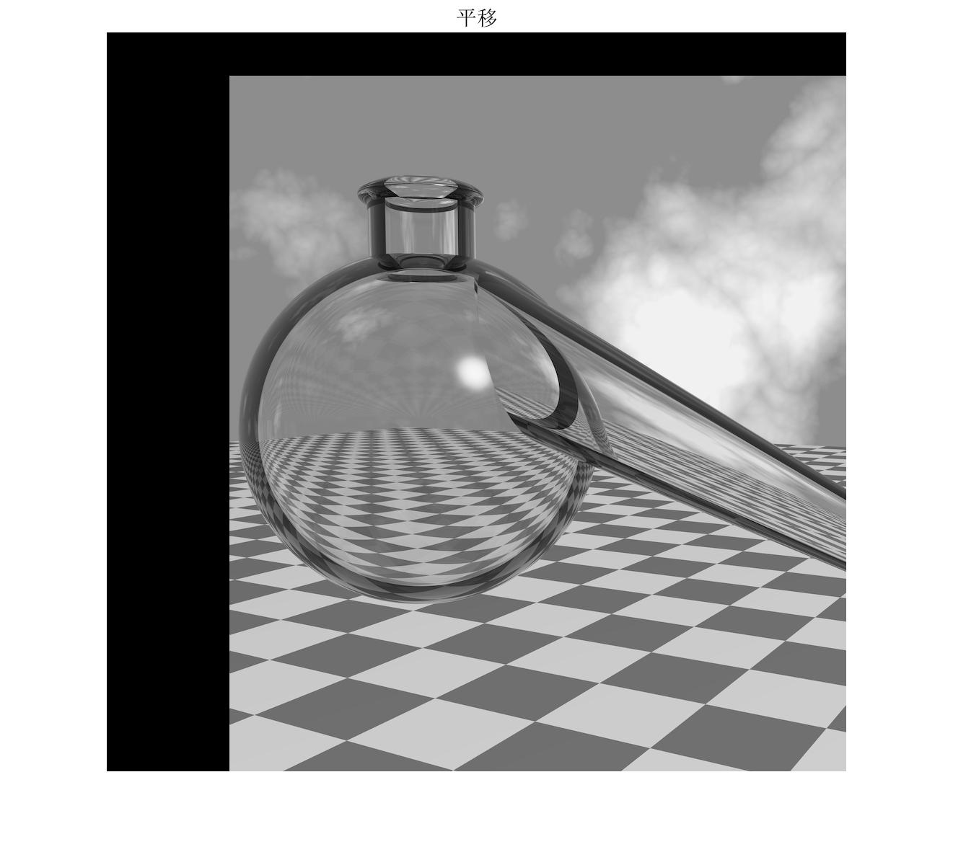

Figure 6.1 Image translation were x=170, y=50

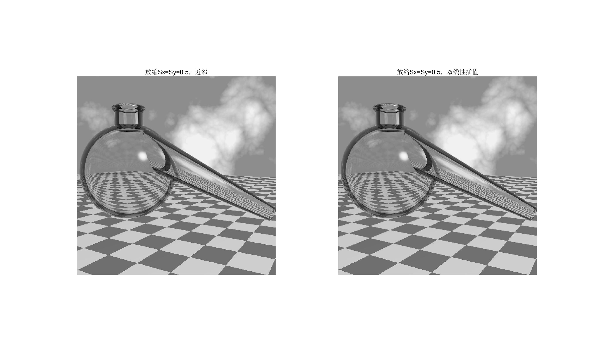

Figure 6.2 Image scaling with using the nearest neighbor and bilinear interpolation methods

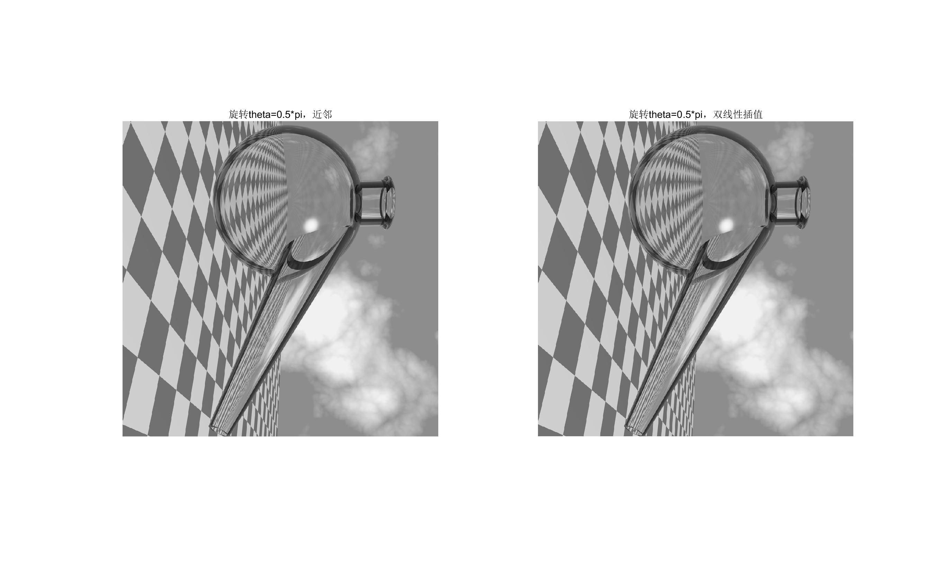

Figure 6.3 Image Ratation using the nearest neighbor and bilinear interpolation methods