**Report 08: Morpholigical Processing**

**Ge Yunhao （116020910017）**

**[Problem 08]**

Implement the "Opening by reconstruction", "Filling holes" and "Border clearing" operations on pages 681-683, and reproduce the results in Figure 9.29, Figures 9.31, and Figure 9.32. (The imagesfig9.29(a) and fig9.31(a) are provided in ftp address.

**[Solve]**

**Program:**

(1) main ：problem8. m.

(2)function：dilation.m; erosion.m; recon.m sign_edge.m

**Input:**

(1) origin\ Fig0929(a)(text_image).tif.

(2) origin \ Fig0931(a)(text_image).tif.

**Output:**

(1) fig 8.1 outimage/Opening by reconstruction.jpg (Original image, image after erosion by structuring element of 51×1, image after opening and image after opening by reconstrucion)

(2) fig 8.2. outimage/Filling holes.

(3) fig 8.3. outimage/erase edge.

**Transformation Function:**

(1) Geodesic dilation.

$$D_{G}^{1st}(F)=\left(F⊕B\right)⋂G$$

$$D_{G}^{nth}(F)=D_{G}^{1st}[D_{G}^{(n-1)th}(F)]$$

(2) Opening by reconstruction.

$$O_{R}^{nth}\left(F\right)=R_{F}^{D}(F⊖nB)$$

(3) Border Sign.

$$F\left(x,y\right)=\left\{\begin{aligned}1-I\left(x,y\right), if I\left(x,y\right) is on the border \\ 0, otherwise \end{aligned}\right.$$

(4) Hole-filling.

$$H={\left[R_{I^{C}}^{D}\left(F\right)\right]}^{C}$$

(5) Border clearing.

$$X=I-R_{I}^{D}(F)$$

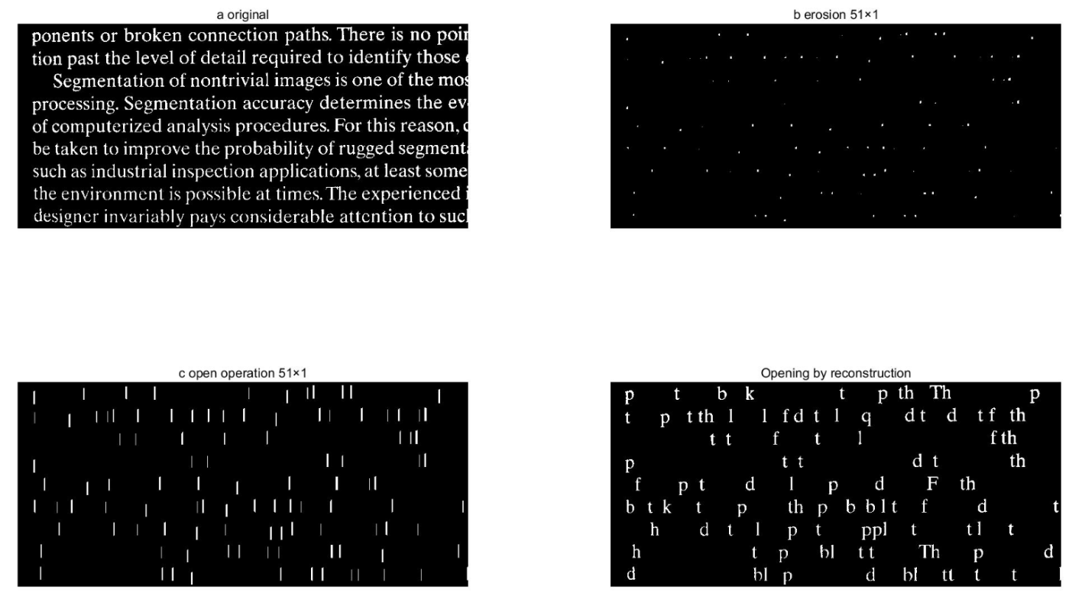

fig 8.1 Opening by reconstruction.jpg (Original image, image after erosion by structuring element of 51×1, image after opening and image after opening by reconstrucion)

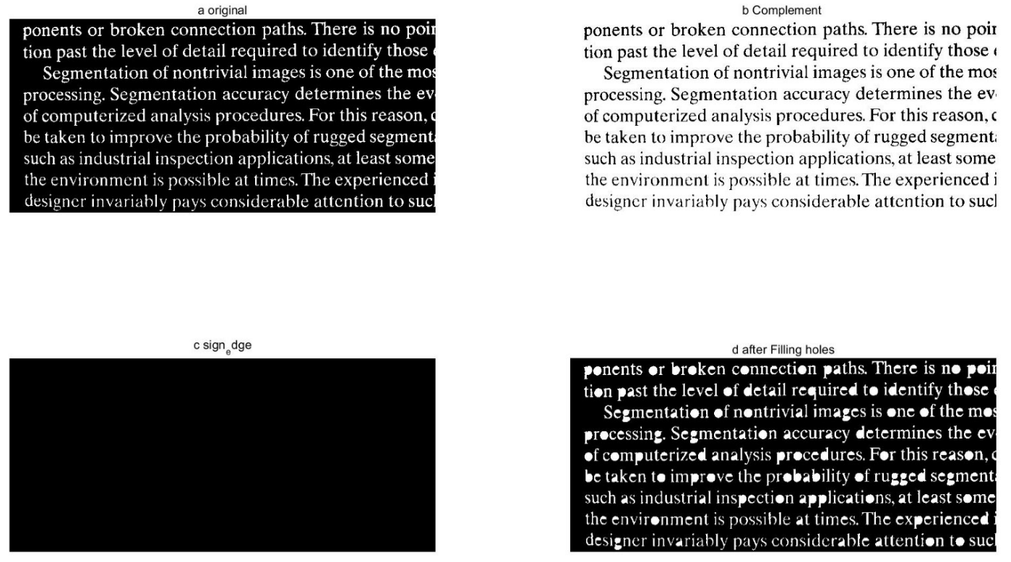

Figure 8.2 Filling holes.

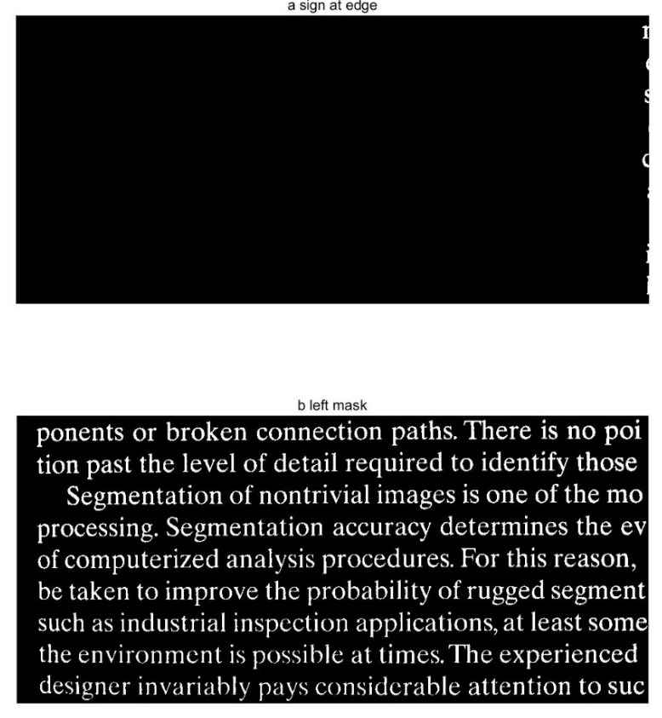

Figure 8.3 erase edge