**Report 09: Image segmentation**

**Ge Yunhao （116020910017）**

**[Problem 09]**

(a) Develop a program to implement the Roberts, Prewitt, Sobel, the Marr-Hildreth and the Canny edge detectors. Use the image ‘building.tif’ to test your detectors. (For technique details of Marr-Hildreth and Canny, please refer to pp.736-747 (3rd edition, Gonzalez DIP) or MH-Canny.pdf at the same address of the slides.)

(b) Develop a program to implement the Otsu’s method of thresholding segmentation, and compare the results with the global thresholding method using test image 'polymersomes.tif'. (For technique details, please refer to pp.763-770 (3rd edition, Gonzalez DIP), or Otsu.pdf at the same ftp address of slides.)

**[Solve]**

**Program:**

Main: Problem_9.m.

Function: Canny.m; EdgeCom.m; EdgeCom2.m; EdgeCom3.m; localmax.m; otsu_value.m

**Input:**

(1) origin\building.tif.

(2) origin \polymersomes.tif.

**Output:**

(1) Figure 9.1 Original image and image after Prewitt Operator with different threshold.

(2) Figure 9.2 Original image and image after Sobel Operator with different threshold.

(3) Figure 9.3 Original image and image after Roberts Operator with different threshold.

(4) Figure 9.4 Original image and image after MH with different threshold.

(5) Figure 9.5 Original image and image after Canny.

(6) Figure 9.6 Original image ,image after Otus and Global thresholding segmentation.

**Transformation Function:**

(1) Gradient.

(2) Magnitude.

(3) Gradient detecting.

a. Roberts cross-gradient operators.

b. Prewitt gradient operators.

c. Sobel gradient operators.

(4) Diagonal edges detecting.

a. Prewitt diagonal edges operators.

b. Prewitt diagonal edges operators.

(5) MH.

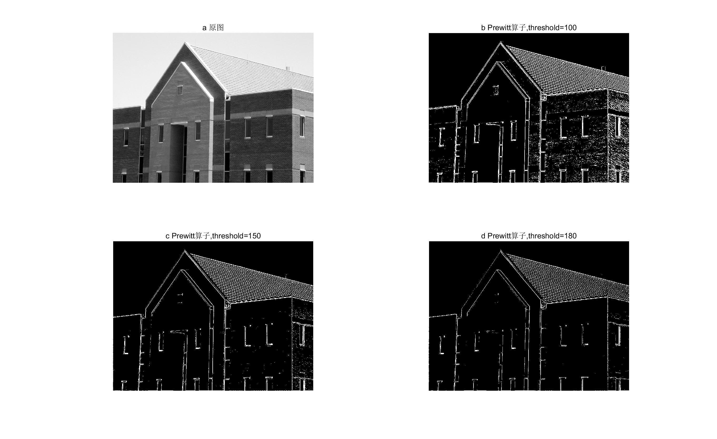

Figure 9.1 Original image and image after Prewitt Operator with different threshold

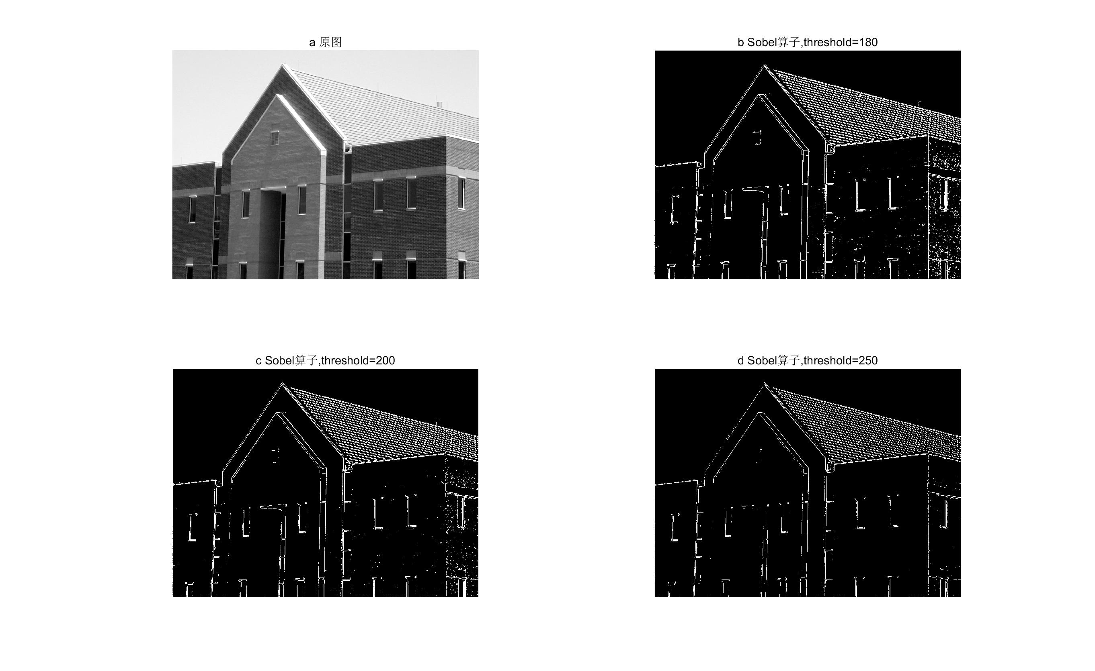

Figure 9.2 Original image and image after Sobel Operator with different threshold

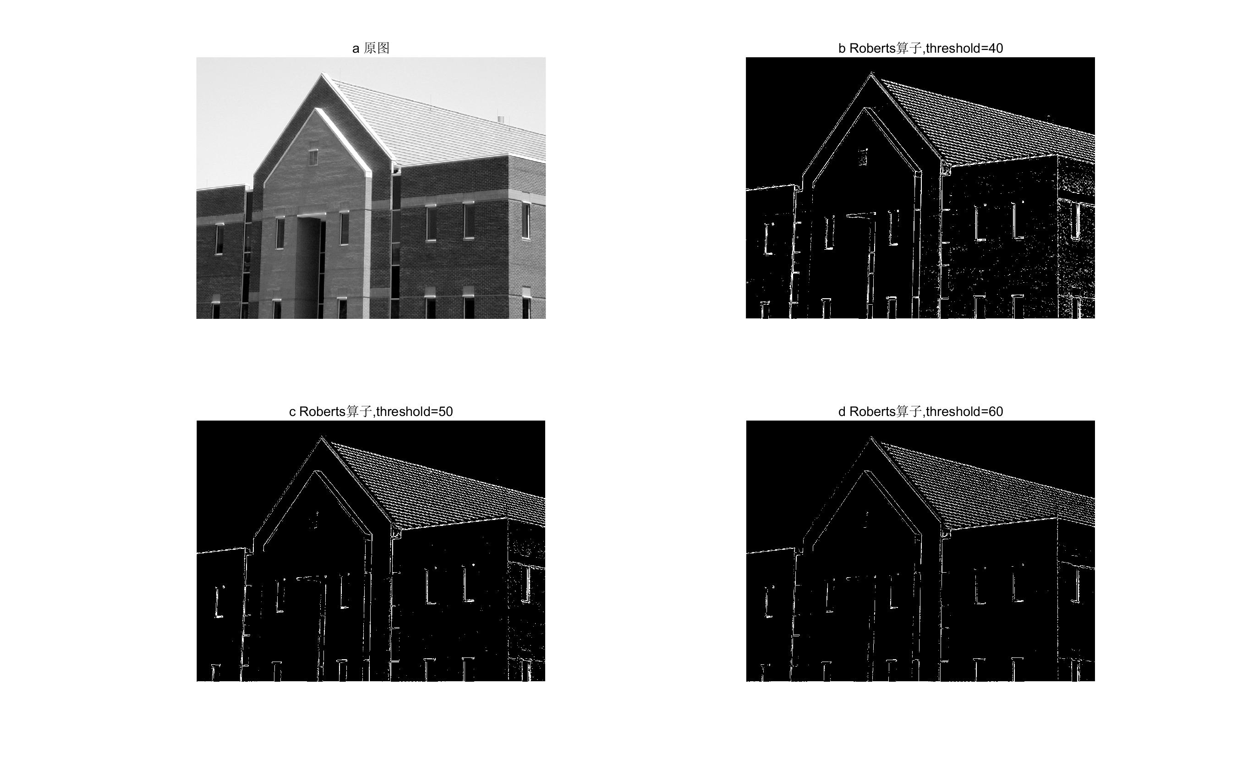

Figure 9.3 Original image and image after Roberts Operator with different threshold

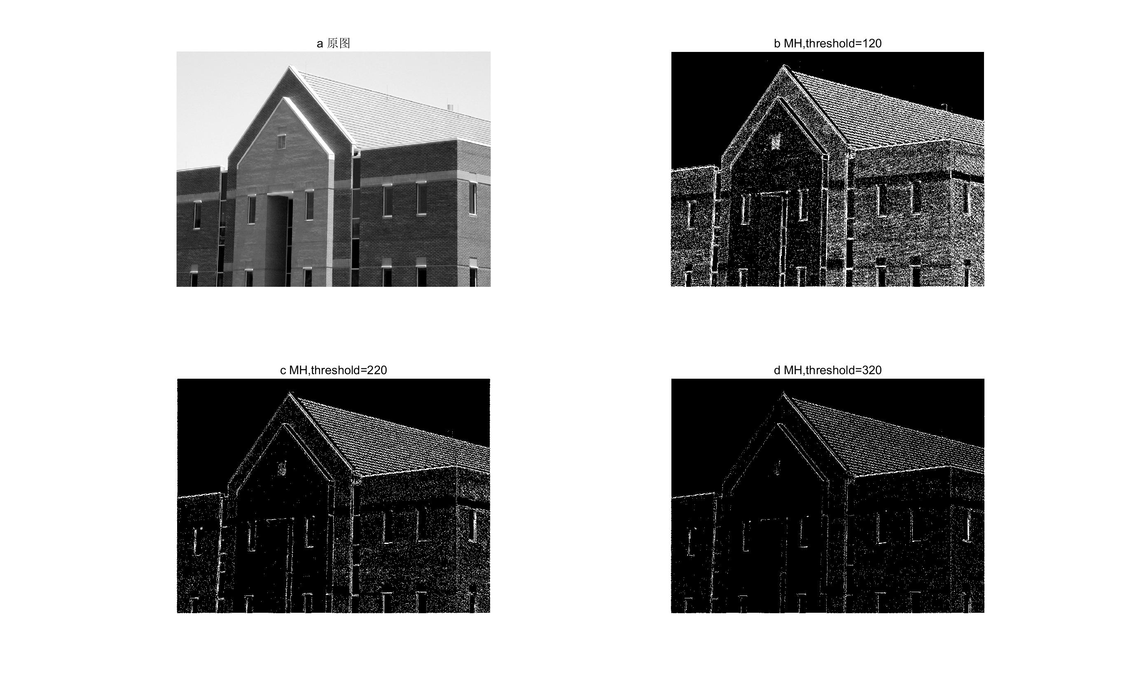

Figure 9.4 Original image and image after MH with different threshold

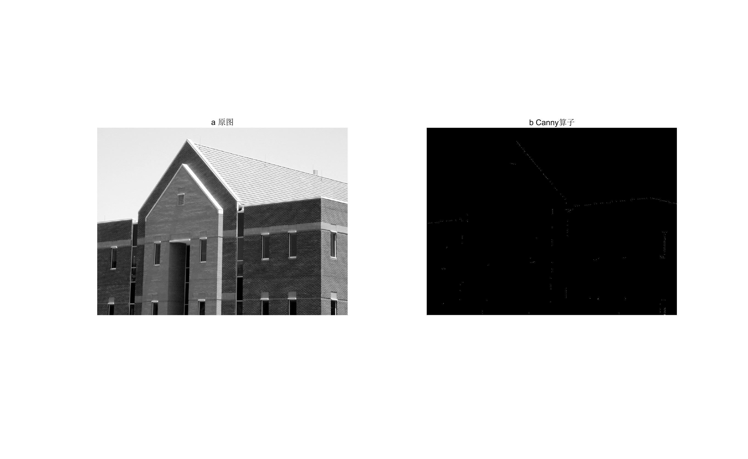

Figure 9.5 Original image and image after Canny

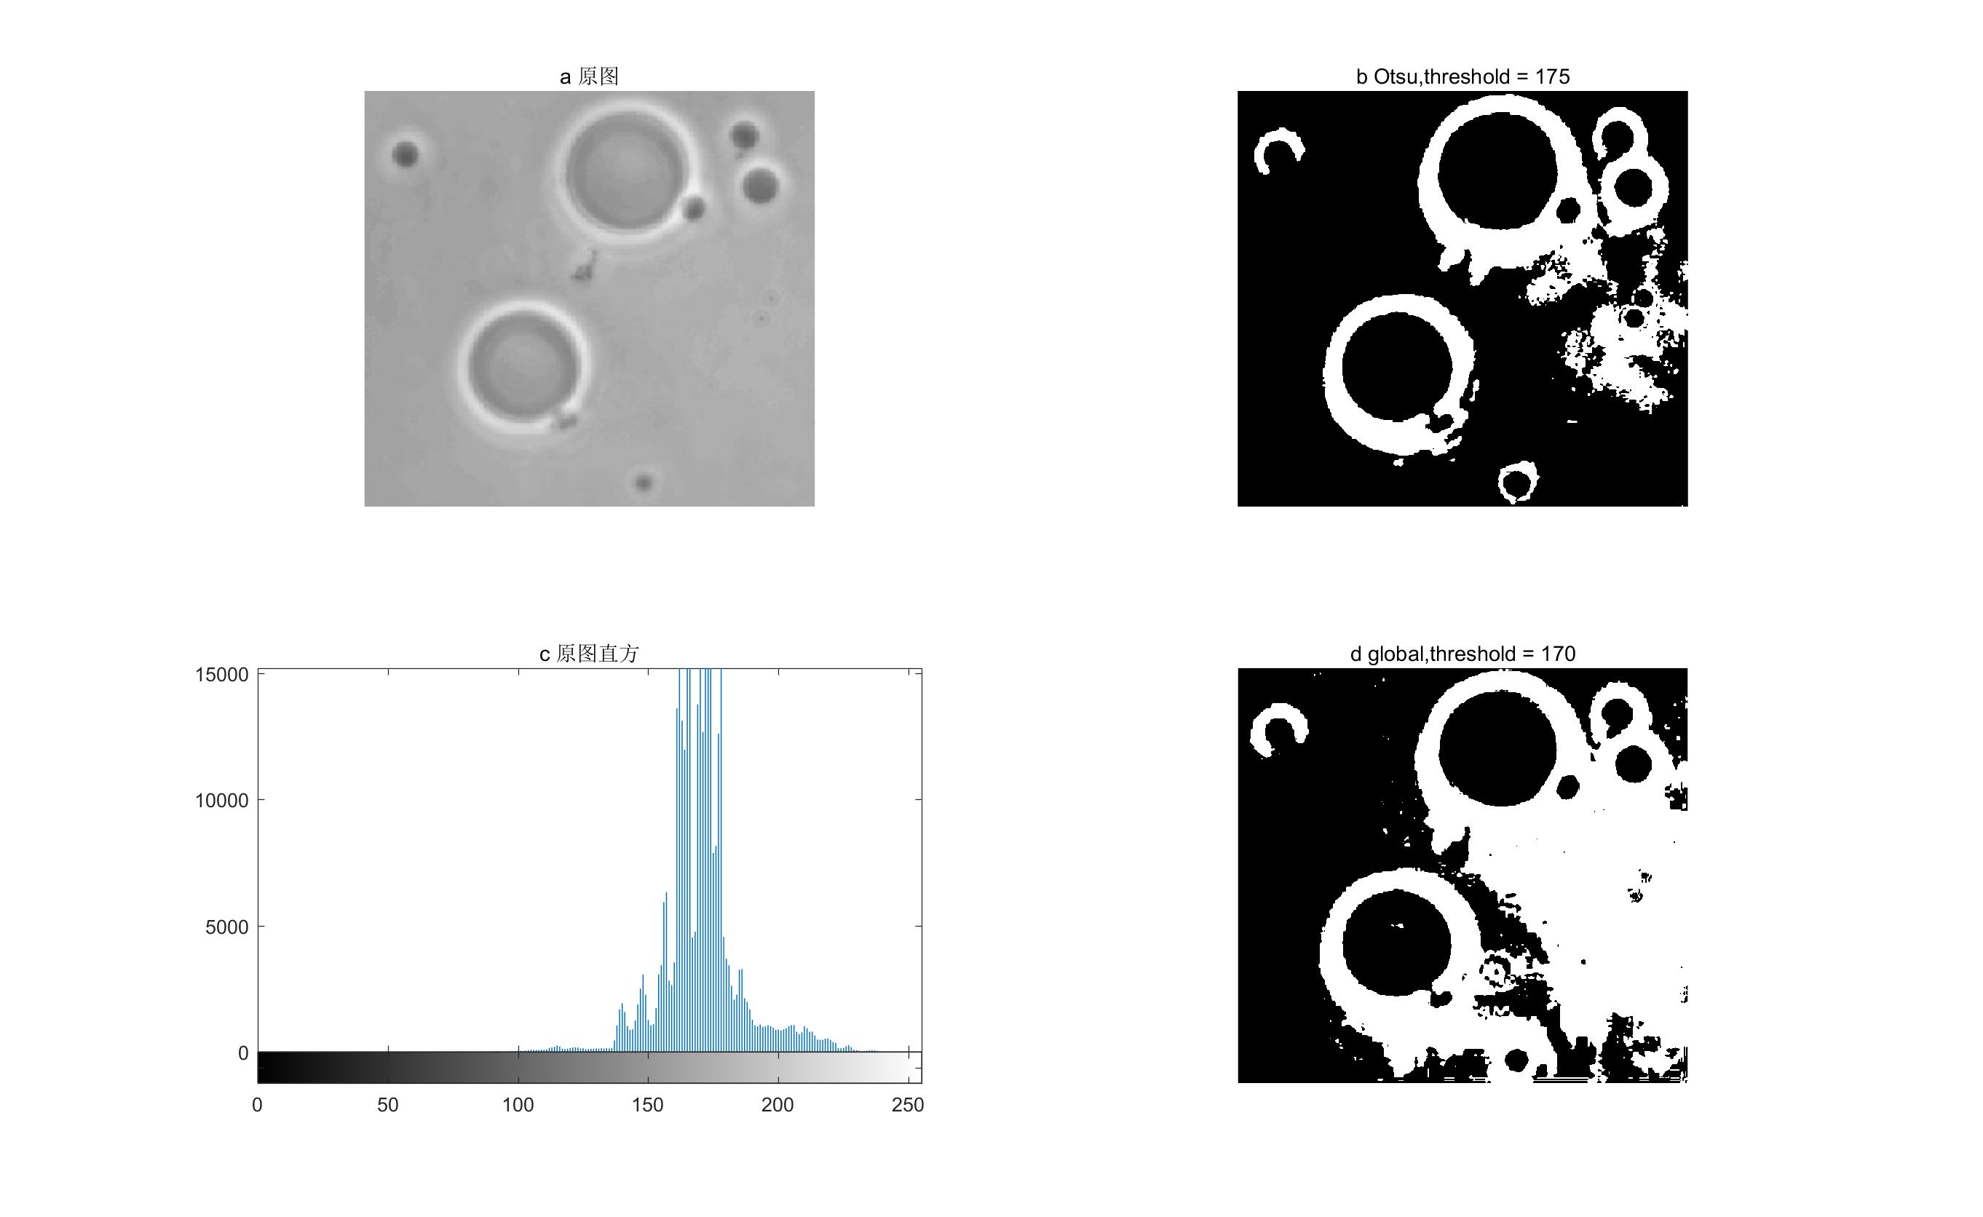

Figure 9.6 Original image ,image after Otus and Global thresholding segmentation