Lab2

Parameter estimation and modeling for cooling system:

After we got both heating and cooling data in Lab 2, both graphs of measured data indicate the property of exponential decay. Therefore we decided to make an assumption that both cooling and heating are first-order systems. In the case of cooling system, the plot of measured data displays an exponential decaying trend starting from around 50 to close to 32. In order to find the estimated time constant, we find the 63% value of (50-32), which is 11.34. So we find the time for the temperature drop down roughly 11 degrees, which is around 45 seconds. This gives us the pole of the transfer function at -1/45. Thus, chose the following first-order model for the cooling system.

$$T=Ae^{-t/τ}+b , where estimated A=20, τ=45, b=32$$

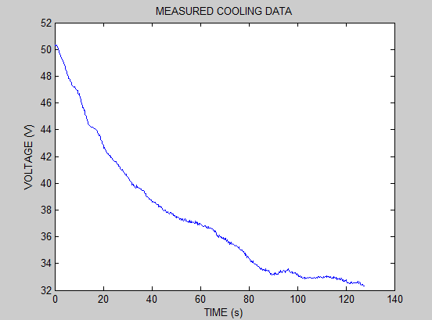

By using this model, we were able to get the following graph with both measured data and estimated data displayed. As shown in the graph, the model fits closely well at the beginning. But they start to diverge after 30 seconds. We thought it may be the offsite on time constant. To get a better model, we used *lsqcurvefit* in Matlab with the same model. It calculated better fitted parameters for A, b and time constant. The result is plotted in the same graph with measured and estimated data. From the graph, the enhanced model simulated the data very well, which also confirms our assumption at the beginning that the cooling system is a first-order system. The final time function of the cooling temperature is shown below.

$$T=18.59e^{-t/43.64}+31.49$$

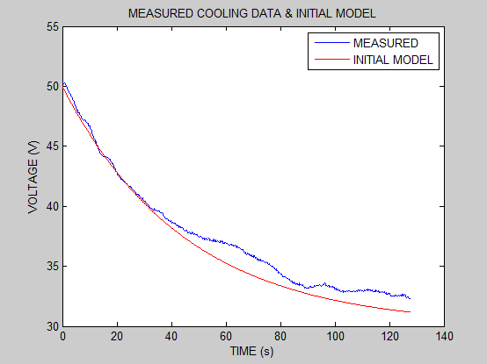

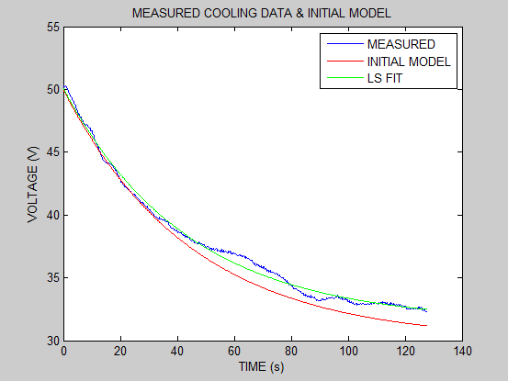

Parameter estimation and model for heating system:

Estimating heating system is very similar to that of cooling system. From the graph of the measured data, we noticed that the heating system shows a negative exponential decay. The data points stated at around 28 degrees and ended around 50 degrees. To find the time constant, we find the time takes the temperature to increase 63% of (50-28). We get roughly around 15 second. Thus, we chose the following first-order system to model the heating system.

$$T=A(1-e^{-\frac{t}{τ}})+b , where estimated A=22, τ=15, b=28$$

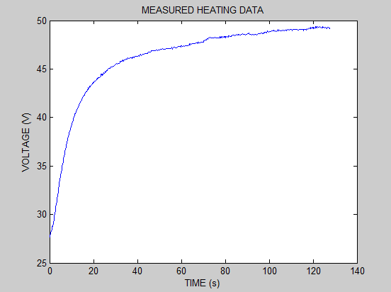

After we plotted both the estimated model and the measured data into the same graph, we find that the model tracing the data very well at the beginning but losing the accuracy after 20 seconds, just like it did in cooling system. Therefore, we used *lsqcurvefit* in Matlab again to get a better estimation. The time function of the temperature after lsqucurvefit is plotted with both first estimation and measured data. The function is shown below:

$$T=20.22(1-e^{-\frac{t}{14.77}})+28.22$$

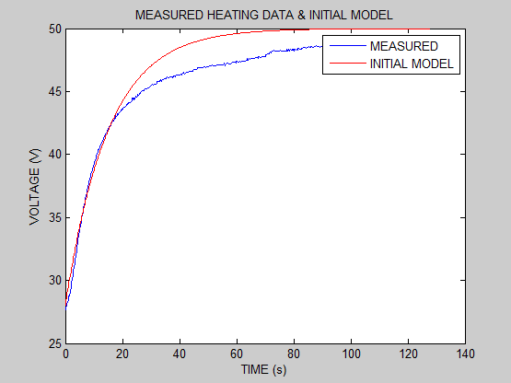

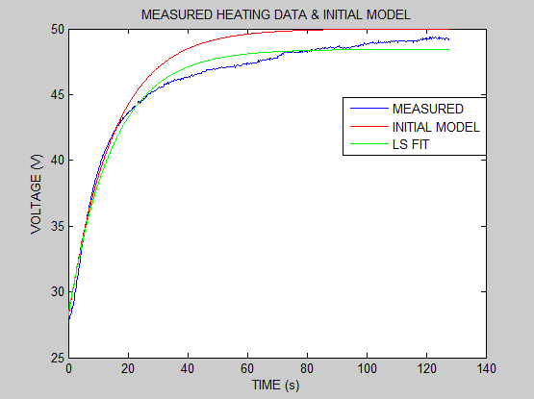

However, from the graph, we noticed that although the enhanced estimation improved the estimation, it’s still not close to the measured data. After consulted Prof. Kozick, we realized that the heating system may be a second-order system, since the measured data shows a fast decay at the beginning and a much slower decay after 20 seconds. Therefore, we changed the model to the second-system model and used a larger time constant for the second exponential decaying component. The magnitude A is divided into A1 and A2. The following is the new second-order model.

$$T=A1\left(1-e^{-\frac{t}{τ1}}\right)+A2\left(1-e^{-\frac{t}{τ2}}\right)+b ,$$

$$where estimated A1=15, A2=5, τ1=15, τ2=60, b=28$$

After gotten the initial estimated parameters, we used *lsqcurvefit* to improve them in Matlab. The estimated models are plotted with the measure data in the same graph. This time, the enhanced model is able to almost overlap the measured data. This confirms the assumption that the heating system is a second-order system instead of a first-order system. The time function of the temperature is shown below

