ENGR 240 – Science of Materials

Laboratory Report Grade Sheet

Names: Yifan Ge, Kaixiang You, Ahmed Mahmood

Lab Report Title: Patterning Using Photolithography

Format: (all of the following are worth 1 point per occurrence)

___ Report title, group member names, and date appear in that order, centered at top of page

___ Page setup: all margins 0.5”, 2 column format for all report text after title and authors

___ Text is left & right justified

___ All text 10 or 11 pt. font, single spacing

___ All table titles and figure captions are 9 - 10 pt. font (one font size smaller than text), bold

___ All tables have titles (above)

___ All figures have captions (below) and NO TITLES

___ Pages are numbered, bottom center

___ All sections have appropriate headings (as listed in rubric)

___ Headings immediately precede corresponding section (not split bottom/top of next page)

___ Significant figures are consistent

___ Plots/Tables have error bars/report standard deviation (when appropriate)

___ All values have appropriate units

___ Non-breaking space used between values and units (hold ctrl-shift-space simultaneously)

___ Symbols for units used where appropriate

___ No constants in tables (e.g., π or common sample dimension)

___ Table column headings contain units

___ Table column headings contain common multipliers (exponents, etc.)

___ Figure axes are labeled

___ Figure axes contain units

___ Figure axes contain common multipliers or log scale if appropriate

___ Figures have white background

___ Each data set in a figure is clearly marked and easily distinguishable

___ Table and figures appear intact and are not split at the bottom/top of next page

___ Consecutive tables and figures do not contain redundant information

___ Limited use of personal pronouns

___ Limited use of direct quotes from the textbook

___ Experimental values are compared to values reported in the literature (when appropriate)

___ Proper use of Appendices

___ Style (scale of 1 to 4)

=___/28

Content: (each of the following is out of 4 points)

Abstract ___ x 1 = ___

Introduction ___ x 2 = ___

M&M ___ x 3 = ___

Results ___ x 4 = ___

Discussion ___ x 5 = ___

Conclusions ___ x 2 = ___

References ___ x 1 = ___

___/72

**LAB 5: Patterning Using Photolithography**

Members: Ahmed Mahmood, Kaixiang You, Yifan Ge

Date: September 28, 2010

**Abstract:-**

In this experiment we learned about Photolithography using a negative tone photo-resist. We found that upon exposure to Ultra-Violet (UV) light, the UV curable adhesive polymerizes and cross-links, thereby displaying the pattern on the photo mask.

**Introduction:-**

Photolithography is a process by which a specific pattern is transferred onto a substrate. The pattern is on a film, called photo mask. The substance that gets cured is called the photoresist, and in our experiment this was a UV curable adhesive, meaning, it would harden upon exposure to UV light, which is let through the photo mask. We used glass substrate. Substrate is the substance to which the photoresist adheres to, and it was transparent, so as to let the UV light pass through it. The adhesive is UV sensitive meaning it hardens upon exposure to UV light. We experimented with varying intensity of UV light and by increasing the time that the photoresist was left exposed to UV light.

**Materials and Methods:-**

We first turned on the UV light and let it warm up for some time. Three glass slides were then obtained and cleaned with ethanol and acetone. Slides must be clean of any fingerprints as these would disrupt the UV light and affect our pattern on the photoresist. They were then dried and cleaned with Oxygen-Plasma cleaner. The adhesive was NOA-81 and it was put in a cap/gasket until full. Glass slide was placed diagonally so as not to let any air bubbles in it. The photo mask was place on the top side of the slide and the whole setup placed under the UV light. We noted the UV light intensity for each experiment and used different time for exposure. After the pre-determined time, we removed the setup, took the slide off the gasket and cleaned off the excess adhesive, dried and cleaned with acetone/ethanol. Finally, they were left to harden in air.

**Results:-**

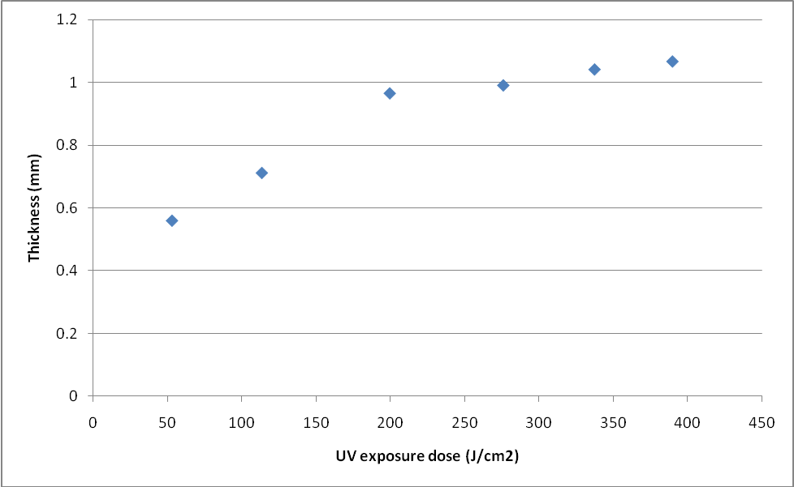

**Figure 1. Thickness versus UV exposure dose.**

**Discussion:-**

From the results data, we can clearly discover that the thickness of the pattern increases along with the increment of UV exposure dose. Also, in Figure 1, the slope of thickness vs. UV exposure dose decreases as UV exposure dose increases. Hence, the increment of UV exposure dose will decrease the effectiveness of the polymerization.

**Conclusion:-**

* The thickness of the pattern increases as UV exposure dose increases.
* The effectiveness of polymerization decreases as UV exposure dose increases.

**Appendix:-**

**Table 1. Data collected from Lab.**

|  |  |  |  |
| --- | --- | --- | --- |
| Time (s) | Intensity (mW/cm2) | UV exposure dose (J/cm2) | Thickness (mm) |
| 50 | 1055 | 52.75 | 0.5588 |
| 100 | 1133 | 113.3 | 0.7112 |
| 150 | 1330 | 199.5 | 0.9652 |
| 200 | 1380 | 276 | 0.9906 |
| 250 | 1350 | 337.5 | 1.0414 |
| 300 | 1300 | 390 | 1.0668 |

UV exposure dose (J/cm2) = UV exposure intensity (mW/cm2) UV exposure time (s)

