**Memorandum**

**To:** Prof. Kozick

**From:** Yifan Ge, Ahmed Mahmood

**Date:** April 18, 2011 2:00pm

**Subject:** ELEC 226 – Lab #6: Design of a Waveform Generator

**Objective**

In this lab, we used our knowledge of circuits to design a system that will generate square, triangle, and sine waves with variable amplitude and variable frequency.

**Design**

In order to achieve the goal, we first investigated an op-amp clock circuit (Figure 1). This circuit can generates both square wave and triangle wave signals depending on where we place the probe. After observation, we decided to use an integrator to integrate the triangle wave to get the sine wave.

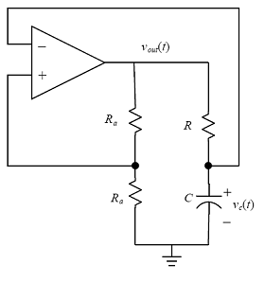

***Vc***

***Rb***

**Figure 1.** Op-amp Clock circuit

**Square Wave**

In the op-amp clock circuit, since the op-amp is acting as an comparator, it compares the value of VRb and the value of Vc. Thus, the Vout is oscillating between +Vcc and –Vcc, as the capacitor is charging and discharging. Therefore, we can simply collect signal from Vout to be our squarewave signal.

**Triangle Wave**

In the op-amp clock circuit, as the capacitor is charging and discharging, the Vc displays a sawtooth wave. In order to make the sawtooth wave look like a triangle wave, we need to decrease the charging time of the capacitor. One way of doing this is to increase the ratio of Ra/Rb, which gives VRb a smaller value. This will decrease the time for capacitor charge up to VRb. However, because the op-amp’s constraint on the output current. The total resistance Ra+Rb need to be around 500Ω. So we picked Ra = 470Ω and Rb = 47Ω. This gave us a good triangle wave at Vc.

**Sine Wave**

Our original idea was to adding a integrator right after the output from Vc. However, two problems happened. The signal came from Vc is no long a triangle wave and the amplitude of the integrated wave is too small. Therefore, we added a inverting amplifier between the integrator circuit and the output from Vc. This modification eliminated the interference and increased the amplitude of the sine wave.

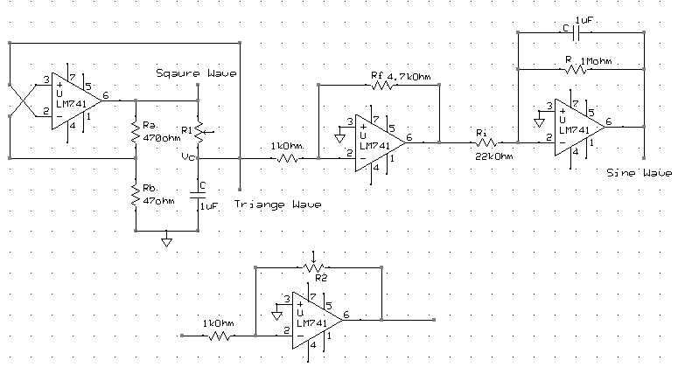

**Figure 2. Circuit diagram for the wave generator (R1 controls frequency and R2 controls amplitude)**

**More Modifications**

We also modified the integrator. By adding a paralleled resistor with the capacitor, it prevents the capacitor from charging up slowly due to the small current goes into the op-amp.

**Frequency and Amplitude Range**

|  |  |  |  |  |
| --- | --- | --- | --- | --- |
| waves | Frequency Min(Hz) | Frequency Max (Hz) | Amplitude Min(V) | Amplitude Max (V) |
| Square | 169 | 1350 | 0 | 13.6 |
| Triangle | 100 | 2100 | 0 | 1.35 |
| Sine | 2050 | 28570 | 0 | 1.2 |

**Table 1. Measured Frequency and Amplitude Range for waves**

**Increasing the Frequency Range**

In order to increase the frequency range, we can decrease the capacitor value. As the capacitor determines period of the waves, by decreasing the capacity, we can decrease the charging period. Thus, this will widen the frequency range to a higher range.