**Memorandum**

**To:** Prof. David Kelley

**From:** Yifan Ge, Brandon Walls

**Date:** September 30, 2010 8:00am

**Subject:** ELEC 225 – Lab #3: Inverting Amplifier with T-Bridge Feedback Network

**Introduction:**

This lab was aimed at stimulating more realistic environments for circuits and to understand potential effects of these environments to circuits. To test out how environmental factors can affect a circuit we put together an op-amp in a high gain analog amplification application shown in Figure 1 (from ELEC 225 Lab #3 handout for Fall 2010 by Prof. Kelley). Once built, we could vary the resistance of the resistors (via our fingers across the resistors) used in the op-amp circuit, simulating environmental changes. We will take note of the variability of the gain while changing the environment, and use this as a standard. We can then build the T-bridge amplifier circuit and compare it to the standard circuit. The T-bridge amplifier shown in Figure 2 (from ELEC 225 Lab #3 handout for Fall 2010 by Prof. Kelley) would act exactly the same under normal circumstances as our original circuit, however it should prevent large changes in gain regardless of environmental changes.

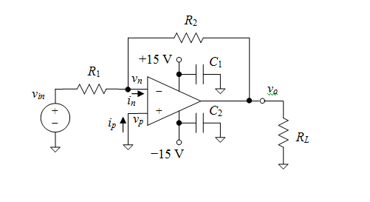

**Figure 1. Standard inverting amplifier circuit**

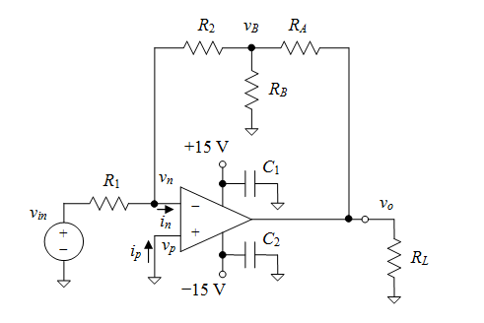

**Figure 2. Inverting amplifier with a T-bridge feedback network**

**Analysis of Standard Inverting Amplifier Circuit**

The primary goal was to build the standard inverting amplifier circuit, which is shown in Figure 1, and determine how the environment affects the output of the circuit. In order to build the circuit, we need to find values for each element. From the lab handout, we have the input resistor, *R1* = 150 kΩ; *RL* is an arbitrary load resistor; *C1* and *C2* are in the 0.1-0.5 µF range; and the closed-loop voltage gain, *G*, is -60 (±5%). So the only element left with unknown value is *R2*. We used nodal analysis to find the value of *R2*.

KCL at node *vn*,

**(Eqn1)**

Because the circuit has negative feedback, we can assume that a virtual short exists across the op-amp’s input terminals, *vn* = *vp* = 0 V. And from the properties of op-amps, we can get that *in* ≈ 0 A. So, **Eqn1** can be written as

$\frac{v_{in}}{R_{1}}=-\frac{v_{o}}{R_{2}}$

As $=\frac{v_{o}}{v_{in}}=-60$, we have $-60=\frac{v_{o}}{v_{in}}=-\frac{R_{2}}{R_{1}}=-\frac{R_{2}}{150kΩ}$

Hence, *R2* = 9 MΩ.

In our experiment, we have

*R1* = 148 kΩ, *R2* = 9.05 MΩ, *C1* = *C2* = 0.220 µF

In order to use a small-amplitude input signal to avoid driving the amplifier into saturation, we used the voltage-divider circuit shown in Figure 3 (from ELEC 225 Lab #3 handout for Fall 2010 by Prof. Kelley).

5.1 k

**Function**

**Generator**

output

jack

(*Rth* = 50 )

51 

to left side of *R*1

to ref. node

+

*vin*

−

**Figure 3. Voltage divider used for small-amplitude input signal.**

In the experiment, we got *vin,pp-measured* = 166 mV, and *vo,pp-measured* = 10 V.

Thus, ${|G}_{measured}|=\frac{v_{in,pp-measured}}{v_{o,pp-measured}}=\frac{10}{0.166}≈60.24$

Since the waves are inverted on the oscilloscope shown in Graph 1, the measured closed-loop gain is close to -60, which verified our calculations. After we built the circuit, we put fingers across *R2* and *R1*, respectively. When we place fingers across R2, *vo* decreased dramatically from 10 V to 1.1 V shown in Graph 2. When our figures are across *R1*, *vo* slightly went up shown in Graph 3. These effects can be explained by the equation:

$v_{o}=-\frac{R_{2}}{R_{1}}v_{in}$

When our fingers are across *R1*(*R2*), the actual *R1* (*R2*) is the equivalent resistance of the paralleled resistor R1 (R2) and our fingers, which is smaller than original *R1* (*R2*). As *R2* and *R1* both have very large resistance, the resistance of our fingers can significantly decrease the actual *R1*(*R2*) value.

As *R2* decreased, *vo* decreased, which caused *vo* dropped from 10 V to 1.1 V. As *R1*­ decreased, *vo* increased, which caused the slight increment of *vo* during the experiment.

**Analysis of Inverting Amplifier with a T-bridge Feedback Network**

The primary goal was to design the T-bridge circuit and observe the differences between the T-bridge inverting amplifier and standard inverting amplifier under environmental changes. To build the circuit, we need to find out the values for *RA*, *RB* and *R2*. In this case, we used the **Eqn2** (from ELEC 225 Lab #3 handout for Fall 2010 by Prof. Kelley).

$\frac{v_{o}}{v_{in}}=-\left(\frac{R_{A}}{R_{2}}+\frac{R_{A}}{R_{B}}+1\right)\frac{R_{2}}{R_{1}}$**(Eqn2)**

As we need the close-loop gain to be -60,

$-\left(\frac{R_{A}}{R_{2}}+\frac{R_{A}}{R_{B}}+1\right)\frac{R_{2}}{R_{1}}=-60$**(Eqn3)**

Since *RB* has to be at least 1 kΩ, we made *RB*= 1 kΩ. In order to prevent these resistors from having large resistance, we chose *RA* = 100 kΩ, which made $\frac{R_{A}}{R_{B}}$ = 100. Solving **Eqn3,** we got *R2* = 89 kΩ.

In our experiment, we had

*RA* = 98.1 kΩ, *RB* = 0.986 kΩ, *R2* = 89.5 kΩ

From the oscilloscope, we got *vo,pp-measured* = 10.0 V, *vin,pp-measured* = 0.166 mV. So |*Gmeasured* |= 60.42, which verifies our calculations.

Then, we put our fingers across *R2*, *RA*, and *RB*, respectively. When fingers were across *R2* and *RA*, *vo* slightly dropped shown in Graph 4 and Graph 5. And when fingers were across *RB*, no noticeable change happened shown in Graph 6. From this we can see, T-bridge feedback network significantly prevented the effects from the environment. No rapid changes happened when fingers were across each resistor in the feedback network. On the other hand, the output voltage of standard inverting amplifier changed rapidly when fingers were across R2.

Finally, we changed the amplitude of the function generator’s signal until half of the waveform is clipped shown in Graph 7. The positive clipping level is 14.31 V. And the negative clipping level is -12.81V. Since *vo* = -60*vin*, we have the maximum value of *vin* is $\frac{-12.81×2}{-60}=427 mV$.

**Conclusion:**

So through our experiments with both circuits, and similar resistance variations to simulate non-optimal circuit conditions, we found that the T-bridge amplifier was a much more robust amplifier. Taking note of the attached supply and amplification voltage graphs it's easy to see that the normal amplifier circuit was extremely vulnerable to small variations in resistance. However, the T-bridge was much more consistent even with variations in resistance.

**Attachments:**

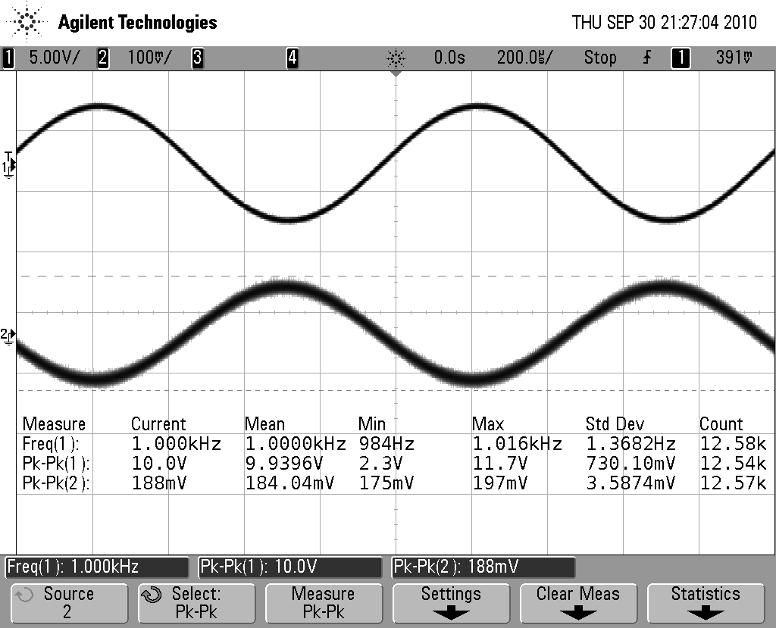

**Graph 1. Normal conditions standard inverting amplifier**

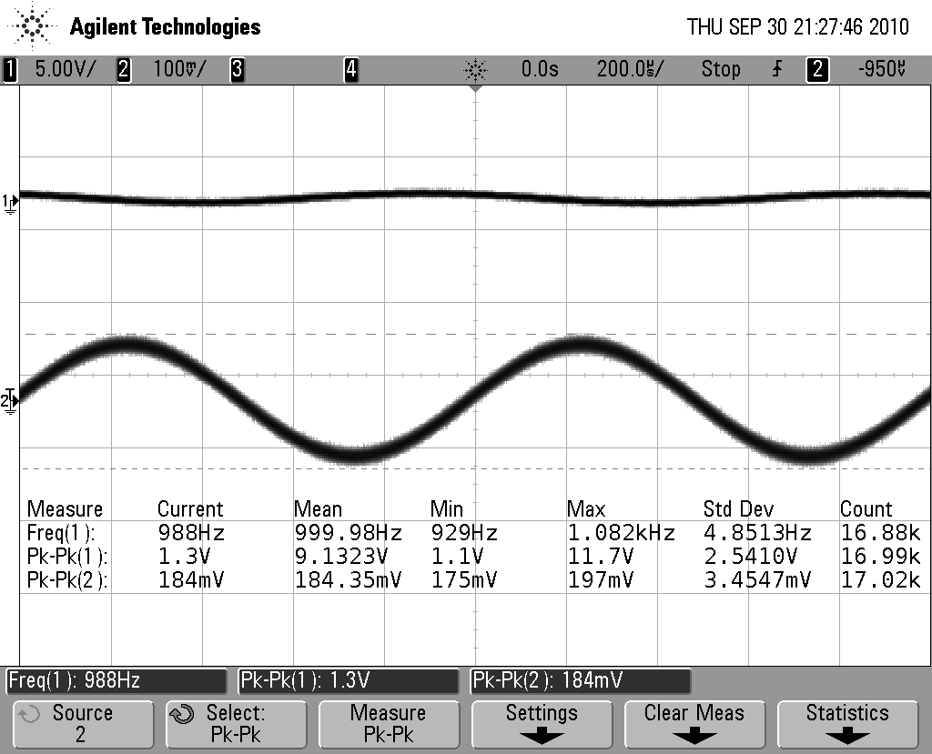

**Graph 2. Fingers across R2 for standard inverting amplifier**

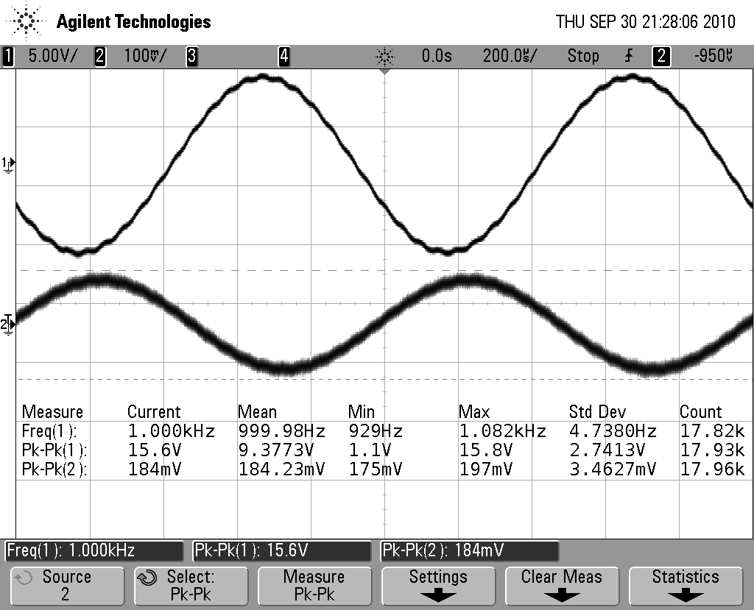

**Graph 3. Fingers across R1 for standard inverting amplifier**

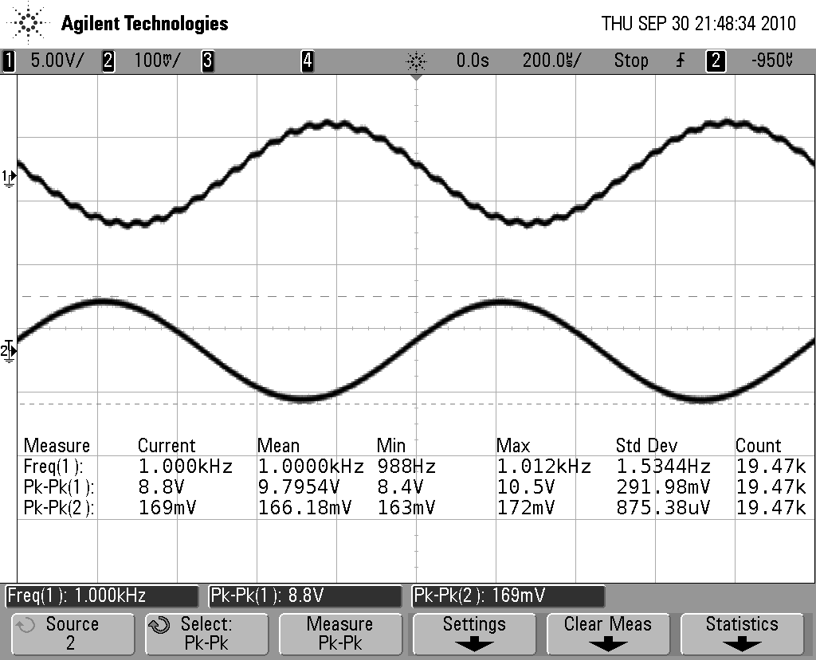

**Graph 4. Fingers across R2 for T-bridge inverting amplifier**

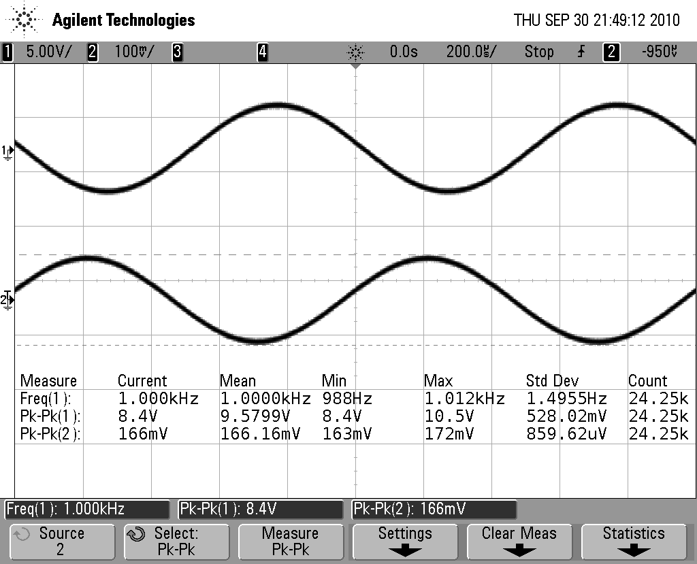

**Graph 5. Fingers across RA for T-bridge inverting amplifier**

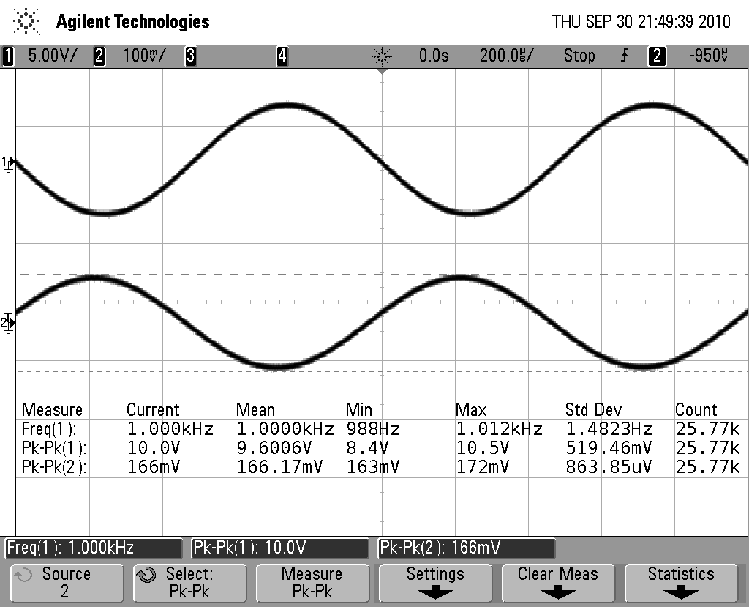

**Graph 6. Fingers across RB for T-bridge inverting amplifier**

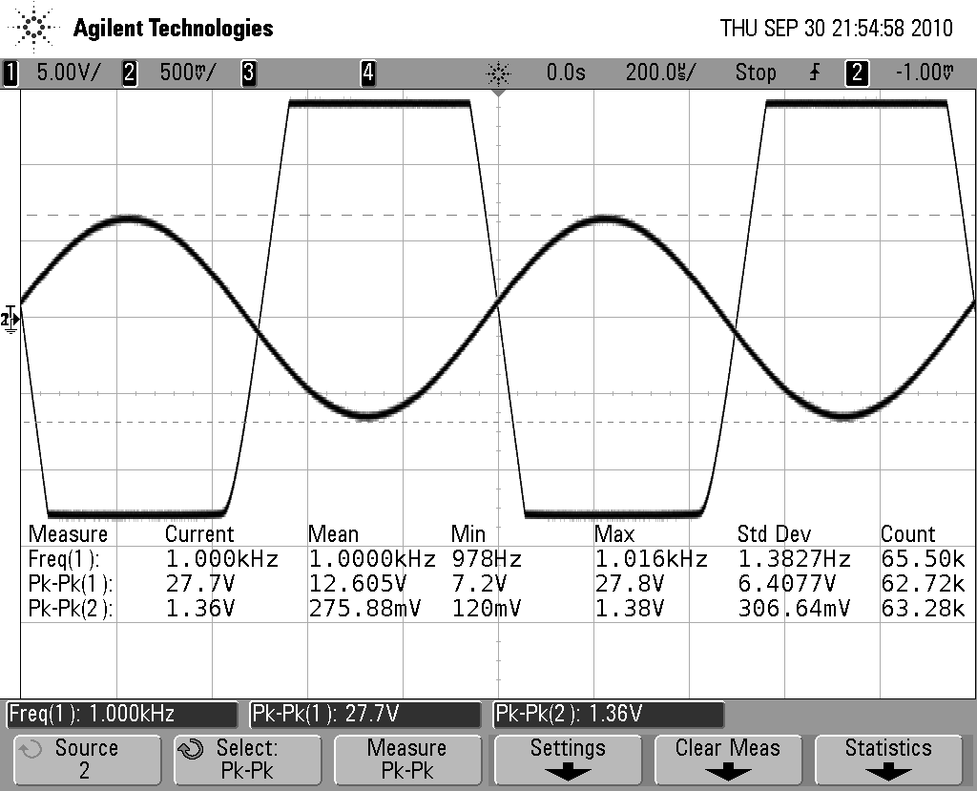

**Graph 7. Saturation of T-bridge inverting amplifier**