**Memorandum**

**To:** Prof. David Kelley

**From:** Yifan Ge, Brandon Walls

**Date:** October 28, 2010 8:00am

**Subject:** ELEC 225 – Lab #5: Resonant Circuits in the Real World

**Introduction**

In this lab we were experimenting with capacitors and inductors driven by a function generator in order to observe realistic properties of these in series. Since all electronic components are imperfect, there is no simple behavior of each component in a realistic setting. In order to make circuits such as these work, knowledge of realistic properties are needed in order to understand and predict behavior of combinations of such components. With the knowledge of how to make these imperfect components work together, devices such as filters and signal sources can be constructed. Also, these components are also used in almost every circuit today which is why this knowledge is essential. We will also incorporate resonance in order to determine at what frequency the two impedances cancel each other out.

**Theoretical Background**

In this lab we were also introduced to some concepts that we will learn more about later. We learned a little about different types of capacitors and forms. We also were introduced to the phenomenon called the skin effect, where in sinusoidal current flows closest to the surface of the wire. Moreover, that the frequency of the current affects how thin that current layer is. So in higher frequencies the layer actually is much thinner making a much higher wire resistance, and vice versa.

+

**V***RL* −

+

**V***C* −

*C*

TEC of function generator

*L*

and

*Rw*

+

**V***RLC*

−

+

−

*Rth* = 50 

**V***th*

**Figure 1.** **Series LC circuit driven by a function generator**

**Determine $R_{w}$ Value in Different Frequencies**

In order to get the resistance of $R_{w}$ indirectly, we have to design a circuit shown in Figure 1 (from ELEC 225 Lab #3 handout for Fall 2010 by Prof. Kelley) and make the sum of the impedances of *C*, *L* equal to 0. So we can use voltage divider formula to find the impedance of $R_{w}$, which is equal to its resistance. As $Z_{C}=\frac{1}{jwC}$ and $Z_{L}=jwL$, $Z_{C}+Z_{L}=0$ can be written as

🡺

Hence, $f_{o}=\frac{w_{o}}{2π}=\frac{1}{2π\sqrt{LC}}$. From this equation, we can derive an expression for *C*,

$$C=\frac{1}{4π^{2}f_{o}^{2}L}$$

In this experiment we have frequencies at $f_{1}=100 Hz, f_{2}=1 kHz, f_{3}=10 kHz, f_{4}=100 kHz.$ Since $f_{o}$ and *L* were given, we calculated the value for *C* in different resonant frequencies. So we get $C_{1}=253 uF, C_{2}=2.53 uF, C_{3}=0.0253 uF, C_{4}=0.000253 uF.$

After we built the circuit, we used oscilloscope to measured the voltage of $V_{RLC}$. In order to get the precise resonance frequency, we adjusted the function generator to get the lowest voltage across RLC, which indicated the cancellation of $Z_{C}$ and $Z_{L}$. As the equivalent impedance of the RLC is equal to the resistance of $R_{w}$, we implemented voltage divider to the circuit, which gave us the following equation.

$$V_{RLC}=\frac{R_{w}}{R_{w}+R_{th}}V_{th}$$

From this equation, we can derive an express of $R_{w}$ in terms of $V_{th}$, $V_{RLC}$, and $R_{th}$.

$$R_{w}=\frac{R_{th}V_{th}}{V_{th}-V_{RLC}}-R_{th}$$

After substituting the values of $V_{th}$, $V_{RLC}$, and $R_{th}$, we were able to determine the value of $R_{w}$ at different resonance frequencies. The detailed measured and calculated results are shown in Table 1.

From the both Table 1 and Figure 2, we can observe that the inductor wire resistance changes with the frequency.

**Measure the Voltage across the Capacitor**

In order to measure the voltage across the capacitor, we have to do it indirectly. This is because the nature of the oscilloscope and function generator. Since the ground probe of the oscilloscope and the ground in the function generator share the same common ground, if we had used the oscilloscope to measure the voltage directly, then both ends of the inductor would be connected to the same ground, which would short the inductor. This will change the voltage across the capacitor.

In this experiment, we chose the resonant frequency to be 9.9 kHz. We used channel 1 of the oscilloscope to display the VRLC and channel 2 of the oscilloscope to display the VRL as shown in Graph 1. Then we used the differential measurement feature of the oscilloscope to measure the voltage across the capacitor as shown in Graph 2. From the results, we noticed VL,pp = VC,pp = 71.25 V. And they are almost out of phase with each other. One factor that keep the two from being completely out of phase could be from the error in the resonant frequency. The other factor could the interference from the capacitance in the probe.

**Data Summary**

We gathered a large amount of data during this lab exercise, and they are organized in Table 1 below. The table shows the calculated results for the capacitor at different resonant frequencies and resistance of the wire in the inductor. We also included the measured data for adjusted resonant frequencies and voltages across RLC.

**Table 1. Calculated and measured data**

|  |  |  |  |  |
| --- | --- | --- | --- | --- |
| L = 10mH | Vth = 10V | Rth = 50Ω |  |  |
|  |  |  |  |  |
| fo (Hz) | C (uF) | fo,measured (Hz) | VRLC (V) | Rw (Ω) |
| 100 | 253 | 110 | 3.38 | 25.53 |
| 1000 | 2.53 | 980 | 3.56 | 27.64 |
| 10000 | 0.0253 | 9980 | 4.06 | 34.18 |
| 100000 | 0.000253 | 97320 | 8.07 | 209.07 |

**Figure 2. Inductor Wire Resistance vs. Frequency**

**Conclusion**

So, we used the resonant frequency of some C and L which we found as seen above in Table 1, and then we found an extremely close estimate of the frequency that this was achieved. Also from the results, we discovered that the wire resistance in the inductor varies with frequency. Since the circuit was operating at the resonant frequency we could assume the total impedence of Z­L and ZC was 0. Knowing this, when we measured the total impedence across the inductor and capacitor, we could assume the only impedence left was the Rw or the resistance in the inductor, allowing us to indirectly measure the voltage across the capacitor.

**Attachment:**

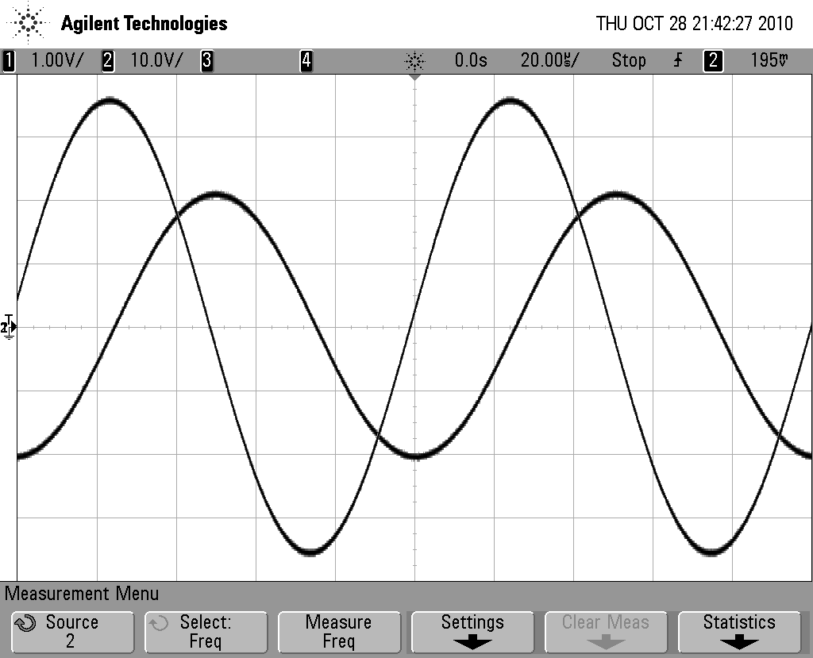

VL

VRLC

**Graph 1. VRLC and VL**

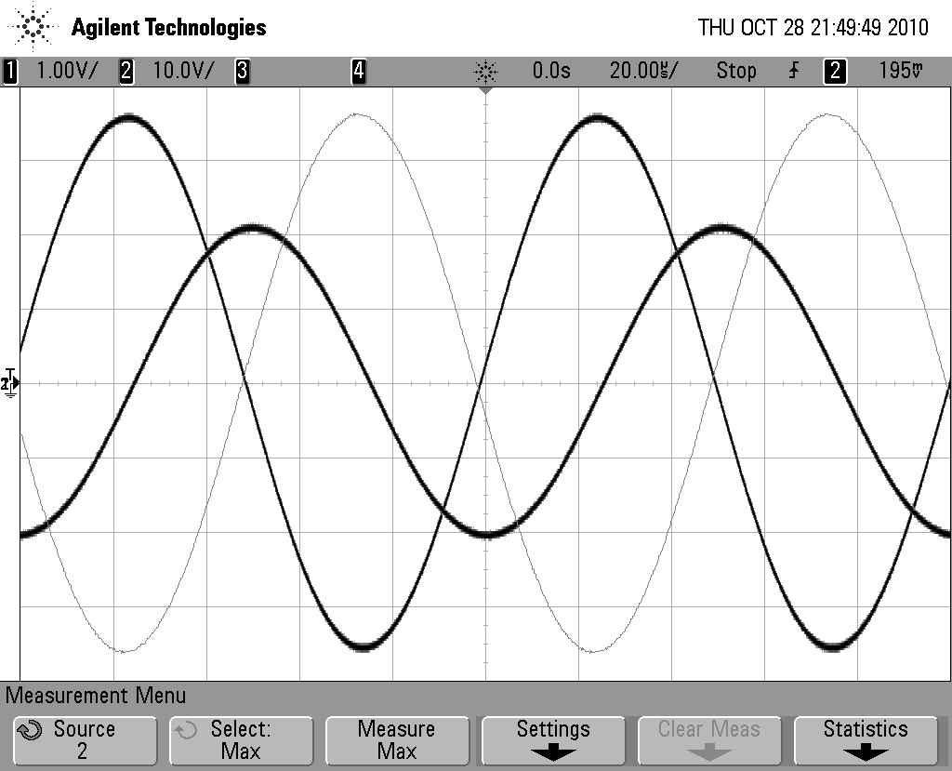

VRLC

VL

VC

**Graph 2. VRLC , VL** , **and VC**