1.Introduction
1.1 Purpose:
The purpose of this project is to develop an integrated Gym and Online Coaching Management System designed to simplify gym operations and enhance both in-person and remote training experiences.

The system enables gym owners and coaches to efficiently manage memberships, payments, schedules, and client progress. At the same time, members can access personalized workout and nutrition plans, track their fitness progress, and communicate directly with their assigned trainers through the system.

A unique feature of this project is the inclusion of an AI-powered chatbot that assists both coaches and members by providing instant answers related to workout routines, diet recommendations, and training guidance — making the system more interactive and intelligent.

Additionally, the system incorporates an e-commerce module that allows users to purchase gym equipment, supplements, and protein products directly from the platform. This not only expands the business opportunities for the gym but also provides convenience for users seeking professional-grade products.

In summary, the system aims to serve as a complete digital ecosystem for gym management, online coaching, and fitness e-commerce, improving efficiency, engagement, and accessibility for all users.

1.2 Document Conventions
This document follows the IEEE SRS standard formatting style.
All section titles are written in bold with numeric headings (e.g., 1.1, 2.1, etc.).
Technical terms, APIs, and technologies (such as React.js, ASP.NET API, and SQL Server) are written in italic.
Functional and non-functional requirements are labeled with unique identifiers (e.g., REQ-1, REQ-2).
Diagrams such as UML, ER, and Use Case models are created following UML 2.0 standards

1.3 Intended Audience and Reading Suggestions
This document is intended for various stakeholders involved in the design, development, and operation of the Gym and Online Coaching Management System.
Intended Audience:
- Project Manager: To understand the overall project scope, objectives, and deliverables.
- Developers and Designers: To refer to the detailed functional and non-functional requirements, database structure, and UI/UX design considerations.
- Quality Assurance (QA) Team: To identify testing criteria, performance expectations, and validation of requirements.
- Gym Owners and Coaches: To gain insight into how the system supports daily operations, client management, and online coaching activities.
- End Users (Gym Members): To understand the key system functionalities such as registration, progress tracking, and communication with trainers.
Reading Suggestions:
- Readers new to the project should start with Section 1: Introduction to understand the system’s purpose and key features.
- Section 3: Overall Description provides a high-level view of the system architecture and user interactions.
- Section 4: System Features details each functional and non-functional requirement.
- Technical readers (developers, testers) should pay close attention to the UML Diagrams and Database Design sections for implementation details.
- Non-technical readers (stakeholders, gym owners) may focus on the overview, use cases, and system benefits sections to understand business value.

1.4 Product Scope
The Gym and Online Coaching Management System aims to provide an all-in-one digital platform that integrates gym management, online personal training, and e-commerce functionalities.
The primary goal of this product is to simplify administrative tasks, enhance member engagement, and bridge the gap between physical gym services and virtual coaching experiences.
The system allows gym owners and staff to manage memberships, track payments, handle trainer schedules, and monitor business performance in real time.
Trainers and coaches can create personalized workout and nutrition plans, monitor client progress, and communicate directly through built-in chat and video features.
Members benefit from convenient access to their personalized fitness dashboards, progress tracking tools, and AI-powered recommendations to improve workout efficiency.
In addition, the platform includes an AI chatbot that offers intelligent assistance regarding workouts, nutrition, and general fitness inquiries — making the system more interactive and user-friendly.
The integrated e-commerce module enables users to browse and purchase gym-related products, supplements, and fitness equipment, adding a commercial dimension to the system.
Overall, the product is designed to:
- Enhance operational efficiency for gyms and trainers.
- Improve user experience through digital engagement and smart automation.
- Provide scalable online coaching tools accessible from anywhere.
- Support business growth through integrated e-commerce and data-driven insights.
1.5 References
- IEEE Std 830-1998, IEEE Recommended Practice for Software Requirements Specifications, IEEE Computer Society, 1998.
→ (Used as a guideline for structuring and organizing this SRS document.)
- Cockburn, Alistair. Writing Effective Use Cases. Addison-Wesley, 2000.
→ (Used for formatting and describing use case scenarios.)
- Object Management Group (OMG). UML 2.0 Specification.
Available at: https://www.omg.org/spec/UML/2.0
→ (Used as the standard for creating UML diagrams and models.)
- Microsoft Documentation. ASP.NET Core Web API Guide.
Available at: https://learn.microsoft.com/en-us/aspnet/core/web-api
→ (Referenced for backend development and API design.)
- React.js Official Documentation.
Available at: https://react.dev/
→ (Referenced for frontend UI/UX development.)
- Microsoft SQL Server Documentation.
Available at: https://learn.microsoft.com/en-us/sql/
→ (Referenced for database design and management.)
- OpenAI Documentation.
Available at: https://platform.openai.com/docs
→ (Used for integrating AI-based chatbot functionalities.)
- Gym and Fitness Industry Reports (2024).
Available at: https://www.statista.com/
→ (Used for understanding user needs and market trends in the fitness industry.)

2. Overall Description
2.1 Product Perspective

The Fit-Track System is a new, fully integrated web-based and mobile-enabled platform designed to manage gym operations, online coaching, and fitness-related e-commerce activities within a unified ecosystem.

It is not an extension of any existing system, but rather a standalone solution that combines three core modules:

  - Gym Management Module – Handles memberships, subscriptions, trainers, and schedules.

  - Online Coaching Module – Enables remote workout and nutrition planning, progress tracking, and communication between coaches and clients.

  - E-Commerce Module – Allows users to browse and purchase fitness equipment, protein products, and supplements directly from the platform.

The system operates as a client-server architecture, where:

The Frontend (React.js and React Native) provides interactive web and mobile user interfaces.

The Backend (ASP.NET Core Web API) manages business logic, authentication, and data processing.

The Database (Microsoft SQL Server) stores user data, workout logs, product details, and transaction records.

The AI Chatbot (OpenAI API integration) serves as an intelligent assistant that interacts with both coaches and members, providing personalized fitness tips, answering nutrition questions, and automating basic support requests.

Additionally, the platform communicates with external payment gateways (Stripe/PayPal) for secure online transactions and supports JWT-based authentication to ensure data security and privacy.

A high-level view of the Fit-Track ecosystem can be summarized as follows:

Users (Admin, Coach, Member) → interact via Web/Mobile UI (React.js / React Native) → send requests to ASP.NET Core API → data stored in SQL Server → AI queries handled through OpenAI API → optional connection to Payment Gateway APIs.
Here System Context Diagram:

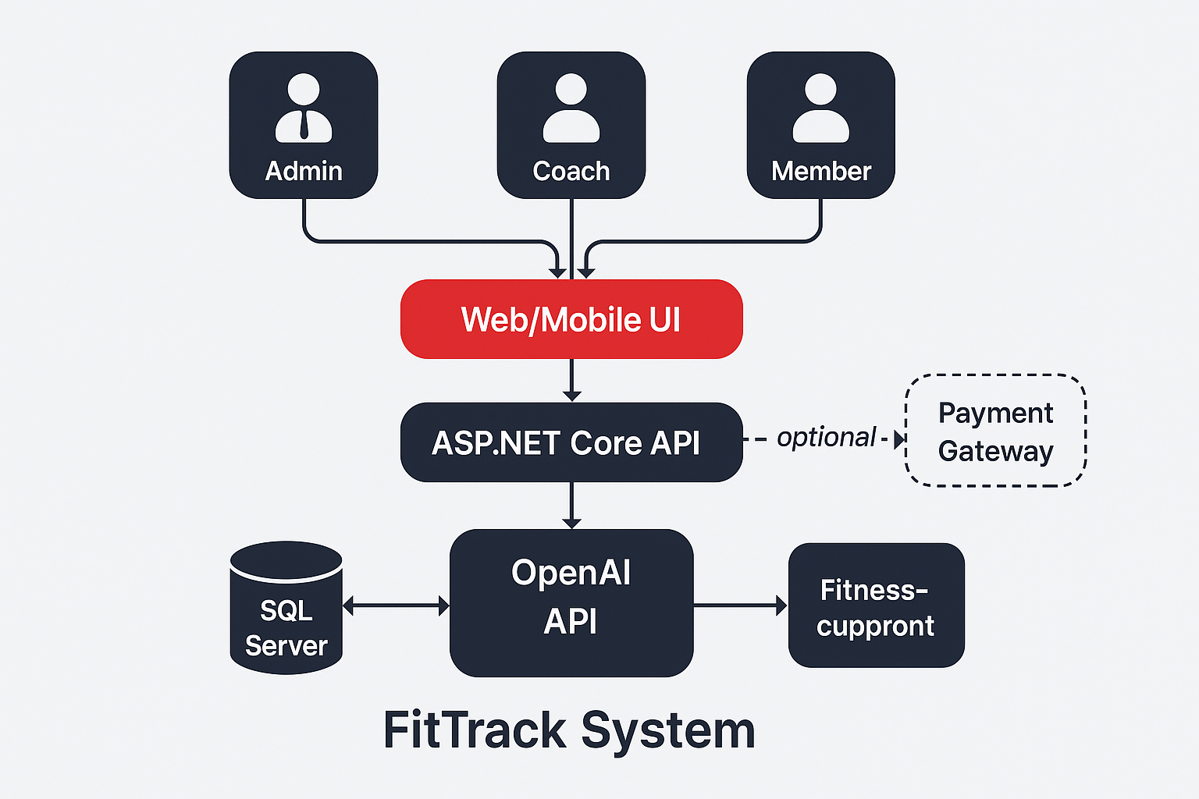
2.2 Product Functions
The Fit-Track System provides a comprehensive set of functions that collectively manage gym operations, online coaching, and e-commerce activities within a single platform.
The main functions of the system are summarized below:

🧍‍♂️ 1. User Management
- Allows users (Admin, Coach, Member) to register, log in, and manage their profiles.
- Supports role-based access control — each user type has different permissions.
- Enables password reset and authentication using JWT tokens.

🏋️‍♀️ 2. Membership & Gym Management
- Admin can create and manage gym branches, membership plans, and subscriptions.
- Coaches can track attendance, assign plans, and monitor client performance.
- Members can renew or upgrade their subscriptions online.

💪 3. Workout & Nutrition Planning
- Coaches can design custom workout and diet plans for each client.
- Members can view and log their daily progress and calories.
- The system automatically tracks progress using workout history and updates analytics dashboards.

💬 4. Communication & AI Chatbot Assistance
- Real-time chat system between coaches and members for guidance.
- Integrated AI-powered chatbot (Fit-Bot) helps users with:
  - Fitness advice and nutrition tips.
  - Exercise recommendations.
  - Instant Q&A and support.

💳 5. Payment & Subscription Processing
- Supports online payments via Stripe or PayPal.
- Auto-generates invoices and payment receipts.
- Tracks renewal dates, cancellations, and billing history.

🛒 6. E-Commerce Module
- Allows users to browse, search, and purchase gym equipment, supplements, and protein products.
- Integrates with inventory management for product availability.
- Secure checkout system with order tracking and status updates.

📊 7. Reporting & Analytics
- Provides detailed reports for Admin and Coaches:
  - Revenue and sales statistics.
  - Membership activity and engagement rate.
  - Fitness progress analysis for each member.

🔔 8. Notifications & Alerts
- System generates automated notifications for:
  - Payment reminders.
  - Training updates.
  - Chat messages and plan changes.
- Supports both in-app and email notifications.

🧩 9. System Administration
- Admin can manage:
  - Users and permissions.
  - Product catalogs.
  - Global configurations (pricing, offers, etc.).

In summary:
Fit-Track functions as a multi-module platform that unifies gym management, online fitness coaching, AI-powered support, and e-commerce — ensuring seamless interaction between admins, coaches, and members.
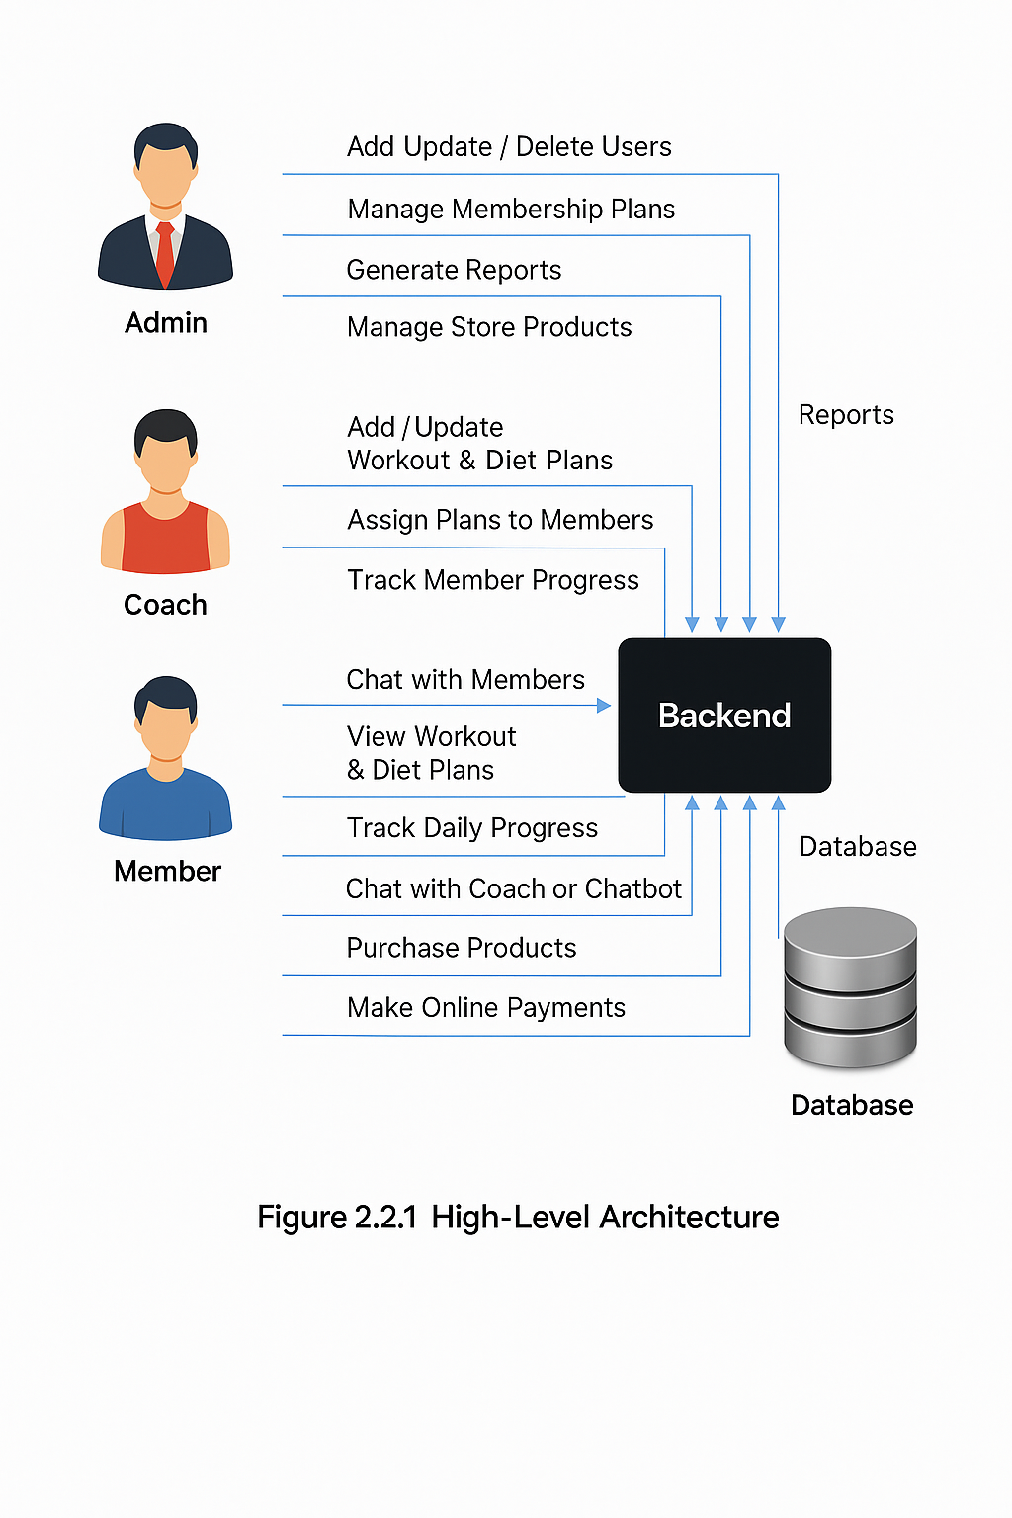
2.3 User Classes and Characteristics
The Fit-Track System is designed to support three main user classes, each having specific roles, permissions, and functionalities within the system.
The user classes are described as follows:
🧍‍♂️ 1. Member (Client User)
Description:
The member is the end-user who subscribes to the gym or online coaching services. Members use the platform to track their fitness journey, follow assigned workout and nutrition plans, and communicate with their assigned coach or the AI chatbot.
Key Responsibilities:
- Register and manage personal profile.
- Access assigned workout and nutrition plans.
- Log daily progress (exercises, calories, time).
- Chat with coach or AI chatbot for guidance.
- Purchase gym-related products from the e-commerce store.
- Make online payments for subscriptions or purchases.
Technical Knowledge:
- Basic computer/mobile usage skills.
- Familiar with fitness and workout tracking applications.
Access Level:
- Limited access (can only view or edit personal data).

🧑‍🏫 2. Coach (Trainer User)
Description:
The coach manages fitness programs for assigned members, providing personalized training and diet plans. Coaches also communicate with members for progress tracking and motivation.
Key Responsibilities:
- Create and assign workout and nutrition plans.
- Monitor member progress and adjust plans as needed.
- Communicate with members via chat or messages.
- Upload training materials, photos, and demonstration videos.
- Generate performance reports for each member.
Technical Knowledge:
- Moderate computer literacy.
- Familiar with fitness and nutrition principles.
Access Level:
- Medium-level access (can view and modify assigned member data).

👨‍💼 3. Admin (System Administrator)
Description:
The admin is responsible for managing the overall system operations, users, payments, and reports. Admins have full system privileges and oversee both the gym management and online services.
Key Responsibilities:
- Add, update, or remove users (coaches and members).
- Manage gym branches, membership plans, and store products.
- Handle payment and billing records.
- Generate reports and analytics on performance and sales.
- Monitor system activity and ensure data accuracy.
Technical Knowledge:
- High-level computer proficiency.
- Familiar with business operations and administrative tools.
Access Level:
- Full access (all administrative and configuration rights).

Summary:
The Fit-Track system differentiates users based on their roles, access levels, and responsibilities, ensuring data security and an optimized experience for each user type.
2.4 Operating Environment
Hardware and Software Requirements

Hardware Requirements:
- Operating System:
Supports all modern operating systems such as Windows, Linux, or macOS.
- Computer Specifications:
Minimum 4 GB RAM, dual-core processor, monitor with a resolution of 1280×720, keyboard, and mouse.
- Storage:
Hard drive should have at least 10 GB of free space, formatted with NTFS or equivalent file system.
- Internet Connection:
A stable internet connection (minimum 2 Mbps) is required for API calls and cloud synchronization.
- Printer (Optional):
A laser or inkjet printer can be used to print reports, invoices, and analytics summaries.

Software Requirements:
- Operating System:
Designed to run on any system compatible with Microsoft Windows 10+ or Linux Ubuntu 20.04+.
- Backend Framework:
ASP.NET Core 8.0 or above for API and business logic.
- Frontend Framework:
React.js (for Web) and React Native (for Mobile).
- Database System:
Microsoft SQL Server 2019 or higher.
- AI Integration:
Requires access to OpenAI API for chatbot functionality.
- Development Tools:
  - Microsoft Visual Studio / Visual Studio Code
  - SQL Server Management Studio (SSMS)
  - Node.js (for frontend dependency management)
  - GitHub (for version control)

2.5 Design and Implementation Constraints
The software development team has given their best effort in designing and implementing the Fit-Track System.
In order to maintain the system’s reliability and long-term durability, several design and implementation constraints were considered.
Although a complete multi-platform solution including both web and mobile applications was planned, due to time and resource limitations, only the web version will be fully implemented in the first phase.
The mobile version using React Native will be introduced later as part of future system upgrades.
The system requires a minimum of 4 GB RAM and a dual-core processor, but it is recommended to have 8 GB RAM for smoother performance.
During the design phase, the team had access to modern frameworks such as ASP.NET Core and React.js, which were selected for their scalability, performance, and developer support.
Considering the client’s budget and timeline, we chose to develop the interfaces in a clean, realistic, and cost-effective manner, avoiding the use of premium UI libraries or paid components.
The focus was to achieve a simple, efficient, and maintainable design that delivers all required functionalities while keeping the project affordable and adaptable for future enhancements.

2.6 Project Documentation
The Project Documentation section provides details about the documents created by the development team throughout the Fit-Track System project.
It includes both the Project Charter and the Project Proposal documents.
- Project Charter:
This document outlines the key objectives of the project, identifies the main stakeholders, and defines the problem statement. It also specifies the scope, timeline, and responsibilities of each team member involved in developing the Fit-Track system.
- Project Proposal:
The proposal explains the client’s requirements, the challenges identified in managing gyms and online coaching, and the system solutions designed to address these problems using the Fit-Track platform.

2.7 User Documentation
A User Manual will be provided to the client to clearly explain how to interact with the Fit-Track System.
It will be written in simple, understandable language to hide the internal complexity of the software.
This documentation will include:
- Step-by-step instructions for system navigation.
- Screenshots of important modules (dashboard, chatbot, store, etc.).
- Guidance on troubleshooting and user support.
A digital copy (PDF) will be provided, and a printed manual can also be delivered along with the final deployment package.

2.8 Assumptions and Dependencies
During development, the following assumptions and dependencies were made:
- It is assumed that the client will provide necessary hosting infrastructure (server or cloud platform) for deployment.
- The system will run smoothly on operating systems Windows 10+, Linux (Ubuntu 20.04+), or macOS 11+.
- The client will maintain an active internet connection to support cloud services, API integration, and AI chatbot functionality.
- The project depends on third-party services such as OpenAI API and payment gateways (Stripe or PayPal). Any service downtime may affect performance temporarily.
- It is assumed that the client will not change major system requirements during the later development stages.
- Future system extensions (e.g., mobile app or extra analytics) will depend on time and budget availability.

