Likehood
Cpu
Likelihood值: [21.054786682128906, 23.542484283447266]
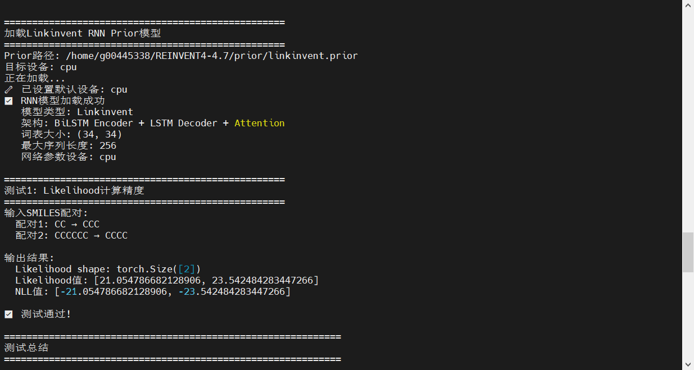
Gpu
Likelihood值: [21.055320739746094, 23.543109893798828]
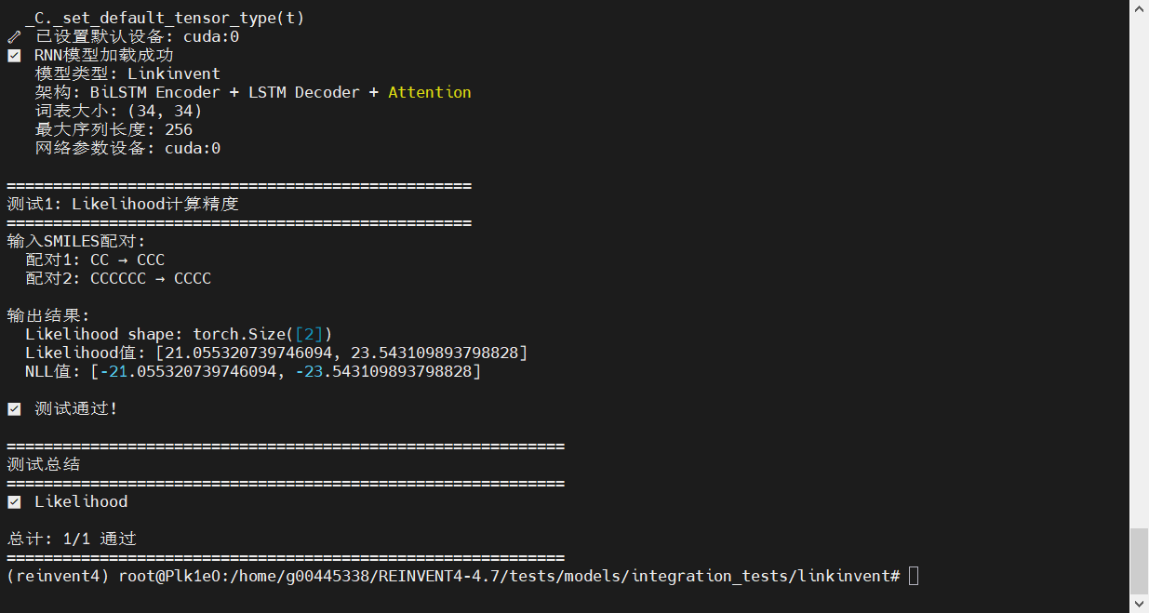

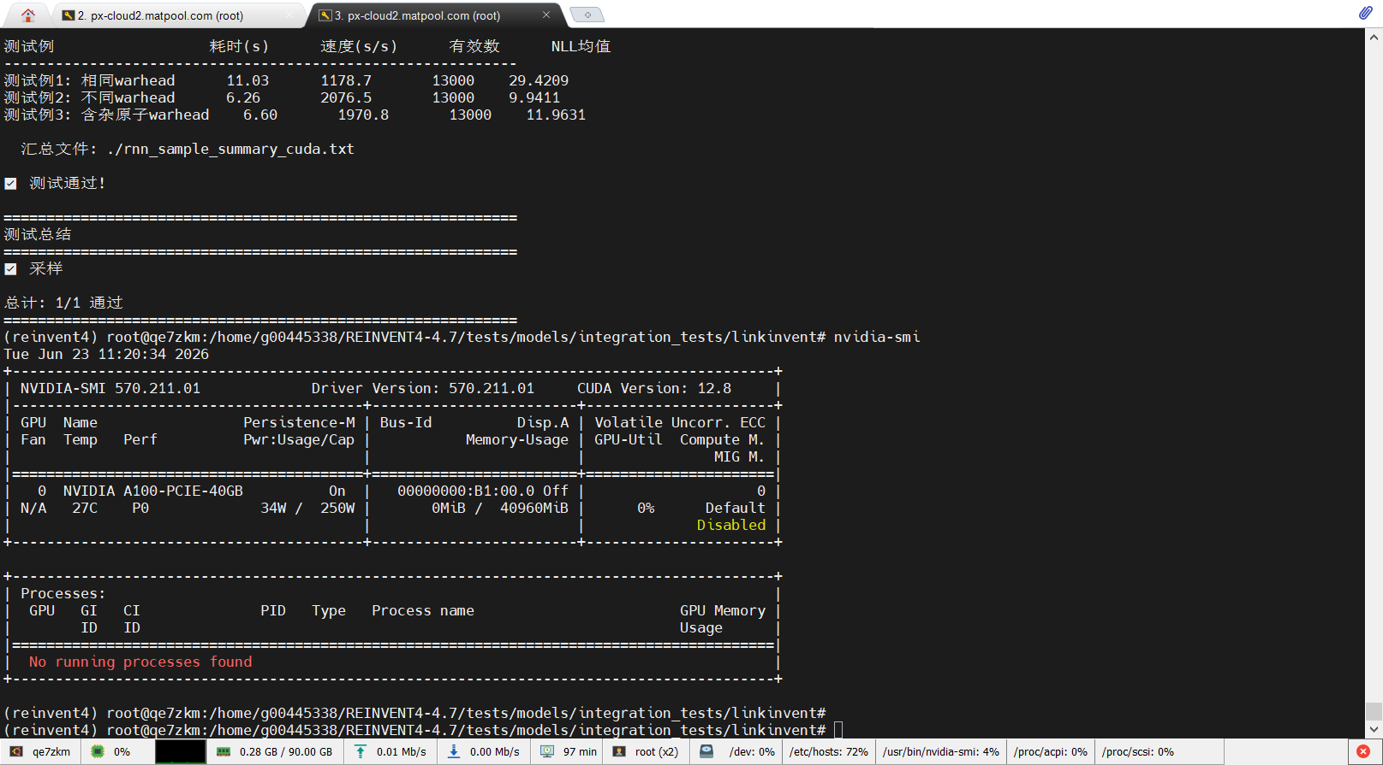

13000-1000
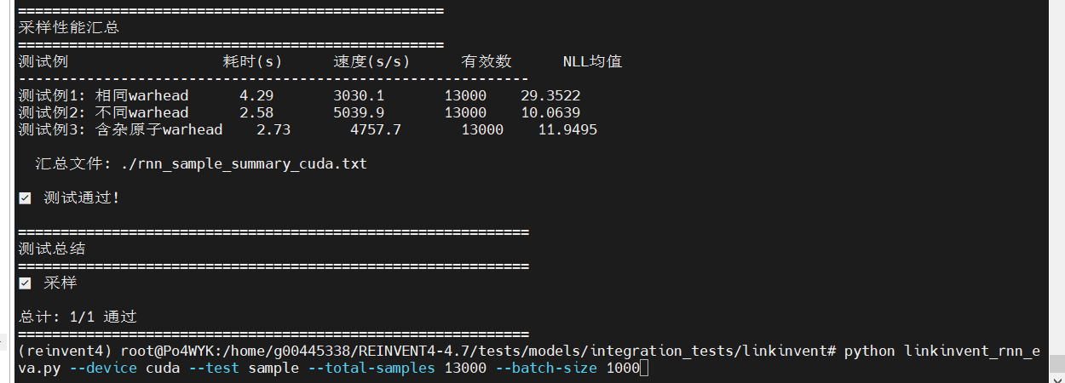

10000-1000
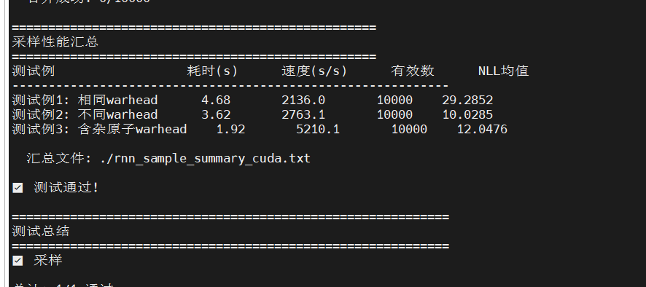
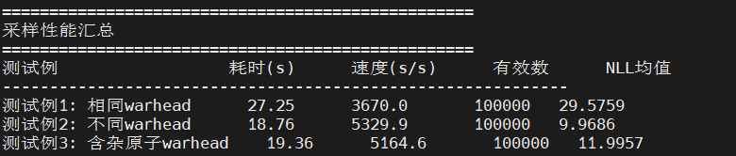

10000-2000
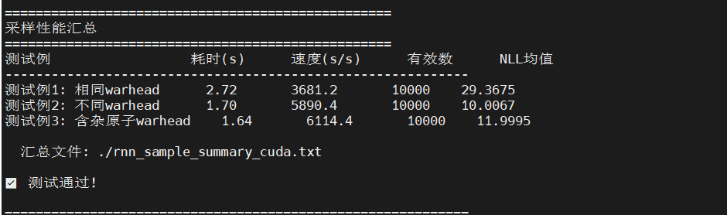
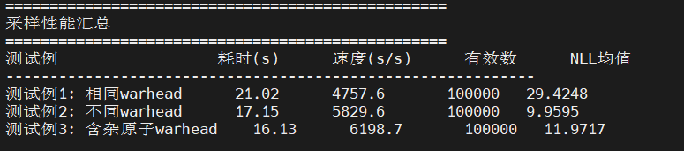

10000-5000
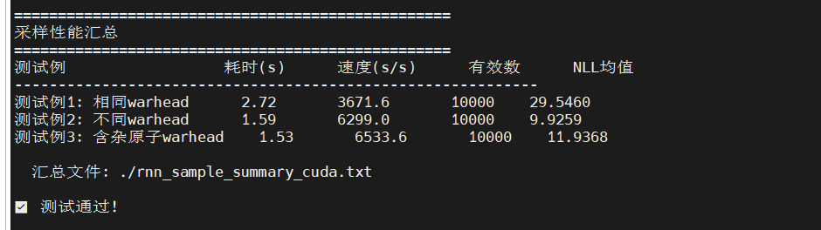
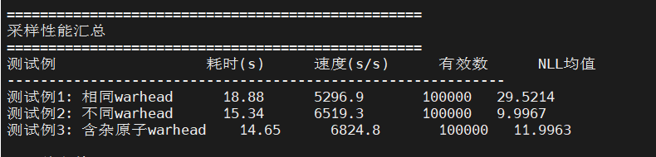

10000-10000
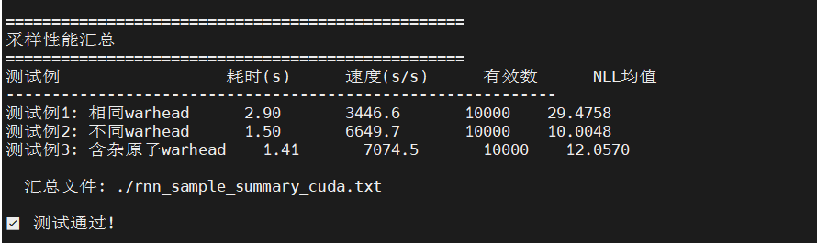
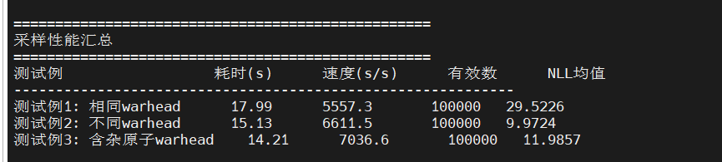

20000
