实验二

词法分析类别码定义如下：

|  |  |  |  |  |  |  |  |
| --- | --- | --- | --- | --- | --- | --- | --- |
| **单词名称** | **类别码** | **单词名称** | **类别码** | **单词名称** | **类别码** | **单词名称** | **类别码** |
| **Ident** | IDENFR | ! | NOT | * | MULT | = | ASSIGN |
| **IntConst** | INTCON | && | AND | / | DIV | ; | SEMICN |
| **FormatString** | STRCON | || | OR | % | MOD | , | COMMA |
| main | MAINTK | while | WHILETK | < | LSS | ( | LPARENT |
| const | CONSTTK | getint | GETINTTK | <= | LEQ | ) | RPARENT |
| int | INTTK | printf | PRINTFTK | > | GRE | [ | LBRACK |
| break | BREAKTK | return | RETURNTK | >= | GEQ | ] | RBRACK |
| continue | CONTINUETK | + | PLUS | == | EQL | { | LBRACE |
| if | IFTK | - | MINU | != | NEQ | } | RBRACE |
| else | ELSETK | void | VOIDTK |  |  |  |  |

【输入形式】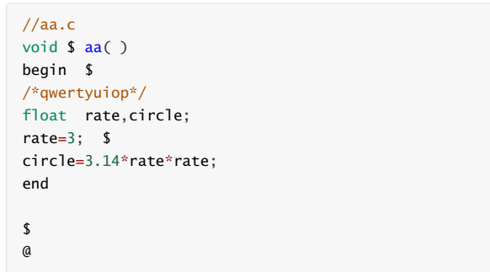  
【输出形式】参考如下。

【样例输出】终端或cmd输出

