SAP S/4HANA + Amazon Bedrock AgentCore + Okta OIDC
Integration Guide

Overview
This guide documents the end-to-end integration of SAP S/4HANA OData APIs with Amazon Bedrock AgentCore Runtime using Okta as the OIDC identity provider. An MCP (Model Context Protocol) server hosted on AgentCore Runtime exposes SAP OData services as tools that can be consumed by AI agents or MCP clients.

Architecture Flow
- Python Client authenticates with Okta (Authorization Code flow)
2. Client receives access_token (JWT)
3. Client sends Bearer token to AgentCore Runtime
4. AgentCore validates JWT against Okta OIDC discovery URL
5. MCP Server receives the token as a tool parameter
6. MCP Server calls SAP OData API with Bearer token
7. SAP validates token against Okta JWKS keys
8. Sales order data flows back to the client
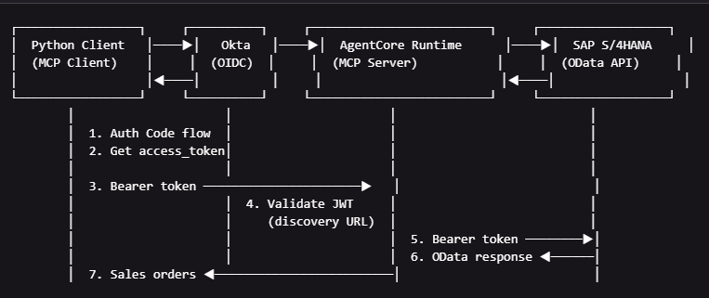

Token Flow
The same Okta access_token is used for both:
• Inbound auth: AgentCore Runtime validates the JWT against Okta's OIDC discovery endpoint
• SAP OData calls: The MCP server passes the token as Authorization: Bearer to SAP
This is possible because SAP is configured to trust the same Okta authorization server.

1. Okta Configuration

1.1 Okta Application Setup
Create a Web Application in Okta with the following settings:
https://help.okta.com/en-us/content/topics/apps/apps_app_integration_wizard_oidc.htm
Setting | Value
Application type | Web Application
Grant type | Authorization Code
Sign-in redirect URIs | http://localhost:8085/callback (Python)  https://oauth.pstmn.io/v1/callback (Postman)
Scopes | openid email
Client authentication | Client secret (Basic Auth)
State | abc

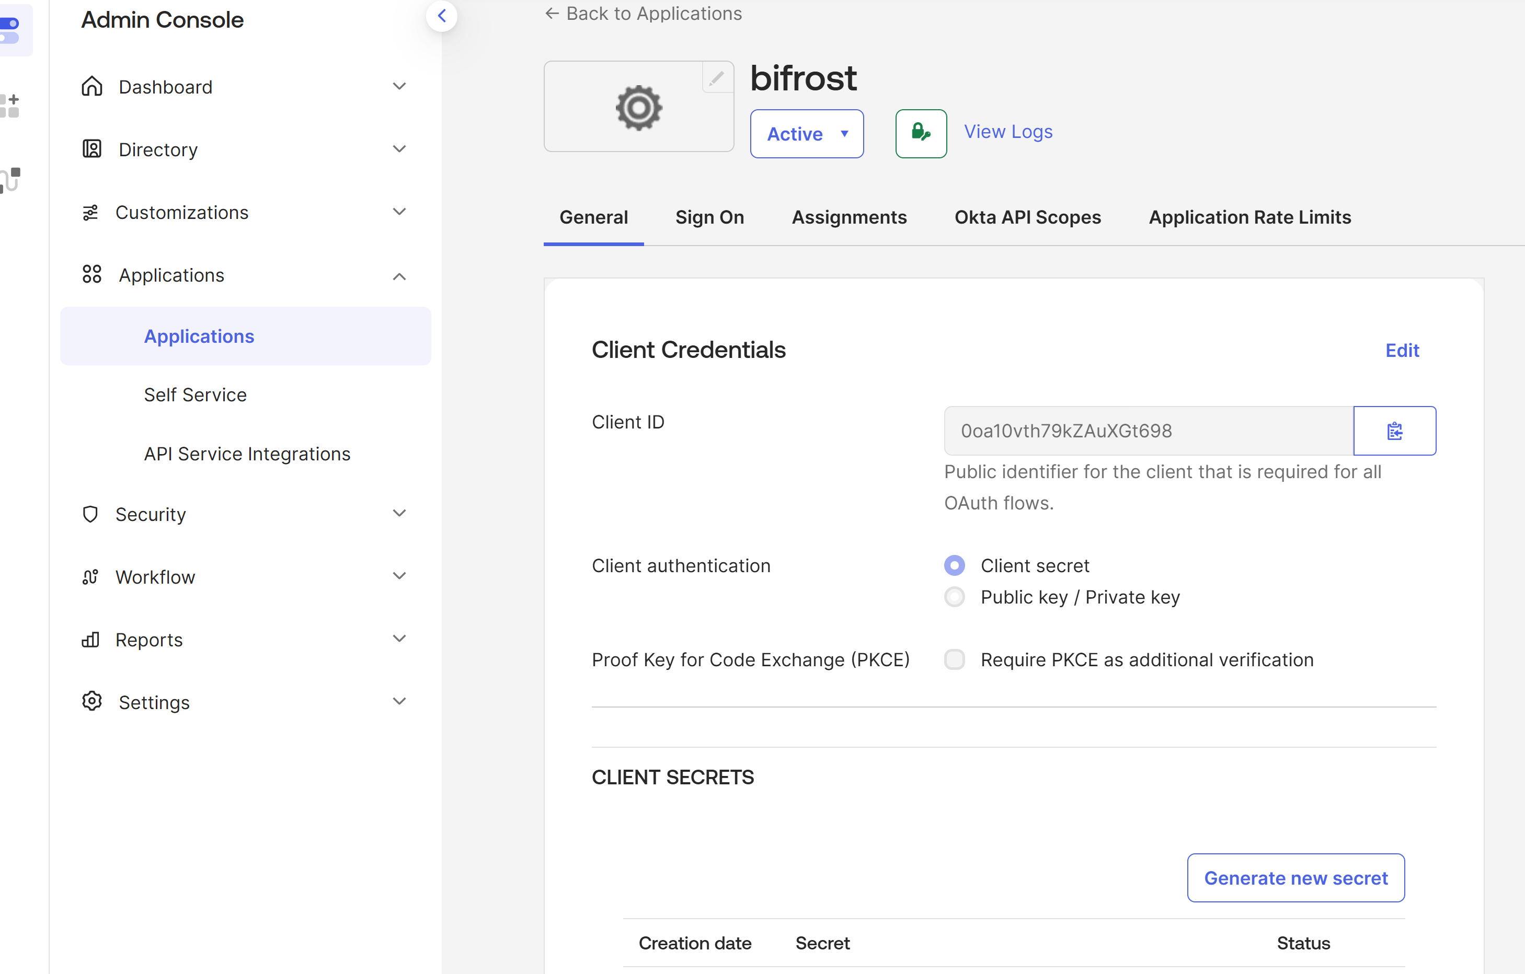

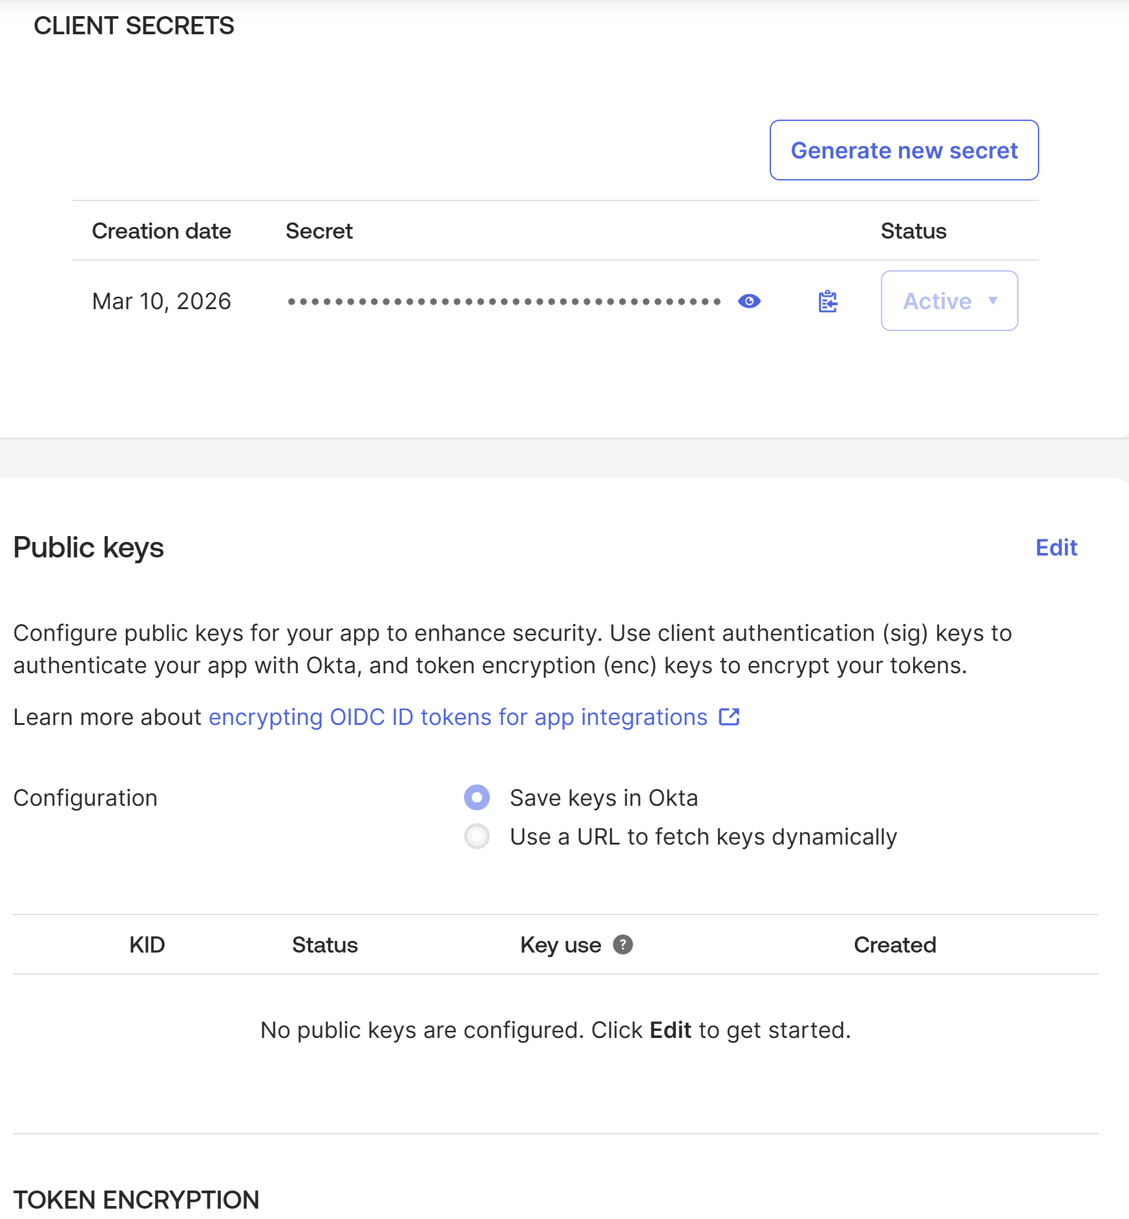
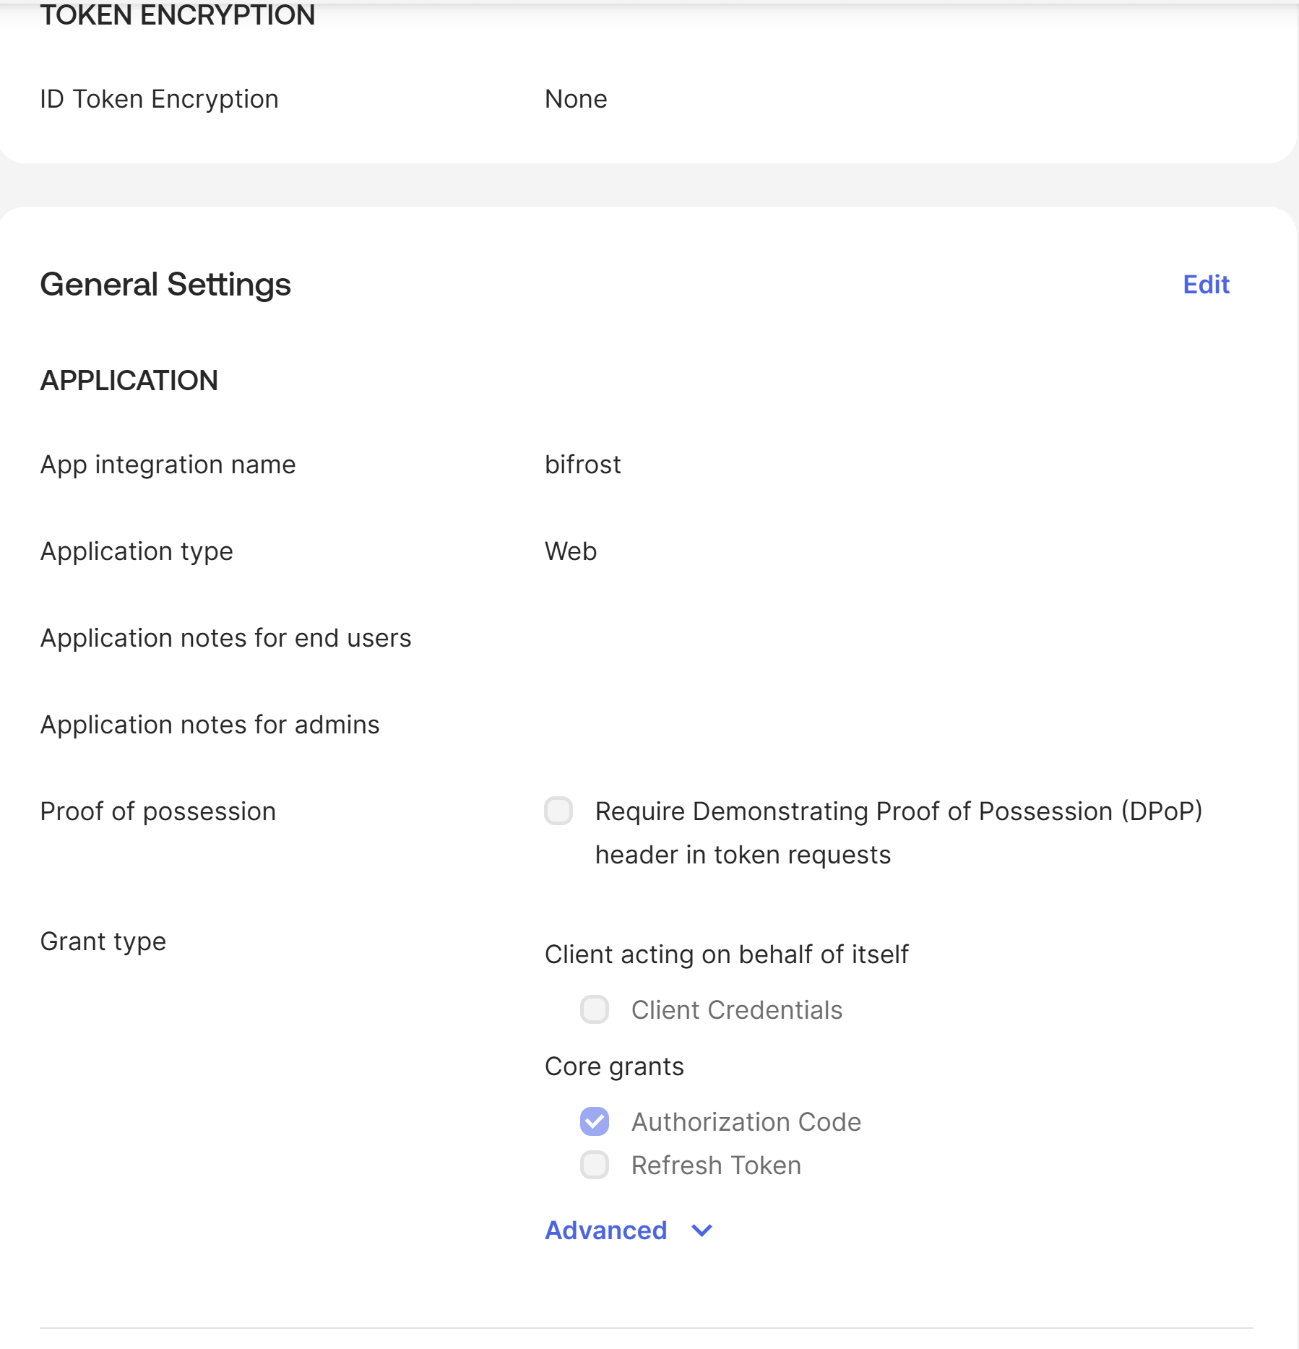

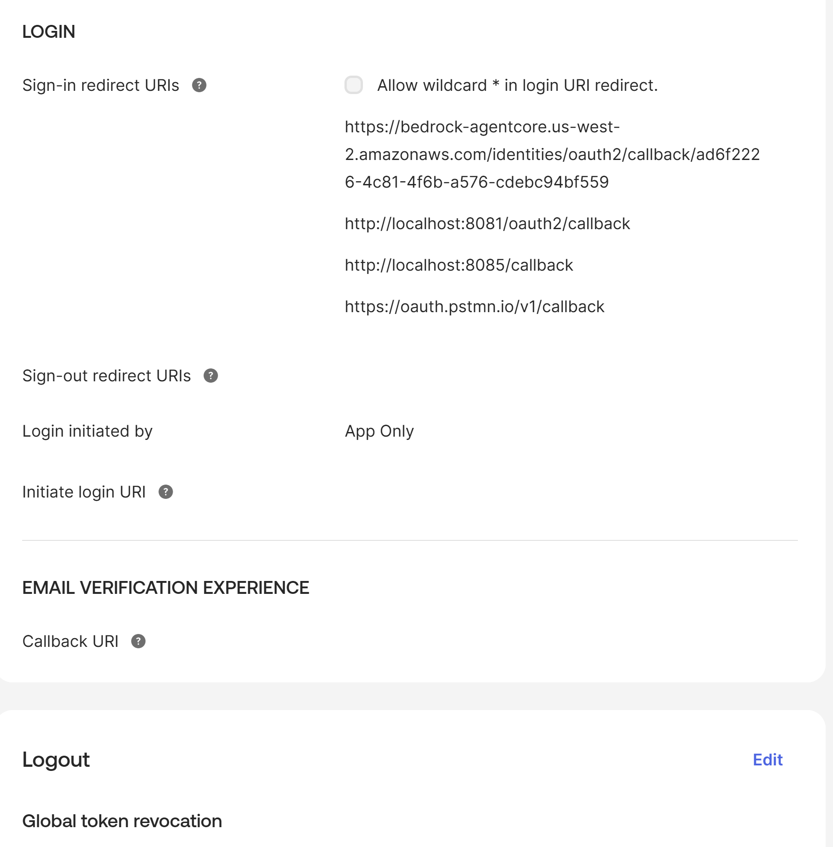

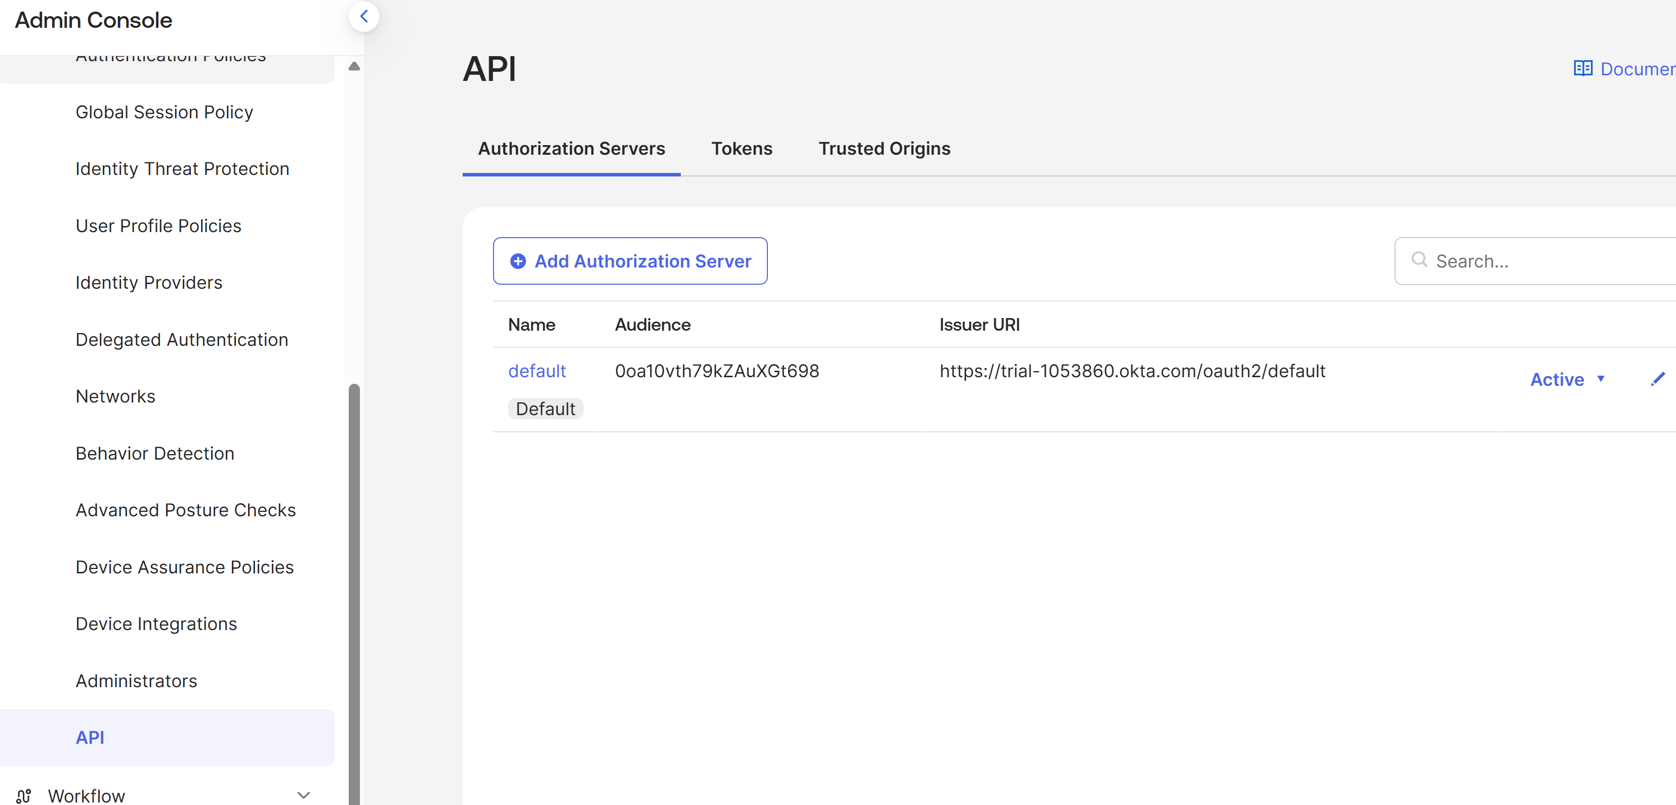

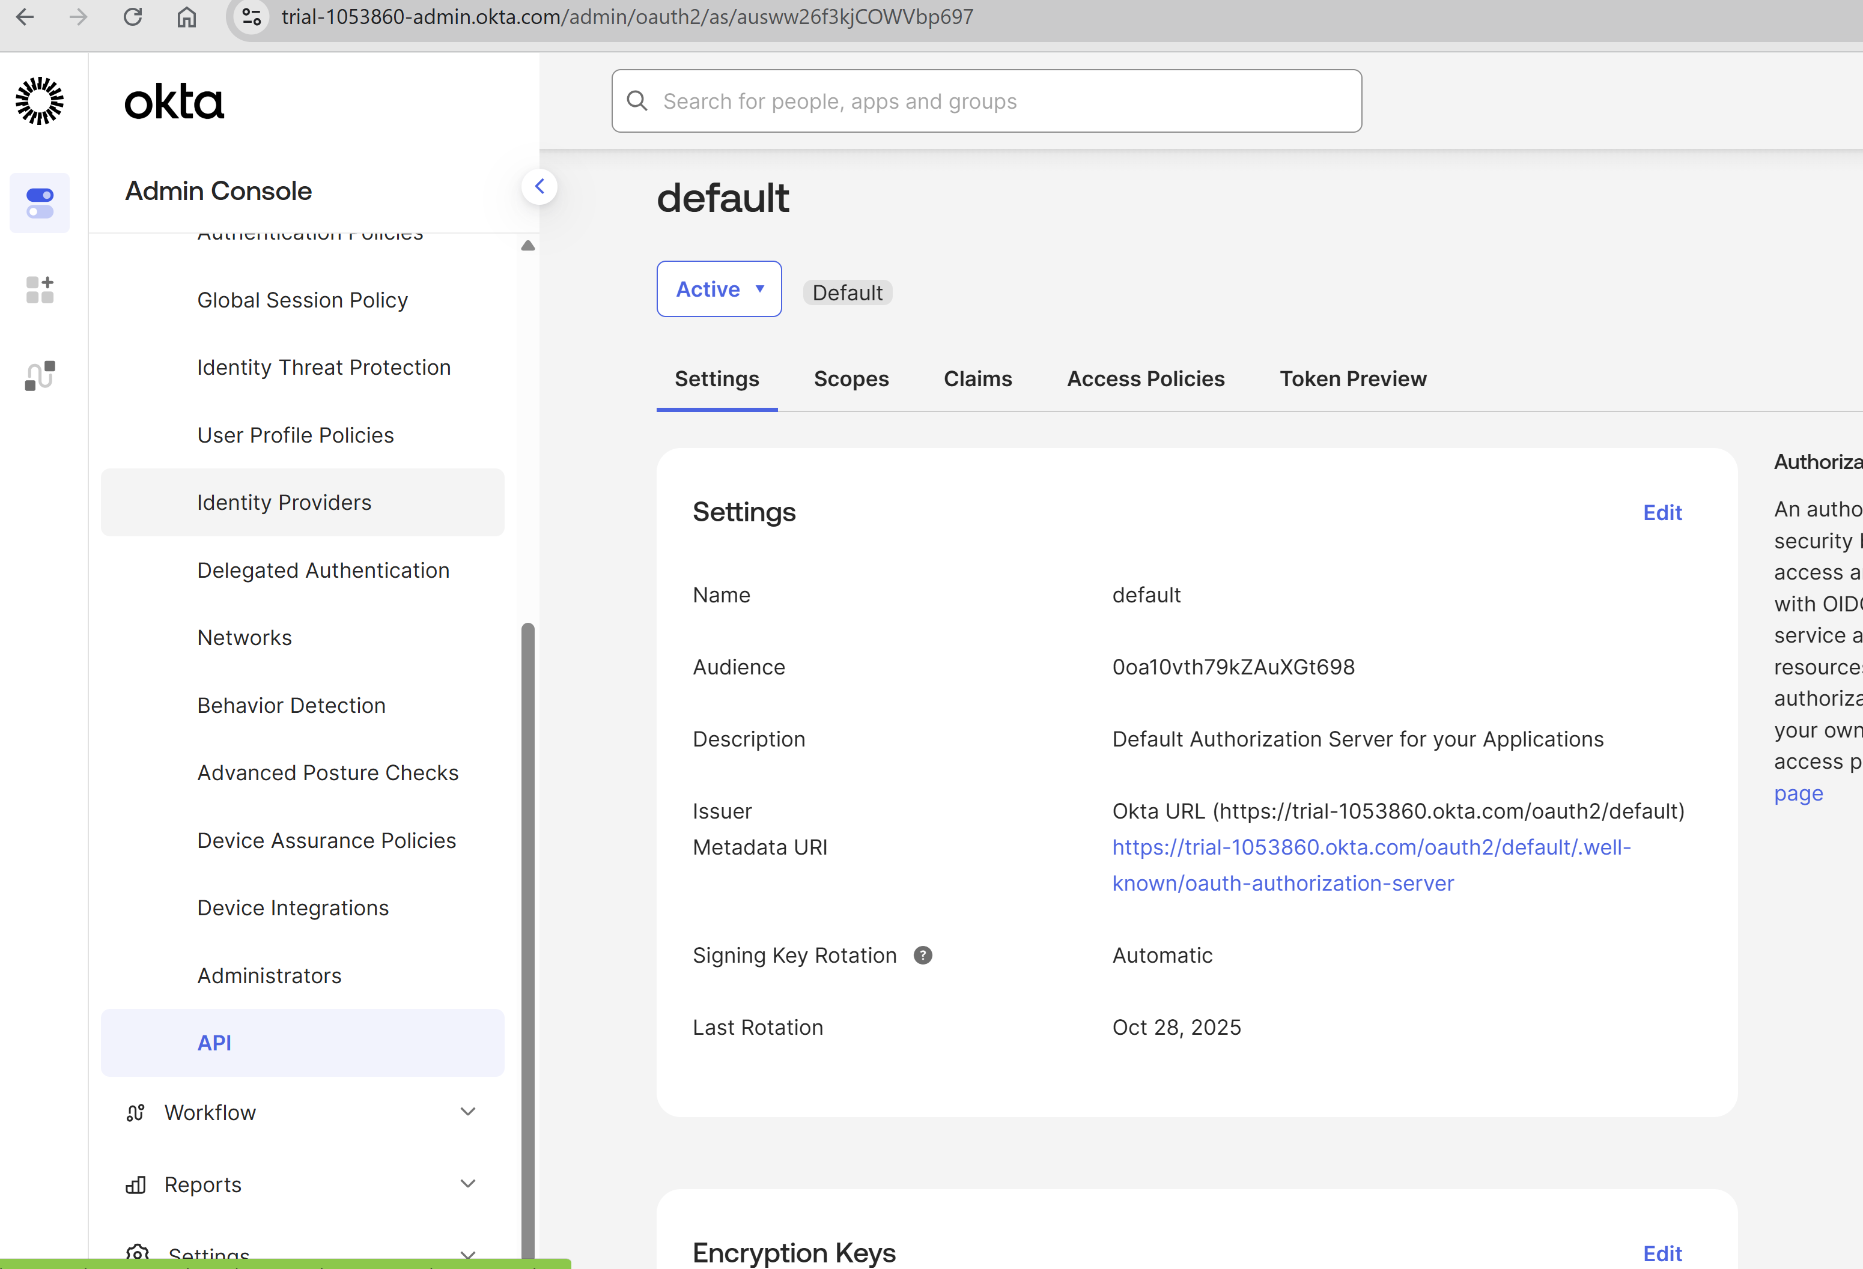

1.2 Okta Endpoints
All endpoints use the default custom authorization server (/oauth2/default):
Endpoint | URL
Authorization | https://trial-1053860.okta.com/oauth2/default/v1/authorize
Token | https://trial-1053860.okta.com/oauth2/default/v1/token
OIDC Discovery | https://trial-1053860.okta.com/oauth2/default/.well-known/openid-configuration
JWKS | https://trial-1053860.okta.com/oauth2/default/v1/keys
Issuer | https://trial-1053860.okta.com/oauth2/default

1.3 Access Token Claims
Claim | Value
iss | https://trial-1053860.okta.com/oauth2/default
aud | https://trial-1053860.okta.com/oauth2/default
cid | 0oa10vth79kZAuXGt698
scp | ["openid", "email"]

1.4 Important Notes
• The access_token (not the id_token) is used for SAP authentication
• The token issuer MUST match what is configured in both SAP and AgentCore
• Using /oauth2/v1/ (org auth server) produces tokens with issuer https://trial-1053860.okta.com — this does NOT match SAP config
• Using /oauth2/default/v1/ produces tokens with issuer https://trial-1053860.okta.com/oauth2/default — this MATCHES SAP config

2. SAP S/4HANA Configuration

2.1 OIDC Provider Setup
SAP is configured to trust Okta as an OIDC identity provider:
Setting | Value
Issuer | https://trial-1053860.okta.com/oauth2/default
Client ID | 0oa10vth79kZAuXGt698
User Mapping Claim | sub claim (OIDC standard)
User Mapping Mechanism | E-Mail
JWKS Download URL | https://trial-1053860.okta.com/oauth2/default/v1/keys

Tcode : SOIDC

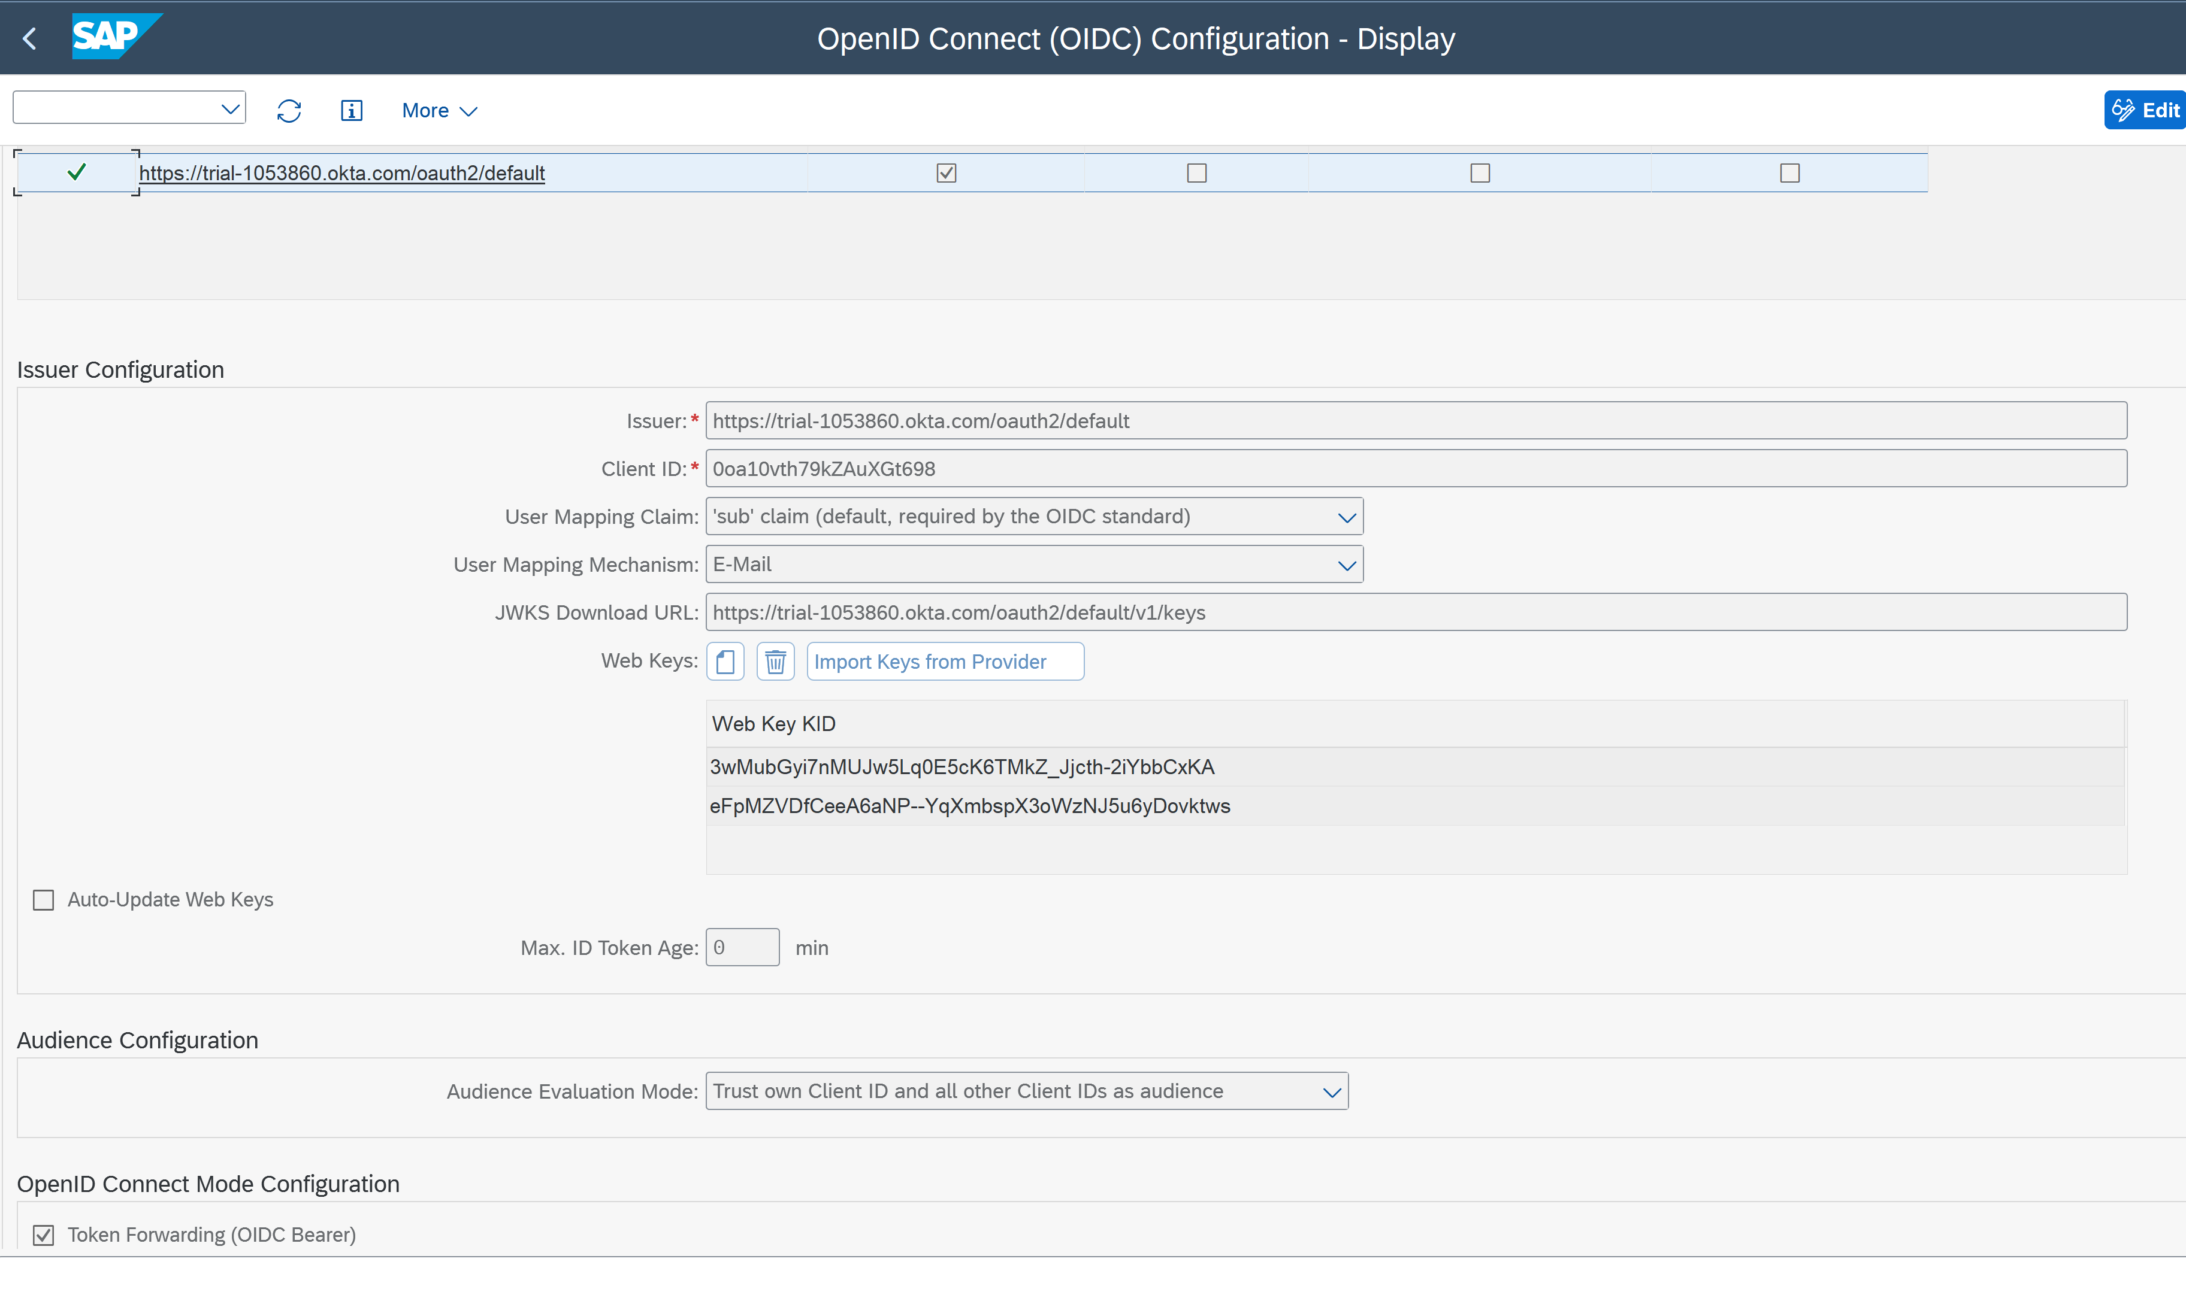

2.2 SAP OData Service
Setting | Value
SAP Server | https://vhcals4hci.awspoc.club
OData Service | /sap/opu/odata/sap/API_SALES_ORDER_SRV/A_SalesOrder
Authentication | Bearer token (Okta access_token)

2.3 SAP Prerequisites
• SAP ICM must have HTTPS enabled
• Okta's SSL root CA certificate must be imported in STRUST (SSL Client PSE)
• SAP must be able to reach Okta endpoints outbound (for JWKS key download)
• If SAP shows RFC error "ThSAPOCMINIT, CM_PRODUCT_SPECIFIC_ERROR cmRc=20", it means SAP cannot reach Okta — check network/proxy settings

3. Amazon Bedrock AgentCore Configuration

3.1 MCP Server Tools
The MCP server (sap_odata_mcp_server.py) exposes two tools:
Tool | Description | Parameters
get_sales_orders | Get sales orders with pagination | bearer_token, top, skip
get_sales_order_by_id | Get a specific sales order | bearer_token, sales_order_id
Key implementation details:
• Uses FastMCP with stateless_http=True (required for AgentCore Runtime)
• Listens on 0.0.0.0:8000/mcp
• Makes OData calls using httpx with verify=False (for self-signed SAP certs)
• The bearer_token parameter is passed by the client — it is the Okta access_token

3.2 Runtime Deployment Configuration
Setting | Value
Agent Name | sap_odata_mcp_server
Protocol | MCP
Platform | linux/arm64
Network Mode | PUBLIC
ECR | Auto-created
Execution Role | Auto-created

3.3 Inbound Auth (JWT Authorizer)
AgentCore Runtime is configured with a custom JWT authorizer:
authorizer_configuration = {
"customJWTAuthorizer": {
"allowedClients": ["0oa10vth79kZAuXGt698"],
"discoveryUrl": "https://trial-1053860.okta.com/oauth2/default/.well-known/openid-configuration"
}
}
AgentCore validates incoming requests by:
1. Extracting the Bearer token from the Authorization header
2. Fetching JWKS keys from the discovery URL
3. Validating the JWT signature, expiry, and cid claim against allowedClients

3.4 Deployment Steps
# Set environment
export OKTA_DOMAIN="trial-1053860.okta.com"
export OKTA_CLIENT_ID="0oa10vth79kZAuXGt698"
export AWS_DEFAULT_REGION="us-east-1"
# Deploy (requires Docker running)
cd sap-agentcore-mcp
pip install -r requirements_server.txt
python deploy_mcp_server.py
The deploy script:
1. Configures AgentCore Runtime with MCP protocol and Okta JWT authorizer
2. Builds a Docker image with the MCP server code
3. Pushes to ECR
4. Creates/updates the AgentCore Runtime
5. Waits for READY status
6. Stores the Agent ARN in SSM Parameter Store (/sap_mcp_server/agent_arn)

3.5 Server Dependencies
mcp>=1.10.0
httpx
boto3
bedrock-agentcore<=0.1.5
bedrock-agentcore-starter-toolkit==0.1.14

4. Python Client (sap_agent_client.py)

4.1 Authentication Flow
The client implements the OAuth2 Authorization Code flow:
1. Starts a local HTTP server on localhost:8085 for the callback
2. Opens the browser to Okta's authorize endpoint
3. User authenticates with Okta (MFA supported)
4. Okta redirects to localhost:8085/callback with an authorization code
5. Client exchanges the code for tokens using Basic Auth (client_id:client_secret)
6. Uses the access_token for both AgentCore and SAP

4.2 MCP Connection
The client connects to AgentCore Runtime via Streamable HTTP:
mcp_url = f"https://bedrock-agentcore.{region}.amazonaws.com"
f"/runtimes/{encoded_arn}/invocations?qualifier=DEFAULT"
headers = {
"authorization": f"Bearer {access_token}",
"Content-Type": "application/json",
}

4.3 Running the Client
# PowerShell
$env:OKTA_CLIENT_SECRET="<your-secret>"
cd sap-agentcore-mcp
pip install -r requirements_client.txt
python sap_agent_client.py "show me top 2 sales orders"

5. Local Testing (test_sap_local.py)
A standalone script that bypasses AgentCore to test the Okta to SAP connection directly. Useful for debugging token or SAP issues without AgentCore in the middle.
The script:
1. Performs the same Okta Authorization Code flow
2. Prints full token contents with decoded claims
3. Calls SAP OData directly with the access_token
# PowerShell
$env:OKTA_CLIENT_SECRET="<your-secret>"
python test_sap_local.py

6. Troubleshooting

401 from AgentCore Runtime
Cause: Token issuer does not match the discovery URL configured in AgentCore.
Fix: Ensure the Okta authorize/token URLs use /oauth2/default/v1/ (not /oauth2/v1/).
Verify: Decode the access_token and check the iss claim matches the discovery URL issuer.

401 from SAP
Cause 1: Wrong token type — SAP expects the access_token, not the id_token.
Cause 2: Token issuer does not match SAP OIDC config (must be https://trial-1053860.okta.com/oauth2/default).
Cause 3: SAP cannot reach Okta to download JWKS keys (RFC error cmRc=20).
Fix: Use test_sap_local.py to test the token directly against SAP.

CodeBuild Failed during deployment
Cause: Dependency version mismatch in requirements_server.txt.
Fix: Use pinned versions: bedrock-agentcore<=0.1.5, bedrock-agentcore-starter-toolkit==0.1.14

Agent already exists (ConflictException)
Cause: Re-deploying without updating.
Fix: Use auto_update_on_conflict=True in agentcore_runtime.launch()

Environment variable not persisting
PowerShell: Use $env:OKTA_CLIENT_SECRET="value"
CMD: Use set OKTA_CLIENT_SECRET=value
Must be set in the same terminal session as the python command.

7. File Reference
File | Purpose
sap_odata_mcp_server.py | MCP server with SAP OData tools (deployed to AgentCore)
deploy_mcp_server.py | Deploys MCP server to AgentCore Runtime with Okta auth
sap_agent_client.py | Python client — Okta login → AgentCore → SAP
test_sap_local.py | Local test — Okta login → SAP directly (no AgentCore)
check_token.py | Debug utility — prints token claims
requirements_server.txt | Server-side dependencies
requirements_client.txt | Client-side dependencies

8. Troubleshooting :
In the tcode SOIDC you can Trace and analyse the token. You can copy paste and validate the token. You would see error or green button. Error descriptions are helpful to debug the issue.

