# **Dataflow and Diagrams**

* + 1. **Update Member Details**

This workflow handles how member detail updates are processed in the app. When a user changes their email or phone number, the system requires OTP verification before applying the changes. The process includes generating and validating the OTP with up to three attempts per day. For other updates (e.g., name, address), the data is submitted directly without OTP. Once the OTP is verified—or bypassed for non-sensitive updates—the system updates the application database, logs the event, pushes changes to Perfect Gym (PGM), and conditionally triggers an update to Telr if the email or phone number was modified. The flow ends after all necessary updates are complete.

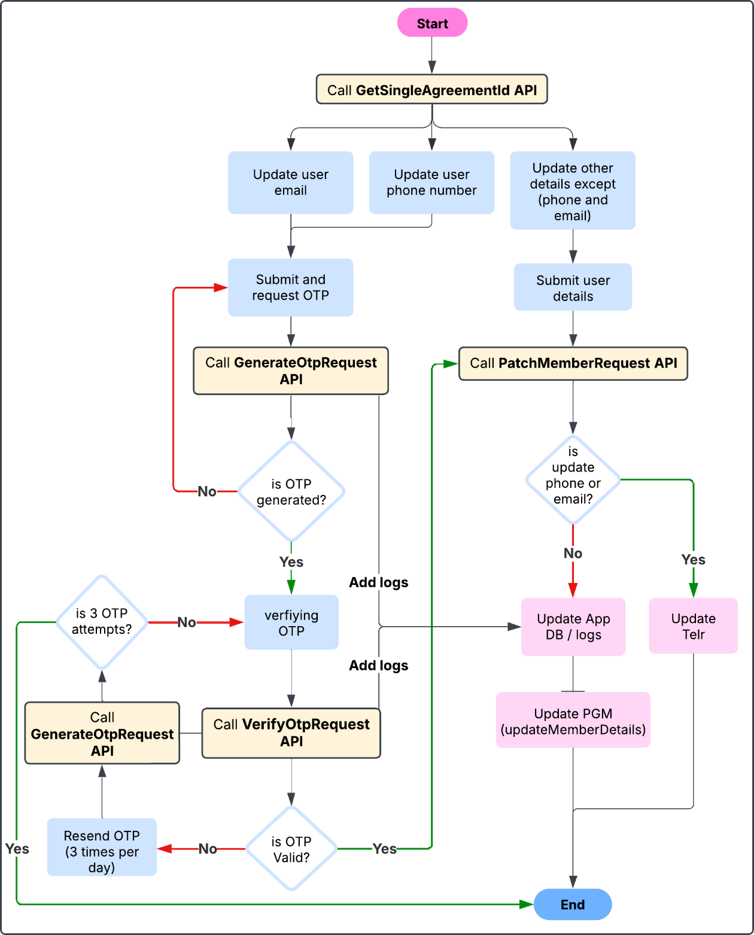

* + 1. **Upgrade Membership**

This flow handles how users upgrade their membership plans in the app. After retrieving available plans, the user selects a new one, and the app calculates the amount to pay. If the user has a promo code, the discount is applied before proceeding to payment. Users then choose whether to pay with an existing card or a new one. The system calls the upgrade API, then redirects to Telr's quicklink checkout. After the payment is completed (or fails/cancels), the app checks the result via a payment status API. If the payment is successful, the user is taken to a success page and the app updates its database and logs. If the payment fails or is cancelled, the user is shown a failed payment page, and only the logs are updated to reflect the outcome.

* + 1. **Freeze Membership**

This flow outlines how users freeze their membership accounts. The system first checks if the account is already frozen. If not, the user fills out a freeze request form and submits it after selecting valid dates. The app confirms a one-time AED 50 fee before opening the Telr payment gateway. After the payment is completed or declined, the app verifies the transaction via the payment status API. If successful, it redirects to a confirmation page and updates the database. If payment fails or is cancelled, the user is shown an appropriate message and the system logs the attempt.

* + 1. **Cancel Membership**

This flow covers how users cancel their membership. It starts by checking if the account is already cancelled. If not, the user fills out a cancellation form, uploads any required documents (if the account is active), and confirms the request. Once confirmed, the system calls the cancellation API and logs the update. After the cancellation is processed, the user is redirected to a confirmation page, and the app updates its internal records accordingly.

* + 1. **Default Payments Membership**

This process manages defaulted membership payments. The app retrieves all outstanding payments and displays them to the user. The user can then choose to pay using a saved card or enter new payment details. Once the payment method is selected, the system triggers a payment request through Telr. After the transaction, the app checks its status and updates the logs. If the payment is successful, the user is taken to a success page. If it fails or is cancelled, they’re shown the appropriate message instead.

* + 1. **History Payments Membership**

This flow manages the process of viewing payment history and updating card details. The app first retrieves all historical payments and displays them to the user. If the user chooses to change their card, they are prompted to confirm a 1 dirham fee. Once confirmed, the app opens a Telr payment link to process the fee. After the transaction, the app checks the payment result and updates the database accordingly. Successful payments redirect to a confirmation screen, while failed or cancelled attempts show the appropriate message.

* + 1. **Home - Membership Details**

This diagram outlines the process for updating a member's card details. The user begins by entering new card information and proceeds to checkout. An API request is made to process the payment. If the payment fails, the system updates the database to reflect the failure. If successful, the backend updates the necessary records, including the Telr gateway and the internal database, followed by sending a confirmation notification to the user to complete the update process.

