三、表达式翻译文法
3.1 赋值语句
S → id = E ;
{gen('=', E.place, _, id.place)}

E → E1 + T
{t = newtemp();
gen('+', E1.place, T.place, t);
E.place = t}

E → E1 - T
{t = newtemp();
gen('-', E1.place, T.place, t);
E.place = t}

E → T
{E.place = T.place}

T → T1 * F
{t = newtemp();
gen('*', T1.place, F.place, t);
T.place = t}

T → T1 / F
{t = newtemp();
gen('/', T1.place, F.place, t);
T.place = t}

T → F
{T.place = F.place}

F → ( E )
{F.place = E.place}

F → id
{F.place = id.place}

F → num
{F.place = num.val}
3.2 数组引用
L → id [ E ]
{t = newtemp();
gen('[]', id.place, E.place, t);
L.place = t;
L.array = id.place}

L → L1 [ E ]
{t = newtemp();
t2 = newtemp();
gen('*', E.place, elemsize(L1), t);
gen('+', L1.place, t, t2);
L.place = t2;
L.array = L1.array}

/* 数组左值赋值 */
S → L = E ;
{gen('[]=', L.array, E.place, L.place)}
四、布尔表达式翻译文法（回填法）
B → B1 || M B2
{backpatch(B1.falselist, M.quad);
B.truelist = merge(B1.truelist, B2.truelist);
B.falselist = B2.falselist}

B → B1 && M B2
{backpatch(B1.truelist, M.quad);
B.truelist = B2.truelist;
B.falselist = merge(B1.falselist, B2.falselist)}

B → ! B1
{B.truelist = B1.falselist;
B.falselist = B1.truelist}

B → E1 relop E2
{B.truelist = makelist(nextquad());
B.falselist = makelist(nextquad()+1);
gen('j'+relop, E1.place, E2.place, 0);
gen('j', _, _, 0)}

B → true
{B.truelist = makelist(nextquad());
gen('j', _, _, 0)}

B → false
{B.falselist = makelist(nextquad());
gen('j', _, _, 0)}

M → ε
{M.quad = nextquad()}
五、控制流语句翻译文法
5.1 if 语句
S → if ( B ) M1 S1 N else M2 S2
{backpatch(B.truelist, M1.quad);
backpatch(B.falselist, M2.quad);
S.nextlist = merge(S1.nextlist, merge(N.nextlist, S2.nextlist))}

S → if ( B ) M S1
{backpatch(B.truelist, M.quad);
S.nextlist = merge(B.falselist, S1.nextlist)}

N → ε
{N.nextlist = makelist(nextquad());
gen('j', _, _, 0)}
5.2 while 语句
S → while M1 ( B ) M2 S1
{backpatch(S1.nextlist, M1.quad);
backpatch(B.truelist, M2.quad);
S.nextlist = B.falselist;
gen('j', _, _, M1.quad)}
5.3 for 语句
S → for ( E1 ; M1 B ; M2 E2 M3 ) S1
{backpatch(B.truelist, M3.quad);
backpatch(S1.nextlist, M2.quad);
backpatch(E2对应跳转, M1.quad);
S.nextlist = B.falselist;
gen('j', _, _, M1.quad)}
5.4 return 语句
S → return E ;
{gen('ret', E.place, _, _)}

S → return ;
{gen('ret', _, _, _)}
六、函数定义与调用翻译文法
6.1 函数声明
FuncDef → Type id ( ParamList ) { M Body }
{gen('entry', id.name, _, _);
gen('alloc', localsize, _, _);
backpatch(Body.nextlist, nextquad());
gen('exit', id.name, _, _)}
6.2 函数调用
E → id ( ArgList )
{for each arg in ArgList (逆序):
gen('param', arg.place, _, _);
t = newtemp();
gen('call', id.place, ArgList.count, t);
E.place = t}

ArgList → ArgList , E
{ArgList.count = ArgList1.count + 1;
ArgList.list = ArgList1.list ++ [E.place]}

ArgList → E
{ArgList.count = 1;
ArgList.list = [E.place]}
七、变量声明翻译文法
Decl → Type id ;
{enter(id.name, Type.type, offset);
offset += Type.width}

Decl → Type id [ num ] ;
{t = array(num.val, Type.type);
enter(id.name, t, offset);
offset += num.val * Type.width}

Decl → struct id { FieldList } ;
{enter_struct(id.name, FieldList.fields)}
八、动作符号含义说明
8.1 核心辅助函数
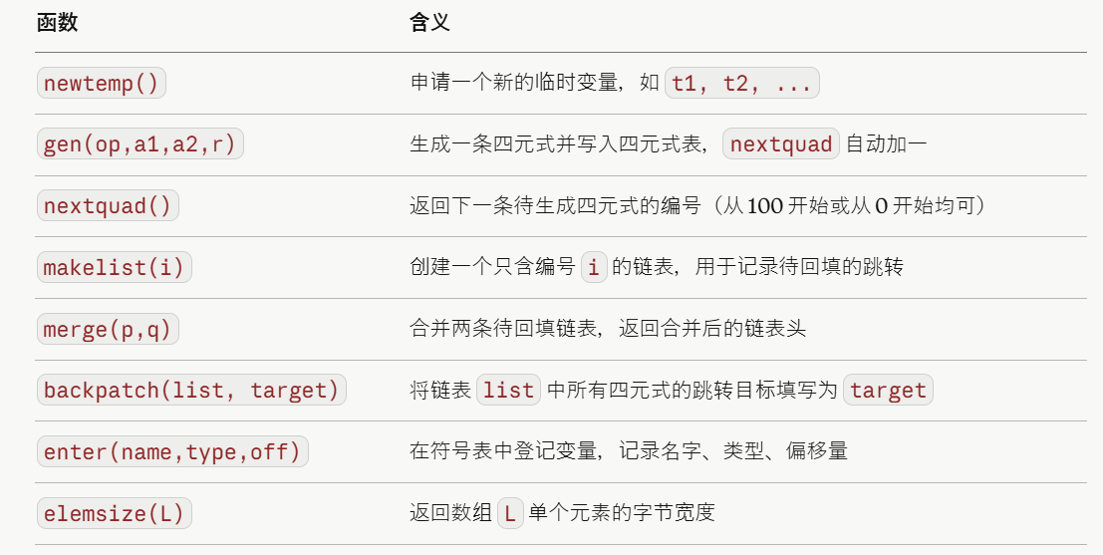
8.2 综合属性与继承属性
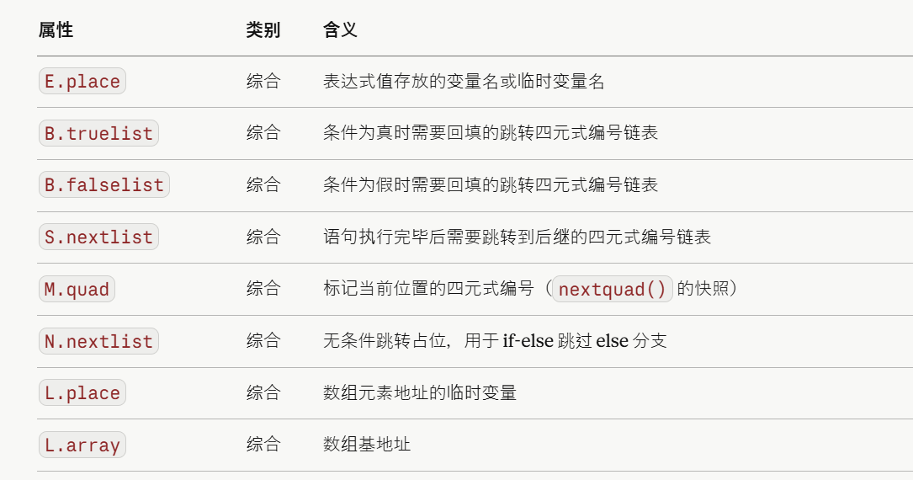
8.3 生成的四元式操作码对照
