

**L2Divine Guide Book**

Version 2.5

Last update: 2010-12-24

**Table of Contents**

[**Chapter 1: L2Divine Account** 8](#_Toc282360186)

[Create account 9](#_Toc282360187)

[Account Management 11](#_Toc282360188)

[**Chapter 2: Installation** 12](#_Toc282360189)

[.NET Framework Installation 13](#_Toc282360190)

[L2Divine Installation 13](#_Toc282360191)

[Virtual Map and Language Installation 13](#_Toc282360192)

[**Chapter 3: Interface** 14](#_Toc282360193)

[Main Screen 15](#_Toc282360194)

[Main Menu 15](#_Toc282360195)

[Setting 15](#_Toc282360196)

[Option 15](#_Toc282360197)

[About 16](#_Toc282360198)

[Config 16](#_Toc282360199)

[Create Account 17](#_Toc282360200)

[Game Account 18](#_Toc282360201)

[Control Panel 18](#_Toc282360202)

[Status 19](#_Toc282360203)

[Message 20](#_Toc282360204)

[Map 21](#_Toc282360205)

[Displays 21](#_Toc282360206)

[Map Function 21](#_Toc282360207)

[Shortcut 22](#_Toc282360208)

[Preference 23](#_Toc282360209)

[General 23](#_Toc282360210)

[Connection 23](#_Toc282360211)

[Alert 25](#_Toc282360212)

[Name 26](#_Toc282360213)

[Combat 27](#_Toc282360214)

[Condition > Fight 27](#_Toc282360215)

[Condition > Area 29](#_Toc282360216)

[Condition > Logout 30](#_Toc282360217)

[Condition > Misc 31](#_Toc282360218)

[Command 31](#_Toc282360219)

[Mob 32](#_Toc282360220)

[Item 33](#_Toc282360221)

[Team 34](#_Toc282360222)

[Party 34](#_Toc282360223)

[Leader 35](#_Toc282360224)

[Follower 35](#_Toc282360225)

[Trading 36](#_Toc282360226)

[Servitor 37](#_Toc282360227)

[Summoning 37](#_Toc282360228)

[Servitor Fight 37](#_Toc282360229)

[Feeding (Pet only) 37](#_Toc282360230)

[Unsummon (Pet only) 37](#_Toc282360231)

[Mini Game 38](#_Toc282360232)

[Fishing 38](#_Toc282360233)

[Manor 40](#_Toc282360234)

[Messaging Control 41](#_Toc282360235)

[Other 42](#_Toc282360236)

[**Chapter 4: Battle Setting** 43](#_Toc282360237)

[Battle Mode 44](#_Toc282360238)

[Normal Mode 44](#_Toc282360239)

[Hunting Mode 45](#_Toc282360240)

[Command 46](#_Toc282360241)

[Attack 47](#_Toc282360242)

[Example for Bounty Hunter, Fortune Seeker 48](#_Toc282360243)

[Example for Spell Singer 49](#_Toc282360244)

[Example for Warder 50](#_Toc282360245)

[Heal 51](#_Toc282360246)

[Example for Elven Elder 52](#_Toc282360247)

[Buff 53](#_Toc282360248)

[Example for Elven Elder 54](#_Toc282360249)

[Debuff 55](#_Toc282360250)

[Example 55](#_Toc282360251)

[Pet Attack 56](#_Toc282360252)

[Example for Hatchling 56](#_Toc282360253)

[Pet Assist 57](#_Toc282360254)

[Example for Hatchling 57](#_Toc282360255)

[**Chapter 5: Trading Setting** 58](#_Toc282360256)

[Private Store 59](#_Toc282360257)

[Shop Setting 59](#_Toc282360258)

[Item Setting 59](#_Toc282360259)

[Item Creation 60](#_Toc282360260)

[Marketplace Scan 61](#_Toc282360261)

[Auto Sell & Buy 64](#_Toc282360262)

[**Chapter 6: In game mode** 65](#_Toc282360263)

[Configuration (9.1.0 and later) 66](#_Toc282360264)

[Clean Hosts File 66](#_Toc282360265)

[Automatic installation 67](#_Toc282360266)

[Manual installation 67](#_Toc282360267)

[Configuration (9.0.8 and below) 68](#_Toc282360268)

[Automatic installation 68](#_Toc282360269)

[Manual installation 68](#_Toc282360270)

[Starting Puppet mode 70](#_Toc282360271)

[Starting Full mode 72](#_Toc282360272)

[**Chapter 7: Tip & Trick** 73](#_Toc282360273)

[Custom path point 74](#_Toc282360274)

[Change battle area using path point (Leader only) 75](#_Toc282360275)

[Open treasure chest 76](#_Toc282360276)

[Down Level 77](#_Toc282360277)

[Summon Friend (Summoner Only) 79](#_Toc282360278)

[**Chapter 8: Script** 80](#_Toc282360279)

[Writing a Script 81](#_Toc282360280)

[Code Comments 81](#_Toc282360281)

[Compare Operator 81](#_Toc282360282)

[Syntax 81](#_Toc282360283)

[Case sensitive 81](#_Toc282360284)

[One command per line 82](#_Toc282360285)

[Complete start and end scope 82](#_Toc282360286)

[Represent string with "" 82](#_Toc282360287)

[Global Property 82](#_Toc282360288)

[Including other script 83](#_Toc282360289)

[**Appendix A: Adding Microsoft Loopback** 84](#_Toc282360290)

[**Appendix B: Script command reference** 90](#_Toc282360291)

[AddHuntingArea(x, y, z, radius) 91](#_Toc282360292)

[AddRectHuntingArea(x, y, z, radius) 91](#_Toc282360293)

[AddItem(Item ID, Count), AddItem(Item Name, Count) 91](#_Toc282360294)

[BattleStart() 91](#_Toc282360295)

[BattleStop() 91](#_Toc282360296)

[BuffLevel(Skill ID), BuffLevel(Skill Name) 91](#_Toc282360297)

[ClearHuntingArea() 91](#_Toc282360298)

[CloseDialog() 91](#_Toc282360299)

[Confirm() 92](#_Toc282360300)

[CountItem(Item ID), CountItem(Item Name) 92](#_Toc282360301)

[CraftItem(Receipt ID) 92](#_Toc282360302)

[CrystalizeItem(Item ID), CrystalizeItem(Item Name) 92](#_Toc282360303)

[Delay(Millisecond) 93](#_Toc282360304)

[DestroyItem(Item ID, count), DestroyItem(Item Name, count) 93](#_Toc282360305)

[DialogContain(text) 93](#_Toc282360306)

[Dismiss(Name) 93](#_Toc282360307)

[DropItem(Item ID, count), DropItem(Item Name, count) 93](#_Toc282360308)

[EnchantItem(Item ID, Item ID) 93](#_Toc282360309)

[EnchantLevel(Item ID) 93](#_Toc282360310)

[Exit 93](#_Toc282360311)

[FishingStart() 93](#_Toc282360312)

[FishingStop() 94](#_Toc282360313)

[ForceAttack(NPC ID), ForceAttack(NPC Name) 94](#_Toc282360314)

[If () {} Else {} 94](#_Toc282360315)

[Include(filename) 94](#_Toc282360316)

[Invite(Name) 95](#_Toc282360317)

[IsMember(Name) 95](#_Toc282360318)

[Jump(Label) 95](#_Toc282360319)

[Label: 95](#_Toc282360320)

[LeaveParty() 95](#_Toc282360321)

[LocInRange(x, y, z, radius) 95](#_Toc282360322)

[Logout(Delay, Relogin Delay) 96](#_Toc282360323)

[MoveTo(x, y, z) 96](#_Toc282360324)

[Msg(Output, Message), Msg(Output, Message, Target) 96](#_Toc282360325)

[NpcDialog(NPC ID), NpcDialog(NPC Name) 97](#_Toc282360326)

[Return 97](#_Toc282360327)

[ReturnToVillage() 97](#_Toc282360328)

[ReturnToClanHall() 97](#_Toc282360329)

[SelectDialog(Link Name), SelectDialog(Link Index) 97](#_Toc282360330)

[SelectTarget(Name), SelectTarget(NPC ID) 98](#_Toc282360331)

[SetBattleArea(x, y, z, radius) 98](#_Toc282360332)

[SetRestArea(x, y, z) 98](#_Toc282360333)

[Sit() 98](#_Toc282360334)

[Stand() 98](#_Toc282360335)

[TargetInRange(Name), TargetInRange(NPC ID) 98](#_Toc282360336)

[TradeStart() 99](#_Toc282360337)

[TradeStop() 99](#_Toc282360338)

[UseItem(Item ID), UseItem(Item Name) 99](#_Toc282360339)

[UseSkill(Skill ID), UseSkill(Skill Name), UseSkill(Skill ID, Target), UseSkill(Skill Name, Target) 99](#_Toc282360340)

[While() {} 99](#_Toc282360341)

# Chapter 1: L2Divine Account

## Create account

To use L2Divine, you must have an active L2Divine account. To create an account, go to http://www.l2divine.com and select “Create Account” banner from the first page. After enter personal information then click “Create Account” and you will receive an activate code via email then login again to enter the code.



Click the “Register” banner.

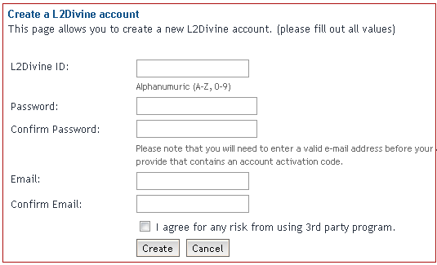

Enter your personal information and accept agreement.

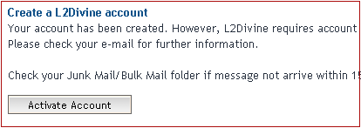

Registration complete

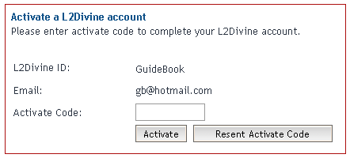

Activate your account

## Account Management

You may manage your L2Divine account via website at www.l2divine.com. Select “My Account” from the main menu. To access your account information you must log in using active L2Divine account and password. Areas of “My Account” include:

* Profile: This area gives you basic information on your account and also let you change your password.
* Game Account: Enter your Lineage II game account that you wish to bot here.



# 

# Chapter 2: Installation

## .NET Framework Installation

Before you can use L2Divine, the one component which must be met is Microsoft .NET Framework version 3.5 or above. You can check to see if you already have the .NET Framework installed by clicking Start on your Windows desktop, selecting Control Panel, and then double-clicking the Add or Remove Programs icon. When that window appears, scroll through the list of applications. If you see Microsoft .NET Framework listed, the latest version is already installed and you do not need to install it again. If not found that mean you need to install it, you can download it from Microsoft, after download complete, Install it and click next until installation finish.

Note! URL for download: http://download.microsoft.com/download/6/0/f/60fc5854-3cb8-4892-b6db-bd4f42510f28/dotnetfx35.exe

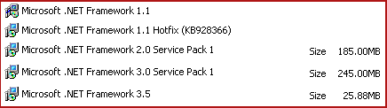

.NET Framework listed in your computer

## L2Divine Installation

After completely install Microsoft .NET Framework 3.5 it's time to install L2Divine. Installing L2Divine is simply by downloading latest released from download section and then unzips it to your local hard disk. You can launch L2Divine by double-clicking on L2Divine.exe.

## Virtual Map and Language Installation

Virtual Map and Language are not included with L2Divine installation file. You can download it separately at download section. After download the latest file, unzip into L2Divine\map and L2Divine\dat folder respectively. Your installation folder should look like figure below.

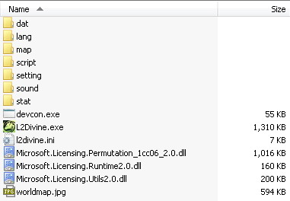

# 

# Chapter 3: Interface

In order to properly usage L2Divine, you must first understand the screen and interface. Start up L2Divine by double clicking at L2Divine.exe. L2Divine window will progress to loading resources at the moment and you will see main screen appear.

## Main Screen

Main screen include:

1. Main Menu: This is where you can set up account and options.
2. Account Area: The game account will be display here.

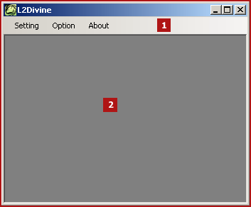

## Main Menu

Setting

* Create Account: Use to create the game account. Short Cut Key: F10
* Battle Start: To toggle on/off all accounts in battle mode. Short Cut Key: F11
* Disconnect: Disconnect all accounts from the game. Short Cut Key: F12
* Close Account: To close active account window.
* Config: Allow you to configuration the server information.
* Exit: Close L2Divine window.

### Option

* DAT Language: Allow you to change data language to English, Chinese, Japanese, Korean, Russian and Thai.
* UI Language: Allow you to change user interface language.
* In Game Mode: Allow you to switch between puppet and full in game mode.
* Hide when minimize: Hide your L2Divine window to window task bar when minimize.
* Proxy Setting: Allow you to use SOCKS5 proxy. Checking on “Use SOCKS5 Proxy” and provide proxy detail.
* Diagnostic: Allow you to diagnose problem of IG mode installation.
* Join DivineDB community: Allow L2Divine to report item drop and NPC location to share among L2Divine user. See more detail at http://www.l2divine.com/divinedb

### About

* About: Your L2Divine version information.

## Config

These windows allow you to configuration server information.

1. Auth Server: Always http://www.l2divine.com
2. L2Divine ID: Your L2Divine ID
3. PWD: The password of your L2Divine ID
4. Profile: Select your server profile. Don’t forget to check on “Set as default Profile”. This option enables you to use Full IG mode.
5. Login Server IP: Login server IP
6. Login Server Port: Login server port
7. Protocol Version: The protocol version.
8. Game Server: Game server list (Separate by ;).

**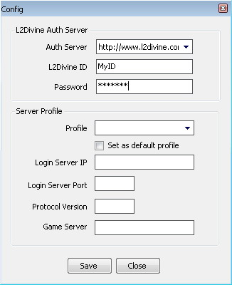**

Note! All setting information is kept in file l2divine.ini. Do not share this file with others because it contains your password.

## Create Account

This window allows you to start up the game account. Below is required information:

1. Lineage II ID: Your Lineage II ID.
2. PWD: The Lineage II password.
3. Character: The character you wish to play. (Select manual for first time)
4. Server Profile: Your server profile.
5. Game Server: The game server you wish to play. (Select manual for first time)
6. Setting File: Setting file for control your character in automatic mode. (Create as your character name for first time)
7. Auto Create: Checking it if you want to automatic create this account next time.
8. Sync Login: Checking it if you want to synchronization all auto creates account. (If this option was checked, All automatic create account will be wait and enter to the game simultaneously)
9. Save: Check for save account setting

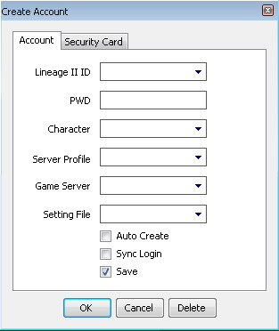

Please remember: The account you wish to play must be registered under active L2Divine account. To register game accounts go to “My Account” at [www.l2divine.com](http://www.l2divine.com).

After enter required information, then press “OK” button to start up game account. The game account will show up in moment.

## Game Account

Game account window separate into 4 parts:

1. Control panel: Display character status, target status and automate button.
2. Status: Displays various details regarding a character.
3. Message: Displays system message, chat, party and so forth within the game.
4. Map: Display virtual map, shortcut, player, NPC, Mob.

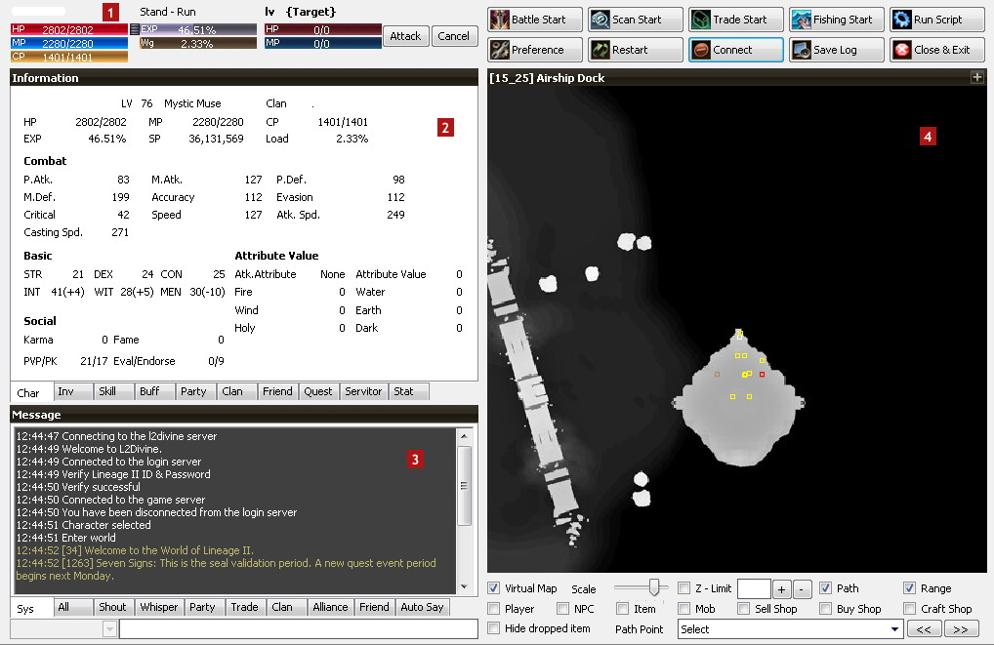

## Control Panel

The control panel enables you to see character status, target status and automate button.

* Character: Display HP, MP, EXP, Vitality, CP and Weight (%).
* Character Action: Display your character movement (Walk/Run) and action (Sit/Stand).
* Target: Display target HP and MP and allow forcing attack.
* Automate Button: Enable you to battle, trade, marketplace scan, fishing, run script and open preference window for set up automate command.

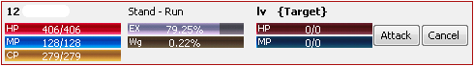

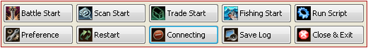

## Status

Display various details of your character.

* Char: Displays the character status
* Inv: Displays the items in character inventory. Grouping into equipment, item and quest. Double-click on an item icon to use it, or use button to drop, destroy, crystallize and Give to Pet.
* Skill: Displays information about magic the character can utilize. Grouping to active and passive. Double-click the skill name for the magic spell to be used or, click to see additional information.
* Buff: Displays skill affected on character.
* Party: Displays party information.
* Clan: Allow you to see clan information and enable you to use clan function.
* Friend: Displays friend name and their status.
* Quest: Displays your current quest and allow you to abort it.
* Summon/Pet: Displays servitor of character
* Stat: Logging your activity, Environment information. Grouping to Player, Mob, NPC, Item, Battle, Trade and Marketplace.

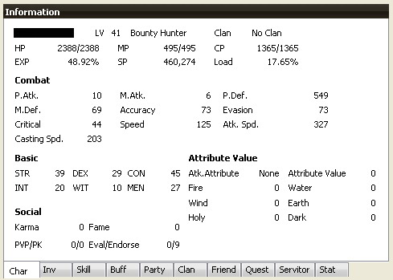

## Message

Displays messages within the game

1. Message Panel: Display system message, party, clan, ally and etc.
2. Auto Say: Enable you to automatic send 5 different type of message in periodical.
3. The text entry field: Used to enter game commands or message to other players in the game. All sent messages will keep in history. You can scroll thought it by press Up and Down arrow button.

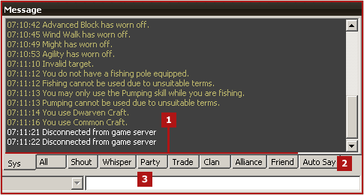

## Map

### Displays

L2Divine displays player, NPCs, mob and item in virtual 2D shape.

* Character: Display as white box in middle of map.
* Player: Display as blue box.
* NPCs: Display as yellow box.
* Mob: Display as red mob or violet box if spoil condition had been activated.
* Item: Display as pink box

Character, player and mob will be display as pink box if affected with abnormal status (Sleep, Hold, and etc). You can action on map by move mouse over each box to see name, click to select target or double click to forcing attack target. Right click on map to see more basic function such as sit/stand, walk/run.

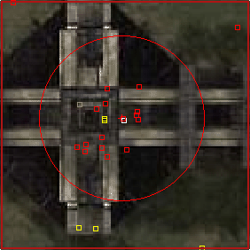

### Map Function

Allow you to manage display of map

* Virtual Map: Toggle display of background map.
* Map scale: Allow you to zoom in/out.
* Z-Limit: Allow you to limit display in vertical direction (Z).
* Increase Altitude (+): Allow you to move up while flying.
* Decrease Altitude (-): Allow you to move down while flying.
* Path: Toggle display of path point.
* Range: Toggle display of range.
* Player: Toggle display of player.
* NPCs: Toggle display of NPCs.
* Item: Toggle display of item.
* Mob: Toggle display of mob.
* Sell shop: Toggle display sell shop title (pink color) on trading player.
* Buy shop: Toggle display buy shop title (yellow color) on trading player
* Craft shop: Toggle display craft shop title (Brown color) on trading player
* Hide dropped item: Allow you to hide dropped item on ground.
* Path point: Enable you to automatic move along with path point in forward or backward direction.

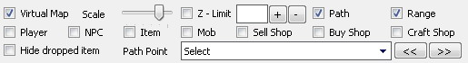

### Shortcut

Allow you to manage shortcut for skill, item, action and script. You can add, edit, delete or schedule your shortcut by right click on slot 1 to 10. The shortcut window required following information.

* Skill: Allow you to use skill.
* Item: Allow you to use item.
* Action: Allow you to action.
* Servitor: Allow you to use pet/summon action. 8.4.4
* Script: Allow you to run script (Not support for schedule).
* Schedule Time: Allow you to repeat shortcut execution in period of time (Optional and supported only skill, item, action and servitor).
* Icon: Allow you to change shortcut icon with 36x36 image file (bmp, jpg, gif, png).

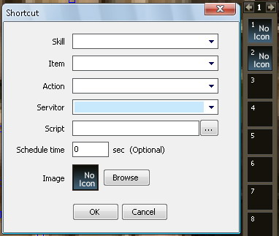

If you want to active/abort your schedule shortcut, Right click on it and select “Active Schedule” or “Abort Schedule”. The active schedule shortcut will be display with blue border. Shortcut3.gif Clicking on small icon Untitled.jpg/Untitled.jpg in top-right corner of map to hide or show shortcut slot.

## Preference

Enables you to manage command for automate task. The setting file will named as your character, prefix with INI and save in \setting folder.

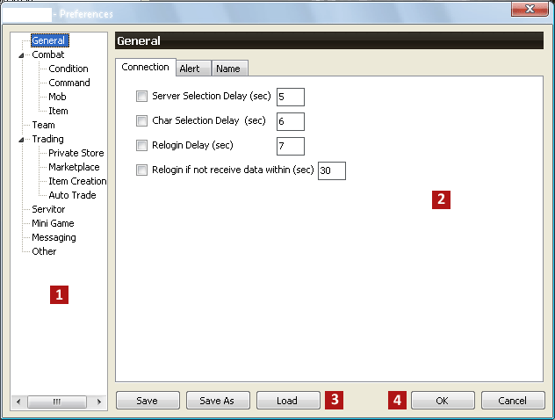

### General

#### Connection

* Server Selection Delay: Allow you to delay in second to select the game server.
* Char Selection Delay: Allow you to delay in second to select character.
* Re-login Delay: Enable you to re-login when server connection lost or character logged out by other condition such as attacked by unknown player.
* Re-login if not receive data within: Enable you to re-login after not receive data within time.

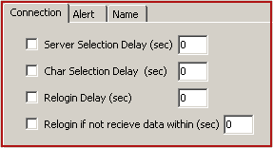

#### Alert

Gives you alert with sound and balloon message.

* Alert only when minimize to tray: Option to give you an alert when L2Divine minimize to tray only.
* Sound: The ringing sound will come up when your character petition by GM, dead, attack/found by enemy or other player, HP fall below limit and disconnect from server. (Press sound_btn.jpg to change sound file)
* Balloon: Allow you to alert by balloon message.

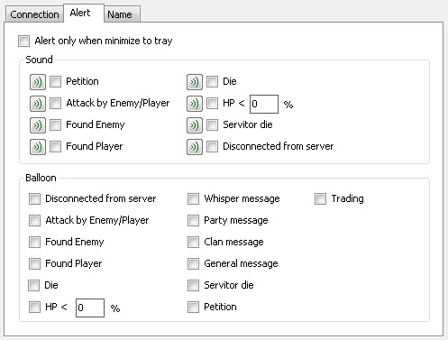

#### Name

Allow you to group player or none-player character to Friend, Enemy, Clan War and RaidNPC. Following are proposed for each group

* Friend: List of your friend, no action required but they can resurrect your character.
* Enemy: List of character which L2Divine will logout or give you alert by sound/balloon when found them.
* ClanWar: List of your clan war. L2Divine will action like enemy when someone in this clan appears.
* RaidNPC: Name of NPC/Mob that you don’t wish to fight Exe. Witch Wader. L2Divine will logout when found them.

See more detail about Logout in Combat > Condition > Logout

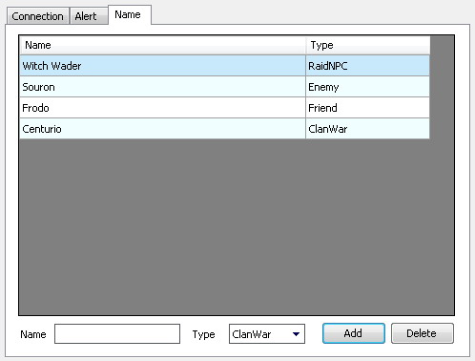

### Combat

Enable you to set command and condition for battle.

#### Condition > Fight



* I'm combat leader: Set character to be team leader who lead teammate and make decision what team should do such as select target or pickup item.
* Battle Mode: Select Normal or Hunting Mode. Each mode has different battle style. Normal mode will fight mob at current location and only required hunting area. Hunting mode will draw mob to battle area before fighting and required both Hunting and Battle area. See more at Battle Setting.
* Battle after login: Enable you to start battle after login.
* Fight Delay: Delay time in second before target to new mob.
* Pickup item: Set character to pickup item in range.
* Pickup unknown item: Force character to pickup unknown item.
* Loot Item & Mob: Loot Item & Mob from other player.
* Change target when other player select mob: Change target if other player select your mob.
* Timeout: Action timeout if target can’t reach or pickup.
* Accept revive from other player: Accept resurrection from other player (Anyone who not in friend list).
* Auto attack aggressive mob: Auto attack mob that target or attack your character.
* Attack unknown mob: Force character to attack unknown mob.
* Sweep & Sow before attack: Force character to sweep and sow mob before attack.
* Pickup item before attack: Force character to pickup item before attack mob.
* Auto counter attack: Enable character to counter attack aggressive mob when not in battle mode.
* Pickup only my item: Force character to pickup only its item.
* Sit: HP and MP (%) condition for rest.
* Stand: HP and MP (%) condition for resume to battle.
* When not found mob: Allow leader to choose whether wait, rest, change hunting area or back to center of area.
* Change to nearest target: Allow team leader to change target to nearest.
* Auto attack high priority mob: Allow leader to change to high priority mob. See how to specified high priority mob at Mob section.
* Pickup item in hunting area: Allow character to pickup item in hunting area only. (Follower will use leader’s hunting area automatically) 8.4.4

#### Condition > Area

Enable you to set battle range.

* Hunting Area: Range for hunting mob. Depend on your battle mode if you select for normal mode, your character will fight mob suddenly in this area (Red circle/rectangle/polygon on map). For hunting mode, this area use for lore mob only. Leader will select target in this area and lead it back to battle area (Yellow circle/rectangle/polygon on map). Only leader is required for this area.
* Battle Area: Actual fights happen on this area. This area required for both leader and follower if you select for hunting mode (show in red circle color).
* Rest Area: Range for your character to rest when HP or MP (%) falls below limit. Rest area will be shown in green cross (**+**) on map. You can leave this area to blank if you want to use current location to rest.

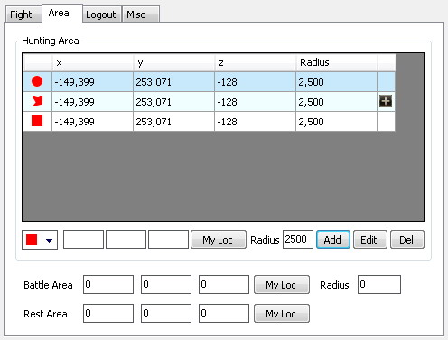

To add polygon range, clicking on D:\Project\Elysian\src\Client\L2Divine\Resources\icon_plus.bmp to open “Area path” windows.

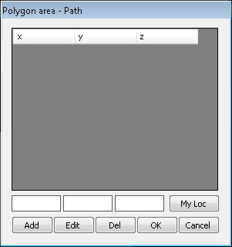

#### Condition > Logout

Enable you to set condition for leave the game.

* Move to rest area before logout: Allow your character move to rest area before logout. Rest area is required. This condition will effect to all other logout event.
* HP<n% logout: Allow you to logout when HP (%) fall below limit and back to the game in second. (Set re-login to 0 if you don’t want to back to the game)
* GM petition: Allow you to logout when petitioning by GM.
* Attacked by Enemy/player: Allow you to logout if enemy or other player attack on you. (You can set enemy name at General > Name)
* Found Enemy: Allow your character logout if enemy appear in range.
* Found Player: Allow your character logout if player appear in range.
* Found Clan war: Allow your character logout if member of clan war appear in range.
* Found RaidNPC: Allow your character logout if NPC appear in range.
* Player lock by mob: Enable you to logout if other player targeted by mob more than limit.
* When X < N: Allow you to logout when item lower than limit.
* When server will be down: Allow you to logout before server down.
* Not gain exp: Allow you to logout if your character not gains EXP.
* Pet hunger <n%: Allow you to logout when pet hunger fall below limit.

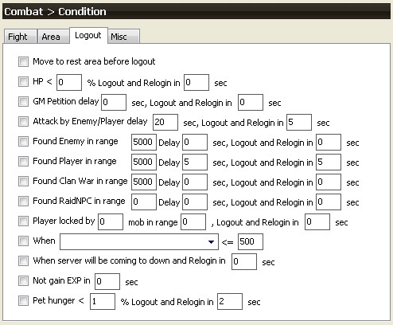

#### Condition > Misc

* Use X when Y < N: Enable you to use skill or item when specified item fall below limit.
* Die return: Allow you to return to village, clan hall, castle etc when die.
* Stop battle when level: Enable your character to stop battle at certain level.

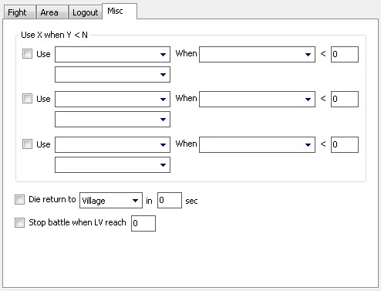

### Command

Command is a set of action that controls your character in battle mode. Grouping to Attack, Heal, Buff, Debuff, Pet Attack and Pet Assist. See more in Battle Setting

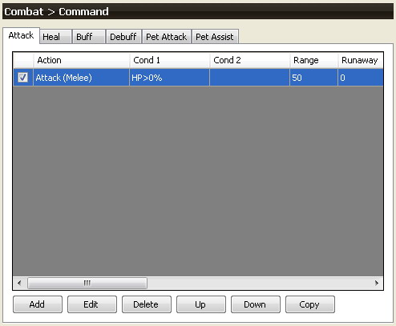

### Mob

Give you certain information about mob, like name, level, and title. It also allows you to set condition for attack, spoil, seed, priority and soul/spirit shot. You can toggle selection by “Check all/Uncheck” all button.

Additional, you can avoid attacking on some mob by defined it title by check on “Not attack mob titled” and given title. For example, “Lv 50 Special Mob, Quest Monster“.

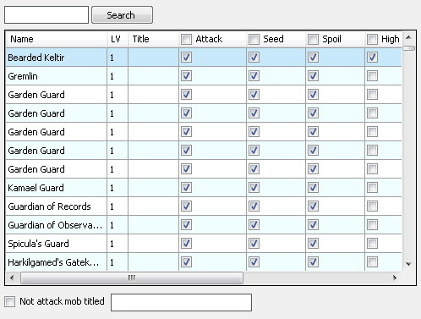

Note! Clicking on column header to sorting data (Apply to all grid).

### Item

Give you certain information about item like name, type and grade. It also allows you to set condition for pick, destroy and auto use item while in battle and fishing.

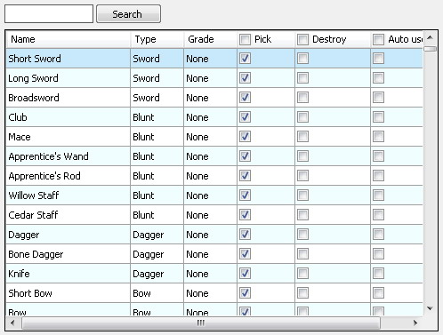

### Team

Enable you to set team action and the game party.

Note! Each account on same L2Divine can detect each other status without joining the game party.

#### Party

* Loot: Allow you to set party loot.
* Auto invite: Allow you to invite certain player to join the game party.
* Invite: Allow you to invite and dismiss certain player in periodical.
* Auto accept invite: Enable you accept party invite from certain player.
* Reject party invite from unknown player: Allow you to reject invite from player that not in your friend list.
* Dismiss party when become leader: Allow you to dismiss party if you are leader.

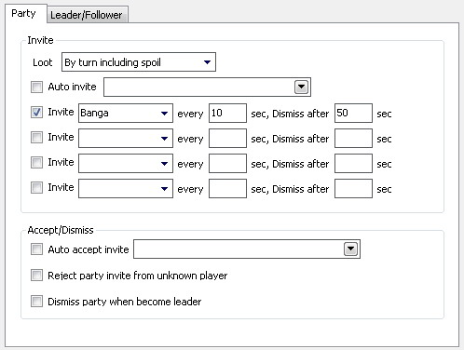

#### Leader

Leader is character who leads battle. (Checked “I'm combat leader” in Combat > Fight). Only 1 leader permitted in a team.

* Rest: Enable leader to rest when certain teammate MP (%) fall below limit.
* Protect: Allow leader to protect teammate with skill and shot item when under attack by mob.
* Pause combat when member dead: Allow leader to wait if one of teammate die. Use this to wait for the healer using resurrection skill.
* Pause combat when member not in party: Allow leader to wait if one of teammate doesn’t in party.

#### Follower

Follower is member of team that action follow leaders.

* My Leader is: Enable you to select certain player to be your leader.
* Follow movement distance: Enable character to move follow leader.
* Assist leader attacking: Enable character to assist leader to attack mob. (Command attack is required)
* Attack when leader selected target: Enable character to attack mob when leader selected target
* Follow shot: Enable character to use certain shot follow leader.
* Follow rest: Allow you to rest when leader sit.
* Auto rest: Allow your character rest when idle.
* Follow return: Enable character to use skill or item to return to nearest village when leader returns.
* Follow social action: Enable you to follow leader social action. (Victory, Dance etc.)
* Follow logout and relogin: Allow you to follow leader to leave the game.
* Follow NPC chat: Allow you to follow leader to chat with NPC.

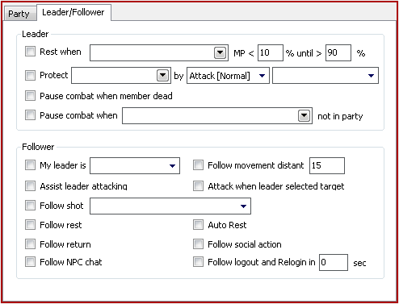

### Trading

Enable you to sell, buy, trade and creating item. It also allows you to set marketplace scan and auto sell and buy item. See more in trading setting.

### Servitor

Enable you to call servitor like summon or pet in battle. Servitor information will display in status window on Servitor information tab.

#### Summoning

* Summoning: Select item to call pet or select skill to call summon.
* Summon pet when master HP (%): Allows you to set HP limit before call pet. (Pet only)

#### Servitor Fight

* Assist master attacking: Enable your servitor to assist master fight with mob. Pet Attack command is required.
* Rest when summon time: Allows master to rest when summon time (%) fall below limit.
* Protect servitor: Enable master to protect servitor.
* Automatic Use: Enable automatic use pet shot.

#### Feeding (Pet only)

* Your pet food: Select food for your pet.
* Give food to pet: Allow master to give amount of food to pet when hunger (%) fall below limit.

Note! When hunger gauge fall below 55% your pet will eat food automatically.

#### Unsummon (Pet only)

* Out of food: Return pet to born when food is run out.
* Hunger (%): Return pet to born when hunger gauge fall below limit.
* HP (%): Return pet to born when hp lower than limit.
* Master HP (%): Return pet to born when master hp lower than limit.

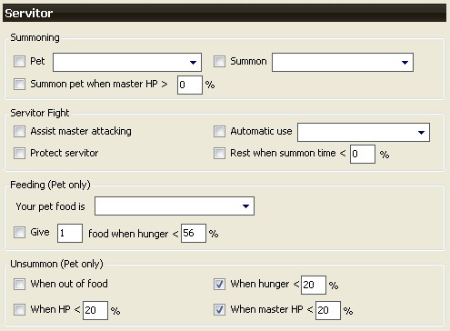

### Mini Game

#### Fishing

Enable you to set condition for fishing. To start fishing, press “Fishing Start” at control panel.

* Fishing after login: Enable you to start fishing after login.
* Battle if caught mob: Enable you to battle when caught mob. Command attack is required (Do not forget to set to equip R-HAND and L-Hand weapon).
* Logout if caught mob: Allows you to logout when caught mob. Useful with Healer who not strong enough to fight with mob.
* Auto detect night fish: Enable character to change luminous lore when night fall for catch night fish.
* Fishing potion: Allows you to use fishing potion every 1 hour.
* Fishing shot: Allows you to use fishing shot.
* Use fishing shot when fish hp (%): Enable you to use fishing shot when fish HP greater than limit.
* Use fishing shot when time: Enable you to use fishing shot when time fall below limit
* Change location: Enable you to change fishing location in periodical.
* Location: Enable you to fishing at certain location. (Note! You can leave this area if you want to use current location as fishing spot but your location must in water area). This option use together with “Change location every n minute”. Benefit of change location is avoided dropping of success rate when fishing in same area for a long time. Location contain 2 point are “Fishing” and “Moving”. Fishing is area that you actual fishing (Display as Red Cross (**+**) in map). Moving is area that your character will move along when change location (Display as Green Cross (**+**) in map). Moving location should behind and far enough to fishing location to guarantee your character is always turn face to water area.

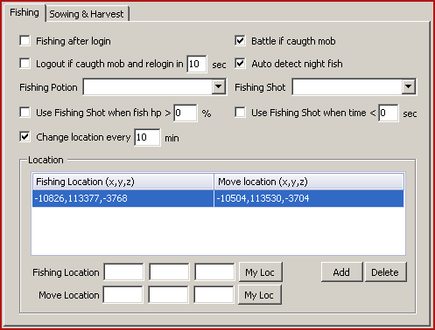

For instance, Figure below is correct setting for fishing on multiple locations. When start fishing, your character will action following:

1. Move to nearest “Moving location” and forward to “Fishing location”. (Location 1 in figure)
2. Fishing start here until change area time reaches. Your character will move back to “Moving location 1” then move forward to “Moving location 2”.
3. Move forward to “Fishing location 2” and start fishing again!

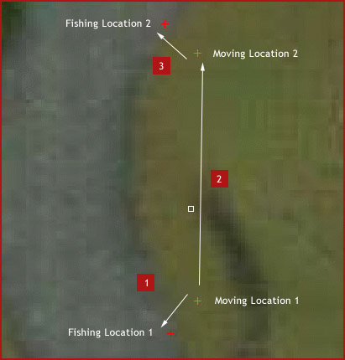

#### Manor

Enable you to sowing in battle.

* Auto Sowing & Harvest: Enable sowing in battle.
* Seed: Seed type to sow.

Note! If you want to spoil, your dwarves should sowing to protect corpse disappear after sweeper before using harvester tool.

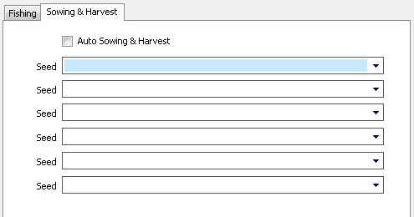

### Messaging Control

Enable you to response skill on other player via whisper message.

* Name: Requester name
* Message: Whisper message
* Skill: Response skill

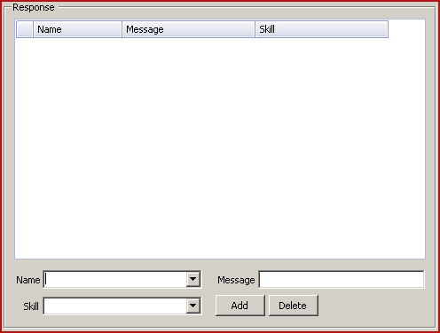

### Other

* Show target LV and HP in IG mode: Give you target information (Level and HP) when selecting mob in IG mode.
* Auto start script after login: Auto starts script after login to game.
* Force use skill: Allow you to force use skill (Like press CRTL key)
* Auto save log before logout: Auto save log before your character logout
* Auto recommend: Allow you to recommend player after enter world.



# 

# Chapter 4: Battle Setting

## Battle Mode

There are 3 types of battle style in L2Divine, Normal, Hunting and Siege mode. Normal mode will fight mob at its location. Hunting mode will draw mob to battle area before fight. Siege mode will give you a chance to fight with NPC.

### Normal Mode

As mention above, this mode will fight mob at its location so both leader and follower will move together in battle. The way to enable your character in normal mode:

1. Select battle mode to Normal mode. (Combat > Condition > Fight > Battle Mode)
2. Leader only: Choose hunting areas by giving hunting location and range (Com > Condition > Area > Hunting). You can see giving area as red circle/rectangle in virtual map.
3. Follower only: Select leader name to lead battle. (Team > Leader/Follower > My Leader is)
4. Set command and other condition then press “Battle Start”

**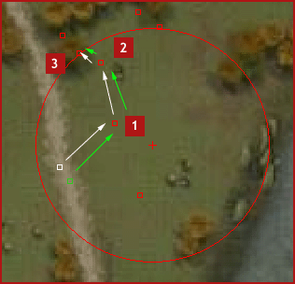**

### Hunting Mode

In this mode, Leader and Follower will have different action:

* Leader: Leader will find nearest mob in hunting area. After locked by mob (If target is not aggressive type, your character will attack it once), leader will draw mob back to battle area and start to fight when reach.
* Follower: Follower will wait at battle area and do not action on (Attack, Heal and Buff) any target outside an area.

The way to enable your character in hunting mode:

1. Select battle mode to Hunting mode. (Combat > Condition > Fight > Battle Mode)
2. Leader only: Choose hunting areas by giving hunting location and range (Com > Condition > Area > Hunting). You can see giving area as yellow circle in virtual map.
3. Choose battle areas by giving battle location and range (Com > Condition > Area > battle). You can see giving area as red circle in virtual map.
4. Set command and other condition then press “Battle Start”

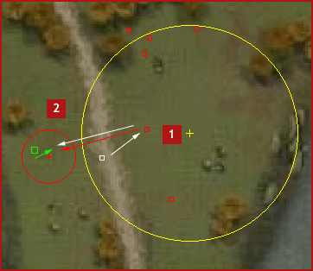

## Command

In order to battle you must set command. Command is a set of action grouping to Attack, Heal, Buff, Debuff, Pet Attack and Pet Assist.



### Attack

Command attack is action for attack mob. Execute in order and restart when targeting to new mob.

* Attack By: Select Attack (Melee) or Skill.
* Attacker Condition 1: Your HP, MP, CP (%), Soul (Unit) and Force (Unit) condition
* Attacker Condition 2: Same as condition 1 (Optional)
* Range: Distance between you and target to attack. Looking for skill range at Status > Skill.
* Shot: Select shot to use.
* Repeat: 1 time (Do only 1 time and ignore for result), Until success (Repeat until skill result success) and Until target die.
* Runaway: Runaway range after launch skill.
* Mob No: Number of surrounded mob.
* Mob HP: HP (%) of mob.
* Target: Attacking target. There are 2 types: Leader’s Target (Attack on current leader target) and Targeting Team (Attack on other mob that under attack your team).
* R Hand: Equipping weapon/shield on your right hand.
* L Hand: Equipping weapon/shield on your left hand.
* NPC ID: MOB ID to attack with this command. If not specified, all mobs will be applied. 8.4.4

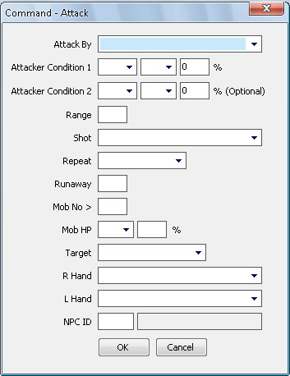

#### Example for Bounty Hunter, Fortune Seeker

1. Spoil 2. Attack (Melee)

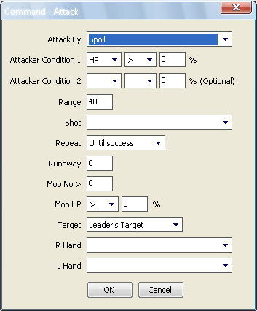 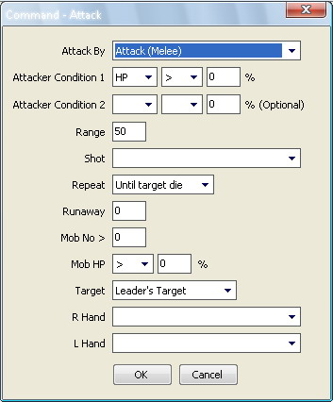

3. Sweep

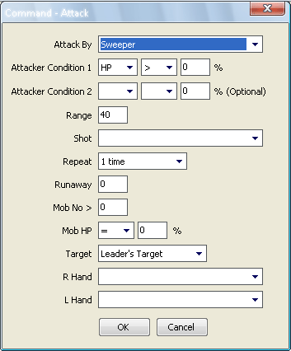

#### Example for Spell Singer

1. Solar Flare 2. Aqua Splash

**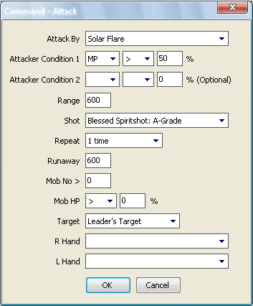 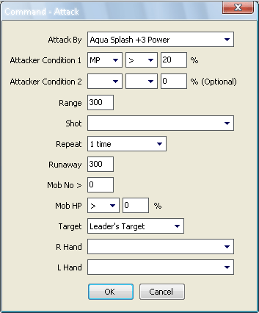**

3. Sleep

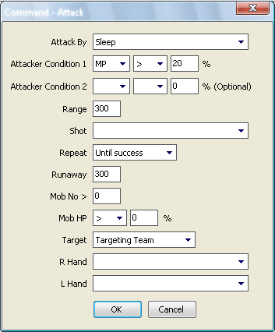

#### Example for Warder

1. Fallen Attack 2. Normal Attack

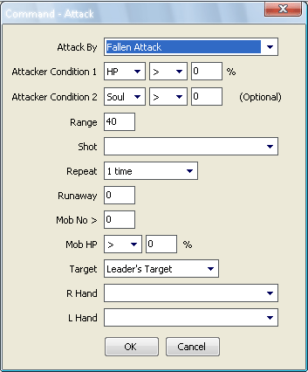 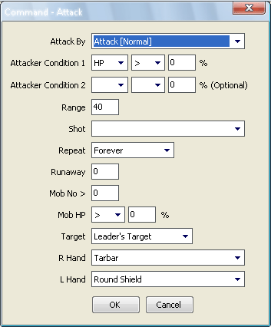

Note! This is just few examples. Create command that best with your battle style.

### Heal

Command heal is action for healing you and your teammate like Greater Heal, Resurrection and Recharge. Execute by condition.

* Target Name: Healing target. (Use “Self” to represent yourself and separate each name by comma)
* Pet Only: Allows you to heal on target’s servitor.
* Healer MP(%): Healer MP(%) limit
* Target Condition 1: Target HP, MP and CP (%) condition.
* Target Condition 2: Same as condition 1 (Optional).
* Action by Skill: Healing skill to use.
* Action by Item: Healing item to use.
* Detection: Auto Detect: Use if currently skill not effect, Delay: Use in periodical and Immediately: Use immediately.
* Shot: Shot to use.
* Priority: High: Use in battle, Low: Use when idle.
* Do not select target: Allow character action without select on target.
* Group heal: Condition to check entire group (All name in target). 8.4.4

Note! Target Condition1, Target Condition 2 and Delay will be ignoring in detection type delay.

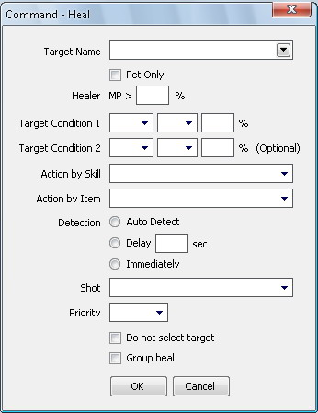

#### Example for Elven Elder

1. Greater Heal 2. Resurrection

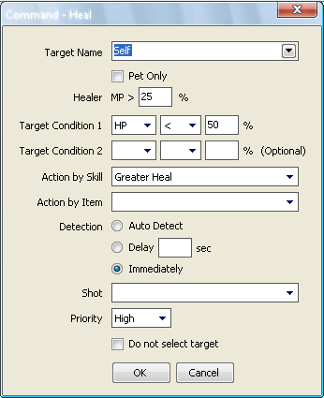 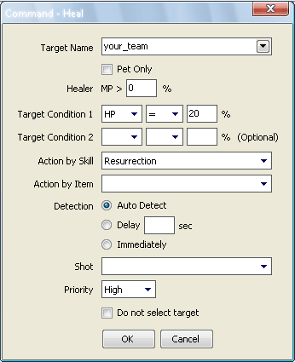

3. Recharge

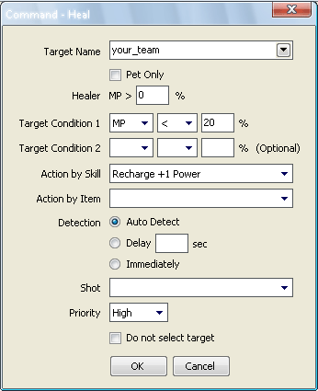

### Buff

Command buff is action for buffing you and your teammate like Wind Walk, Might and Shield. Execute by condition.

* Target Name: Buff target.
* Pet Only: Allows you to buff on target’s servitor.
* Buffer Condition 1: Buffer HP, MP, CP (%), Soul and Force condition.
* Buffer Condition 2: Same as condition 1 (Optional).
* Action by Skill: Buff skill to use.
* Action by Item: Buff item to use.
* Detection: Auto Detect: Use if currently skill not effect, Delay: Use in periodical, Toggle On: Use if not effect and Toggle Off: Use if effected.
* Priority: High: Use in battle, Low: Use when idle.
* Shot: Shot to use before action. 8.4.4
* R Hand: Equip weapon before action. 8.4.4
* Party Only: Action when in party.
* Do not select target: Allow character action without select on target.

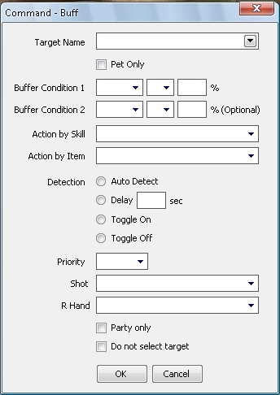

#### Example for Elven Elder

1. Might

**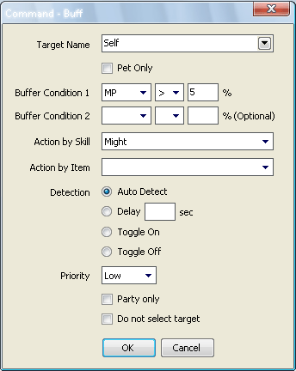**

### Debuff

Command debuff is action for remove abnormal effect from you and your teammate like Poison, Death Penalty and Bleed. Execute by condition.

* Target Name: Debuff target.
* Pet Only: Allows you to debuff on target’s servitor.
* Debuff: Skill effect to remove
* Healer Condition MP (%): Healer MP limit
* Action by Skill: Debuff skill to use. (Include normal attack to wake up from sleep)
* Action by Item: Debuff item to use.

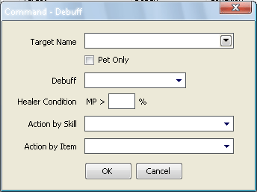

#### Example

1. Paralysis

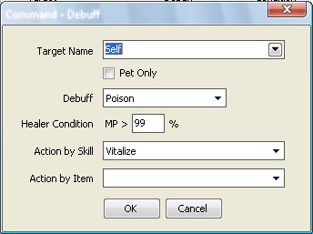

### Pet Attack

Command pet attack is action for servitor to attack mob along with master. (Activate by check “Assist master attacking” at Servitor > Master Assists). Execute in order and restart when master targeting to new mob.

* Attack By: Pet skill
* Hunger: Hunger limit (Only pet and left 0 for summon)
* Pet HP: Servitor HP (%)
* Pet MP: Servitor MP (%)
* Range: Range between master and mob to start servitor action
* Beast Shot: Allows servitor to use beast shot.
* Repeat: Repeating time like Until target die and 1 Time
* Mob HP: HP Condition to attack mob

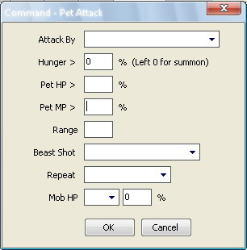

#### Example for Hatchling

1. Bright Burst 2. Attack

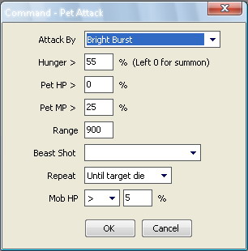 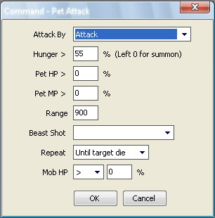

### Pet Assist

Command pet assist is action for servitor to support master or itself like Servitor Recharge and Servitor Heal. Execute when condition is true.

* Target name: Target to assist
* Pet MP: Servitor MP limit
* Target Condition 1: HP, MP and Hunger condition of target
* Action by Skill: Use pet skill
* Action by Item: Use item in pet inventory
* Detection: Auto Detect: Use if currently skill not effect, Delay: Use in periodical
* Do not select target: Select target or not

#### 

#### Example for Hatchling

1. Bright Heal

**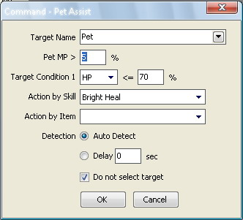**

# 

# Chapter 5: Trading Setting

Trading is rich features of L2Divine. With multiple trade functions, make your trading very easy. Go to Preference > Trading to see function that L2Divine can do.

## Private Store

Enable you to set up private store like buying, selling and craft item.

### Shop Setting

* Shop after login: Allows you to setup private store after login
* Default shop: Select your default private store
* Reset shop every: Time (minute) to reset store
* Cycle item for Sell/Buy shop: Enable you to cycle item when store being reset
* Logout after shop empty: Allows you to logout when items sold out. (Sell shop only)
* Shop location: Location that your store will be setup. If not set, current location will be use.

### Item Setting

* Shop type: Allows you to set items of store
* Shop title: Allows you to set title of store
* Package Sell: Enable you to setup package sale (Store sale only)

**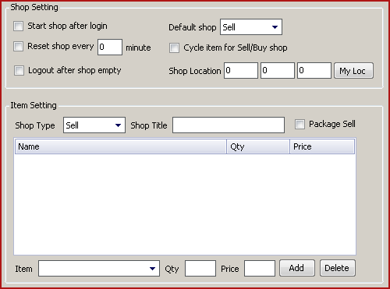**

## Item Creation

Enable you to create item automatically.

* Recipe: Display recipe include common and dwarven
* Qty: No of item to create
* M(%): MP limit
* Load(%): Weight limit
* Delay (Second): Creation delay time

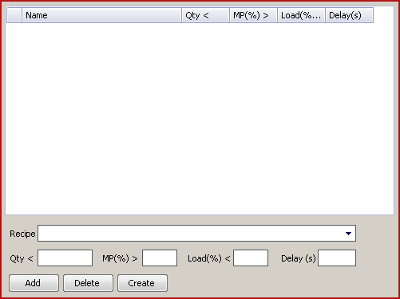

Note! You can create item while battle or trading by press “Create” before “Battle Start” or “Trade Start” button.

## Marketplace Scan

Enable you to search item in player store.

* Start shop after scan complete: Allows you to setup private store after scan complete (Private store setup is required)
* Shop type: Allow you to select store type to scan.
* Rescan every: Time(minute) to rescan marketplace.
* Scan location: Range for scan (Multiple supported). If not set, your current location will be use at range 3,000.
* Preview: Enable preview of scan location in virtual map. Display as yellow circle.

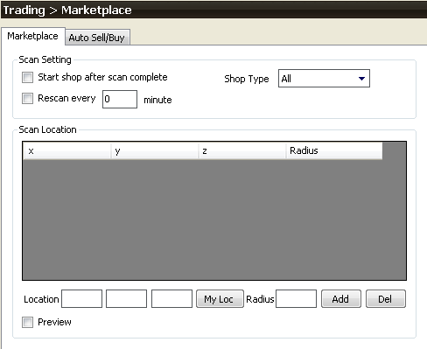

The way to enable your character in marketplace scan mode:

1. Giving scan range.

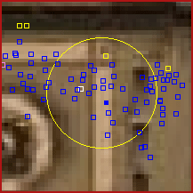

1. Press “Scan start” at control panel and wait until finish. (Your character will moving and progress message will display during scan)

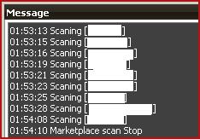

1. Go to Information > Stat > Marketplace to see scan result.

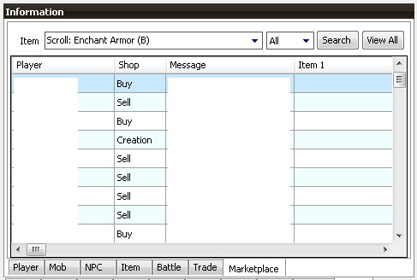

Marketplace stat gives you certain information include:

* Player store information: Allows you to see player store information nearby like player name, store type, store title, item, qty and price (Click on the name to see more information). Only store title will show at first time. Item name, quantity and price will show up after scan.
* Filter: Allows you to filter founded item.

Note! Double click on player name to move your character to player location.

1. Filter interest item by select item, store type and press “Search”.

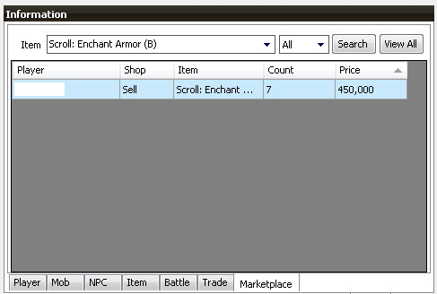

Search result will give you all item that founded from scan process include quantity and price . For instance, Figure above show all “Scroll: Enchant Armor (B)” in marketplace. Only one store sells it with 7 pieces at 450,000 adena. Use search result to compare best price to save your adena!

Note! To go back to marketplace, click on “View All”

### Auto Sell & Buy

Enable you to sell and buy item during marketplace scan.

* Type: Select trading type to sell or buy.
* Item: Item to sell or buy
* Qty: Item quantity
* Price: Item price.

For instance, your character will sell “Shining Arrow” to store that buy at price 1,000 or more. In other word, your character will buy “Animal skin” from store that sell at price 400 and below.

**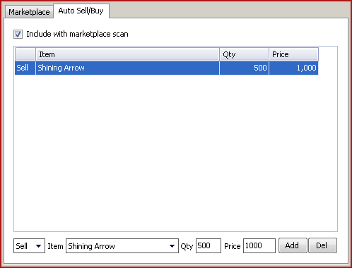**

# 

# Chapter 6: In game mode

Enable you to use game client in automatic mode. L2Divine has 2 In Game modes:

* Puppet: Using OOG and IG together. Firstly, you need to create OOG account and as long as OOG still connected you can switch to IG anytime.
* Full: Using only game client normally.

To switch between IG mode, Go to Option > In Game mode

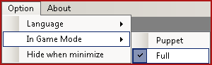

## Configuration (9.1.0 and later)

The way to configuration L2Divine 9.1.0 and later to support In Game mode:

### Clean Hosts File

Remove anything related to Lineage2 in your hosts file.



Note! Hosts file location for windows XP/Vista/7 is

“C:\WINDOWS\system32\drivers\etc” and “C:\WINNT\system32\drivers\etc” for

windows 2000.

### Automatic installation

Go to Option > Diagnostic and press “Auto Fix”. L2Divine will automatic create required component that need to run IG mode for you. You probably diagnose your IG problem by press “Check”. If everything OK, you should see every step done with PASS.



### Manual installation

1. Edit login information (Setting > Config):
   * Select your server profile
   * Check “Set as default profile”
   * Input login server IP

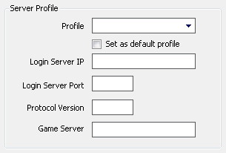

1. Create 2 Microsoft Loopback with following IP address:

* IP1 : 61.90.252.1, Sub net mask : 255.255.255.252

Note! Read about adding Microsoft Loopback at Appendix A

## Configuration (9.0.8 and below)

The way to configuration L2Divine 9.0.8 and below to support In Game mode:

### Automatic installation

Go to Option > Diagnostic and press “Auto Fix”. L2Divine will automatic create required component that need to run IG mode for you. You probably diagnose your IG problem by press “Check”. If everything OK, you should see every step done with PASS.

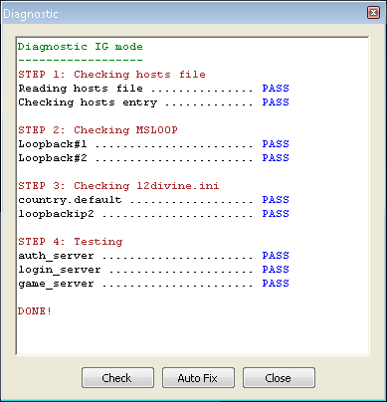

### Manual installation

1. Edit login information (Setting > Config):
   * Select your server profile
   * Check “Set as default profile”
   * Input login server IP



1. Create 2 Microsoft Loopback with following IP address:

* IP1 : 61.90.252.1, Sub net mask : 255.255.255.252
* IP2 : 61.90.252.2, Sub net mask : 255.255.255.252

Note! Read about adding Microsoft Loopback at Appendix A

1. Add your host name and IP1 to your Hosts file

* 61.90.252.1 YourHostName

Note! Hosts file location for windows XP/Vista is “C:\WINDOWS\system32\drivers\etc” and “C:\WINNT\system32\drivers\etc” for windows 2000.

1. Update IP2 to “loopbackip2” in section “Option” of l2divine.ini

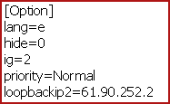

## Starting Puppet mode

1. Create OOG account

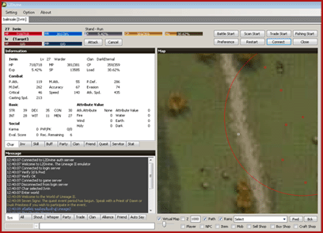

1. Open game client and login with any ID and PWD

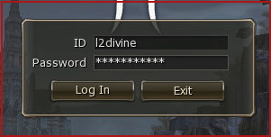

1. Select server “Tor” (Tor is virtual server created by L2Divine. It doesn’t exist on retail.)

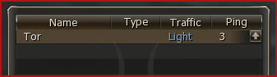

1. Select current OOG character

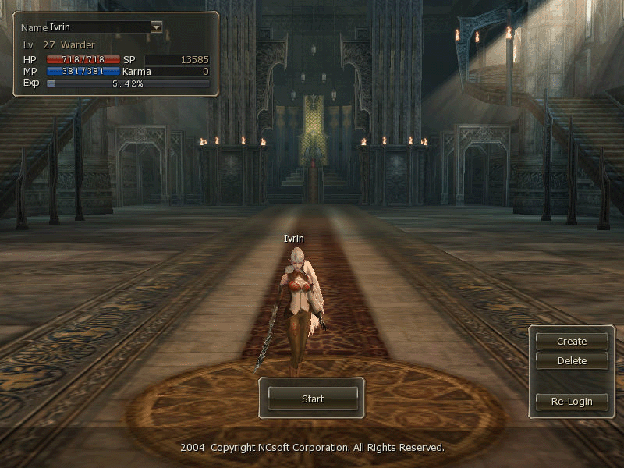

1. Press “End” to open “Preference window” and “Home” to toggle in battle mode. Additional information (Level, HP) will show when selected target.

**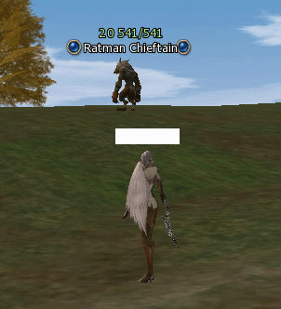**

## Starting Full mode

1. Open L2Divine

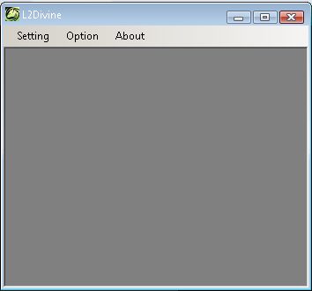

1. Start game, input ID and PWD, select server and character.

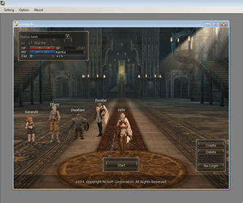

1. L2Divine account will popup during game loading. After loading complete, Press “End” to open “Preference window” and “Home” to toggle in battle mode. Additional information (Level, HP) will show when selected target.

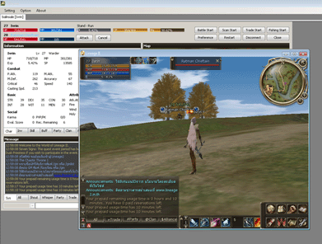

# 

# Chapter 7: Tip & Trick

## Custom path point

1. Open map file (/map/xx\_yy.map) and go to [pathpoint] section then input your path no., name and location. (Use /loc command to get current character location).

tip_pathpoint2.jpg

1. Restart L2Divine to take effect. To move with path point, go to bottom right of virtual map and select path then press Untitled.jpg for backward or Untitled.jpg for forward.



## Change battle area using path point (Leader only)

1. Go to Combat > Condition > Fight and check on “Change hunting area”.

Untitled.jpg

1. Make multiple hunting areas. Provide location and 0 for radius to make path point (Show as white line in map). Every point will connect each other as path.

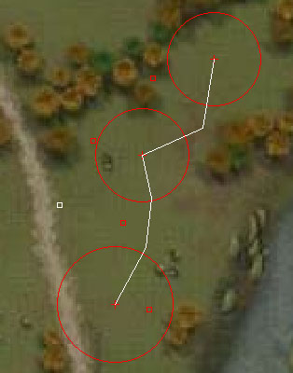

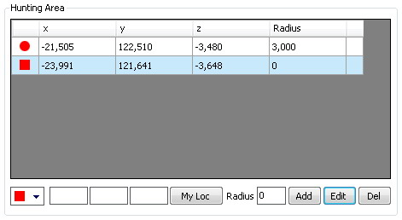

## Open treasure chest

1. Go to Mini Game > Sowing & Harvest, check on “Auto Sowing & Harvest” and select key item to use in battle.

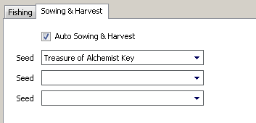

1. Go to Combat > Mob and checking on “Seed” to “Treasure Chest” mob.

**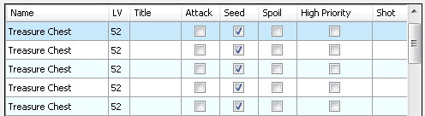**

## Down Level

1. Go to Combat > Condition > Fight.
   * Check on “I'm combat leader”
   * Change battle mode to “Siege”
   * Check on “Change hunting area”

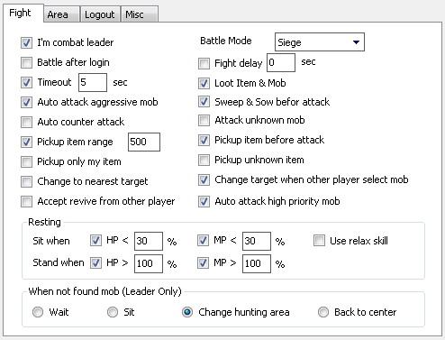

1. Go to Combat > Condition > Area.
   * Make hunting area surround target NPC.
   * Make path point that pass through every spawn location. (Depend on each town)

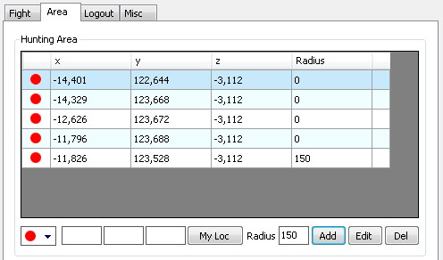

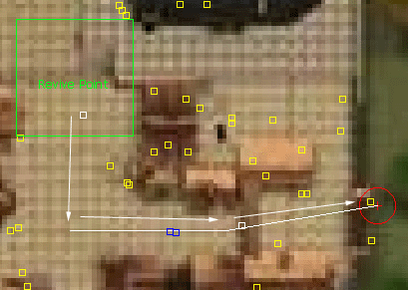

1. Go to Combat > Condition > Misc
   * Checking on “Die return to Village” and input time to return.
   * Checking on “Stop battle when level =” and input level that you want to down to.

**Untitled.jpg**

1. Input “Normal Attack” in attack command to make your character able to hit on NPC.

## Summon Friend (Summoner Only)

1. Invite target to join party by “/invite name”

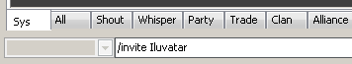

1. Select target by “/target name” or double-click on member in party window.

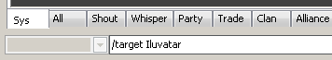

1. Use skill “Summon Friend”

# Chapter 8: Script

## Writing a Script

The easiest way to write a simple script is with a text editor. So, using the text editor of your choice, create a text file with the following text. DivineScript are case sensitive, so if you type the code in yourself, pay particular attention to the capitalization. See Appendix B for command reference

Example

*// A Very Simple Example  
Msg(Console, "Hello Divine")*

To run this script, Save above script to file and clicking on “Run Script” button then select it and confirm on dialog.

Code Comments

Double slashes or // is code comments. It's placed in source files to describe what is happening in the code to comment-out lines of code to isolate the source of execution.

Compare Operator

You can use operators to compare value in If and While command. Divine supported for operator below

== Equal

!= Not equal

> Greater than

< Lower than

>= Equal or greater than

<= Equal or lower than

! Not

Example

*// Use potion when HP fall below 50%*

*If (Char.HP% < 50)*

*{*

*UseItem("Potion")*

*}*

Syntax

### **Case sensitive**

Valid syntax

*Msg(Console, "Hello Divine")*

Invalid Syntax

*MSG(Console, "Hello Divine")*

*mSG(Console, "Hello Divine")*

### One command per line

Valid syntax

*if (CountItem("Iron Ore") > 0)*

*{*

*}*

Invalid Syntax

*if (CountItem("Iron Ore") > 0) {*

*}*

### Complete start and end scope

Valid syntax

*while (Char.HP > 500)*

*{*

*}*

Invalid Syntax

*while (Char.HP > 500)*

*}*

### Represent string with ""

Valid syntax

*Msg(Console, "Hello Divine")*

Invalid Syntax

*Msg(Console, Hello Divine)*

### Global Property

You can use following properties to represent your status

*Char.HP* Represent HP

*Char.HP%* Represent HP percentage

*Char.MP* Represent MP

*Char.MP%* Represent MP percentage

*Char.CP*  Represent CP

*Char.CP%* Represent CP percentage

*Char.Soul* Represent soul (Kamael only)

*Char.LV*  Represent level

*Char.Load%* Represent weight percentage

*Char.InParty* Represent your party status

*Char.Vitality* Represent vitality

*Target.HP* Represent Target HP

*Target.HP%* Represent Target HP percentage

*Target.MP* Represent Target MP

*Target.MP%* Represent Target MP percentage

### Including other script

You can insert the content of one script file into another script file, with the Include command.

Example – main.txt

*Include("mylib.txt")*

*Msg(Console, "Hello 1")*

*Msg(Console, "Hello 2")*

Example - mylib.txt

*Msg(Console, "MyLib -> Hello 1")*

*Msg(Console, "MyLib -> Hello 2")*

Note! The specified script must be in the same directory with the file that uses the command.

# Appendix A: Adding Microsoft Loopback

1. Go to > Start > Setting > Control Panel > Add Hardware

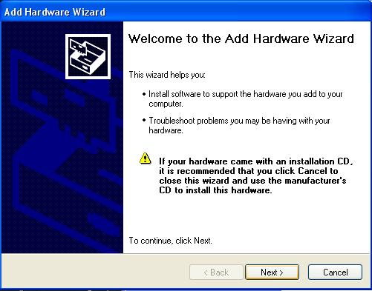

1. Select “Yes, I have ...”

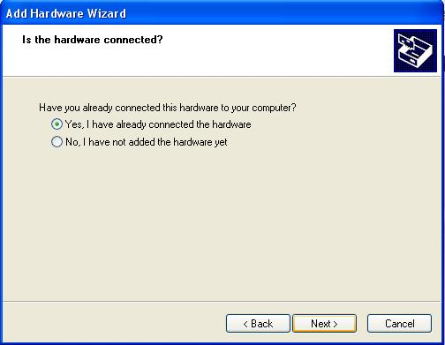

1. Scroll down to last line and select “Add a new hardware device”

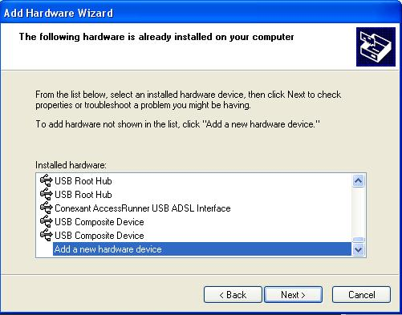

1. Select “Install the hardware ...”

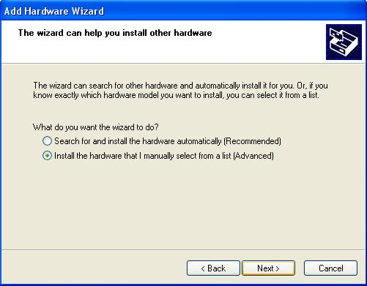

1. Select “Network Adapters”

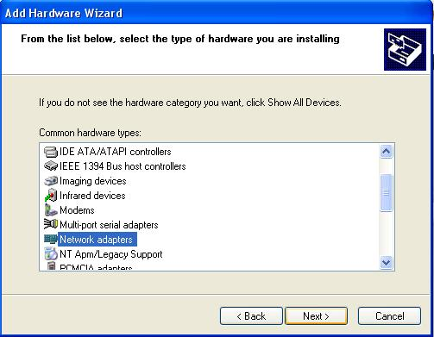

1. Select “Microsoft” and “Microsoft Loopback Adapter”

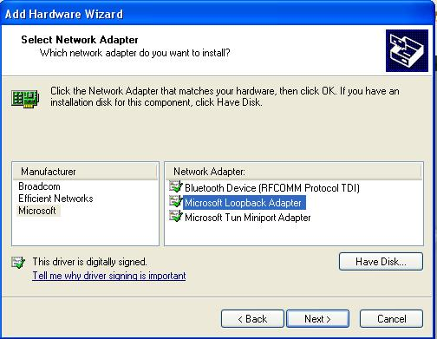

1. Press next until finish
2. Go to > Start > Setting > Control Panel > Network Connection and select last Local Area Network

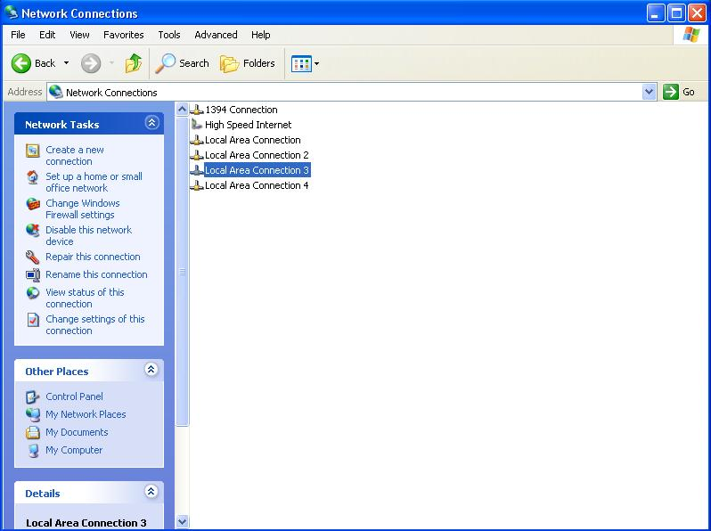

1. Select “Properties”

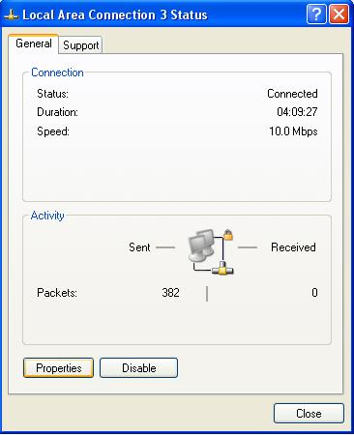

1. Select "Internet Protocol (TCP/IP)” then select “Properties”

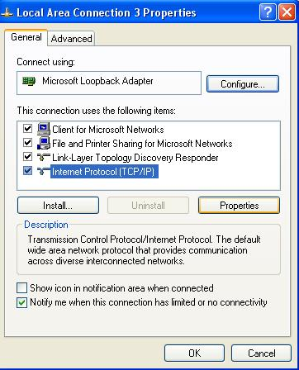

1. Select “Use the following IP address” and input IP and Subnet mask.

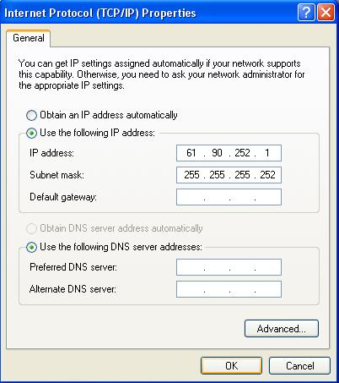

# Appendix B: Script command reference

### AddHuntingArea(x, y, z, radius)

Parameter Location (x,y,z) and radius

Return None

Propose Add hunting area to current setting

Example *AddHuntingArea(115968, -174345, -760, 2500)*

### AddRectHuntingArea(x, y, z, radius)

Parameter Location (x,y,z) and radius

Return None

Propose Add hunting area (rectangle) to current setting

Example *AddRectHuntingArea(115968, -174345, -760, 2500)*

### AddItem(Item ID, Count), AddItem(Item Name, Count)

Parameter Item ID or Item Name, Quantity (Use \* for all)

Return None

Propose Add item to buy, sell, withdraw and deposit list of opening trade dialog.

Example *AddItem("Scroll of Escape", 1)*

*AddItem(17, \*)*

### BattleStart()

Parameter None

Return None

Propose Activate character in battle mode (Same as press “Battle Start" button)

### BattleStop()

Parameter None

Return None

Propose Deactivate character from battle mode (Same as press "Battle Stop" button)

### BuffLevel(Skill ID), BuffLevel(Skill Name)

Parameter Skill ID or Skill Name

Return Level of skill affected

Propose Get level of skill effected (Use with If and While command)

### ClearHuntingArea()

Parameter None

Return None

Propose Remove all hunting area from current setting

### CloseDialog()

Parameter None

Return None

Propose Close opening NPC dialog

### Confirm()

Parameter None

Return None

Propose Confirm buy, sell, withdraw and deposit item with NPC

Example *// Talk with Mr.CAT*

*NpcDialog(31756)*

*Delay(2000)*

*// Select link no. 6, 1 to buy item*

*SelectDialog(6)*

*Delay(2000)*

*SelectDialog(1)*

*Delay(2000)*

*// Add Crystal D-Grade x 3 to trade list*

*AddItem(1458, 3)*

*// Confirm trade*

*Confirm()*

*// Close openning dialog*

*CloseDialog()*

### CountItem(Item ID), CountItem(Item Name)

Parameter Item ID or Item Name

Return Total quantity of item

Propose Count item in inventory (Use with If and While command)

Example *// Count no of Soulshot: D Grade*

*While (CountItem(1463) < 1000)*

*{*

*// Do something*

*}*

### CraftItem(Receipt ID)

Parameter Reciept ID

Return None

Propose Manufaturing item

Example *// Create Soulshot: D Grade*

*CraftItem(20)*

### CrystalizeItem(Item ID), CrystalizeItem(Item Name)

Parameter Item ID or Item name

Return None

Propose Crystallize item

### Delay(Millisecond)

Parameter Time in millisecond

Return None

Propose Pause script execution

### DestroyItem(Item ID, count), DestroyItem(Item Name, count)

Parameter Item ID/Name and count

Return None

Propose Destroy item

### DialogContain(text)

Parameter Text

Return True/False

Propose Check opening dialog contain whether specific text or not

(Use with If and While command)

Example If (DialogContain("2.4 km"))

{

SelectDialog("2.4 km")

Return

}

### Dismiss(Name)

Parameter Player name

Return None

Propose Dismiss player from party

### DropItem(Item ID, count), DropItem(Item Name, count)

Parameter Item ID/Name and count

Return None

Propose Drop item at current location

### EnchantItem(Item ID, Item ID)

Parameter Weapon or Armor ID, Enchant Scroll ID

Return None

Propose Enchant weapon and armor with specific enchant scroll

Example See@Enchant Item.txt

### EnchantLevel(Item ID)

Parameter Item ID

Return Level of enchantment

Propose Get enchant level of specific item ID (Use with If and While command)

### Exit

Parameter None

Return None

Propose Exit script

### FishingStart()

Parameter None

Return None

Propose Active character in fishing mode (Same as press "Fishing Start" button)

### FishingStop()

Parameter None

Return None

Propose Deactivate character from fishing mode (Same as press "Fishing Stop" button)

### ForceAttack(NPC ID), ForceAttack(NPC Name)

Parameter NPC ID or NPC Name

Return None

Propose Force attack to NPC

Example *Down Level:*

*// Attack until die*

*While (Char.HP > 0)*

*{*

*ForceAttack(30545)*

*Delay(2000)*

*}*

*// Return to nearest village*

*ReturnToVillage()*

*Delay(2000)*

*// Down level until 25*

*If (Char.LV > 25)*

*{*

*Jump("Down Level")*

*}*

### If () {} Else {}

Parameter Global property/function, comparator and value

Return True/False

Propose Compare your statement

Example *If (CountItem(1835) == 0)*

*{*

*// Select list no. 1 to buy item*

*SelectDialog(1)*

*}*

*Else*

*{*

*// Sell list no. 3 to sell item*

*SelectDialog(3)*

*}*

### Include(filename)

Parameter filename

Return None

Propose Include other script file

### Invite(Name)

Parameter Player name

Return None

Propose Invite target to join party

Example Invite("dev")

### IsMember(Name)

Parameter Player name

Return True/False

Propose Check player whether in party or not

Example *If (IsMember("dev"))*

*{*

*Msg(Console, "dev joined party")*

*}*

*Else*

*{*

*Msg(Console, "dev not in party")*

*}*

### Jump(Label)

Parameter Address label

Return None

Propose Jump to specified label

### Label:

Parameter None

Return None

Propose Define address

Example *MY\_PROC:*

### LeaveParty()

Parameter None

Return None

Propose Leave from party

### LocInRange(x, y, z, radius)

Parameter location (x, y, z) and radius

Return True/False

Propose Check location whether in specified circle area or not (Use with If and While

command)

Example *If (LocInRange(-59569, -56184, -2032, 500))*

*{*

*Msg(Console, "In range")*

*}*

*Else*

*{*

*Msg(Console, "Not in range")*

*}*

### Logout(Delay, Relogin Delay)

Parameter Logout delay time and relogin delay time (In second)

Return None

Propose Force logout and relogin

Example *// Logout now and reloing in next 10 second*

*Logout(0, 10)*

### MoveTo(x, y, z)

Parameter location (x, y, z)

Return None

Propose Move your character to specified location. Use /loc command to get your current

location.

Example *// Move to black wolf spawn location*

*MoveTo(116633, -183771, -1568)*

*MoveTo(116504, -183755, -1560)*

*MoveTo(116548, -184397, -1568)*

*MoveTo(116633, -185163, -1744)*

*MoveTo(117115, -186064, -2088)*

*MoveTo(117678, -186667, -2384)*

*MoveTo(118566, -187339, -2776)*

*MoveTo(119119, -188103, -3096)*

*MoveTo(119674, -188351, -3264)*

*MoveTo(120054, -187729, -3304)*

*MoveTo(119537, -186438, -3248)*

### Msg(Output, Message), Msg(Output, Message, Target)

Parameter Output and message. Following are output type.

*Console* Represent console message (Use internal in Divine)

*General* Represent general message

*Shout* Represent shout message

*Trade* Represent trade message

*Party* Represent party message

*Clan* Represent clan message

*Ally* Represent ally message

*Friend* Represent friend message (Target required)

*Whisper* Represent whisper message (Target required)

Return None

Propose Send message to target

Example *Msg(General, "Hello")*

*Msg(Whisper, "Hello", "Dev")*

### NpcDialog(NPC ID), NpcDialog(NPC Name)

Parameter NPC ID or NPC name

Return None

Propose Open NPC dialog

Example See@Revenge of the Redbonnet.txt

### Return

Parameter None

Return None

Propose Return to next command of called Jump

Example *Jump("Start")*

*MyProc1:*

*Msg(Console, "Proc1 Command 1")*

*Return*

*MyProc2:*

*Msg(Console, "Proc2 Command 1")*

*Msg(Console, "Proc2 Command 2")*

*Return*

*Start:*

*Msg(Console, "Command 1")*

*Jump("MyProc1")*

*Msg(Console, "Command 2")*

*Jump("MyProc2")*

*Msg(Console, "Command 3")*

### ReturnToVillage()

Parameter None

Return None

Propose Return to nearest village after die

Example See@Down Level.txt

### ReturnToClanHall()

Parameter None

Return None

Propose Return to clan hall after die

Example

### SelectDialog(Link Name), SelectDialog(Link Index)

Parameter Link name or Link index

Return None

Propose Select link from opening NPC dialog

Example

### SelectTarget(Name), SelectTarget(NPC ID)

Parameter Player name, NPC ID or name

Return None

Propose Target on Player/NPC/Mob (Synonym "Me" for your character)

Example *// Buff myself*

*SelectTarget("Me")*

*UseSkill(1059)*

*UseSkill(1068)*

*UseSkill(1077)*

*UseSkill(1040)*

*UseSkill(1204)*

### SetBattleArea(x, y, z, radius)

Parameter Location and radius

Return None

Propose Set battle area to current setting

Example *SetBattleArea(115968, -174345, -760, 2500)*

### SetRestArea(x, y, z)

Parameter Location

Return None

Propose Set rest area to current setting

Example *SetRestArea(115968, -174345, -760)*

### Sit()

Parameter None

Return None

Propose Set character to sit

Example

### Stand()

Parameter None

Return None

Propose Set character to stand

### TargetInRange(Name), TargetInRange(NPC ID)

Parameter Name or NPC ID

Return True/False

Propose Check player/NPC whether in range or not (Use with If and While command)

Example If (TargetInRange(32378))

{

Msg(Console, "Found")

}

Else

{

Msg(Console, "Not Found")

}

### TradeStart()

Parameter None

Return None

Propose Activate character in trading mode (Same as press "Trade Start" button)

Example See@Craft Item.txt

### TradeStop()

Parameter None

Return None

Propose Deactivate character from trading mode (Same as press "Trade Stop" button)

### UseItem(Item ID), UseItem(Item Name)

Parameter Item ID or Item name

Return None

Propose Use item

Example *UseItem(1830)*

*UseItem("Scroll of Escape")*

### UseSkill(Skill ID), UseSkill(Skill Name), UseSkill(Skill ID, Target), UseSkill(Skill Name, Target)

Parameter Skill ID or Skill Name and target

Return None

Propose Use skill on target

Example See@Faverites Buff.txt

### While() {}

Parameter Global property/function, comparator and value

Return True/False

Propose Loop until result of your statement become to false

Example *// Start battle*

*Battle:*

*BattleStart()*

*// Fight until Black Wolf Pelt == 40*

*While (CountItem(1482) < 40)*

*{*

*Delay(10000)*

*}*

*// Stop battle*

*BattleStop()*