**Design: Floor Plan Light Switch (Good)**

Yunzhou Feng

May 15, 2016

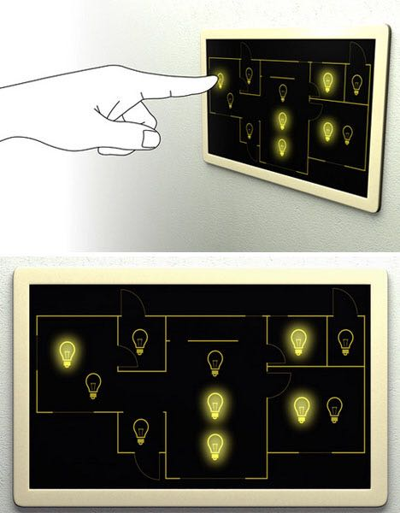

This is a floor plan light switch which controls all the light switches in the house. The switch is touch-screen. The floor plan of the house is shown on the screen. Each light in the house is displayed as a traditional light bulb on the screen. Every bulb’s position in the floor plan represents a light’s position in the house. When the bulb is bright, the relative light is on. If the bulb is dim, the relative light is off. If the user wants to turn on or off a light in the house, he or she just need to tap on the relative bulb.

This floor plan light switch is a very good design. A central switch control is functional and convenient. Bulbs represent the lights; brightness represents the status (on/off) of the light; floor plan represents the whole house. The symbols in this design are all very clear and straight-forward. Because the switch is like a pad, the user would think of tabbing at first, and the only motion the switch needs is tabbing. Even for those who do not know what this design is for, they can test it out very easily.

This design can apply to all sorts of electric appliances. Make some symbols for TVs, air conditioners, etc. The design can be used to control electric devices in a house, in a building, or even in a factory. This design can be put into mobile devices. Users can manage their electric appliances when they move using their mobile devices.