**Welcome to the Scheduled Auto PowerOn/PowerOff Script for OCI (Oracle Cloud Infrastructure).**

**Auto_PowerOn_PowerOff_Script**: A single script for all OCI resources that support power on/off operations.

**Pre-requisites:**

* 24/7 Always up and running VM with python installed will be used for configuring the solution.
* Python to be installed on the instance/Master node where the solution is going to be configured (Always Free tier can be used as well)
* To configure the solution and to access the OCI API, VM instance principals’ method or User configuration can be used and necessary permission to manage all resource needs to be given to the VM.

**To enable the VM instance principal to access the OCI API and to control OCI resources, we will need dynamic group and policy in-place:**

* Copy OCID of the VM where the solution is going to be configured.
* Go to Identity -> Dynamic group -> Create new dynamic group.
* Name it as Schedule Permissions or custom name as preferred.
* Paste the OCID under – “Matching Rules field (Example: ANY {OCID}”
* Click Create

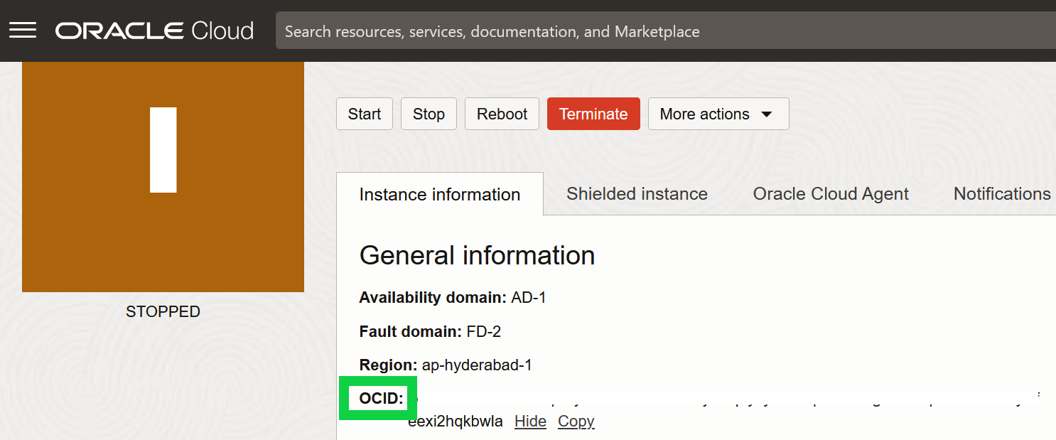

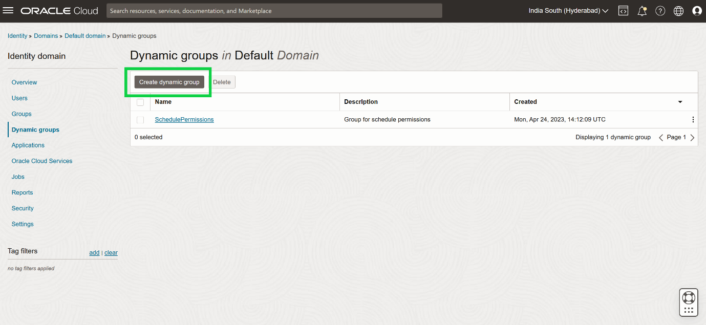

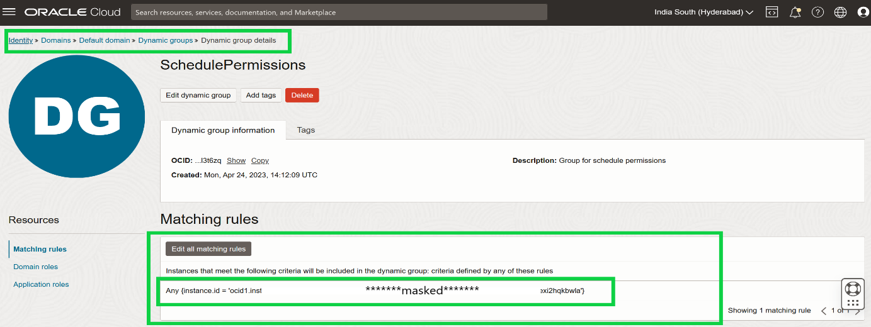

**Give the permissions to the group to be able to manage resources in the tenancy:**

* Go to Identity > policies
* Create new policy.
* Name it as SchedulePolicy or custom name as preferred.
* Add Policy statement.
* Policy statement > Allow dynamic-group SchedulePermissions to manage all-resources in tenancy.
* Click Create policy.

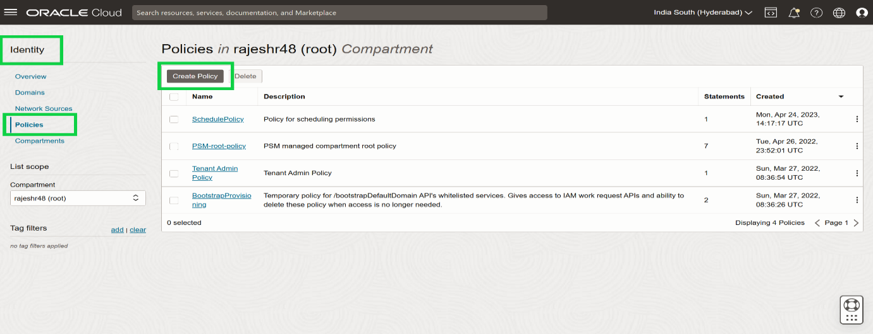

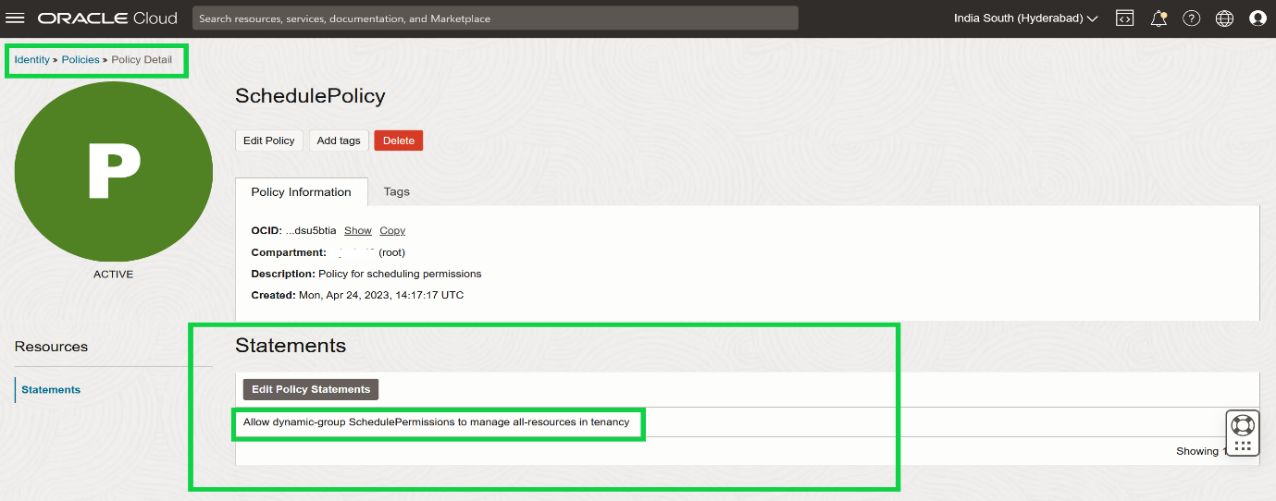

**Script execution on the master node:**

* Execute install.sh (bash script) – which installs all the necessary components needed.
* Then cd OCI-folder/
* Execute python script (CreateNameSpaces.py) on Master Node.
* Assign/Add tag on the slave or other than master node.
* There must be one dedicated Master node from which the script would be executed.

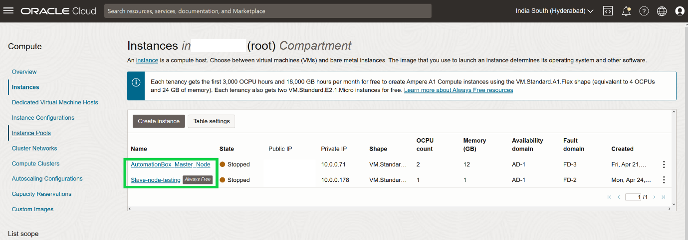

**OCI Power On and Power OFF instances:**

* To perform the operations such as Power on and Power OFF, you need to create a predefined tag called SCHEDULE (can be changed).
* In this predefined tag, you need entries for the days of the week, weekdays, weekends and anyday.
* The tag names are cases sensitive.
* A single resource can contain multiple tags. The priority of tags is as followed (from low to high)
* Anyday
* Weekday or Weekend
* Day of the week (Like Monday, Tuesday...)
* Day of the month (Example 1 = 1st or 15 = 15th of the month)

**Values for the AnyDay, Weekday, Weekend and Day of week tags:**

The value of the tag needs to contain 24 numbers and/or wildcards (*) (else it is ignored), separated by commas. If the value is 0 it will power off the resource and if the value is 1 it will power on the resource. (If that is supported for that resource).

When a wild card is used, the service will stay unmodified for that hour. For example, the below schedule will turn of a compute instance in the evening/night, but allows the user to manage the state during the day.

Schedule.AnyDay: 0,0,0,0,0,0,0,0,*,*,*,*,*,*,*,*,0,0,0,0,0,0,0,0

**Values for Nth day of the Month**

If you want to have a schedule for the Nth day of the month, like 1st Saturday or 3rd Saturday, you need to add extra Tag Key definitions.

For example, if you want to have a schedule for the 2nd Saturday of the months, create an extra Tag Key definition called **Saturday2**

A specific Nth day of month schedule overwrites a normal day of the month schedule. So, a **Saturday2** overwrites a **Saturday** schedule.

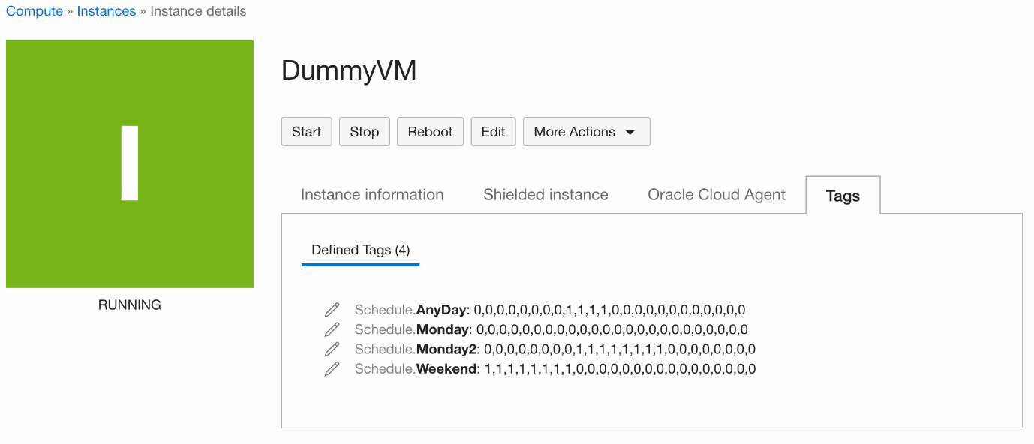

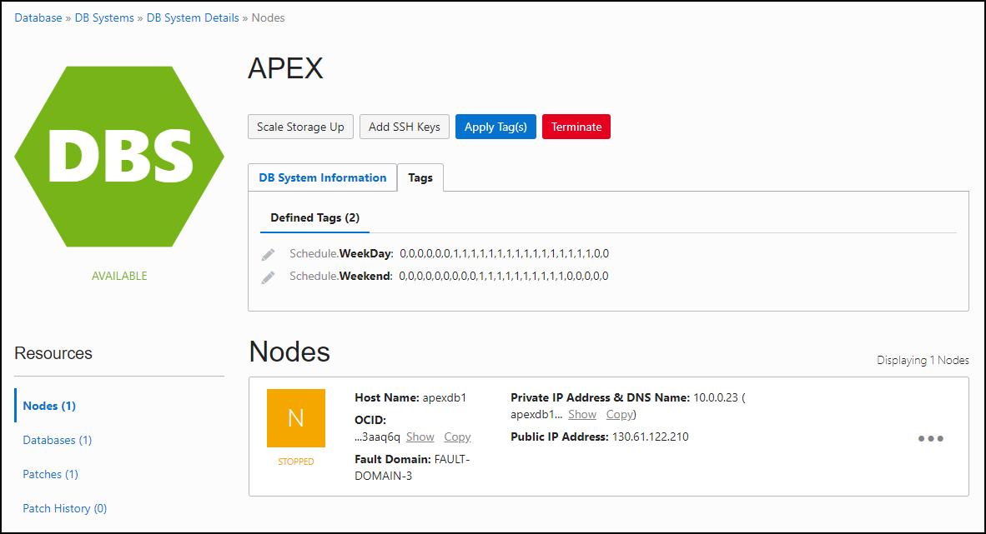

The script supports 3 running methods: All, Up, Down

* All: This will execute power on/off operation
* Down: This will execute only power off [value 0]
* Up: This will execute only power on [value 1]

The thinking behind this is that most OCI resources are charged per hour. So, you likely want to run power off operations just before the end of the hour and run power on operations just after the hour.

**To remove the server from the auto schedule (PowerOn/PowerOff):**

* Login to OCI cloud UI
* Select/Choose the server from the OCI cloud.
* Remove the tag (as per the picture)

###