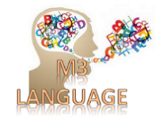Semantic Annotator to unify sensor data by designing a nomenclature/dictionnary/language

|  |  |
| --- | --- |
| Creator | Amelie Gyrard (Eurecom - Insight - NUIG/DERI)  Designed and implemented by Amélie Gyrard, she was a PhD student at Eurecom under the supervision of Prof. Christian Bonnet and Dr. Karima Boudaoud.  Currently, the M3 language/dictionary/nomenclature and its Semantic Annotator is maintained since she is a post-doc researcher at Insight within the IoT unit led by Dr. Martin Serrano. She is highly involved in the [FIESTA-IoT (Federated Interoperable Semantic IoT/Cloud Testbeds and Applications)](http://www.fiesta-iot.eu/) H2020 project. |
| Contributors | Thanks to Pankesh Patel for fruitful questions and numerous questions ☺ |
| Send Feedback | Do not hesitate to ask for help or give us feedback, advices to improve our tools or documentations, fix bugs and make them more user-friendly and convenient: |
| Google Group | <https://groups.google.com/d/forum/m3-semantic-web-of-things>  (Not really active yet) |
| Last updated | July 2016   * Why M3 ontology, Why SSN is not sufficient (Pankesh’s question)   June 2016   * Add semantic annotator * Add M3 ontology   March 2016   * Check actuators and RFID with M3 ontology |
| Created | 2015 |
| Status | Work in progress |
| Goal | We propose to use common terms to describe sensors, measurements, actuators and domains. Of course, we should improve it all together. This work synthetizes all concepts found in existing ontologies or projects related to Internet of Things (IoT) and are implemented in the M3 ontology to unify sensor measures/ IoT data. This step is essential to define interoperable/unified rules to interpret sensor measures. The M3 nomenclature defines a unified data model for the Internet of Things and is an extension of the W3C SSN ontology.  The M3 taxonomy describes sensor names, measurement names, units and IoT applicative domains. This is a kind of dictionary for IoT to easily deal with synonyms, etc. This M3 taxonomy is implemented as an ontology extending W3C SSN ontology. The M3 ontology is a cornerstone component to semantically annotate data and extract meaningful information from IoT/sensor data.  This documentation also enables understanding the Semantic Annotator:   * A nomenclature/language/dictionary to unify terms to describe sensor data * A semantic annotator to unify databased on semantic web technologies (RDF) * Web services to query the M3 ontology |
| Caption | Rows in green, compliant with:   * M3 ontology * Linked Open Rules * IoT application template   Rows in white or red (to finish) |
| Definitions | * **Correctness** means that are no incompatibility with other rules. * **Completeness** means that all sensor values are covered by an high level information. |
| Links | * M3 Web site: <http://www.sensormeasurement.appspot.com/> * NS_M3 = [http://sensormeasurement.appspot.com/m3#](http://sensormeasurement.appspot.com/m3) * SenML language: <http://www.ietf.org/archive/id/draft-jennings-senml-10.txt> * LOV4IoT: * <http://www.sensormeasurement.appspot.com/?p=ontologies> |
| This work has been extended for [FIESTA-IoT](http://fiesta-iot.eu/) EU project | This M3 taxonomy has been reused and refactor for the FIESTA-IoT EU project   * Refactored * Aligned with other ontologies such as IoT-lite, QU-rec-20, etc. * Extended with more Quantity Kinds, units to cover the one required by different testbeds (e.g., KETI, University of Surrey, Smart Santander, Com4Innov) * M3-lite taxonomy: http://purl.org/iot/vocab/m3-lite# |

Table of contents

I. Citations 7

II. M3 nomenclature/language dictionary 7

1. Sensor and measurement interpretation 7

a) Healthcare 7

b) Weather 9

c) Smart home 10

d) Transportation 11

e) Agriculture 12

f) Emotion 12

g) Energy 13

h) Environment 13

i) Generic 13

2. IoT Applicative Domains 14

3. Actuators 14

4. Others Measurement names 16

III. M3 language 17

1. Why W3C SSN ontology is not enough? 17

2. Why do we need the M3 ontology? 17

3. M3-lite taxonomy (M3 ontology V2) 18

4. M3 interoperable domain knowledge 18

5. M3 hub to combine cross-domain ontologies 18

IV. Semantic Annotator: M3 Converter 22

6. M3 converter user interface 22

7. Code example to semantically annotate IoT data with M3 23

8. Enrich the M3 converter and adapt it to your data 23

V. Simulating SenML sensor measurements 26

VI. Converting senML sensor data 29

VII. Querying the M3 nomenlature/ontology 32

1. Web service: querying sensors 32

2. Web service: querying actuators 32

3. Web service: querying domains 33

4. Web service: querying health devices 33

5. Web service: querying transport devices 33

6. Web service: querying home devices 33

VIII. Code 34

1. eurecom.data.converter 34

IX. Semantic annotator: Tutorial 35

1. Use case: M3 framework 35

2. Use Case: M3 embedded in Android-powered devices 35

3. Use Case: FIESTA-IoT project 35

4. Use Case: Insight testbed 35

X. References 35

Table of figures

Figure 1. M3 ontology: extension of W3C SSN 18

Figure 2. M3 to build cross-domain knowledge 19

Figure 3. M3 to build cross-domain knowledge: Naturopathy and security example 19

Figure 4. Without M3, the knowledge is not connected 20

Figure 5. M3 used to build cross-domain knowledge: ontologies, datasets and reasoning 21

Figure 6. Semantically annotating IoT data with the M3 converter user interface 22

Figure 7. Semantically annotating IoT data with the M3 converter web service 23

Figure 8. Rules provided in the template to semantically annotate sensor data 24

Figure 9. Add new rules to semantically annotate sensor data according to the M3 ontology. 24

Figure 10. Explicit M3 measurement type is reused in the reasoning process 25

Figure 11. Simulate M2M area networks 26

Figure 12. Simulating sensor measurements 28

Figure 13. Semantically annotating IoT data with the M3 converter user interface 29

Figure 14. Semantically annotating sensor data 30

Figure 15. The converter package 34

Terms and acronyms

|  |  |
| --- | --- |
| IoT | Internet of Things (IoT) |
| M3 framework | Machine-to-Machine Measurement (M3) framework |

# Citations

* Enrich Machine-to-Machine Data with Semantic Web Technologies for Cross-Domain Applications. IEEE World Forum on Internet of Things (WF-IoT), Seoul, Korea, March 6-8, 2014.   
  Amelie Gyrard, Christian Bonnet and Karima Boudaoud
* Standardizing Generic Cross-Domain Applications in Internet of Things. Third Workshop on Telecommunications Standards, Part of IEEE Globecom 2014, Austin, TX, USA, 8-12 December 2014. Amelie Gyrard, Soumya Kanti Datta, Christian Bonnet and Karima Boudaoud
* A unified language to describe M2M/IoT data. OneM2M, MAS Working Group 5, 22-27 March 2015, Sophia Antipolis, France. Amelie Gyrard, Christian Bonnet
* An Ontology to Semantically Annotate the Machine-to-Machine (M2M) Device Measurements.  
  ETSI M2M Workshop 2013, 5-7 November 3013, Mandelieu, France. Amelie Gyrard, Christian Bonnet and Karima Boudaoud

# M3 nomenclature/language dictionary

## Sensor and measurement interpretation

E.g., precipitation and rainfall sensor have the same meaning and represents the same sensor, we should explicitly describe this information in machine to machine communications to ensure interoperability in each layer of the OneM2M architecture.

### Healthcare

**Table 1. Healthcare domain: sensors, measurements and units**

|  |  |  |  |  |
| --- | --- | --- | --- | --- |
| **M3 or SenML domain** | **M3 or SenML sensor/ measurement name** | **Description, other names (synonyms)** | **M3 or SenML Unit** | **M3 rules** |
| Health | BodyThermometer/  BodyTemperature | Body thermometer | DegreeCelcius | Completeness OK (3 rules [Obaid 2013] + 3 rules [Jara 2009]), Correctness OK |
| Health | HeartBeatSensor/  HeartBeat | Pulse sensor, pulse oxymeter, pulse-ox, heart beat, heart rate, pulse rate, cardiac frequency, breath rate | BeatPerMinute | Correctness ok (2 rules [5 rules Tanatong 2011] & [Hristoskova 2014]) + **Completeness No (>300 nothing)** |
| Health | PulseOxymeter/  SPO2 | Pulse oxymeter, spO2, blood oxygen saturation sensor, pulse and oxygen in blood sensor | Percent | Correctness OK (1 rule [Hristoskova 2014]) + **Completeness NO** |
| Health | CholesterolSensor/  Cholesterol | cholesterol | MmolPerLiter | Correctness OK (1 rule [Bravo 2009-2013]) + **Completeness NO** |
| Health | Glucometer/  BloodGlucose | Glucometer, glucose sensor, blood glucose meter, blood sugar level | GramPerLiter | Completeness OK (3 rules [Guermah 2014]), Correctness OK |
| Health | BloodPressureSensor/  BloodPressure | blood pressure meter, sphygmomamometer, MAP (Mean arterial pressure), CVP (central venous pressure) | mmHg | 0 rule |
| Health | SkinConductanceSensor/  SkinConductance | skin conductance, galvanic skin response sensor, GSR, sweating | ? | 0 rule |
| Health | WeightSensor/  Weight | Weight sensor, body weight, weight scale | Kilo, Pound | 0 rule |
| Health | Pedometer/  NumberStep |  |  |  |

### Weather

**Table 2. Weather domain: sensors, measurements and units**

|  |  |  |  |  |
| --- | --- | --- | --- | --- |
| **M3 or SenML domain** | **M3 or SenML sensor/ measurement name** | **Description, other names (synonyms)** | **M3 or SenML Unit** | **M3 rules** |
| Weather | HumiditySensor/  Humidity | Hygrometer, humidity sensor, moisture sensor, soil moisture probes | Percent | Correctness OK (Conflict resolved with [Kofler 2011] and [Rodriguez 2014]) +  Completeness OK (5 rules [Staroch 2013]) |
| Weather | WindDirectionSensor/  WindDirection | Wind direction | DegreeAngle | Completeness OK (5 rules [Staroch 2013]  ) + Correctness OK |
| Weather | SunPositionDirectionSensor/  SunPosition | sun position direction to detect east, west, south, north | DegreeAngle | Completeness OK (5 rules [Staroch 2013]  ) + Correctness OK |
| Weather | AtmosphericPressureSensor/  AtmosphericPressure | Atmospheric pressure sensor, Barometer, barometric pressure sensor | Pascal | Completeness OK (5 rules [Staroch 2013]) + Correctness OK (even with [Kofler 2011] ) |
| Weather | CloudCoverSensor/  CloudCover | Cloud cover sensor | Okta | Completeness OK (5 rules [Staroch 2013]) +Correctness OK (even with [Kofler 2011] ) |
| Weather | SunPositionElevationSensor/  SunElevation | sun position elevation to detect (twilight, day, night, etc.) | DegreeAngle | 8 rules [Staroch 2013]  **Completeness NO + Correctness NO** |
| Weather | SolarRadiationSensor/  SolarRadiation | Solar radiation sensor, par (photo synthetically active radiation) sensor, sun light, solar sensors, sun’s radiation intensity | WattPerMeterSquare | Completeness OK (5 rules [Staroch 2013]) **+** Correctness OK (even with [Kofler 2011] ) |
| Weather | VisibilitySensor/  Visibility | Visibility sensor to detect fog | Miles, Meter |  |
| Weather | Thermometer, AirThermometer/  Temperature | Thermometer, temperature sensor, thermistor | DegreeCelsius | Integrate [Kofler 2011] 15 rules  See LOV4IoT [Staroch 2013] (6 home temperature rules) |
| Weather | LightSensor/  Luminosity | Light, luminosity, illuminance, lighting | Lux |  |
| Weather | PrecipitationSensor/  Precipitation | Precipitation sensor, rainfall sensor, rain fall, pluviometer, rain, rainfall gauge | MilimeterPerHour |  |
| Weather | WindSpeedSensor/  WindSpeed | Wind speed sensor, wind velocity sensor, anemometer | MeterPerSecond | [Kofler 2011] 16 rules  See LOV4IoT [Staroch 2013] 5  overlapping |
| Weather | WindChillSensor/  WindChill | Wind chill |  |  |

### Smart home

**Table 3. Smart home domain: sensors, measurements and units**

|  |  |  |  |  |
| --- | --- | --- | --- | --- |
| **M3 or SenML domain** | **M3 or SenML sensor/ measurement name** | **Description, other names (synonyms)** | **M3 or SenML Unit** | **M3 rules** |
| BuildingAutomation | SoundSensor/  Sound | Noise, sound, microphone, audio sensor | dB | Correctness OK (3 rules [Rodriguez 2014] ) +  **Completeness NO** (Between 30 and 110, overlapping with Vasileios] |
| Weather | Thermometer/  Temperature | Thermometer, temperature sensor, thermistor | DegreeCelsius | [Kofler 2011] 15 rules (only 9 implemented)  See LOV4IoT [Staroch 2013] (6 home temperature rules)  Rodriguez 3 rules  Overlapping  overlapping with Vasileios  Yus |
| BuildingAutomation | LightSensor/  Luminosity | Light, luminosity, illuminance, lighting, illumination | lux | Pb with Vasileios |
| BuildingAutomation | Presence | Presence sensor, motion sensor, occupancy detector, pyroelectric IR occupancy, intrusion detector/ trespassing, infrared sensor, motion sensor, motion detector, motion sensor, proximity, passive infrared (PIR) | ? | 2 rules combined with light  See LOV4IoT  [Jacquet 2013] |
| BuildingAutomation | PowerConsumption |  | Watts |  |
| Weather | HumiditySensor/  Humidity | Hygrometer, humidity sensor, moisture sensor, soil moisture probes | Percent | 5 rules See LOV4IoT [Staroch 2013]  Completeness ok  Correctness : Overlapping with kofler, Rodriguez  More rules staroch |
| BuildingAutomation | gyroscope | Gyroscope attached to objects (e.g., mop) to detect if they are used | rad/s | No too complicated need machine learning to detect activities |
| BuildingAutomation | pressure | Pressure for beds, sofa, couch to detect (lying, sitting), bed occupancy |  |  |
| BuildingAutomation | Accelerometer/  Motion | Accelerometer | m/s² |  |
| BuildingAutomation | magnetic field | Magnetometer, magnetic sensor attached to cupboards to detect if they are opened or closed |  |  |
| BuildingAutomation | Camera | Video sensor |  |  |
| BuildingAutomation | SmokeDetector |  |  | Percent |
| BuildingAutomation | GasDetector |  |  |  |

### Transportation

**Table 4. Transportation domain: sensors, measurements and units**

|  |  |  |  |
| --- | --- | --- | --- |
| **M3 or SenML domain** | **M3 or SenML sensor/ measurement name** | **Description, other names** | **M3 or SenML Unit** |
| Transportation | battery | Battery charge level |  |
| Transportation | motorTemperature |  |  |
| Transportation | RoadSurfaceThermometer/  RoadTemperature |  |  |
| Transportation | SpeedSensor/  Speed | Speed sensor, speedometer, velocity sensor (car) |  |
| Transportation | NumberVehicleSensor/ NumberVehicle |  |  |
| Transportation | tire pressure |  |  |
| Transportation | fuel | Fuel level |  |
| Transportation | DistanceSensor/  Distance | Distance sensor, safety distance |  |
| Transportation | rpm | Position and/or rotational speed |  |
| Transportation | maf | mass air flow sensor | maf |
| Transportation | SoundSensor/  Sound |  | dB |
| Transportation | AlcoholLevelSensor/  AlcoholLevel |  |  |

### Agricu**l**ture

**Table 5. Agriculture domain: sensors, measurements and units**

|  |  |  |  |
| --- | --- | --- | --- |
| **M3 or SenML domain** | **M3 or SenML sensor/ name** | **Description, other names (synonyms)** | **M3 or SenML Unit** |
| Agriculture | SoilHumiditySensor/ SoilHumidity |  | Percent |
| Agriculture | LeafWetnessSensor/ LeafWetness |  | Percent |
| Agriculture | AirThermometer/ AirTemperature | Thermometer, temperature sensor, thermistor | °C, K, F |
| Agriculture | SoilThermometer/ SoilTemperature | Thermometer, temperature sensor, thermistor |  |
| Agriculture | Luminosity | LightIntensity |  |
| Agriculture | PHSensor/  PH |  |  |

### Emotion

**Table 6. Emotion domain: sensors, measurements and units**

|  |  |  |  |  |
| --- | --- | --- | --- | --- |
| **M3 or SenML domain** | **M3 or SenML sensor name** | **M3 or SenML measurement name** | **Description, other names (synonyms)** | **M3 or SenML Unit** |
| Emotion | SkinConductanceSensor | SkinConductanceSensor | skin conductance, galvanic skin response sensor, GSR, sweating |  |

### Energy

**Table 6. Emotion domain: sensors, measurements and units**

|  |  |  |  |  |
| --- | --- | --- | --- | --- |
| **M3 or SenML domain** | **M3 or SenML sensor name** | **M3 or SenML measurement name** | **Description, other names (synonyms)** | **M3 or SenML Unit** |
| Energy | EnergyMeter/ Energy | Energy | Electricity meter, electric meter, energy meter | KiloWattHour |

### Environment

**Table 7. Air quality domain: sensors, measurements and units**

|  |  |  |  |  |
| --- | --- | --- | --- | --- |
| **M3 or SenML domain** | **M3 or SenML sensor/ measurement name** | **Description, other names (synonyms)** | **M3 or SenML Unit** | **M3 rules** |
| Environment | AirPollutantSensor/  AirPollution | Air pollutant sensor | EAQI | 5 rules Completeness + Correctness  Kofler + See LOV4IoT [Staroch 2013] |
| Environment | SaltMeter  / Salinity |  | ppt |  |
| Environment | oxygen | oxygen sensor |  |  |
| Environment | no | Nitrogen oxide sensor |  |  |
| Environment | CO | Carbon monoxide CO sensor |  |  |
| Environment | SO2 | Sulfure dioxide sensor |  |  |
| Environment | CO2 | Carbon Dioxyde Sensor | Ppm (parts per million) |  |
| Environment | pH | pH |  |  |

### Generic

**Table 8. Generic domain: sensors, measurements and units**

|  |  |  |  |  |
| --- | --- | --- | --- | --- |
| **M3 or SenML domain** | **M3 or SenML sensor name** | **M3 or SenML measurement name** | **Description, other names (synonyms)** | **M3 or SenML Unit** |
| Generic | HumiditySensor | Humidity | Hygrometer, humidity sensor, moisture sensor, soil moisture probes | Percent |
| Generic | Thermometer | Temperature | Thermometer, temperature sensor, thermistor | °C |
| Generic | LightSensor | Luminosity | Light, luminosity, illuminance, lighting | lux |
| Generic |  | gps | Global positioning system, gps, location sensor | lon, lat, alt |
| Generic |  | frequency |  | Hz |
| Generic |  | shake | Shake sensor, vibration |  |

## IoT Applicative Domains

E.g., Aix means Air en Provence which is a city.

E.g., you use the temperature in the health domain enable the computer to understand that the measurement corresponds to a body temperature.

For instance, Fire is a subclass of Environment.

FOI when duplication with measurement type,

FOI for feature of Interest

**Table 9. Domain names**

|  |  |
| --- | --- |
| **M3 or SenML Domain name** | **Description, other names (synonyms)** |
| BuildingAutomation (subclass: Activity) | Smart home, building automation, or building or room (kitchen, bathroom, living room, dining room) |
| Health | healthcare |
| Weather | Weather forecasting, meteorology |
| Agriculture | Agriculture, smart farm, garden |
| Environment (subclass: Fire) | Environment (earthquake, flooding, forest fire, air pollution) |
| Emotion | Affective science, emotion, mood, emotional state; brain wave |
| Transport | Intelligent transportation systems (ITS), smart car/vehicle, transportation |
| EnergyFOI | Smart grid, smart energy |
| Tourism | Tourism |
| Location | Location, place, GPS coordinates |
| City | Smart city, city automation, public lighting |
| TrackingGood  (subclasses: TrackingFood, TrackingCD) | Tracking RIFD goods |
| Generic | Others |

## Actuators

If SenML value = 0 it means the actuator is not used

If SenML value = 1 it means the actuator is used

**Table 10. Actuator names**

|  |  |  |
| --- | --- | --- |
| **M3 or SenML domain** | **M3 or SenML Actuator name** | **Description, other names (synonyms)** |
| Transport | FogLamp | Fog lamp |
| Transport | Brake |  |
| Transport | ABS | Abs, anti-lock braking system |
| Transport | ESP | Electronic stability program |
| Transport | SeatBeltTensionSensor | Seat belt tension sensor |
| BuildingAutomation | WaterFlow | water flow attached to sinks, showers, flushing |
| BuildingAutomation, Transportation | AirConditioner | Air conditioner, ac |
| BuildingAutomation, Transportation | AlarmSystem |  |
| BuildingAutomation | Heating |  |
| BuildingAutomation | Blind |  |
| BuildingAutomation | Ventilation |  |
| BuildingAutomation | Curtain |  |
| BuildingAutomation | Window |  |
| BuildingAutomation | Cupboard |  |
| BuildingAutomation | DishWasher |  |
| BuildingAutomation | WashingMachine |  |
| BuildingAutomation | Drawer |  |
| BuildingAutomation | Door |  |
| BuildingAutomation | Boiler |  |
| BuildingAutomation | CoffeeMachine | Coffee machine, coffee maker |
| BuildingAutomation | Computer | Computer, pc |
| BuildingAutomation | Shower | Water actuator |
| BuildingAutomation | TV | tv, television |
| BuildingAutomation | Lavatory |  |
| BuildingAutomation | Fridge | Refrigerator, fridge |
| BuildingAutomation | Freezer | Chiller |
| BuildingAutomation | Microwave |  |
| BuildingAutomation | Lamp | Dimmable light, lamp |

**Table 11. RFID tags common terms**

|  |  |
| --- | --- |
| **RFID tags name** | **Description, other names (synonyms)** |
| RFID_Food | food |
| RFID_Book | book (isbn) |
| RFID_CD | cd, music |
| RFID_DVD | dvd, movie |
| RFID_Garment | clothes, garments |
| RFID_BrushTeeth |  |
| RFID_Broom |  |
| RFID_TeaBag |  |
| RFID_Cup |  |
| RFID_Mop |  |
| RFID_Bed |  |
| RFID_Sofa |  |
| RFID_Pan |  |
| pill box |  |
| passport |  |
| luggage |  |
| parking space |  |
| toll |  |
| animal |  |
| payment card |  |
| transit pass |  |

## Others Measurement names

E.g., t temp and temperature have the same meaning and represents the temperature measurement.

The same as the one referenced for sensors

**Table 12. measurement names**

|  |  |
| --- | --- |
| **M3 or SenML measurement name** | **Description, other names (synonyms)** |
| lon | longitude |
| lat | latitude |
| Others measurements are the same than those referenced for sensors |  |

# M3 language

## Why W3C SSN ontology is not enough?

As explained by [W3C SSN](http://www.w3.org/2005/Incubator/ssn/XGR-ssn-20110628/#Directions_for_future_work) (final report):

* The W3C SSN ontology does not describe domain concepts, time, locations, etc. these are intended to be included from other ontologies via OWL imports.
* Future work: Standardise the SSN ontology to bridge the Internet of Things
* Future work: Standardise the SSN ontology to use it in a Linked Sensor Data context

To sum up, W3C SSN is insufficient to unify sensor metadata such as describing units, sensor measurement types, applicative domains, and sensor types.

They suggest to reuse domain ontologies, but a deep analysis from the Linked Open Vocabularies for Internet of Things (LOV4IoT)[1] dataset [1] [2] shows that we can find several ontologies describing units, or the same sensor types.

## Why do we need the M3 ontology?

To add reasoning on sensor data, we identified the need to design a common taxonomy to unify sensor metadata.

For this reason, we build this taxonomy that we called M3 nomenclature/language [3] as presented in the previous section.

The M3 nomenclature has been implemented in our [M3 ontology](http://sensormeasurement.appspot.com/m3). The M3 Ontology references more than 30 sensors, measurements, units and about 10 domains. The M3 ontology is focused on the ssn:ObservationValue concept from the [W3C SSN ontology](http://www.w3.org/2005/Incubator/ssn/ssnx/ssn)which describes sensors and observations, and related concepts.

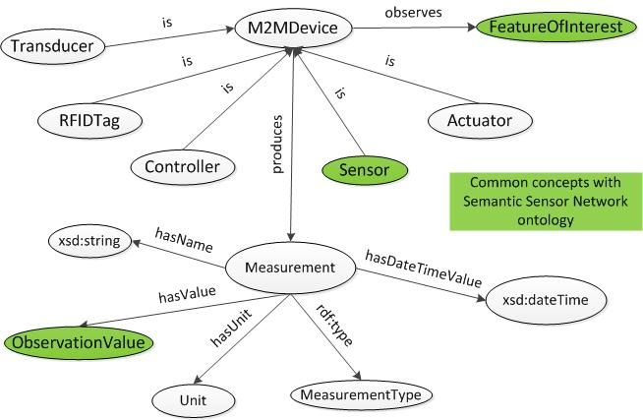

Figure 1. M3 ontology: extension of W3C SSN

## M3-lite taxonomy (M3 ontology V2)

[M3-lite taxonomy](https://mimove-apps.paris.inria.fr/ontology/m3lite.html) is a refinement of the M3 ontology (refactored, cleaned and aligned with the vision of the EU H2020 [FIESTA-IoT](http://fiesta-iot.eu/) project).

## M3 interoperable domain knowledge

The key aspect of the M3 ontology is enabling linking domain ontologies and rules to deduce meaningful knowledge from sensor data.

## M3 hub to combine cross-domain ontologies

The Machine-to-Machine Measurement (M3) hub interlinked cross-domain knowledge (ontologies, datasets and rules) as follows:

* Link ontologies in the same domain
* Link cross-domain ontologies
* Link rules thanks to the [Sensor-based Linked Open Rules (S-LOR)](http://localhost:55040/?p=swot_template) to interpret IoT data.

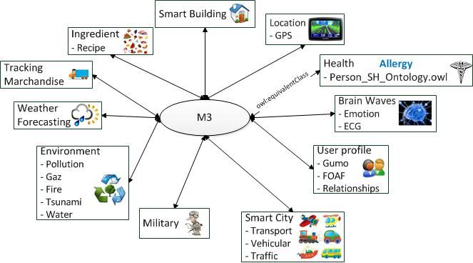

Figure 2. M3 to build cross-domain knowledge

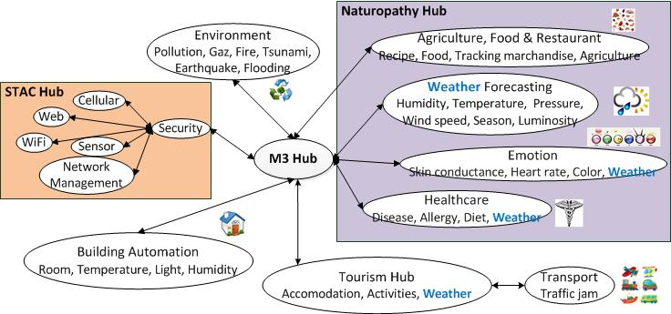

Figure 3. M3 to build cross-domain knowledge: Naturopathy and security example

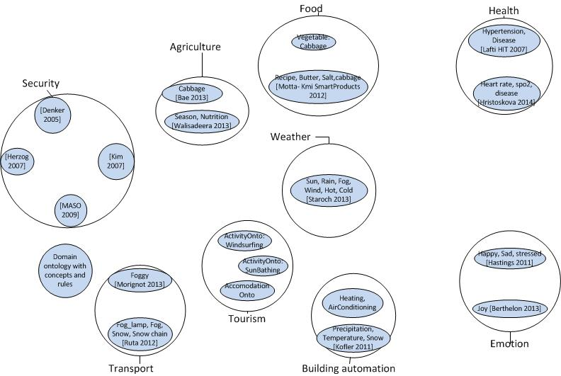

Figure 4. Without M3, the knowledge is not connected

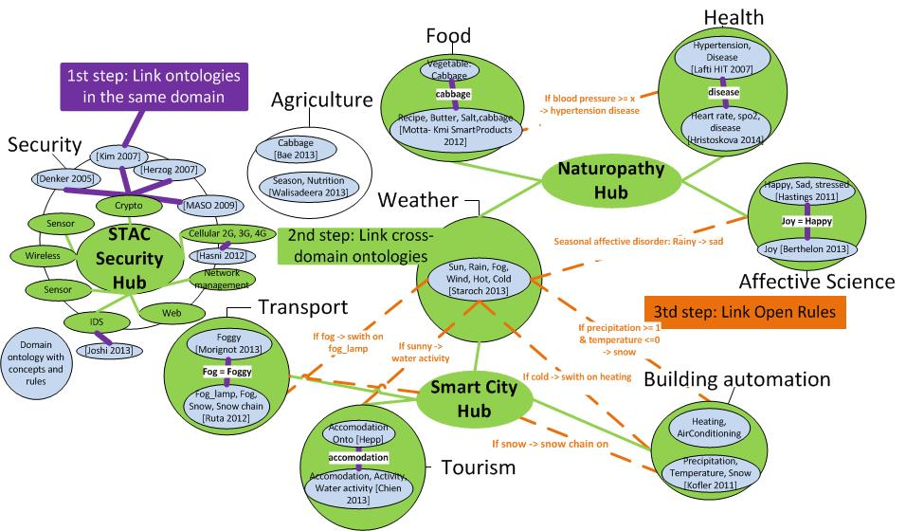

Figure 5. M3 used to build cross-domain knowledge: ontologies, datasets and reasoning

# Semantic Annotator: M3 Converter

## M3 converter user interface

The developer can use the M3 converter user interface: http://www.sensormeasurement.appspot.com/?p=senml_converter

See user guide: [www.sensormeasurement.appspot.com/documentation/UserGuide.pdf](http://www.sensormeasurement.appspot.com/documentation/UserGuide.pdf)

**Use Chrome to get the data in a text format, with Firefox you only have the JavaScript alert popup.**

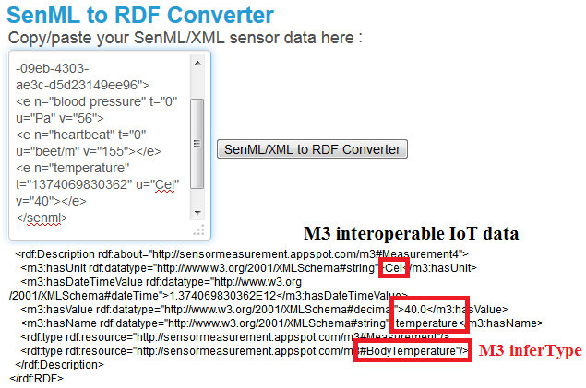

Figure 6. Semantically annotating IoT data with the M3 converter user interface

## Code example to semantically annotate IoT data with M3

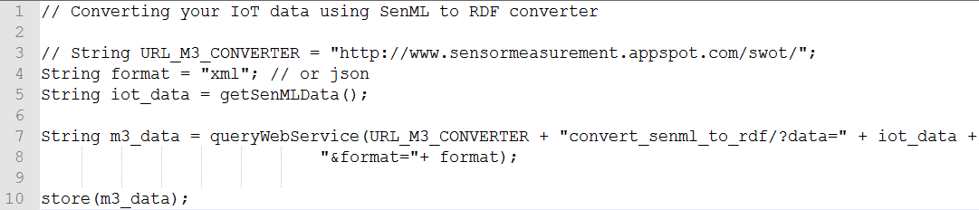

Figure 7. Semantically annotating IoT data with the M3 converter web service

## Enrich the M3 converter and adapt it to your data

When you download a template with the SWoT generator[2] you also get the rules to semantically annotate data, the file is called ’ruleM3Converter.txt’.



**We did not have time to implement all the M3 nomenclature. Further, we frequently update the M3 nomenclature[3].**



But you can still improve and add more rules to semantically annotate your sensor data.

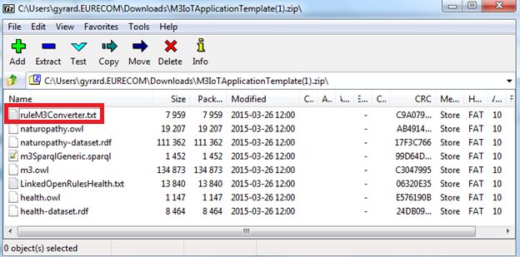

Figure 8. Rules provided in the template to semantically annotate sensor data

The following rule means that we explicitly add the context:

If you get a temperature from health domain (subclassOf m3:FeatureOfInterest), we will explicitly add that it corresponds to a body temperature.

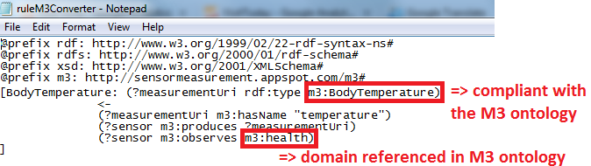

Figure 9. Add new rules to semantically annotate sensor data according to the M3 ontology.

This is important because after, you have the rules adapted to this kind of measurement.

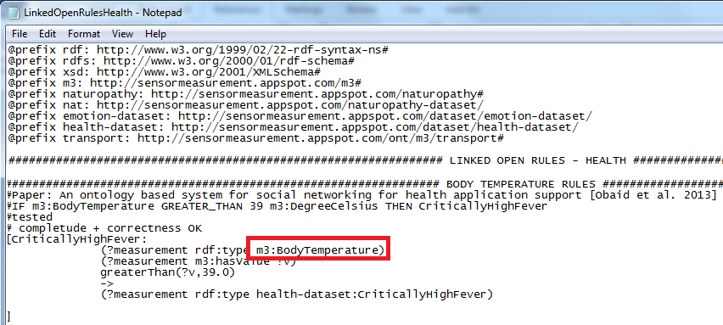

Figure 10. Explicit M3 measurement type is reused in the reasoning process

# Simulating SenML sensor measurements

The following interface enables to simulate sensor data:

<http://emulator-box-services.appspot.com/senmladmin/zones>

These data are compliant with the SenML[4] format.

You can simulate heterogeneous domains (healthcare, smart kitchen, smart home, etc.), as you can see in Figure 8. You can create a new domain (Add sub zone button).

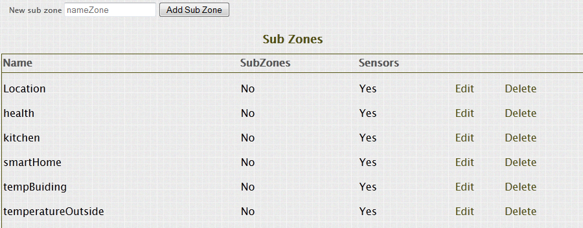

Figure 11. Simulate M2M area networks

Click on the button “Edit” associated to the kitchen zone.

You go to the following URL:

<http://emulator-box-services.appspot.com/senmladmin/ahdzfmVtdWxhdG9yLWJveC1zZXJ2aWNlc3IWCxIJWm9uZUFkbWluIgdraXRjaGVuDA/edit>.

You can simulate smart devices (sensors, actuators, transducer, controllers and RFID tags).

In this use case, we simulate RFID tags embedded on ingredients.

We simulate SenML measurements (in XML or JSON).

A measurement has a name, a value, a unit, and the date.

Example 1: Measure name: Temperature, Unit: Degree Celsius, Value: 35

Example 2: Measure name: banana, Unit: Gram, Value: 1000

**Use the M3 nomenclature[5] to describe sensor measurements.**

**To be sure that the M3 converter will semantically annotate correctly the sensor measurements.**

**It will ease the process to build the application with the Semantic Web of Things template.**

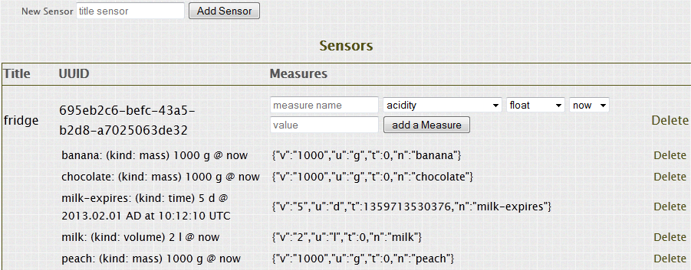

Figure 12. Simulating sensor measurements

# Converting senML sensor data

Go to the M3 converter to semantically annotate SenML data with RDF according to the M3 ontology.

Web page: <http://www.sensormeasurement.appspot.com/?p=senml_converter>

**Use Chrome to get the data in a text format, with Firefox you only have the JavaScript alert popup.**



Figure 13. Semantically annotating IoT data with the M3 converter user interface

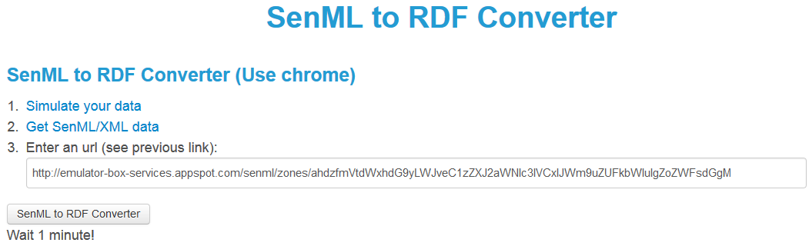

Figure 14. Semantically annotating sensor data

# Querying the M3 nomenlature/ontology

## Web service: querying sensors

Search for all M3 sensors:

<http://www.sensormeasurement.appspot.com/m3/subclassOf/?nameClass=Sensor&format=json>

Results:

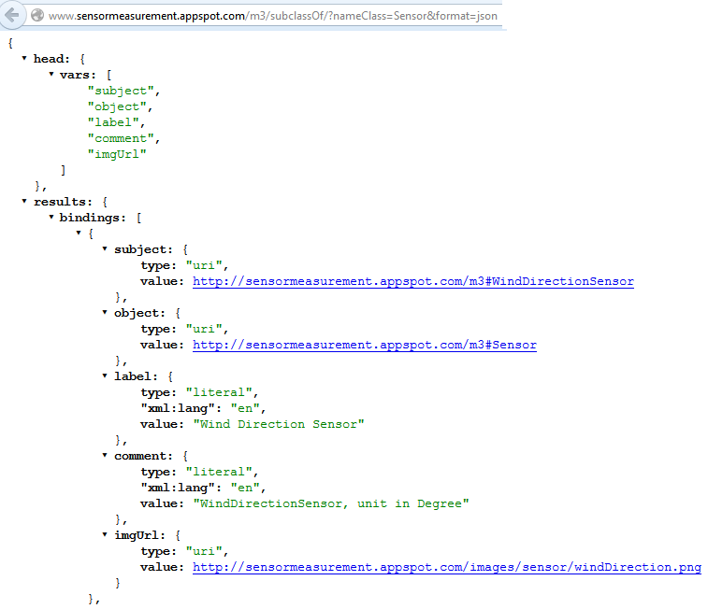

## Web service: querying actuators

Search for all M3 actuators:

<http://www.sensormeasurement.appspot.com/m3/subclassOf/?nameClass=Actuator&format=json>

## Web service: querying domains

Search for all M3 domains (=FeatureOfInterest):

<http://www.sensormeasurement.appspot.com/m3/subclassOf/?nameClass=FeatureOfInterest&format=json>

## Web service: querying health devices

Search for all M3 health devices:   
<http://www.sensormeasurement.appspot.com/m3/subclassOf/?nameClass=HealthM2MDevice&format=json>

## Web service: querying transport devices

Search for all M3 transport devices:   
<http://www.sensormeasurement.appspot.com/m3/subclassOf/?nameClass=TransportM2MDevice&format=json>

## Web service: querying home devices

Search for all M3 home devices:   
<http://www.sensormeasurement.appspot.com/m3/subclassOf/?nameClass=HomeM2MDevice&format=json>

# Code

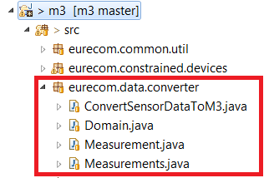

Figure 15. The converter package

## eurecom.data.converter

* Domain.java: Class which transforms XML data to RDF data. Have a public ArrayList containing the measurements, getter and setter of the nameZone.
* ConvertSensorDataToM3.java: Behaviour of the conversion of java object (Measurements) into RDF data and of the other way. Can create also some instance object into RDF (type of object: Measurement, FeatureOfInterest, and Sensor).
* Measurement.java && Measurements.java: Objects measurements, describe the object that is used to transform Xml data into RDF data. Mostly composed by variables and their getter/setter.
* *Note*: A Domain has an ArrayList of Measurements (with an S) and Measurements has an ArrayList of Measurement. Where Measurement is just a data (30 °C for instance), Measurements is a bunch of data (all the data from one sensors) and FeatureOfInterest could be the domain (Temperature).

# Semantic annotator: Tutorial

TO DO

## Use case: M3 framework

TO DO

Semantically annotate XML data following the SenML format.

It employs the M3 ontology.

## Use Case: M3 embedded in Android-powered devices

TO DO

Semantically annotate JSON data following the SenML format provided by Raspberry Pi.

It employs the M3 ontology.

## Use Case: FIESTA-IoT project

TO DO

It employs the M3-lite taxonomy.

## Use Case: Insight testbed

TO DO

Data sent by netatmo devices.

It employs the M3-lite taxonomy.

# References

[1] A. Gyrard, G. Atemezing, C. Bonnet, K. Boudaoud, and M.Serrano. Reusing and unifying background knowledge for internet of things with lov4iot. In *Future Internet of Things and Cloud (FiCloud), 2016 4th International Conference on*, Aug 2016.

[2] A. Gyrard, C. Bonnet, K. Boudaoud, and M.Serrano. Lov4iot: A second life for ontology-based domain knowledge to build semantic web of things applications. In *Future Internet of Things and Cloud (FiCloud), 2016 4th International Conference on*, Aug 2016.

[3] Amélie Gyrard, Soumya Kanti Datta, Christian Bonnet, and Karima Boudaoud. Standardizing generic cross-domain applications in Internet of Things. In *GLOBECOM 2014, 3rd IEEE Workshop on Telecommunication Standards: From Research to Standards, December 8, 2014, Austin, Texas, USA*, Austin, UNITED STATES, 12 2014.

1. http://sensormeasurement.appspot.com/?p=ontologies
2. http://www.sensormeasurement.appspot.com/?p=m3api
3. http://www.sensormeasurement.appspot.com/documentation/NomenclatureSensorData.pdf
4. http://www.ietf.org/archive/id/draft-jennings-senml-10.txt
5. www.sensormeasurement.appspot.com/documentation/NomenclatureSensorData.pdf