CS550 Big Data Analytics and apps

Using the same program in lab2 We generated text files in the device

Viz: Training Punch.Txt, Training LR.txt,TrainingRL.txt, TrainingCombo.txt

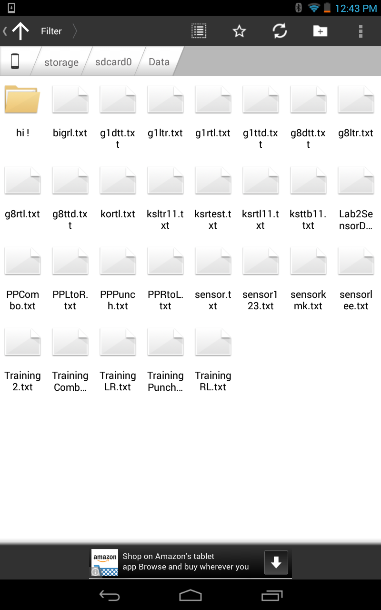

Using winscp I uploaded these files to the Cloudera group9

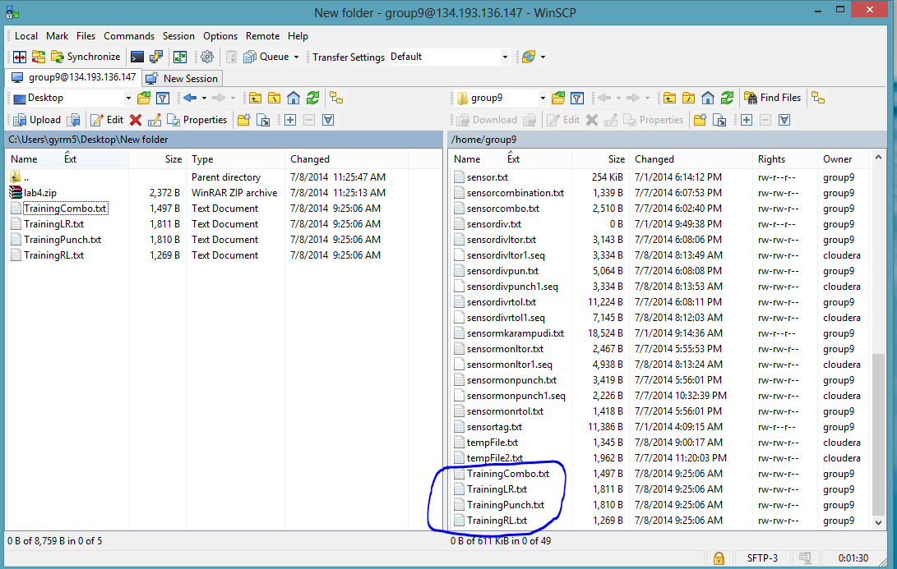

I checked the files in Cloudera using putty

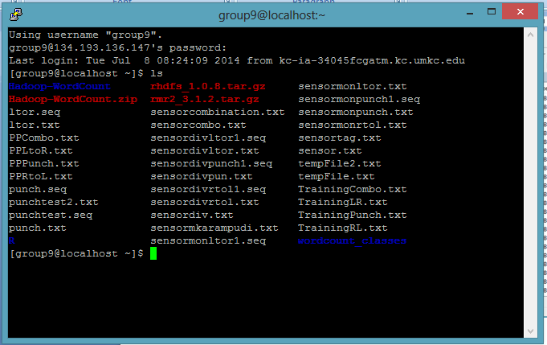

Then I used the web links to generate the sequence files due to server over load of requests my browser displayed connection error

<http://134.193.136.147:8080/HMMWS/jaxrs/ge%20neric/TrainFileOperation/-home-group9-TrainingLR.txt/-home-group9-TrainingLR.seq>

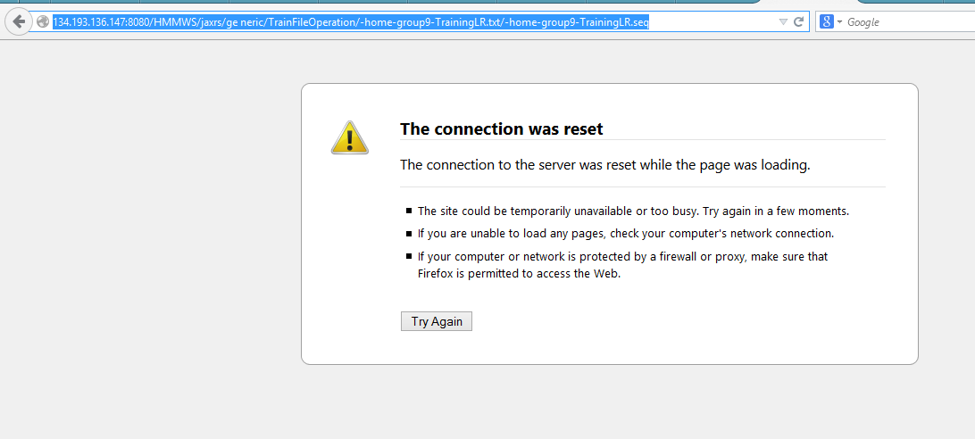

Similarly all the links showed the same results

Using the program in the lab3 I have written save file on retrieve button click to save the file

