**MidTerm (Gift – Buddy)**

**Submitted By : GIRESHBABU YEMAPARALA (16137268)**

Introduction:

This project is mainly concentrated over the Customer Satisfaction over the Vast resources of Gift registries, user can maintain their own gift registry and can send invitations to the events and the friends can view his intended gifts in the gift wish list.

Design:

Architecture Diagram :



Class Diagram



2. Features Implemented

a. Add gifts from the Local Disk

b. Add events

c. Delete Events

d. Display Events

e. Display Gifts

f. Send Invitation

My Webservices : Include Login Webservice,

Existing Webservices : Amazon Shopping Api, Froggle Api

3. Database Model:

Database : GiftBuddy

Tables : Registry

Values : Name, Price, Location, Comment, Image_Id

Table : Events

Values, Event Name, EventLocation, EventTime, EventDescription, ID

Mobile User Interface:

The mobile user interface Includes jquery Mobile web ui.

Project Screen Shots :

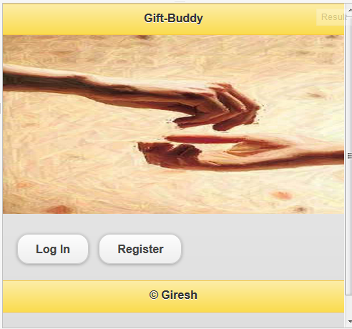

This is the Mainpage where the user can login or register

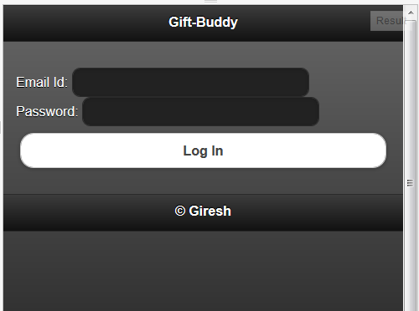

This is the main Login Page which is resulted from the Login Button Event

On Login Success leads to the UserPage

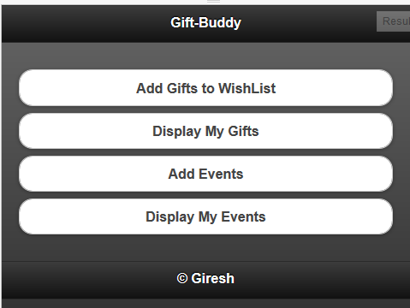

User Page Contains the following Events “ Add Gifts to Wish List”, “ Display Gifts”,” Add Events” “Display Events”

On the event of the Add gifts to the wish list

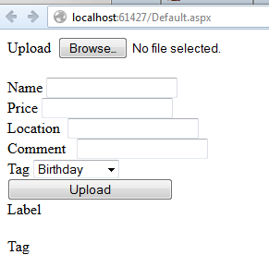

When the fields are populated and selected It returns “ Sucessfully Inserted”

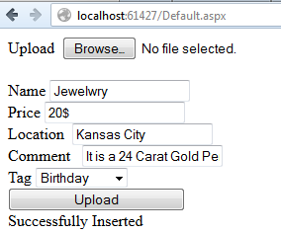

On the event of the Display Gifts user has to select the Tag which is the corresponding group of the gifts

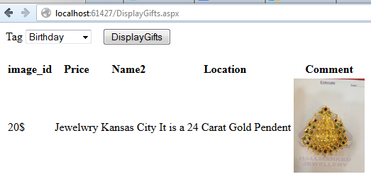

It displays the user the gifts user that particular tag

-On the event of the Add Events It display the fields of events

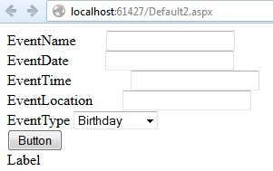

Fill in all the forms and Submit it to the “Button” Which returns the label value as the “Added Sucessfully ”

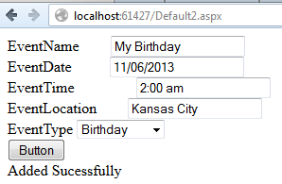

On the event of the Display Events it displays the events from the database

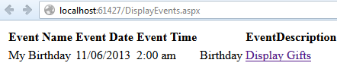

On the event of Display gifts under the Underlying link redirects the page to display gifts under the particular event description.

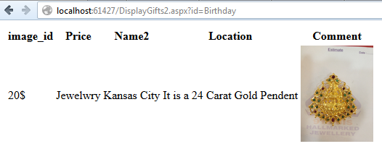

On the event of the Invite friends User can send the event Invitations to the friend by email

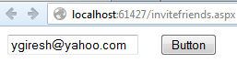

The event mail is listed under the inbox of the friends email

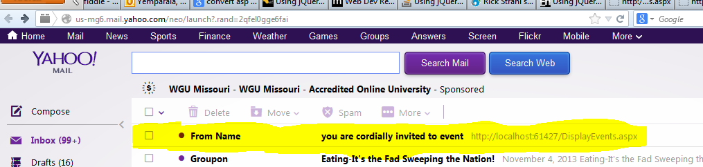

The mail caontains

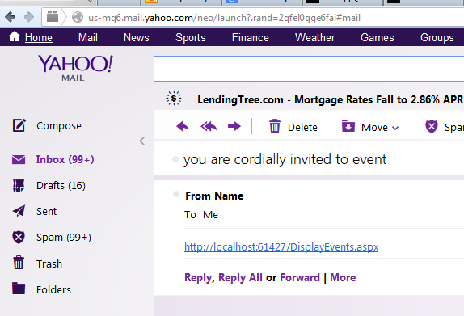

On the link in the mail it displays the user a list of events and the corresponding gifts

Refernces:

<http://msdn.microsoft.com/en-us/magazine/jj650891.aspx>

<http://jqueryui.com/themeroller/>

[www.ajax.com](http://www.ajax.com)

[www.dotnetcurry.com](http://www.dotnetcurry.com)