05/30/2025
GLODIPAY WOOCOMMERCE SPECIFICATION
VERSION 1.0

Manual Plugin Installation from ZIP File

Prerequisites:
Always create a backup of your website before installing or updating any plugin to avoid data loss in case of issues.

Step 1: Download the Plugin
- Please contact GLODIPAY to obtain the plugin installation file.

Step 2: Log in to Your WordPress Admin Panel
- Access your WordPress admin panel by entering your website URL followed by /wp-admin.
Example: http://yourwebsite.com/wp-admin

Step 3: Navigate to the "Add Plugins" Page
- In the left menu of the WordPress admin panel, click "Plugins" > "Add New Plugin".
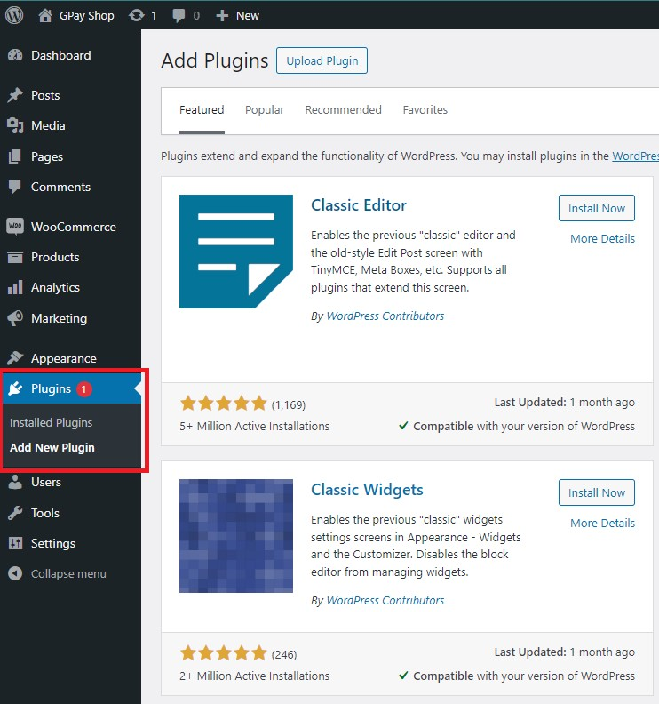

Step 4: Click "Upload Plugin"
- On the Add Plugins page, you will see a button labeled "Upload Plugin" at the top. Click this button.
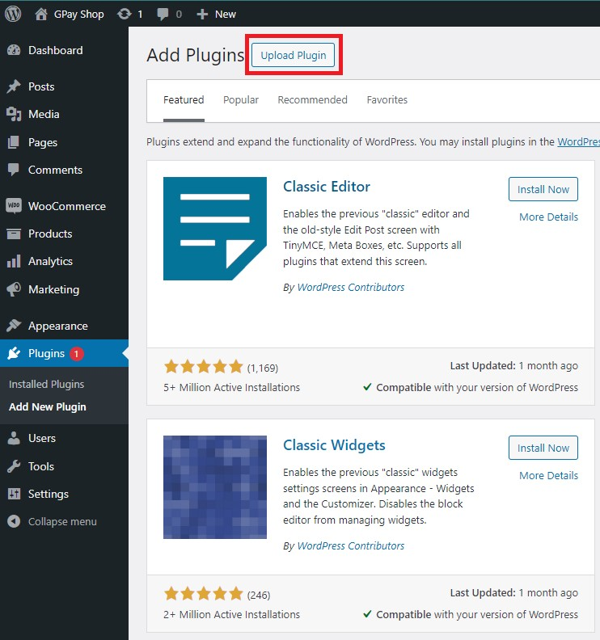

Step 5: Select the ZIP File Containing the Plugin
- After clicking "Upload Plugin", a dialog box will appear, allowing you to choose the ZIP file from your computer.
- Select the ZIP file obtained in Step 1.
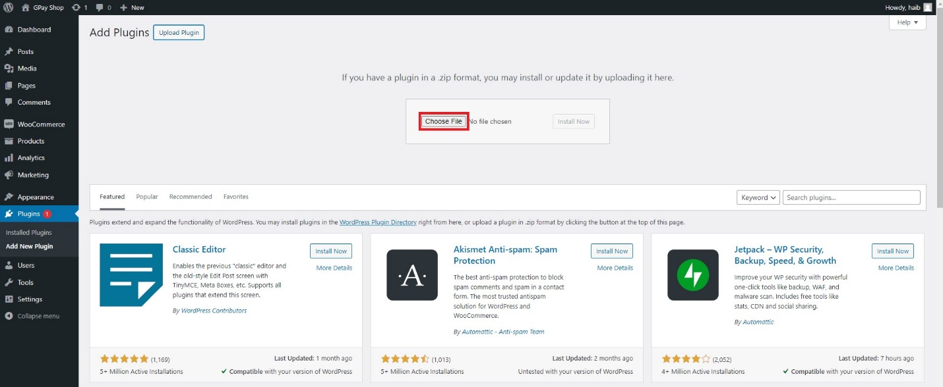

Step 6: Install the Plugin
- Once you have selected the ZIP file, click "Install Now" to proceed.
- WordPress will install the plugin from the uploaded ZIP file.
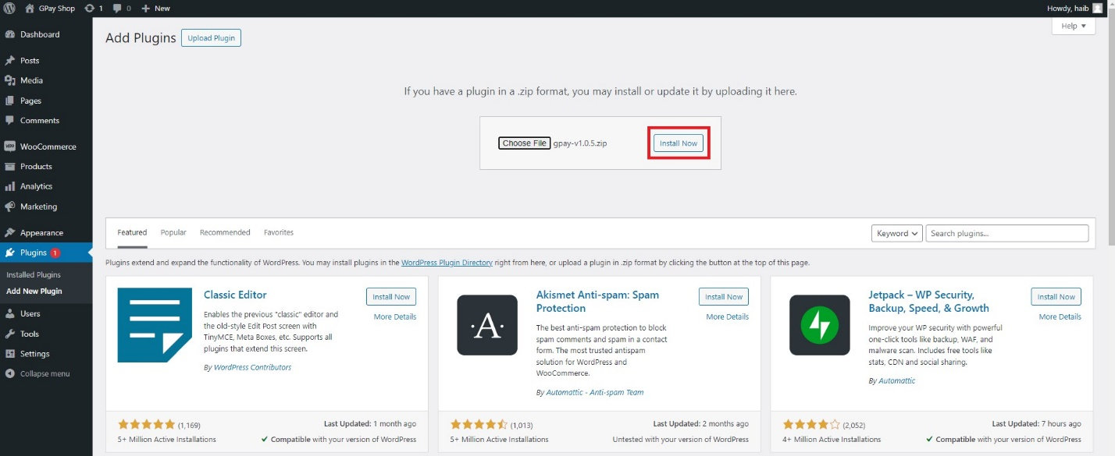

Step 7: Activate the Plugin
- After the installation is complete, you will see a success message.
- Click "Activate Plugin" to enable the plugin.
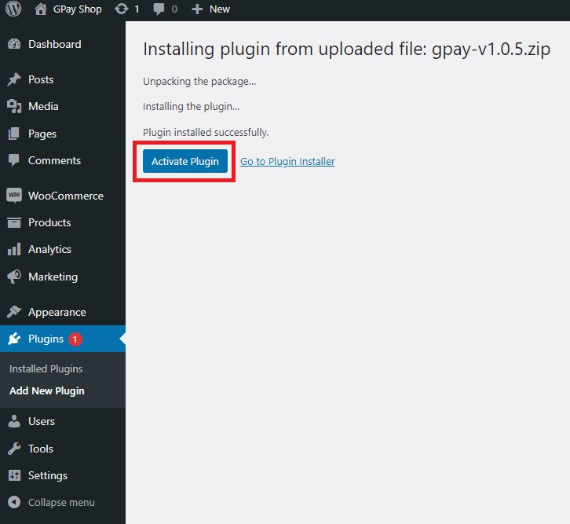
Alternatively, you can activate the plugin from the Plugins page.
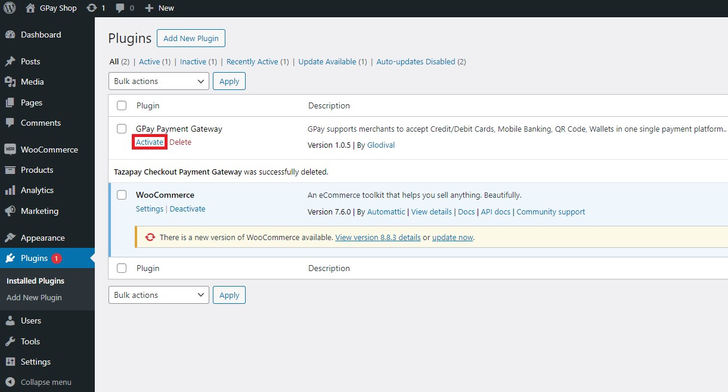

Step 8: Verify the Plugin
- Finally, check if the plugin has been installed and is functioning correctly by visiting your website and testing the payment process.

Configuring the Plugin

Step 1: Access GLODIPAY Portal
- Log in to your Merchant Account (ensure email verification and KYB completion).
- Click "API Keys" from the left menu.
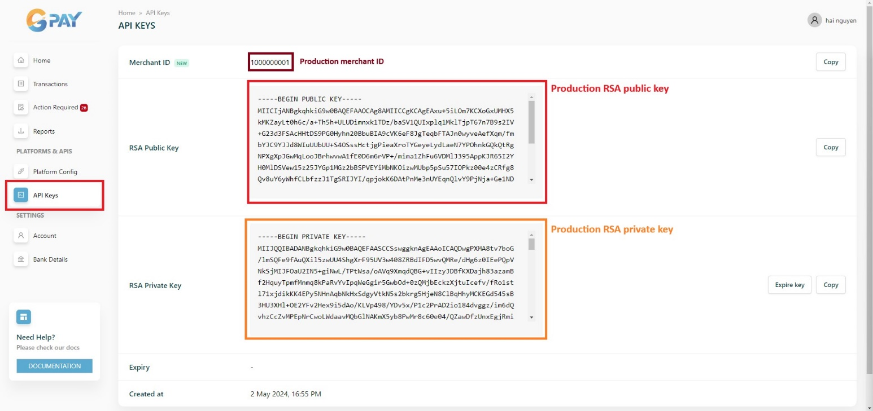

Step 2: Retrieve API Keys
- In the API Keys section, you will find:
  - Merchant ID
  - Base Endpoint
  - RSA Public Key
  - RSA Private Key
  - Expiration Date
- Copy these keys for integration.

Step 3: Configure the Plugin in WordPress

Method 1: Through Plugin Settings Page
- Go to WordPress Admin Panel (/wp-admin).
- Navigate to Plugins > GPay Payment Gateway > Settings.
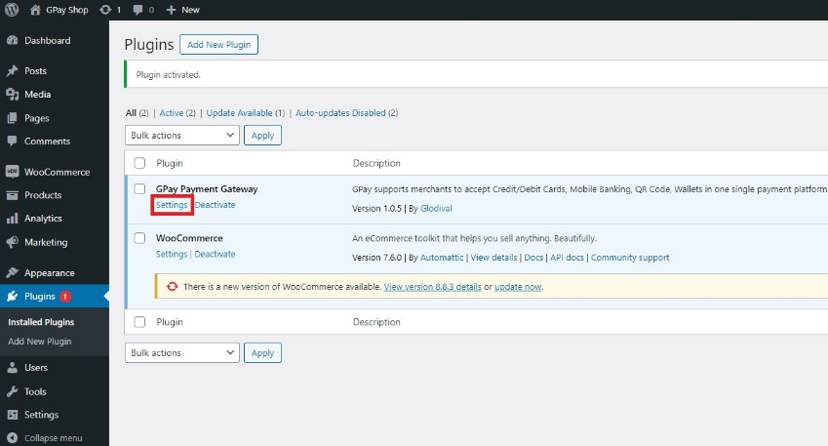

Method 2: Through WooCommerce Settings
- In the WordPress Admin Panel, go to WooCommerce > Settings.
- Click on the Payments tab.
- Locate GPay Payment Gateway and configure the following options:
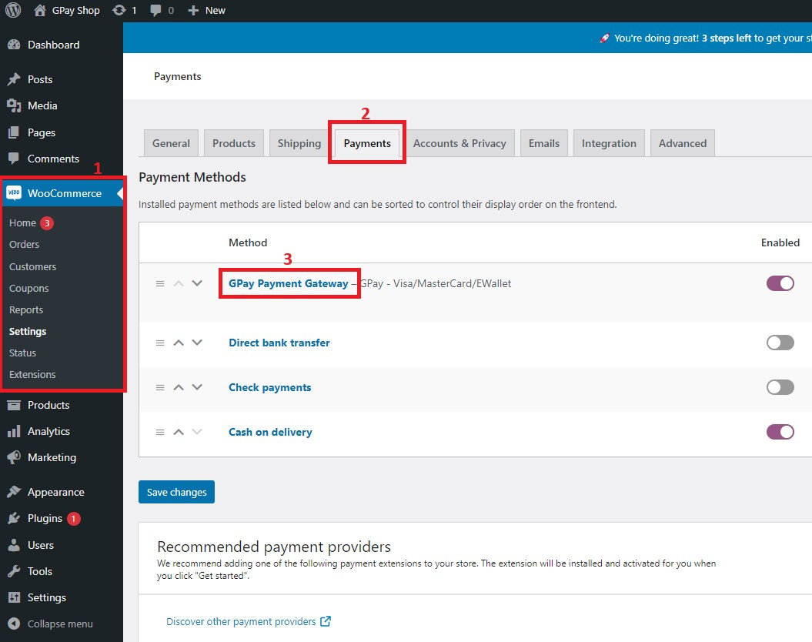
✅ Enable/Disable
- Ensure this option is checked to activate the plugin.
✅ Sandbox Mode
- Enable to use Test Mode (Sandbox).
- Disable to use Live Mode (Production).
✅ Thank You Page URL (Optional)
- Specify a custom thank-you page URL after payment completion.
- Leave blank to use WooCommerce's default Thank You page.
Example: https://www.example.com/thank-you
✅ Enter API Keys
- Sandbox Merchant ID & RSA Keys (for testing).
- Production Merchant ID & RSA Keys (for live transactions).
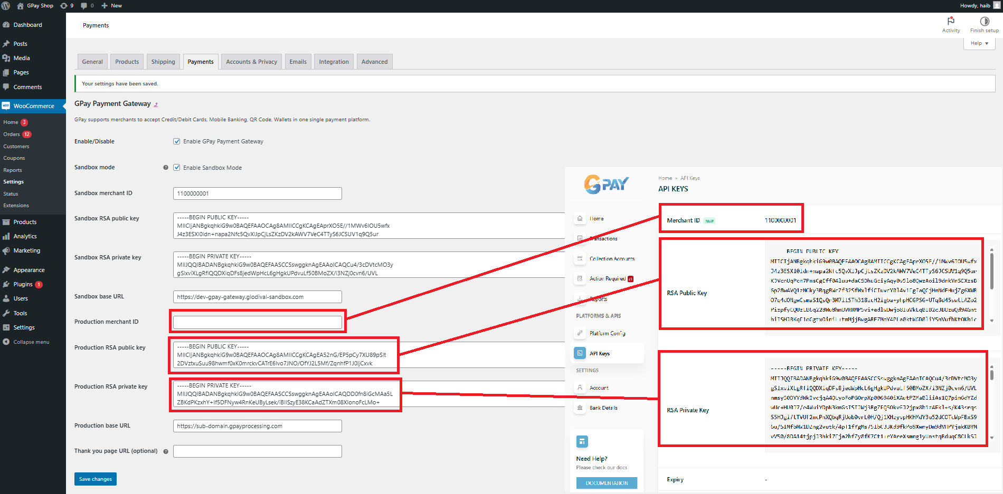

Final Step: Test the Integration
After configuring the plugin, test the payment process to ensure everything is working correctly.

Conclusion
This document provides a step-by-step guide to installing and configuring the GPay WooCommerce Payment Gateway. Always test in Sandbox Mode before switching to Live Mode. 🚀

