**이산최적화 HW#2**

**20172050 박규남**

**1.**

Let denote whether vertex is visited.

Let denote the number of team members traveling from to .

Let if , 0 o/w

Let denote the depot.

Let denote the number of resources required at vertex .

Let denote the start time at .

,

,

,

,

,

,

,

,

,

**2.**

(a)Budget is limited to $100m. For Northwest, there are four alternatives which are exclusive: digital circuit lab, large lecture room, heat transfer lab, and computer-aided design expansion. For Southeast, there are two competing options: faculty office and manufacturing research center. Tunnel is dependent on a new manufacturing research center.

(b)

if project is selected. 0 o/w.

(c)

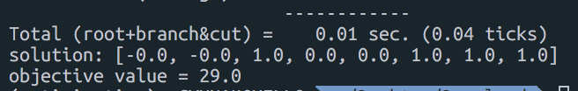

Objective value is 29. The solution is to build Computer Vision lab, computer-aided design expansion, manufacturing research center, and tunnel.

**3.**

(a)

Let denote cost of work pattern , .

Let denote whether work pattern is selected.

Let denote the availability of flight in work pattern , , .

(b)

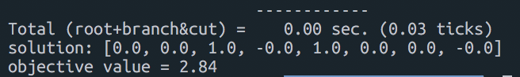

Objective value is 8.6. The solution is to choose work pattern #3 and #5.

**4.**

(a)

Let denote the cost of modifying plant to produce model . If plant can’t afford to produce model , .

(b)

If the optimal basis B has , then the linear programming relaxation solves IP.

(c)

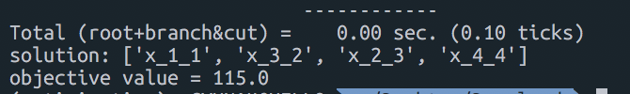

Objective value is 8.6. The solution is to produce model 1 in plant #1, model 2 in plant #3, model 3 in plant #2, model 4 in plant #4.

**5.**

Model #1:

Solving TSP as an assignment problem is not enough since the solution can have sub-tour. Thus, adding sub-tour elimination constraints are required to avoid it. However, there are exponentially many constraints if we naively consider it. As a bypass, we can iteratively include sub-tour constraint when it actually happens.

The procedure is described in TSP_model_1.py file attached. The result is captured below:

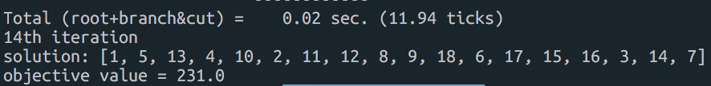

The objective value is 231.

The optimal solution is 1🡪5🡪13🡪4🡪10🡪2🡪11🡪12🡪8🡪9🡪18🡪6🡪17🡪15🡪16🡪3🡪14🡪7

Model #2:

In this model, we replace subtour elimination constraints by deploying variable , which means the number of nodes visited after visiting node .

The procedure is described in TSP_model_2.py file attached. The result is captured below:



The objective value is 231.

The optimal solution is 1🡪5🡪13🡪4🡪10🡪2🡪11🡪12🡪8🡪9🡪6🡪18🡪17🡪15🡪16🡪3🡪14🡪7

Model #3:

This model adopts different subtour constraints under quadratic objective statement. Here I applied QAP approach which only deals with y variables. This approach took a longest processing time compared with other models.

The procedure is described in TSP_model_3.py file attached. The result is captured below:



The objective value is 231.

The optimal solution is 1🡪7🡪14🡪3🡪16🡪15🡪17🡪18🡪6🡪9🡪8🡪12🡪11🡪2🡪10🡪4🡪13🡪5