Assignment 05

Automation with SQL Server Agent

In this “hands on” activity you will create a SQL Server Agent job, then explain how to do so in a Google Blog. The job will be a simple full backup of a database. *This activity will take you about 3 to 9 hours, so plan accordingly!*

The activity consists of the follow steps:

1. Watch videos.
2. Study resources.
3. Perform Tasks.
4. Submit your work to the Canvas site.

# Watch some videos

Please watch some videos about what SQL Server Agent is and how it is used. After that you will watch some videos about creating a Google Blog.

|  |
| --- |
| Assignment Videos < 120 min (Links are to external sites) |
| [SQL Server DBA Tutorial 116-Overview of SQL Server Agent ...](https://www.youtube.com/watch?v=DmqKDUkfTp4) |
| [SQL Server DBA Tutorial 117-How to Create Job using SQL Server ...](https://www.youtube.com/watch?v=EfDv9dwh0I8) |
| [SQL Server Agent](https://youtu.be/1mKPQveCMUE) |
| [Creating a Google Blog](https://youtu.be/L8kePEXR7zk) |
| [Blogger Tutorial for Beginners - Introduction - Part 1](https://youtu.be/PMqsqSe5Oys) |

# Study web resource

Please read the following pages on how to use SQL Server Agent and how to create a Google Blog.

|  |
| --- |
| Reading < 120 min (Links are to external sites) |
| [Getting Started with SQL Server Agent - Part 1 - MSSQLTips.com](https://www.mssqltips.com/sqlservertip/4848/getting-started-with-sql-server-agent--part-1) |
| [Automating Database Administration with SQL Server Agent](https://www.thoughtco.com/automating-database-administration-1019880) |
| [Create and Schedule a Job in SQL Server 2008 - C# Corner](http://www.c-sharpcorner.com/UploadFile/raj1979/create-and-schedule-a-job-in-sql-server-2008/) |
| [Getting Started with Google Blogger](https://www.lifewire.com/what-is-google-blogger-1616420) |

# Tasks

Perform the following tasks!

## Overview

The following is an overview of the tasks you need to perform for this assignment.

NOTE: Points are awarded as a percentage of the total maximum points. This is based on the quality of the work, as outlined in the “GRADING RUBRIC: GENERAL ASSIGNMENTS” section of the syllabus!

**Create a SQL Agent Job + 20 Total**

* Create and test a Job + 15 pts.
* Create a SQL Script for the Job +5 pts.

**Create a Word Document + 40 Total**

* Document written as a technical support document +25 pts.
* Document has Introduction paragraph +5 pts.
* Document has Summary paragraph +5 pts.
* Document is well written and makes sense +10 pts.

**Create a Blog + 30 Total**

* Create a Google Blog + 10 pts.
* Upload text and images from your Word document + 10 pts.
* Blog is easy to read, and makes sense, and has images + 10 pts.

**Post a Blog + 5 Total**

* Post your Link + 5 pts.

**Review a Blog + 5 Total**

Review your Peer Partner Blog +5 pts.

## Tasks Details

The following are details about the tasks you need to perform.

### Create a SQL Server Agent Job

You need to create a SQL Server Agent job that will backup up the Northwind Database.

Create the job with the following options:

* Job name = 'RefreshNorthwindReports'
* Description = 'Backups the Northwind db and restores a copy of it for reporting '
* Category = 'Database Maintenance'
* Owner = 'sa'
* Task Type = 'TSQL'
* Database = 'tempdb'
* Command = 'Exec pMaintRefreshNorthwindReport'
* Schedule = Once each day at 12:01 AM

**NOTE**: The SQL code for the maintenance stored procedure is in the "Assignment05StarterScript.sql" file.

Test that your job works as expected at least twice. Then, use the Script feature to create a SQL script for the job (figure 1).

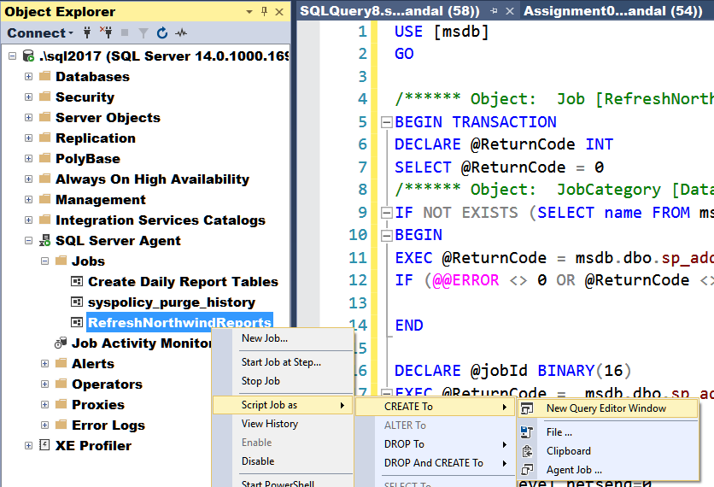

Figure 1: Using the Script feature to create a SQL script for a job.

### Write a Paper

Create a Word document that outlines how to create and execute a SQL Server Agent job.

This document should be written as a technical support document that new hire can read to understand what the process does, and technicians might use to troubleshoot the process. Include screen shots, please. The document should be about 2 to 4 pages (including any pictures) in length. Please use Microsoft Word or something compatible for your paper. I recommend that you start with the pictures, place them in your Word document, and then add a short paragraph to describe what you are seeing/doing.

**NOTES:**

1) Read this two page article on creating technical documentation before you start: <http://www.developer.com/tech/article.php/3848981/The-7-Rules-for-Writing-World-Class-Technical-Documentation.htm>

2) If you need help getting screenshots see this page ( <http://m.wikihow.com/Take-a-Screenshot-in-Microsoft-Windows>).

3) Make sure you format it like a college paper instead of the text message. Things like having your name, date, class, and citations are always expected of a college student!

### Create a Google Blog

You will now use your Word document to create a Google Blog. The Blog does not have to look exactly like your Word document but should contain the same information. Other students will be reviewing it so please leave it public, but you may want to configure it not now show in Blogger's listing or search engine until you have had more practice.

**Note**: You will be able to delete your Blog after the course is over.

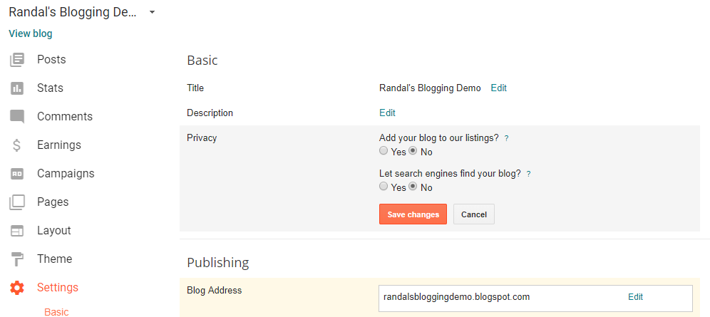

Figure 2: Using settings to configure privacy

### Post a Blog

Now that you have created a Blog, you need to share it will the class. Please post this on the discussion board created for this purpose (Module 05 Blog Links.)

**Important**: Update the Word document to include a link to your Blog at the top of the page.

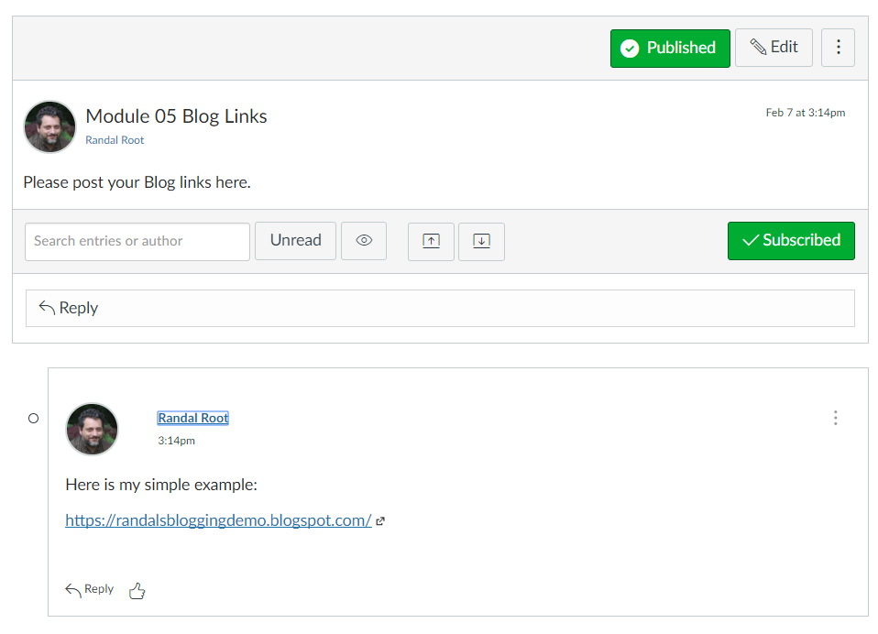

Figure 3: The example of posting a Blog link on the discussion board.

Your Blog does not have to look great, but is should be easy to read, makes sense when read, and includes images. Here is my simple example: <https://randalsbloggingdemo.blogspot.com/>

To post you images you need to first save them to your hard drive and then upload them to Blogger. Here is an article that will help you save your images to your drive:

<https://support.office.com/en-us/article/save-a-picture-smartart-graphic-or-slide-as-a-separate-file-3c4f9ca4-945a-4c33-af91-d10e4e3ea715>

### Review a Blog

Next you will be given a review partner via Canvas. Once you receive notice from Canvas on who this is, go to their Blog and review it.

Your review must contain 2 things that you liked about it and 1 thing that you feel could make is better.

**Note**: You will be notified about your review partner a couple of days AFTER the assignment is due. This process only works "well" if everyone turns in the assignment on time so please try to do so!

# Submit your work to the Canvas site

Place the SQL Script that creates the SQL Server Agent job and your Word file describing how the job works into one folder and ZIP that folder. Next, upload the resulting ZIP file to the Canvas web site.

***You’re done!***