# 2.人员信息

### 源码:

<https://github.com/gyw666/javaDesign2>

## version 1

##### 题目要求:

设计 Person 类，有姓名、地址、电话号码和电子邮件等属性。其子类为 Student 和

Employee，其中 Employee 类又有教员类 Faculty 和职员类 staff。学生类有班级状态（大一、

大二、大三或大四），这些状态为常量。Employee 类有办公室、工资和受聘日期。定义一

个名为 MyDate 的类，包含 year、month 和 day 数据域。Faculty 类有办公时间和级别。Staff

类有职务称号。重写每个类中的 toString 方法，显示相应的类名和人名。

编写测试类 Test1，要求随机产生不同的对象，并将这些对象存储到数组中，并用方法

printMessages(Person[] persons)将对象的信息输出。

##### 源码

<https://github.com/gyw666/javaDesign2>

##### 思路:

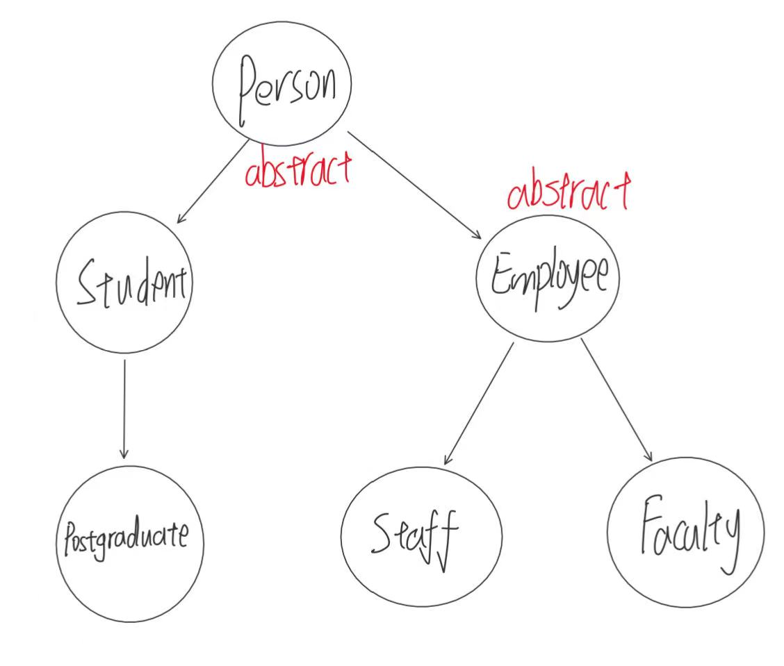

##### 代码

package personType;
  
  
import java.io.*;
  
  
public abstract class Person {
  
 private String name;
  
 private String address;
  
 private String phoneNumber;
  
 private String emailAddress;
  
  
 public Person() {
  
 }
  
  
 public Person(String name, String address, String phoneNumber, String emailAddress) {
  
 this.name = name;
  
 this.address = address;
  
 this.phoneNumber = phoneNumber;
  
 this.emailAddress = emailAddress;
  
 }
  
  
 /**
  
 * 获取
  
 * @return name
  
 */
  
 public String getName() {
  
 return name;
  
 }
  
  
 /**
  
 * 设置
  
 * @param name
  
 */
  
 public void setName(String name) {
  
 this.name = name;
  
 }
  
  
 /**
  
 * 获取
  
 * @return address
  
 */
  
 public String getAddress() {
  
 return address;
  
 }
  
  
 /**
  
 * 设置
  
 * @param address
  
 */
  
 public void setAddress(String address) {
  
 this.address = address;
  
 }
  
  
 /**
  
 * 获取
  
 * @return phoneNumber
  
 */
  
 public String getPhoneNumber() {
  
 return phoneNumber;
  
 }
  
  
 /**
  
 * 设置
  
 * @param phoneNumber
  
 */
  
 public void setPhoneNumber(String phoneNumber) {
  
 this.phoneNumber = phoneNumber;
  
 }
  
  
 /**
  
 * 获取
  
 * @return emailAddress
  
 */
  
 public String getEmailAddress() {
  
 return emailAddress;
  
 }
  
  
 /**
  
 * 设置
  
 * @param emailAddress
  
 */
  
 public void setEmailAddress(String emailAddress) {
  
 this.emailAddress = emailAddress;
  
 }
  
  
 public String toString() {
  
 return "personType.Person{name = " + name + ", address = " + address + ", phoneNumber = " + phoneNumber + ", emailAddress = " + emailAddress + "}";
  
 }
  
  
 public boolean fileWrite(String fileName) {
  
 //先读取原来文件中的地址,再加上现在对象的信息,最后再重新输出
  
 String content=fileRead(fileName)+this.toString();
  
 File writeName = new File(fileName);
  
 try {
  
 BufferedWriter out = new BufferedWriter(new FileWriter(writeName));
  
 out.write(content);
  
 out.flush();
  
 out.close();
  
 } catch (IOException e) {
  
 throw new RuntimeException(e);
  
 }
  
 return true;
  
 }
  
  
 public String fileRead(String pathName) {
  
 File fileName = new File(pathName);
  
 String line = "";
  
 try {
  
 InputStreamReader reader = new InputStreamReader(new FileInputStream(fileName));
  
 BufferedReader br = new BufferedReader(reader);
  
  
 String tempLine="";
  
 while (tempLine != null) {
  
 tempLine = br.readLine();
  
 if (tempLine != null) {
  
 line += tempLine;
  
 line += "\n";
  
 }
  
  
 }
  
  
 } catch (FileNotFoundException e) {
  
 throw new RuntimeException(e);
  
 } catch (IOException e) {
  
 throw new RuntimeException(e);
  
 }
  
 return line;
  
 }
  
}

package personType;
  
  
public class Student extends Person {
  
 private final static String grade1="freshman";
  
 private final static String grade2="sophomore";
  
 private final static String grade3="junior";
  
 private final static String grade4="senior";
  
 public Student(){}
  
 public Student(String name,String address,String phoneNumber,String emailAddress){
  
 super(name,address,phoneNumber,emailAddress);
  
 }
  
  
 public String toString() {
  
 return "class:personType.Student,name:" + this.getName();
  
 }
  
}

package personType;
  
  
public abstract class Employee extends Person {
  
 private String office;
  
 private String salary;
  
 private MyData data;
  
  
 public Employee() {
  
 }
  
  
 public Employee(String name, String address, String phoneNumber, String emailAddress,String office, String salary, MyData data) {
  
 super(name, address, phoneNumber, emailAddress);
  
 this.office = office;
  
 this.salary = salary;
  
 this.data = data;
  
 }
  
  
 /**
  
 * 获取
  
 * @return office
  
 */
  
 public String getOffice() {
  
 return office;
  
 }
  
  
 /**
  
 * 设置
  
 * @param office
  
 */
  
 public void setOffice(String office) {
  
 this.office = office;
  
 }
  
  
 /**
  
 * 获取
  
 * @return salary
  
 */
  
 public String getSalary() {
  
 return salary;
  
 }
  
  
 /**
  
 * 设置
  
 * @param salary
  
 */
  
 public void setSalary(String salary) {
  
 this.salary = salary;
  
 }
  
  
 /**
  
 * 获取
  
 * @return data
  
 */
  
 public MyData getData() {
  
 return data;
  
 }
  
  
 /**
  
 * 设置
  
 * @param data
  
 */
  
 public void setData(MyData data) {
  
 this.data = data;
  
 }
  
  
 public String toString() {
  
 return "personType.Employee{office = " + office + ", salary = " + salary + ", data = " + data + "}";
  
 }
  
}

package personType;
  
  
public class Faculty extends Employee {
  
 private String workTime;
  
 private String rank;
  
  
 public Faculty() {
  
 }
  
  
 public Faculty(String name, String address, String phoneNumber, String emailAddress, String office, String salary, MyData data, String workTime, String rank) {
  
 super(name, address, phoneNumber, emailAddress, office, salary, data);
  
 this.workTime = workTime;
  
 this.rank = rank;
  
 }
  
  
 /**
  
 * 获取
  
 * @return workTime
  
 */
  
 public String getWorkTime() {
  
 return workTime;
  
 }
  
  
 /**
  
 * 设置
  
 * @param workTime
  
 */
  
 public void setWorkTime(String workTime) {
  
 this.workTime = workTime;
  
 }
  
  
 /**
  
 * 获取
  
 * @return rank
  
 */
  
 public String getRank() {
  
 return rank;
  
 }
  
  
 /**
  
 * 设置
  
 * @param rank
  
 */
  
 public void setRank(String rank) {
  
 this.rank = rank;
  
 }
  
  
 public String toString() {
  
 return "class:personType.Faculty,name:"+this.getName();
  
 }
  
}

package personType;
  
  
public class Staff extends Employee {
  
 private String title;
  
  
 public Staff() {
  
 }
  
  
 public Staff(String name, String address, String phoneNumber, String emailAddress, String office, String salary, MyData data, String title) {
  
 super(name,address,phoneNumber,emailAddress,office,salary,data);
  
 this.title = title;
  
 }
  
  
 /**
  
 * 获取
  
 * @return title
  
 */
  
 public String getTitle() {
  
 return title;
  
 }
  
  
 /**
  
 * 设置
  
 * @param title
  
 */
  
 public void setTitle(String title) {
  
 this.title = title;
  
 }
  
  
 public String toString() {
  
 return "class:personType.Staff,name:"+this.getName();
  
 }
  
}

package personType;
  
  
public class Postgraduate extends Student {
  
 private String searchField;
  
 private String tutor;
  
  
 public Postgraduate() {
  
 }
  
  
 public Postgraduate(String name,String address,String phoneNumber,String emailAddress,String searchField, String tutor) {
  
 super(name,address,phoneNumber,emailAddress);
  
 this.searchField = searchField;
  
 this.tutor = tutor;
  
 }
  
  
 /**
  
 * 获取
  
 * @return searchField
  
 */
  
 public String getSearchField() {
  
 return searchField;
  
 }
  
  
 /**
  
 * 设置
  
 * @param searchField
  
 */
  
 public void setSearchField(String searchField) {
  
 this.searchField = searchField;
  
 }
  
  
 /**
  
 * 获取
  
 * @return tutor
  
 */
  
 public String getTutor() {
  
 return tutor;
  
 }
  
  
 /**
  
 * 设置
  
 * @param tutor
  
 */
  
 public void setTutor(String tutor) {
  
 this.tutor = tutor;
  
 }
  
  
 public String toString() {
  
 return "class:personType.Postgraduate,name:"+this.getName();
  
 }
  
}

package personType;
  
  
public class MyData {
  
 private String year;
  
 private String month;
  
 private String day;
  
  
 public MyData() {
  
 }
  
  
 public MyData(String year, String month, String day) {
  
 this.year = year;
  
 this.month = month;
  
 this.day = day;
  
 }
  
  
 /**
  
 * 获取
  
 * @return year
  
 */
  
 public String getYear() {
  
 return year;
  
 }
  
  
 /**
  
 * 设置
  
 * @param year
  
 */
  
 public void setYear(String year) {
  
 this.year = year;
  
 }
  
  
 /**
  
 * 获取
  
 * @return month
  
 */
  
 public String getMonth() {
  
 return month;
  
 }
  
  
 /**
  
 * 设置
  
 * @param month
  
 */
  
 public void setMonth(String month) {
  
 this.month = month;
  
 }
  
  
 /**
  
 * 获取
  
 * @return day
  
 */
  
 public String getDay() {
  
 return day;
  
 }
  
  
 /**
  
 * 设置
  
 * @param day
  
 */
  
 public void setDay(String day) {
  
 this.day = day;
  
 }
  
  
 public String toString() {
  
 return "personType.MyData{year = " + year + ", month = " + month + ", day = " + day + "}";
  
 }
  
}

##### 测试类

package Test;
  
  
import personType.*;
  
  
import java.util.Random;
  
  
  
public class Test1 {
  
 public static final String FILENAME="person.txt";
  
 public static void main(String[] args) {
  
 //personType.Student personType.Faculty staff
  
 //MyDate(year,month,day)
  
 Random rand = new Random();
  
 int capacity = rand.nextInt(500);
  
 Person[] persons = new Person[capacity];
  
 for (int i = 0; i < capacity; i++) {
  
 //1 personType.Student
  
 //2 personType.Faculty
  
 //3 personType.Staff
  
 int type = 1+rand.nextInt(3);
  
 switch (type) {
  
 case 1: {
  
 //personType.Student
  
 persons[i]=new Student(getName(),getAddress(),getPhoneNumber(),getEmailAddress());
  
 break;
  
 }
  
 case 2: {
  
 //personType.Faculty
  
 persons[i]=new Faculty(getName(),getAddress(),getPhoneNumber(),getEmailAddress(),getOffice(),getSalary(),getMyData(),getWorkTime(),getRank());
  
 break;
  
 }
  
 case 3: {
  
 //personType.Staff
  
 persons[i]=new Staff(getName(),getAddress(),getPhoneNumber(),getEmailAddress(),getOffice(),getSalary(),getMyData(),getTitle());
  
 break;
  
 }
  
 }
  
 }
  
 //打印
  
 printMessages(persons);
  
 }
  
  
 public static void printMessages(Person[] persons) {
  
 for(Person person: persons){
  
 System.out.println(person);
  
 }
  
 }
  
  
  
 //生成随机日期
  
 public static MyData getMyData() {
  
 Random rand = new Random();
  
 //生成随机年份
  
 String year = 2000+rand.nextInt(25) + "";
  
 int m = rand.nextInt(13);
  
 String month = m + "";
  
 String day = "";
  
 if (m == 1 || m == 3 || m == 5 || m == 7 || m == 8 || m == 10 || m == 12) {
  
 //一个月有31天
  
 day = rand.nextInt(32) + "";
  
 } else {
  
 //一个月有30天
  
 day = rand.nextInt(31) + "";
  
 }
  
 return new MyData(year, month, day);
  
 }
  
  
 //生成随机名字
  
 public static String getName() {
  
 return "name" + new Random().nextInt(100);
  
 }
  
  
 //生成随机地址
  
 public static String getAddress() {
  
 return "address" + new Random().nextInt(100);
  
 }
  
  
 //生成随机电话
  
 public static String getPhoneNumber() {
  
 return "phoneNumber" + new Random().nextInt(100);
  
 }
  
  
 //生成随机邮箱
  
 public static String getEmailAddress() {
  
 return "emailAddress" + new Random().nextInt(100);
  
 }
  
  
 //升成随机办公室
  
 public static String getOffice() {
  
 return "office" + new Random().nextInt(100);
  
 }
  
  
 //生成随机薪资
  
 public static String getSalary() {
  
 return "salary" + new Random().nextInt(100);
  
 }
  
  
 //生成随机办公时间
  
 public static String getWorkTime() {
  
 return "time" + new Random().nextInt(100);
  
 }
  
  
 //生成随机等级
  
 public static String getRank() {
  
 return "rank" + new Random().nextInt(100);
  
 }
  
  
 //生成随机职称
  
 public static String getTitle() {
  
 return "title" + new Random().nextInt(100);
  
 }
  
  
  
}

##### 输出效果

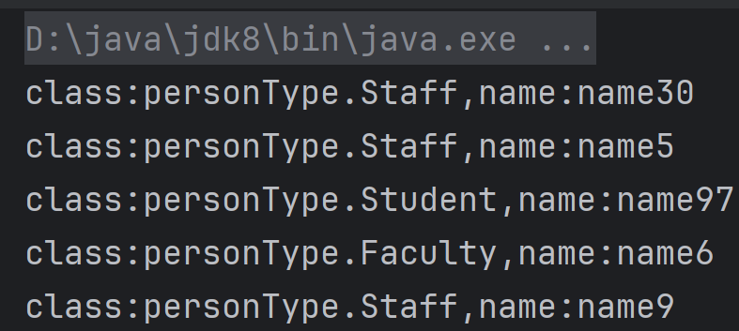

## version 2

##### 题目要求:

在上面实现类的基础上，为每个类增加一个将当前对象序列化到指定文件的方法writeToFile(File f)。为 Student 类创建一个新的子类 Postgraduate，有研究方向和导师姓名两个新增数据域。编写测试类 Test2，要求随机产生不同的对象，并将这些对象序列化到指

定的文件中，并用方法 printMessages(Person[] persons)将对象的信息输出。

##### 测试类

package Test;
  
  
import personType.*;
  
  
import java.util.Random;
  
  
  
public class Test2 {
  
 public static final String FILENAME="person.txt";
  
 public static void main(String[] args) {
  
 //personType.Student personType.Faculty staff
  
 //MyDate(year,month,day)
  
 Random rand = new Random();
  
 int capacity = rand.nextInt(500);
  
 Person[] persons = new Person[capacity];
  
 for (int i = 0; i < capacity; i++) {
  
 //1 personType.Student
  
 //2 personType.Faculty
  
 //3 personType.Staff
  
 //4 personType.Postgraduate
  
 int type = 1+rand.nextInt(4);
  
 switch (type) {
  
 case 1: {
  
 //personType.Student
  
 persons[i]=new Student(getName(),getAddress(),getPhoneNumber(),getEmailAddress());
  
 break;
  
 }
  
 case 2: {
  
 //personType.Faculty
  
 persons[i]=new Faculty(getName(),getAddress(),getPhoneNumber(),getEmailAddress(),getOffice(),getSalary(),getMyData(),getWorkTime(),getRank());
  
 break;
  
 }
  
 case 3: {
  
 //personType.Staff
  
 persons[i]=new Staff(getName(),getAddress(),getPhoneNumber(),getEmailAddress(),getOffice(),getSalary(),getMyData(),getTitle());
  
 break;
  
 }
  
 case 4: {
  
 //personType.Postgraduate
  
 persons[i]=new Postgraduate(getName(),getAddress(),getPhoneNumber(),getEmailAddress(),getResearchField(),getTutor());
  
 }
  
 }
  
 }
  
 //打印
  
 printMessages(persons);
  
 //将对象信息输出至person.txt
  
 for(Person person: persons){
  
 person.fileWrite(FILENAME);
  
 }
  
 System.out.println(capacity);
  
 }
  
  
 public static void printMessages(Person[] persons) {
  
 for(Person person: persons){
  
 System.out.println(person);
  
 }
  
 }
  
  
  
 //生成随机日期
  
 public static MyData getMyData() {
  
 Random rand = new Random();
  
 //生成随机年份
  
 String year = 2000+rand.nextInt(25) + "";
  
 int m = rand.nextInt(13);
  
 String month = m + "";
  
 String day = "";
  
 if (m == 1 || m == 3 || m == 5 || m == 7 || m == 8 || m == 10 || m == 12) {
  
 //一个月有31天
  
 day = rand.nextInt(32) + "";
  
 } else {
  
 //一个月有30天
  
 day = rand.nextInt(31) + "";
  
 }
  
 return new MyData(year, month, day);
  
 }
  
  
 //生成随机名字
  
 public static String getName() {
  
 return "name" + new Random().nextInt(100);
  
 }
  
  
 //生成随机地址
  
 public static String getAddress() {
  
 return "address" + new Random().nextInt(100);
  
 }
  
  
 //生成随机电话
  
 public static String getPhoneNumber() {
  
 return "phoneNumber" + new Random().nextInt(100);
  
 }
  
  
 //生成随机邮箱
  
 public static String getEmailAddress() {
  
 return "emailAddress" + new Random().nextInt(100);
  
 }
  
  
 //升成随机办公室
  
 public static String getOffice() {
  
 return "office" + new Random().nextInt(100);
  
 }
  
  
 //生成随机薪资
  
 public static String getSalary() {
  
 return "salary" + new Random().nextInt(100);
  
 }
  
  
 //生成随机办公时间
  
 public static String getWorkTime() {
  
 return "time" + new Random().nextInt(100);
  
 }
  
  
 //生成随机等级
  
 public static String getRank() {
  
 return "rank" + new Random().nextInt(100);
  
 }
  
  
 //生成随机职称
  
 public static String getTitle() {
  
 return "title" + new Random().nextInt(100);
  
 }
  
  
 //生成随机研究方向
  
 public static String getResearchField() {
  
 return "research" + new Random().nextInt(100);
  
 }
  
  
 //生成随机导师姓名
  
 public static String getTutor() {
  
 return "tutor" + new Random().nextInt(100);
  
 }
  
  
}

##### 输出文件

person.txt

class:personType.Faculty,name:name0
  
class:personType.Staff,name:name46
  
class:personType.Student,name:name31
  
class:personType.Staff,name:name41
  
class:personType.Student,name:name59
  
class:personType.Faculty,name:name51
  
class:personType.Staff,name:name50
  
class:personType.Student,name:name70
  
class:personType.Postgraduate,name:name10
  
class:personType.Student,name:name26
  
class:personType.Student,name:name32
  
class:personType.Faculty,name:name62
  
class:personType.Postgraduate,name:name4
  
class:personType.Postgraduate,name:name19
  
class:personType.Postgraduate,name:name79
  
class:personType.Postgraduate,name:name14
  
class:personType.Staff,name:name1
  
class:personType.Student,name:name74
  
class:personType.Faculty,name:name60
  
class:personType.Staff,name:name9
  
class:personType.Postgraduate,name:name75
  
class:personType.Staff,name:name38
  
class:personType.Postgraduate,name:name90
  
class:personType.Postgraduate,name:name42
  
class:personType.Postgraduate,name:name38
  
class:personType.Postgraduate,name:name11
  
class:personType.Staff,name:name84
  
class:personType.Faculty,name:name60
  
class:personType.Faculty,name:name60
  
class:personType.Staff,name:name97
  
class:personType.Student,name:name77
  
class:personType.Student,name:name23
  
class:personType.Faculty,name:name93
  
class:personType.Faculty,name:name57
  
class:personType.Faculty,name:name26
  
class:personType.Faculty,name:name36
  
class:personType.Staff,name:name70
  
class:personType.Faculty,name:name45
  
class:personType.Student,name:name34

## version 3

##### 题目要求:

在版本 2 的基础上设计实现一个具有 GUI 界面的人员信息管理系统，要求实现基本的人员增、删、改、查的功能，人员信息列表应采用 TableView 组件。

##### 测试类

package Test;
  
  
import javafx.geometry.Side;
  
import javafx.scene.control.*;
  
import javafx.scene.control.Button;
  
import javafx.scene.control.TextField;
  
import javafx.scene.image.Image;
  
import javafx.scene.layout.*;
  
import personType.*;
  
import javafx.application.Application;
  
import javafx.collections.FXCollections;
  
import javafx.collections.ObservableList;
  
import javafx.scene.Scene;
  
import javafx.scene.control.cell.PropertyValueFactory;
  
import javafx.stage.Stage;
  
import java.util.ArrayList;
  
import java.util.Random;
  
  
  
public class Test3 extends Application {
  
 //每个按钮和textField的宽度
  
 public static final int deleteButtonHeight = 24;
  
  
 //需要用到的button
  
 //为了方便管理可以用HBox/VBox(写这个的时候不知道这个知识点)
  
 Button delete1 = new Button("删除");
  
 Button delete2 = new Button("删除");
  
 Button delete3 = new Button("删除");
  
 Button delete4 = new Button("删除");
  
 Button delete5 = new Button("删除");
  
 Button delete6 = new Button("删除");
  
 Button delete7 = new Button("删除");
  
 Button delete8 = new Button("删除");
  
 Button delete9 = new Button("删除");
  
 Button delete10 = new Button("删除");
  
 Button delete11 = new Button("删除");
  
 Button delete12 = new Button("删除");
  
 Button delete13 = new Button("删除");
  
 Button delete14 = new Button("删除");
  
 Button delete15 = new Button("删除");
  
  
 Button search1 = new Button("Student");
  
 Button search2 = new Button("Faculty");
  
 Button search3 = new Button("Staff");
  
 Button search4 = new Button("Postgraduate");
  
  
 Button modify1 = new Button("修改");
  
 Button modify2 = new Button("修改");
  
 Button modify3 = new Button("修改");
  
 Button modify4 = new Button("修改");
  
 Button modify5 = new Button("修改");
  
 Button modify6 = new Button("修改");
  
 Button modify7 = new Button("修改");
  
 Button modify8 = new Button("修改");
  
 Button modify9 = new Button("修改");
  
 Button modify10 = new Button("修改");
  
 Button modify11 = new Button("修改");
  
 Button modify12 = new Button("修改");
  
 Button modify13 = new Button("修改");
  
 Button modify14 = new Button("修改");
  
 Button modify15 = new Button("修改");
  
  
 Button confirmButton = new Button("确定修改");
  
  
 //修改人物信息时需要用到的文本输入框
  
 TextField nameField = new TextField();
  
 TextField addressField = new TextField();
  
 TextField phoneNumberField = new TextField();
  
 TextField emailAddressField = new TextField();
  
 TextField tutorField = new TextField();
  
 TextField searchField = new TextField();
  
 TextField titleField = new TextField();
  
 TextField workTimeField = new TextField();
  
 TextField rankField = new TextField();
  
 TextField salaryField = new TextField();
  
 TextField officeField = new TextField();
  
  
 //设置为全局变量,存储要修改的行数
  
 int modifyChoice;
  
  
  
 public static void main(String[] args) {
  
 //personType.Student personType.Faculty staff
  
 //MyDate(year,month,day)
  
 launch(args);
  
  
 }
  
  
 //获取随机人物列表
  
 public static ArrayList<Person> gerPersonList() {
  
 Random rand = new Random();
  
 int capacity = 30 + rand.nextInt(500);
  
  
  
 ArrayList<Person> persons = new ArrayList<>();
  
 for (int i = 0; i < capacity; i++) {
  
 //1 personType.Student
  
 //2 personType.Faculty
  
 //3 personType.Staff
  
 //4 personType.Postgraduate
  
 int type = 1 + rand.nextInt(4);
  
 switch (type) {
  
 case 1: {
  
 //personType.Student
  
 persons.add(new Student("Student" + getName(), getAddress(), getPhoneNumber(), getEmailAddress()));
  
 break;
  
 }
  
 case 2: {
  
 //personType.Faculty
  
 persons.add(new Faculty("Faculty" + getName(), getAddress(), getPhoneNumber(), getEmailAddress(), getOffice(), getSalary(), getMyData(), getWorkTime(), getRank()));
  
 break;
  
 }
  
 case 3: {
  
 //personType.Staff
  
 persons.add(new Staff("Staff" + getName(), getAddress(), getPhoneNumber(), getEmailAddress(), getOffice(), getSalary(), getMyData(), getTitle()));
  
 break;
  
 }
  
 case 4: {
  
 //personType.Postgraduate
  
 persons.add(new Postgraduate("Postgraduate" + getName(), getAddress(), getPhoneNumber(), getEmailAddress(), getResearchField(), getTutor()));
  
 }
  
 }
  
 }
  
 return persons;
  
 }
  
  
 //生成随机日期
  
 public static MyData getMyData() {
  
 Random rand = new Random();
  
 //生成随机年份
  
 String year = 2000 + rand.nextInt(25) + "";
  
 int m = rand.nextInt(13);
  
 String month = m + "";
  
 String day = "";
  
 if (m == 1 || m == 3 || m == 5 || m == 7 || m == 8 || m == 10 || m == 12) {
  
 //一个月有31天
  
 day = rand.nextInt(32) + "";
  
 } else {
  
 //一个月有30天
  
 day = rand.nextInt(31) + "";
  
 }
  
 return new MyData(year, month, day);
  
 }
  
  
 //生成随机名字
  
 public static String getName() {
  
 return "" + new Random().nextInt(100);
  
 }
  
  
 //生成随机地址
  
 public static String getAddress() {
  
 return "address" + new Random().nextInt(100);
  
 }
  
  
 //生成随机电话
  
 public static String getPhoneNumber() {
  
 return "" + new Random().nextInt(100000);
  
 }
  
  
 //生成随机邮箱
  
 public static String getEmailAddress() {
  
 return "emailAddress" + new Random().nextInt(100);
  
 }
  
  
 //升成随机办公室
  
 public static String getOffice() {
  
 return "office" + new Random().nextInt(100);
  
 }
  
  
 //生成随机薪资
  
 public static String getSalary() {
  
 return "salary" + new Random().nextInt(100);
  
 }
  
  
 //生成随机办公时间
  
 public static String getWorkTime() {
  
 return "time" + new Random().nextInt(100);
  
 }
  
  
 //生成随机等级
  
 public static String getRank() {
  
 return "rank" + new Random().nextInt(100);
  
 }
  
  
 //生成随机职称
  
 public static String getTitle() {
  
 return "title" + new Random().nextInt(100);
  
 }
  
  
 //生成随机研究方向
  
 public static String getResearchField() {
  
 return "research" + new Random().nextInt(100);
  
 }
  
  
 //生成随机导师姓名
  
 public static String getTutor() {
  
 return "tutor" + new Random().nextInt(100);
  
 }
  
  
 @Override
  
 public void start(Stage primaryStage) throws Exception {
  
 //获取列表.里面内容为随机产生的人物
  
 ArrayList<Person> persons = gerPersonList();
  
 //tableView可以使用的list
  
 ObservableList<Person> list = FXCollections.observableArrayList();
  
 //随机产生的人物列表内容加入list
  
 list.addAll(persons);
  
  
  
 //初始化界面
  
 //把list传给tableView
  
 TableView<Person> tableView = new TableView<>(list);
  
 //生成表头,并加入tableView
  
 //personType.Person成员
  
 TableColumn<Person, String> tc_name = new TableColumn<>("姓名");
  
 tableView.getColumns().add(tc_name);
  
 TableColumn<Person, String> tc_address = new TableColumn<>("地址");
  
 tableView.getColumns().add(tc_address);
  
 TableColumn<Person, String> tc_phoneNumber = new TableColumn<>("电话");
  
 tableView.getColumns().add(tc_phoneNumber);
  
 TableColumn<Person, String> tc_emailAddress = new TableColumn<>("邮箱");
  
 tableView.getColumns().add(tc_emailAddress);
  
 //personType.Postgraduate成员
  
 TableColumn<Person, String> tc_tutor = new TableColumn<>("导师");
  
 tableView.getColumns().add(tc_tutor);
  
 TableColumn<Person, String> tc_searchField = new TableColumn<>("研究方向");
  
 tableView.getColumns().add(tc_searchField);
  
 //personType.Staff成员
  
 TableColumn<Person, String> tc_title = new TableColumn<>("职称");
  
 tableView.getColumns().add(tc_title);
  
 //personType.Faculty成员
  
 TableColumn<Person, String> tc_workTime = new TableColumn<>("工作时间");
  
 tableView.getColumns().add(tc_workTime);
  
 TableColumn<Person, String> tc_rank = new TableColumn<>("等级");
  
 tableView.getColumns().add(tc_rank);
  
 //p]ersonType.employee成员
  
 TableColumn<Person, String> tc_salary = new TableColumn<>("薪资");
  
 tableView.getColumns().add(tc_salary);
  
 TableColumn<Person, String> tc_office = new TableColumn<>("办公室");
  
 tableView.getColumns().add(tc_office);
  
 TableColumn<Person, String> tc_data = new TableColumn<>("入职日期");
  
 tableView.getColumns().add(tc_data);
  
  
 //把对应的内容加入相应的列
  
 //personType.person
  
 tc_name.setCellValueFactory(new PropertyValueFactory<Person, String>("name"));
  
 tc_address.setCellValueFactory(new PropertyValueFactory<Person, String>("address"));
  
 tc_phoneNumber.setCellValueFactory(new PropertyValueFactory<Person, String>("phoneNumber"));
  
 tc_emailAddress.setCellValueFactory(new PropertyValueFactory<Person, String>("emailAddress"));
  
 //personType.Postgraduate
  
 tc_tutor.setCellValueFactory(new PropertyValueFactory<Person, String>("tutor"));
  
 tc_searchField.setCellValueFactory(new PropertyValueFactory<Person, String>("searchField"));
  
 //personType.Staff
  
 tc_title.setCellValueFactory(new PropertyValueFactory<Person, String>("title"));
  
 //personType.Faculty
  
 tc_workTime.setCellValueFactory(new PropertyValueFactory<Person, String>("workTime"));
  
 tc_rank.setCellValueFactory(new PropertyValueFactory<Person, String>("rank"));
  
 //personType.employee
  
 tc_salary.setCellValueFactory(new PropertyValueFactory<Person, String>("salary"));
  
 tc_office.setCellValueFactory(new PropertyValueFactory<Person, String>("office"));
  
 tc_data.setCellValueFactory(new PropertyValueFactory<Person, String>("data"));
  
  
 //AnchorPane对象
  
 AnchorPane ap = new AnchorPane();
  
 //把设置好的tableView加入ap
  
 ap.getChildren().addAll(tableView);
  
  
 //增
  
 addFunction(list, tableView, ap);
  
 //删
  
 deleteFunction(list, tableView, ap);
  
 //查
  
 searchFunction(list, tableView, ap);
  
 //改
  
 modifyFunction(list, ap, tableView);
  
 //退出系统
  
 exitFunction(ap);
  
  
  
 //设置cqut背景
  
  
 //创建背景图片
  
 Image image = new Image("file:D:\\java\\javaDesign\\src\\Test\\cqut.png");
  
 //创建背景,放在右下角
  
 BackgroundImage backgroundImage = new BackgroundImage(image,
  
 BackgroundRepeat.NO_REPEAT,
  
 BackgroundRepeat.NO_REPEAT,
  
 new BackgroundPosition(
  
 Side.RIGHT, 0, true, Side.BOTTOM, 0, true),
  
 BackgroundSize.DEFAULT);
  
  
 // 设置背景
  
 ap.setBackground(new Background(backgroundImage));
  
  
 //构造ap的Scene
  
 Scene scene = new Scene(ap);
  
  
 //设置primaryStage
  
 primaryStage.setScene(scene);
  
 primaryStage.setHeight(640); //高
  
 primaryStage.setWidth(1200); //宽
  
 primaryStage.setAlwaysOnTop(true);//始终显示
  
  
 primaryStage.show();
  
  
 }
  
  
 //查询功能
  
 private void searchFunction(ObservableList<Person> list, TableView<Person> tableView, AnchorPane ap) {
  
 //查询按钮
  
 Button bu_search = new Button("查找人物");
  
 //设置位置
  
 bu_search.setLayoutX(600);
  
 bu_search.setLayoutY(450);
  
 //设置点击事件
  
 bu_search.setOnAction(event -> {
  
 //隐藏不相关的组件
  
 setModifyButtonVisual(false);
  
 setDeleteButtonVisual(false);
  
 setTextFieldNotVisible();
  
 //设置四种查询类型按钮的位置,再查询按钮的正下方
  
 search1.setLayoutX(600);
  
 search2.setLayoutX(600);
  
 search3.setLayoutX(600);
  
 search4.setLayoutX(600);
  
 search1.setLayoutY(450 + 1 * deleteButtonHeight);
  
 search2.setLayoutY(450 + 2 * deleteButtonHeight);
  
 search3.setLayoutY(450 + 3 * deleteButtonHeight);
  
 search4.setLayoutY(450 + 4 * deleteButtonHeight);
  
 //显示查询按钮
  
 setSearchButtonVisual(true);
  
 //设置点击事件
  
 search1.setOnAction(event1 -> {
  
 for (int j = 0; j < 100; j++) { //不知道为什么一次并不能完全筛选,在这里我设置筛选100词
  
 //查询逻辑就是把不是该类型的删除
  
 for (int i = 0; i < list.size(); i++) {
  
 if (!(list.get(i) instanceof Student)) {
  
 list.remove(i);
  
 }
  
 }
  
 }
  
 tableView.refresh();
  
 System.out.println("查询成功");
  
 });
  
  
 search2.setOnAction(event1 -> {
  
 for (int j = 0; j < 100; j++) {
  
 for (int i = 0; i < list.size(); i++) {
  
 if (!(list.get(i) instanceof Faculty)) {
  
 list.remove(i);
  
 }
  
 }
  
 }
  
 tableView.refresh();
  
 });
  
  
 search3.setOnAction(event1 -> {
  
 for (int j = 0; j < 100; j++) {
  
 for (int i = 0; i < list.size(); i++) {
  
 if (!(list.get(i) instanceof Staff)) {
  
 list.remove(i);
  
 }
  
 }
  
 }
  
 tableView.refresh();
  
 });
  
  
 search4.setOnAction(event1 -> {
  
 for (int j = 0; j < 100; j++) {
  
 for (int i = 0; i < list.size(); i++) {
  
 if (!(list.get(i) instanceof Postgraduate)) {
  
 list.remove(i);
  
 }
  
 }
  
 }
  
 tableView.refresh();
  
 });
  
  
 //添加查询按钮
  
 ap.getChildren().add(search1);
  
 ap.getChildren().add(search2);
  
 ap.getChildren().add(search3);
  
 ap.getChildren().add(search4);
  
 tableView.refresh();
  
  
 });
  
 ap.getChildren().add(bu_search);
  
 }
  
  
 //修改功能
  
 private void modifyFunction(ObservableList<Person> list, AnchorPane ap, TableView<Person> tableView) {
  
 //修改按钮
  
 Button bu_modify = new Button("修改信息");
  
 //确定按钮,修改完后点击
  
 //设置位置
  
 confirmButton.setLayoutX(1040);
  
 confirmButton.setLayoutY(22 + 17 * deleteButtonHeight);
  
 //设置点击事件
  
 confirmButton.setOnAction(event -> {
  
 Person temp = list.get(modifyChoice);
  
 //姓名
  
 nameField.setVisible(true);
  
 temp.setName(nameField.getText());
  
 //地址
  
 addressField.setVisible(true);
  
 temp.setAddress(addressField.getText());
  
 //电话
  
 phoneNumberField.setVisible(true);
  
 temp.setPhoneNumber(phoneNumberField.getText());
  
 //邮箱
  
 emailAddressField.setVisible(true);
  
 temp.setEmailAddress(emailAddressField.getText());
  
 if (temp instanceof Postgraduate) {
  
 //导师
  
 tutorField.setVisible(true);
  
 ((Postgraduate) temp).setTutor(tutorField.getText());
  
 //研究方向
  
 searchField.setVisible(true);
  
 ((Postgraduate) temp).setSearchField(searchField.getText());
  
 }
  
 if (temp instanceof Employee) {
  
 //办公室
  
 officeField.setVisible(true);
  
 ((Employee) temp).setOffice(officeField.getText());
  
 //工资
  
 salaryField.setVisible(true);
  
 ((Employee) temp).setSalary(salaryField.getText());
  
 }
  
 if (temp instanceof Staff) {
  
 //职称
  
 titleField.setVisible(true);
  
 ((Staff) temp).setTitle(titleField.getText());
  
 }
  
 if (temp instanceof Faculty) {
  
 //上班时间
  
 workTimeField.setVisible(true);
  
 ((Faculty) temp).setWorkTime(workTimeField.getText());
  
 //等级
  
 rankField.setVisible(true);
  
 ((Faculty) temp).setRank(rankField.getText());
  
 }
  
 System.out.println("修改成功");
  
 list.set(modifyChoice, temp);
  
 });
  
  
 //设置按钮不可见,只有当行修改按钮点击后才可见
  
 confirmButton.setVisible(false);
  
 ap.getChildren().add(confirmButton);
  
  
 //设置总修改按钮位置
  
 bu_modify.setLayoutX(700);
  
 bu_modify.setLayoutY(450);
  
  
 //每行设置修改按钮
  
 modify1.setLayoutX(975);
  
 modify2.setLayoutX(975);
  
 modify3.setLayoutX(975);
  
 modify4.setLayoutX(975);
  
 modify5.setLayoutX(975);
  
 modify6.setLayoutX(975);
  
 modify7.setLayoutX(975);
  
 modify8.setLayoutX(975);
  
 modify9.setLayoutX(975);
  
 modify10.setLayoutX(975);
  
 modify11.setLayoutX(975);
  
 modify12.setLayoutX(975);
  
 modify13.setLayoutX(975);
  
 modify14.setLayoutX(975);
  
 modify15.setLayoutX(975);
  
  
 modify1.setLayoutY(22 + 0 * deleteButtonHeight);
  
 modify2.setLayoutY(22 + 1 * deleteButtonHeight);
  
 modify3.setLayoutY(22 + 2 * deleteButtonHeight);
  
 modify4.setLayoutY(22 + 3 * deleteButtonHeight);
  
 modify5.setLayoutY(22 + 4 * deleteButtonHeight);
  
 modify6.setLayoutY(22 + 5 * deleteButtonHeight);
  
 modify7.setLayoutY(22 + 6 * deleteButtonHeight);
  
 modify8.setLayoutY(22 + 7 * deleteButtonHeight);
  
 modify9.setLayoutY(22 + 8 * deleteButtonHeight);
  
 modify10.setLayoutY(22 + 9 * deleteButtonHeight);
  
 modify11.setLayoutY(22 + 10 * deleteButtonHeight);
  
 modify12.setLayoutY(22 + 11 * deleteButtonHeight);
  
 modify13.setLayoutY(22 + 12 * deleteButtonHeight);
  
 modify14.setLayoutY(22 + 13 * deleteButtonHeight);
  
 modify15.setLayoutY(22 + 14 * deleteButtonHeight);
  
  
  
 //设置事件
  
 setPerModifyButtonEvent(list, modify1, 0);
  
 setPerModifyButtonEvent(list, modify2, 1);
  
 setPerModifyButtonEvent(list, modify3, 2);
  
 setPerModifyButtonEvent(list, modify4, 3);
  
 setPerModifyButtonEvent(list, modify5, 4);
  
 setPerModifyButtonEvent(list, modify6, 5);
  
 setPerModifyButtonEvent(list, modify7, 6);
  
 setPerModifyButtonEvent(list, modify8, 7);
  
 setPerModifyButtonEvent(list, modify9, 8);
  
 setPerModifyButtonEvent(list, modify10, 9);
  
 setPerModifyButtonEvent(list, modify11, 10);
  
 setPerModifyButtonEvent(list, modify12, 11);
  
 setPerModifyButtonEvent(list, modify13, 12);
  
 setPerModifyButtonEvent(list, modify14, 13);
  
 setPerModifyButtonEvent(list, modify15, 14);
  
  
 //添加行修改按钮
  
 ap.getChildren().add(modify1);
  
 ap.getChildren().add(modify2);
  
 ap.getChildren().add(modify3);
  
 ap.getChildren().add(modify4);
  
 ap.getChildren().add(modify5);
  
 ap.getChildren().add(modify6);
  
 ap.getChildren().add(modify7);
  
 ap.getChildren().add(modify8);
  
 ap.getChildren().add(modify9);
  
 ap.getChildren().add(modify10);
  
 ap.getChildren().add(modify11);
  
 ap.getChildren().add(modify12);
  
 ap.getChildren().add(modify13);
  
 ap.getChildren().add(modify14);
  
 ap.getChildren().add(modify15);
  
  
  
 setModifyButtonVisual(false);
  
  
 nameField.setLayoutX(1025);
  
 addressField.setLayoutX(1025);
  
 phoneNumberField.setLayoutX(1025);
  
 emailAddressField.setLayoutX(1025);
  
 tutorField.setLayoutX(1025);
  
 searchField.setLayoutX(1025);
  
 titleField.setLayoutX(1025);
  
 workTimeField.setLayoutX(1025);
  
 rankField.setLayoutX(1025);
  
 salaryField.setLayoutX(1025);
  
 officeField.setLayoutX(1025);
  
  
 //设置修改内容文本输入框位置
  
 nameField.setLayoutY(22 + 0 * deleteButtonHeight);
  
 addressField.setLayoutY(22 + 1 * deleteButtonHeight);
  
 phoneNumberField.setLayoutY(22 + 2 * deleteButtonHeight);
  
 emailAddressField.setLayoutY(22 + 3 * deleteButtonHeight);
  
 tutorField.setLayoutY(22 + 4 * deleteButtonHeight);
  
 searchField.setLayoutY(22 + 5 * deleteButtonHeight);
  
 titleField.setLayoutY(22 + 6 * deleteButtonHeight);
  
 workTimeField.setLayoutY(22 + 7 * deleteButtonHeight);
  
 rankField.setLayoutY(22 + 8 * deleteButtonHeight);
  
 salaryField.setLayoutY(22 + 9 * deleteButtonHeight);
  
 officeField.setLayoutY(22 + 10 * deleteButtonHeight);
  
  
 //设置输入框提示背景
  
 nameField.setPromptText("请输入姓名");
  
 addressField.setPromptText("请输入地址");
  
 phoneNumberField.setPromptText("请输入电话");
  
 emailAddressField.setPromptText("请输入邮箱");
  
 tutorField.setPromptText("请输入导师姓名");
  
 searchField.setPromptText("请输入研究方向");
  
 titleField.setPromptText("请输入职称");
  
 workTimeField.setPromptText("请输入工作时间");
  
 rankField.setPromptText("请输入等级");
  
 salaryField.setPromptText("请输入薪资");
  
 officeField.setPromptText("请输入办公室");
  
  
 //设置文本输入框不可见
  
 setTextFieldNotVisible();
  
  
 //添加文本输入框
  
 ap.getChildren().add(nameField);
  
 ap.getChildren().add(addressField);
  
 ap.getChildren().add(phoneNumberField);
  
 ap.getChildren().add(emailAddressField);
  
 ap.getChildren().add(tutorField);
  
 ap.getChildren().add(searchField);
  
 ap.getChildren().add(titleField);
  
 ap.getChildren().add(workTimeField);
  
 ap.getChildren().add(rankField);
  
 ap.getChildren().add(salaryField);
  
 ap.getChildren().add(officeField);
  
  
 //总修改按钮事件
  
 bu_modify.setOnAction(event -> {
  
 setModifyButtonVisual(true);
  
 setDeleteButtonVisual(false);
  
 setSearchButtonVisual(false);
  
 tableView.refresh();
  
 });
  
 ap.getChildren().add(bu_modify);
  
 }
  
  
 private static void exitFunction(AnchorPane ap) {
  
 //退出按钮
  
 Button bu_exit = new Button("退出");
  
 //设置按钮位置
  
 bu_exit.setLayoutX(800);
  
 bu_exit.setLayoutY(450);
  
 //设置按钮事件
  
 bu_exit.setOnAction(event -> {
  
 //结束jvm
  
 System.exit(0);
  
 });
  
 ap.getChildren().add(bu_exit);
  
 }
  
  
 //删除功能
  
 private void deleteFunction(ObservableList<Person> list, TableView<Person> tableView, AnchorPane ap) {
  
 //删除按钮
  
 Button bu_delete = new Button("删除人物");
  
 bu_delete.setLayoutX(500);
  
 bu_delete.setLayoutY(450);
  
 //设置行删除按钮
  
 setDelete_bu(list, tableView, ap, 975, 22 + 0 * deleteButtonHeight, 0, delete1);
  
 setDelete_bu(list, tableView, ap, 975, 22 + 1 * deleteButtonHeight, 1, delete2);
  
 setDelete_bu(list, tableView, ap, 975, 22 + 2 * deleteButtonHeight, 2, delete3);
  
 setDelete_bu(list, tableView, ap, 975, 22 + 3 * deleteButtonHeight, 3, delete4);
  
 setDelete_bu(list, tableView, ap, 975, 22 + 4 * deleteButtonHeight, 4, delete5);
  
 setDelete_bu(list, tableView, ap, 975, 22 + 5 * deleteButtonHeight, 5, delete6);
  
 setDelete_bu(list, tableView, ap, 975, 22 + 6 * deleteButtonHeight, 6, delete7);
  
 setDelete_bu(list, tableView, ap, 975, 22 + 7 * deleteButtonHeight, 7, delete8);
  
 setDelete_bu(list, tableView, ap, 975, 22 + 8 * deleteButtonHeight, 8, delete9);
  
 setDelete_bu(list, tableView, ap, 975, 22 + 9 * deleteButtonHeight, 9, delete10);
  
 setDelete_bu(list, tableView, ap, 975, 22 + 10 * deleteButtonHeight, 10, delete11);
  
 setDelete_bu(list, tableView, ap, 975, 22 + 11 * deleteButtonHeight, 11, delete12);
  
 setDelete_bu(list, tableView, ap, 975, 22 + 12 * deleteButtonHeight, 12, delete13);
  
 setDelete_bu(list, tableView, ap, 975, 22 + 13 * deleteButtonHeight, 13, delete14);
  
 setDelete_bu(list, tableView, ap, 975, 22 + 14 * deleteButtonHeight, 14, delete15);
  
 //设置不可见,当点击总删除按钮时可见
  
 setDeleteButtonVisual(false);
  
 //总删除按钮点击事件
  
 bu_delete.setOnAction(event -> {
  
 //设置无关组件不可见
  
 setSearchButtonVisual(false);
  
 setModifyButtonVisual(false);
  
 //设置相关组件可见
  
 setDeleteButtonVisual(true);
  
 setTextFieldNotVisible();
  
  
 });
  
 ap.getChildren().add(bu_delete);
  
 }
  
  
 //增加功能
  
 private void addFunction(ObservableList<Person> list, TableView<Person> tableView, AnchorPane ap) {
  
 //添加按钮
  
 Button bu_add = new Button("添加人物");
  
 //设置按钮位置
  
 bu_add.setLayoutX(400);
  
 bu_add.setLayoutY(450);
  
 //设置按钮事件
  
 bu_add.setOnAction(event -> {
  
 //设置其他无关组件不可见
  
 setSearchButtonVisual(false);
  
 setDeleteButtonVisual(false);
  
 setModifyButtonVisual(false);
  
 setTextFieldNotVisible();
  
 //获取随机人物对象并添加至list
  
 list.add(gerPersonList().get(0));
  
 System.out.println("添加成功");
  
 tableView.refresh();
  
 });
  
  
 ap.getChildren().add(bu_add);
  
 }
  
  
 private void setTextFieldNotVisible() {
  
 nameField.setVisible(false);
  
 addressField.setVisible(false);
  
 phoneNumberField.setVisible(false);
  
 emailAddressField.setVisible(false);
  
 tutorField.setVisible(false);
  
 searchField.setVisible(false);
  
 titleField.setVisible(false);
  
 workTimeField.setVisible(false);
  
 rankField.setVisible(false);
  
 salaryField.setVisible(false);
  
 officeField.setVisible(false);
  
 confirmButton.setVisible(false);
  
 }
  
  
 //行修改按钮功能
  
 private void setPerModifyButtonEvent(ObservableList<Person> list, Button modify, int line) {
  
 modify.setOnAction(event -> {
  
 modifyChoice = line;
  
 confirmButton.setVisible(true);
  
 modifyEvent(list, line);
  
 });
  
 }
  
  
 private void setSearchButtonVisual(boolean value) {
  
 search1.setVisible(value);
  
 search2.setVisible(value);
  
 search3.setVisible(value);
  
 search4.setVisible(value);
  
  
 }
  
  
 private void setDeleteButtonVisual(boolean value) {
  
 delete1.setVisible(value);
  
 delete2.setVisible(value);
  
 delete3.setVisible(value);
  
 delete4.setVisible(value);
  
 delete5.setVisible(value);
  
 delete6.setVisible(value);
  
 delete7.setVisible(value);
  
 delete8.setVisible(value);
  
 delete9.setVisible(value);
  
 delete10.setVisible(value);
  
 delete11.setVisible(value);
  
 delete12.setVisible(value);
  
 delete13.setVisible(value);
  
 delete14.setVisible(value);
  
 delete15.setVisible(value);
  
 }
  
  
 private void setDelete_bu(ObservableList<Person> list, TableView<Person> tableView, AnchorPane ap, double x, double y, int index, Button delete) {
  
 //设置行删除按钮的位置
  
 delete.setLayoutX(x);
  
 delete.setLayoutY(y);
  
 //设置行删除按钮的事件
  
 delete.setOnAction(event1 -> {
  
 list.remove(index);
  
 tableView.refresh();
  
 System.out.println("成功删除");
  
 });
  
 ap.getChildren().add(delete);
  
 }
  
  
 private void setModifyButtonVisual(boolean value) {
  
 modify1.setVisible(value);
  
 modify2.setVisible(value);
  
 modify3.setVisible(value);
  
 modify4.setVisible(value);
  
 modify5.setVisible(value);
  
 modify6.setVisible(value);
  
 modify7.setVisible(value);
  
 modify8.setVisible(value);
  
 modify9.setVisible(value);
  
 modify10.setVisible(value);
  
 modify11.setVisible(value);
  
 modify12.setVisible(value);
  
 modify13.setVisible(value);
  
 modify14.setVisible(value);
  
 modify15.setVisible(value);
  
 }
  
  
  
 //修改具体实现逻辑
  
 private void modifyEvent(ObservableList<Person> list, int line) {
  
 Person temp = list.get(line);
  
 //姓名
  
 nameField.setVisible(true);
  
 nameField.setText(temp.getName());
  
 temp.setName(nameField.getText());
  
 //地址
  
 addressField.setVisible(true);
  
 addressField.setText(temp.getAddress());
  
 temp.setAddress(addressField.getText());
  
 //电话
  
 phoneNumberField.setVisible(true);
  
 phoneNumberField.setText(temp.getPhoneNumber());
  
 temp.setPhoneNumber(phoneNumberField.getText());
  
 //邮箱
  
 emailAddressField.setVisible(true);
  
 emailAddressField.setText(temp.getEmailAddress());
  
 temp.setEmailAddress(emailAddressField.getText());
  
 if (temp instanceof Postgraduate) {
  
 //导师
  
 tutorField.setVisible(true);
  
 tutorField.setText(((Postgraduate) temp).getTutor());
  
 ((Postgraduate) temp).setTutor(tutorField.getText());
  
 //研究方向
  
 searchField.setVisible(true);
  
 searchField.setText(((Postgraduate) temp).getName());
  
 ((Postgraduate) temp).setSearchField(searchField.getText());
  
 }
  
 if (temp instanceof Employee) {
  
 //办公室
  
 officeField.setVisible(true);
  
 officeField.setText(((Employee) temp).getOffice());
  
 ((Employee) temp).setOffice(officeField.getText());
  
 //工资
  
 salaryField.setVisible(true);
  
 salaryField.setText(((Employee) temp).getSalary());
  
 ((Employee) temp).setSalary(salaryField.getText());
  
 }
  
 if (temp instanceof Staff) {
  
 //职称
  
 titleField.setVisible(true);
  
 titleField.setText(((Staff) temp).getTitle());
  
 ((Staff) temp).setTitle(titleField.getText());
  
 }
  
 if (temp instanceof Faculty) {
  
 //上班时间
  
 workTimeField.setVisible(true);
  
 workTimeField.setText(((Faculty) temp).getWorkTime());
  
 ((Faculty) temp).setWorkTime(workTimeField.getText());
  
 //等级
  
 rankField.setVisible(true);
  
 rankField.setText(((Faculty) temp).getRank());
  
 ((Faculty) temp).setRank(rankField.getText());
  
 }
  
 System.out.println("修改成功");
  
 list.set(line, temp);
  
 }
  
  
  
}

##### 输出效果

初始界面

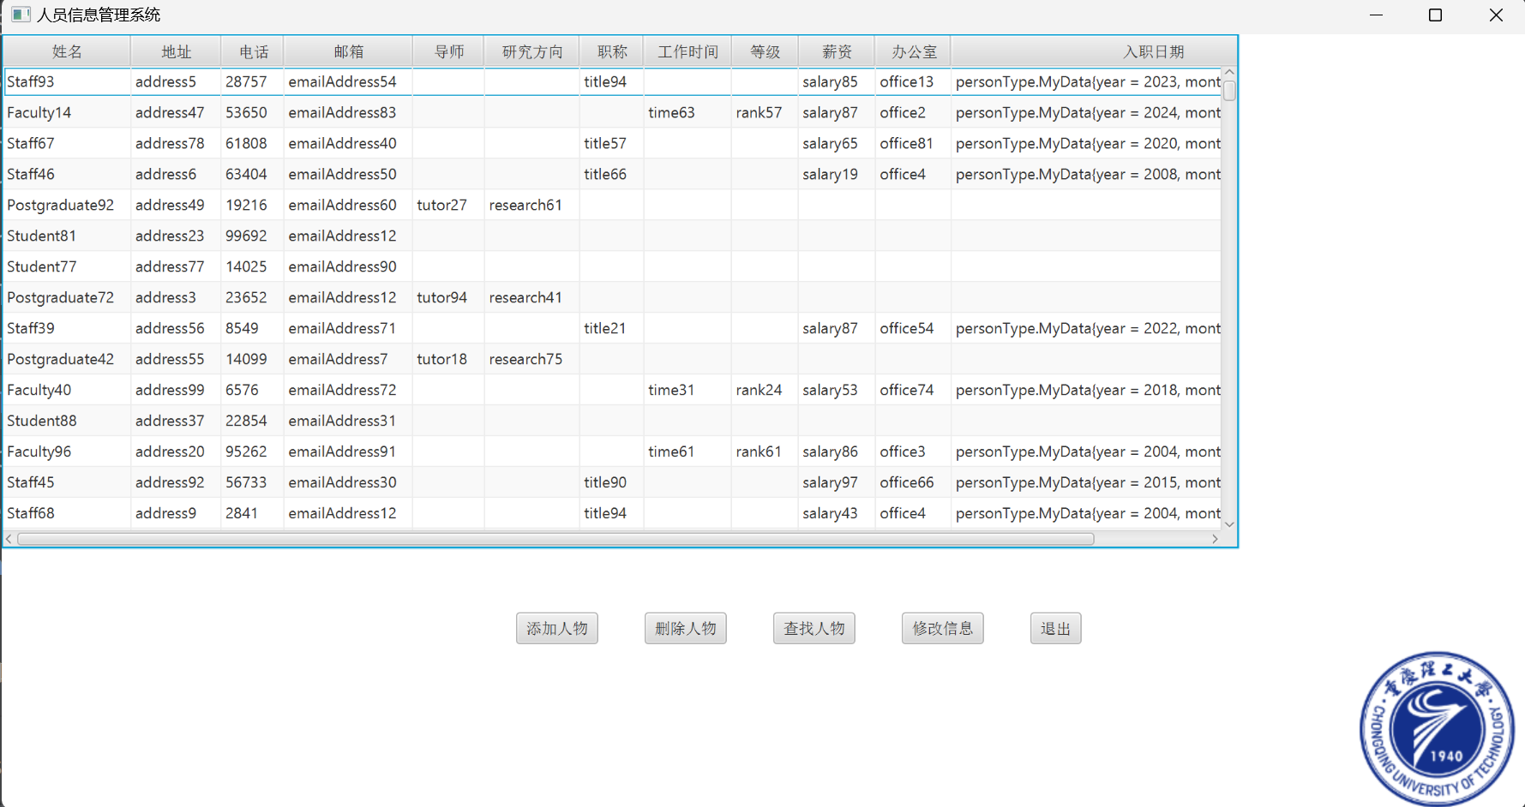

修改信息界面

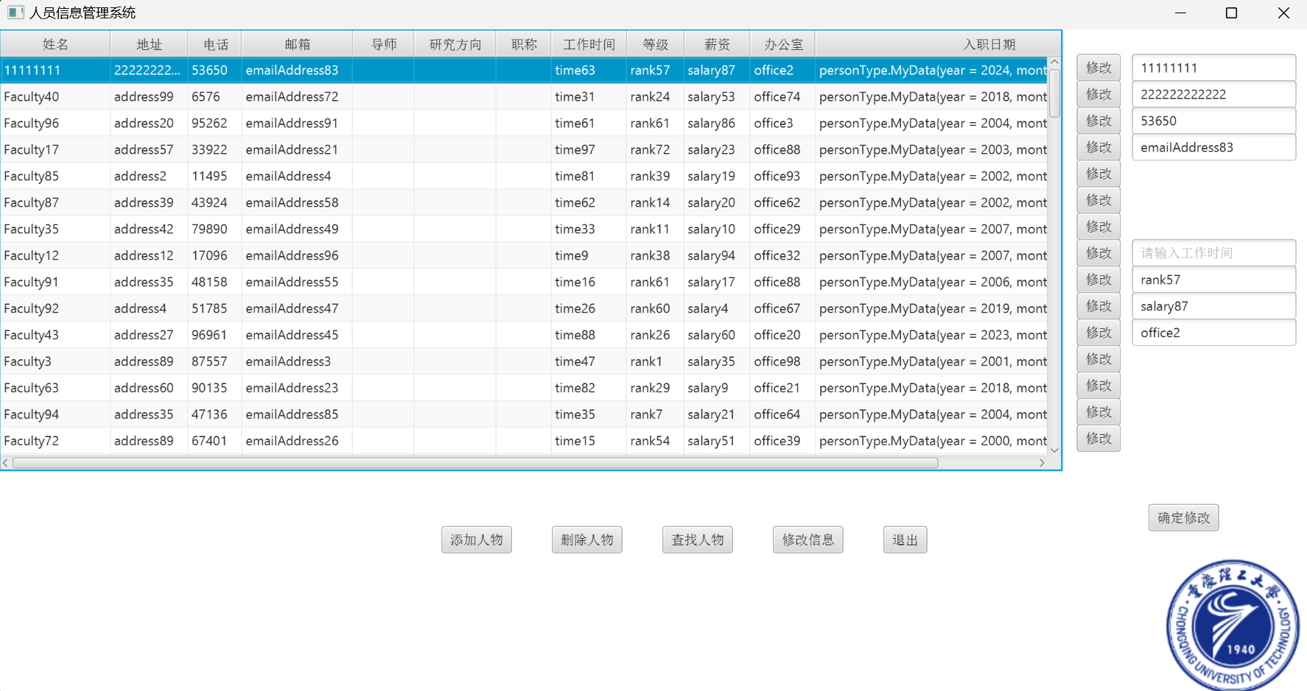

查询界面

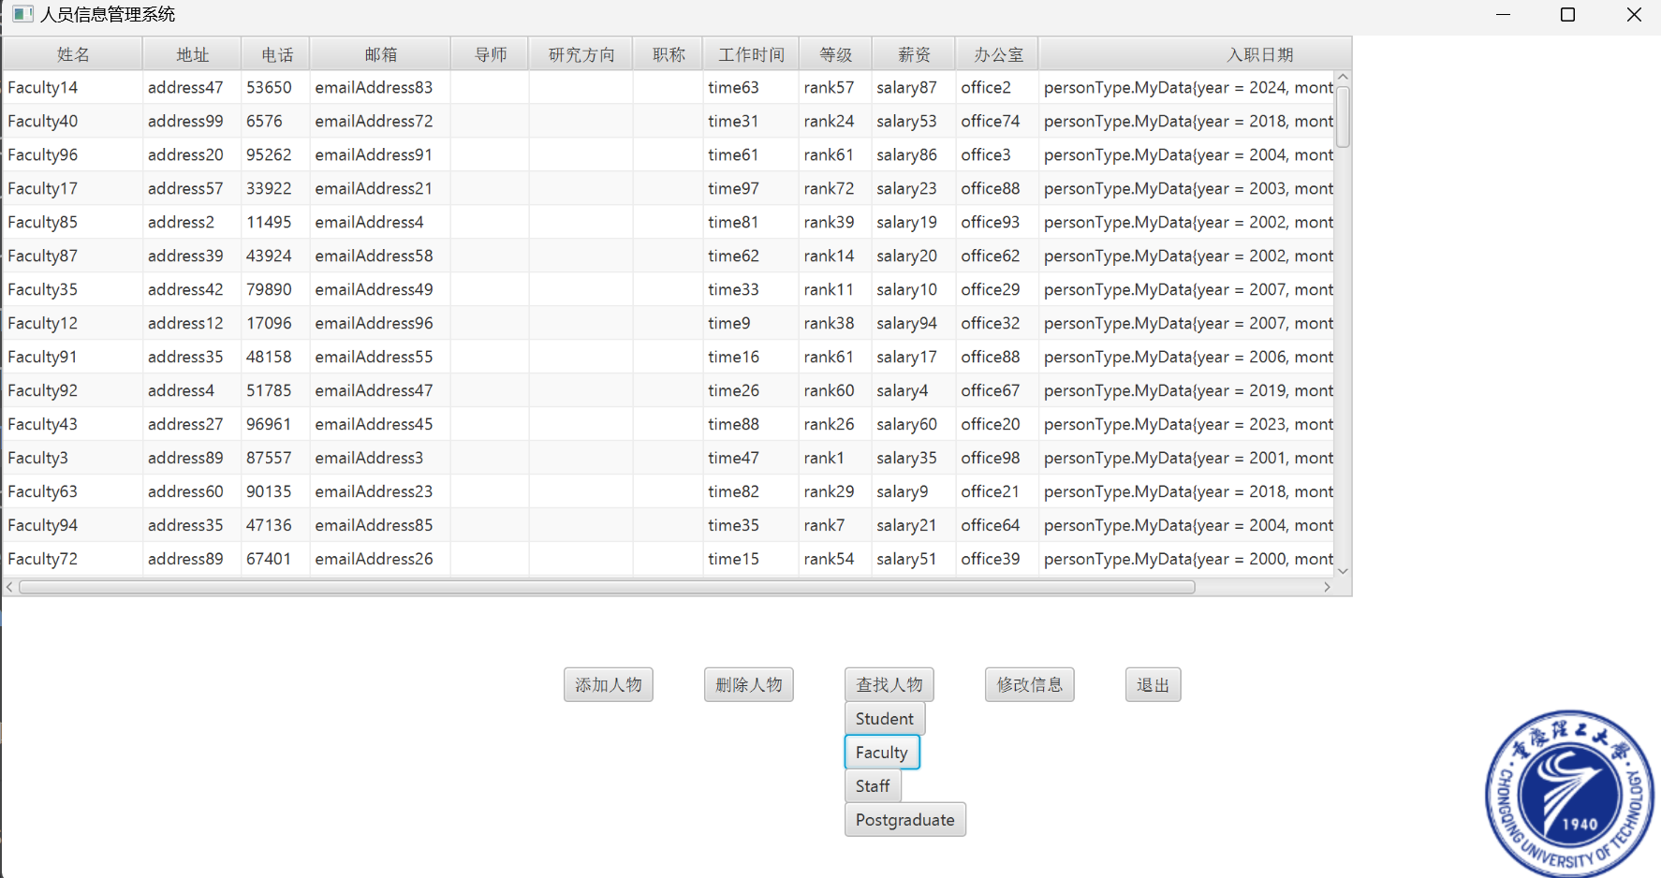

删除界面

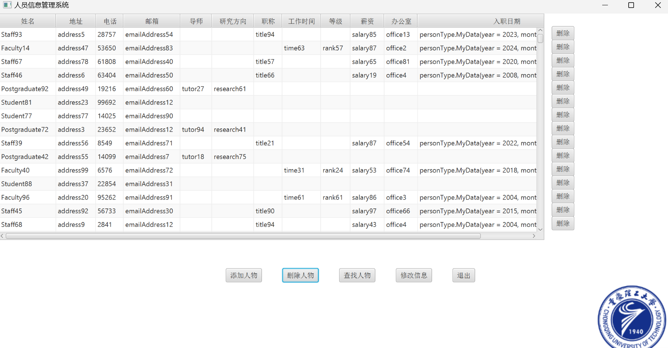

# 6.模拟风扇

### 源码:

<https://github.com/gyw666/javaDesign6>

## version 1

##### 题目要求:

模拟实现电风扇，可以调 3 档速度（慢速、中速、快速）；开关按钮；定时吹风；描述

风扇的扇叶大小、颜色等。

设计 Fan 类，属性包括：3 个常量 SLOW（1）、MEDIUM（2）、FAST（3）代表风扇

的速度；1 个 int 属性 speed 指定速度，默认值为 SLOW；1 个 boolean 属性 on 指定开关机，

默认值 false；1 个 double 属性 radius 指定风扇扇叶大小；1 个 String 属性 color 指定扇叶颜

色，默认值为 blue。方法包括这些属性的访问器、构造函数、重写 Object 类的 toString()和

equals()方法等。

##### 代码

package fanType;
  
  
public class Fan1 implements Comparable<Fan1>{
  
 public static final int SLOW = 1;
  
 public static final int MEDIUM = 2;
  
 public static final int FAST = 3;
  
  
 private int speed;
  
 private boolean on;
  
 private String color;
  
 private double radius;
  
  
  
 public Fan1() {
  
 speed = SLOW;
  
 on = false;
  
 color = "blue";
  
 }
  
  
  
 public Fan1(int speed, boolean on, String color, double radius) {
  
 this.speed = speed;
  
 this.on = on;
  
 this.color = color;
  
 this.radius = radius;
  
 }
  
  
 /**
  
 * 获取
  
 * @return speed
  
 */
  
 public int getSpeed() {
  
 return speed;
  
 }
  
  
 /**
  
 * 设置
  
 * @param speed
  
 */
  
 public void setSpeed(int speed) {
  
 this.speed = speed;
  
 }
  
  
 /**
  
 * 获取
  
 * @return on
  
 */
  
 public boolean isOn() {
  
 return on;
  
 }
  
  
 /**
  
 * 设置
  
 * @param on
  
 */
  
 public void setOn(boolean on) {
  
 this.on = on;
  
 }
  
  
 /**
  
 * 获取
  
 * @return color
  
 */
  
 public String getColor() {
  
 return color;
  
 }
  
  
 /**
  
 * 设置
  
 * @param color
  
 */
  
 public void setColor(String color) {
  
 this.color = color;
  
 }
  
  
 /**
  
 * 获取
  
 * @return radius
  
 */
  
 public double getRadius() {
  
 return radius;
  
 }
  
  
 /**
  
 * 设置
  
 * @param radius
  
 */
  
 public void setRadius(double radius) {
  
 this.radius = radius;
  
 }
  
  
 public String toString() {
  
 return "fan1{ speed = " + speed + ", on = " + on + ", color = " + color + ", radius = " + radius + "}";
  
 }
  
  
 @Override
  
 public int compareTo(Fan1 o) {
  
 return Double.compare(this.radius, o.radius);
  
 }
  
}

##### 测试类

package Test;
  
import fanType.Fan1;
  
  
public class test1 {
  
 public static void main(String[] args) {
  
 Fan1 fan1 = new Fan1();
  
 fan1.setSpeed(Fan1.FAST);
  
 fan1.setRadius(10);
  
 fan1.setColor("yellow");
  
 fan1.setOn(true);
  
 System.out.println(fan1.toString());
  
 }
  
}

##### 输出效果

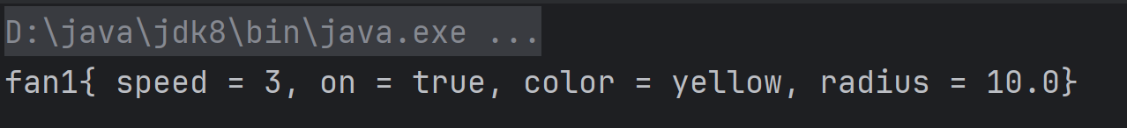

## version 2

##### 题目要求:

修改版本 1 中 Fan 类，让其继承 Pane 类，并且把 color 属性设置为 Color 类型，默认属

性为 red。随机产生 radius，取值范围为 1-5；随机产生颜色，取值范围为 red、blue、yellow、

green、orange；根据 color、radius 属性值绘制风扇。运行如下图：

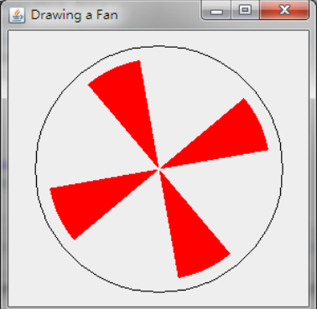

##### 代码

package fanType;
  
  
import javafx.scene.layout.Pane;
  
import javafx.scene.shape.*;
  
import javafx.scene.paint.Color;
  
  
import java.util.Random;
  
  
  
public class Fan2 extends Pane{
  
 private Color color;
  
 private int radius;
  
 public Fan2() {
  
 color = Color.RED;
  
 drawFan();
  
 }
  
  
 public void setRadius(int radius) {
  
 this.radius = radius;
  
 drawFan();
  
 }
  
  
 public int getRadius() {
  
 return radius;
  
  
 }
  
  
 public void setColor(Color color) {
  
 this.color = color;
  
 drawFan();
  
 }
  
  
 public Color getColor() {
  
 return color;
  
 }
  
  
 public Fan2(Color color, int radius) {
  
 this.color = color;
  
 this.radius = radius;
  
 drawFan();
  
 }
  
  
 private void drawFan() {
  
 double centerX = 400;
  
 double centerY = 300;
  
 for (int i = 0; i < 4; i++) {
  
 Arc arc = new Arc(centerX,centerY,radius,radius,i*90+30,30);
  
 arc.setType(ArcType.ROUND);
  
 arc.setFill(color);
  
 arc.setStroke(Color.BLACK);
  
 arc.setStrokeWidth(1);
  
 this.getChildren().add(arc);
  
 }
  
 // 创建Path对象
  
 Path path = new Path();
  
  
 // 起点：在圆弧的顶部（3点钟位置）
  
 MoveTo moveTo = new MoveTo();
  
 moveTo.setX(centerX + radius); // 起点X坐标
  
 moveTo.setY(centerY); // 起点Y坐标
  
  
 // 创建上半圆弧
  
 ArcTo arcTo1 = new ArcTo();
  
 arcTo1.setX(centerX - radius); // 上半圆弧终点X坐标
  
 arcTo1.setY(centerY); // 上半圆弧终点Y坐标
  
 arcTo1.setRadiusX(radius); // X轴方向的半径
  
 arcTo1.setRadiusY(radius); // Y轴方向的半径
  
 arcTo1.setSweepFlag(false); // 指定弧的方向为逆时针
  
  
 // 创建下半圆弧
  
 ArcTo arcTo2 = new ArcTo();
  
 arcTo2.setX(centerX + radius); // 下半圆弧终点X坐标
  
 arcTo2.setY(centerY); // 下半圆弧终点Y坐标
  
 arcTo2.setRadiusX(radius); // X轴方向的半径
  
 arcTo2.setRadiusY(radius); // Y轴方向的半径
  
 arcTo2.setSweepFlag(false); // 指定弧的方向为逆时针
  
  
 // 将起点和圆弧添加到路径
  
 path.getElements().add(moveTo);
  
 path.getElements().add(arcTo1);
  
 path.getElements().add(arcTo2);
  
  
 // 设置路径的样式
  
 path.setStroke(Color.BLACK);
  
 path.setStrokeWidth(2);
  
 path.setFill(null);
  
  
 // 将路径添加到Pane
  
 this.getChildren().add(path);
  
  
 }
  
  
  
 public static Color getRandomColor() {
  
 int choice=new Random().nextInt(5);
  
 switch (choice) {
  
 case 0:{
  
 return Color.RED;
  
 }
  
 case 1:{
  
 return Color.BLUE;
  
 }
  
 case 2:{
  
 return Color.YELLOW;
  
 }
  
 case 3:{
  
 return Color.GREEN;
  
 }
  
 case 4:{
  
 return Color.ORANGE;
  
 }
  
 }
  
 return null;
  
 }
  
  
 public static int getRandomRadius(){
  
 return 100*(1+new Random().nextInt(5));
  
 }
  
}

##### 测试类

package Test;
  
  
import fanType.Fan2;
  
import javafx.application.Application;
  
import javafx.scene.Scene;
  
import javafx.scene.paint.Color;
  
import javafx.stage.Stage;
  
  
  
public class test2 extends Application {
  
  
 public static void main(String[] args) {
  
 launch(args);
  
 }
  
  
  
 @Override
  
 public void start(Stage primaryStage) throws Exception {
  
 Color color = Fan2.getRandomColor();
  
 int radius = Fan2.getRandomRadius();
  
 Fan2 fan = new Fan2(color,radius);
  
  
 Scene scene =new Scene(fan,800,600);
  
 primaryStage.setScene(scene);
  
 primaryStage.setAlwaysOnTop(true);
  
 primaryStage.setTitle("顾砚文牌牛逼风扇");
  
 primaryStage.show();
  
  
 }
  
}

##### 输出效果

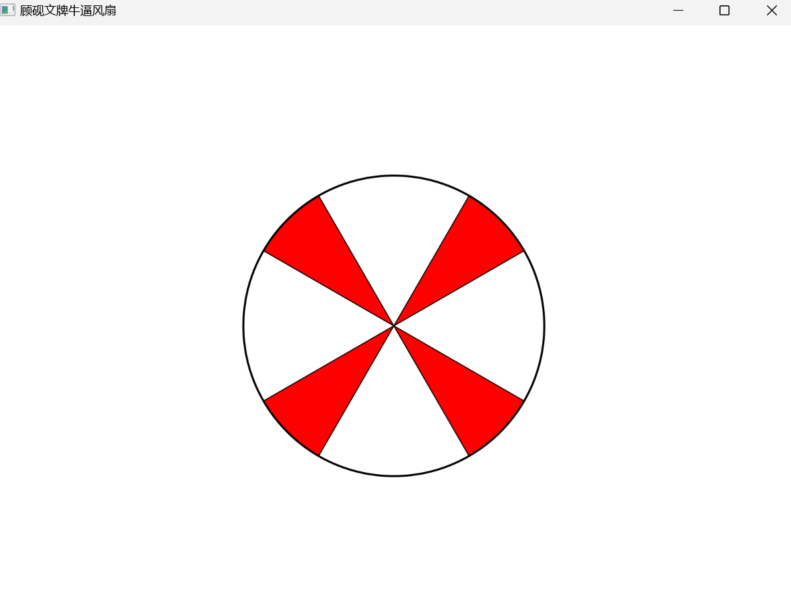

## version 3

##### 题目要求:

让版本 2 中的风扇转起来。创建一个 FanControl 类包含以下内容：Start、Stop、Reverse

按钮，用于开启、关闭、反转控制；一个滚动条控制速度。运行示例如下：

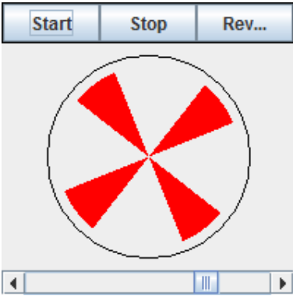

##### 代码

package fanType;
  
  
import javafx.animation.KeyFrame;
  
import javafx.animation.Timeline;
  
import javafx.geometry.Pos;
  
import javafx.scene.Group;
  
import javafx.scene.Scene;
  
import javafx.scene.control.Button;
  
import javafx.scene.control.Slider;
  
import javafx.scene.layout.BorderPane;
  
import javafx.scene.layout.HBox;
  
import javafx.scene.layout.Pane;
  
import javafx.scene.layout.VBox;
  
import javafx.scene.shape.*;
  
import javafx.scene.paint.Color;
  
import javafx.stage.Stage;
  
import javafx.util.Duration;
  
  
import java.util.Random;
  
  
  
public class Fan3 extends Pane{
  
 private Color color;
  
 private int radius;
  
 Group group=new Group();
  
 Scene scene;
  
 public Fan3() {
  
 color = Color.RED;
  
 }
  
  
 public void setRadius(int radius) {
  
 this.radius = radius;
  
 }
  
  
 public int getRadius() {
  
 return radius;
  
  
 }
  
  
 public void setColor(Color color) {
  
 this.color = color;
  
 }
  
  
 public Color getColor() {
  
 return color;
  
 }
  
  
 public Fan3(Color color, int radius) {
  
 this.color = color;
  
 this.radius = radius;
  
 }
  
  
 public void drawFan(Stage primaryStage) {
  
 double centerX = 400;
  
 double centerY = 300;
  
 for (int i = 0; i < 4; i++) {
  
 Arc arc = new Arc(centerX,centerY,radius,radius,i*90+30,30);
  
 arc.setType(ArcType.ROUND);
  
 arc.setFill(color);
  
 arc.setStroke(Color.BLACK);
  
 arc.setStrokeWidth(1);
  
 group.getChildren().add(arc);
  
 }
  
 // 创建Path对象
  
 Path path = new Path();
  
  
 // 起点：在圆弧的顶部（3点钟位置）
  
 MoveTo moveTo = new MoveTo();
  
 moveTo.setX(centerX + radius); // 起点X坐标
  
 moveTo.setY(centerY); // 起点Y坐标
  
  
 // 创建上半圆弧
  
 ArcTo arcTo1 = new ArcTo();
  
 arcTo1.setX(centerX - radius); // 上半圆弧终点X坐标
  
 arcTo1.setY(centerY); // 上半圆弧终点Y坐标
  
 arcTo1.setRadiusX(radius); // X轴方向的半径
  
 arcTo1.setRadiusY(radius); // Y轴方向的半径
  
 arcTo1.setSweepFlag(false); // 指定弧的方向为逆时针
  
  
 // 创建下半圆弧
  
 ArcTo arcTo2 = new ArcTo();
  
 arcTo2.setX(centerX + radius); // 下半圆弧终点X坐标
  
 arcTo2.setY(centerY); // 下半圆弧终点Y坐标
  
 arcTo2.setRadiusX(radius); // X轴方向的半径
  
 arcTo2.setRadiusY(radius); // Y轴方向的半径
  
 arcTo2.setSweepFlag(false); // 指定弧的方向为逆时针
  
  
 // 将起点和圆弧添加到路径
  
 path.getElements().add(moveTo);
  
 path.getElements().add(arcTo1);
  
 path.getElements().add(arcTo2);
  
  
 // 设置路径的样式
  
 path.setStroke(Color.BLACK);
  
 path.setStrokeWidth(2);
  
 path.setFill(null);
  
  
 // 将路径添加到Pane
  
 group.getChildren().add(path);
  
  
  
  
 Button blueButton = new Button("蓝色");
  
 Button yellowButton = new Button("黄色");
  
 Button greenButton = new Button("绿色");
  
 Button orangeButton = new Button("橙色");
  
 Button redButton = new Button("红色");
  
  
 VBox hc=new VBox(10, blueButton, yellowButton, greenButton, orangeButton, redButton);
  
 hc.setAlignment(Pos.BOTTOM_RIGHT);
  
  
  
  
 Button radius_50=new Button("50");
  
 Button radius_100=new Button("100");
  
 Button radius_150=new Button("150");
  
 Button radius_200=new Button("200");
  
 Button radius_250=new Button("250");
  
  
 VBox r=new VBox(10, radius_50, radius_100, radius_150, radius_200, radius_250);
  
 r.setAlignment(Pos.BOTTOM_LEFT);
  
  
 radius_100.setOnAction(event -> {
  
 new Fan3(this.color,100).drawFan(primaryStage);
  
 });
  
  
 radius_150.setOnAction(event -> {
  
 new Fan3(this.color,150).drawFan(primaryStage);
  
 });
  
  
 radius_200.setOnAction(event -> {
  
 new Fan3(this.color,200).drawFan(primaryStage);
  
 });
  
  
 radius_50.setOnAction(event -> {
  
 new Fan3(this.color,50).drawFan(primaryStage);
  
 });
  
  
 radius_250.setOnAction(event -> {
  
 new Fan3(this.color,250).drawFan(primaryStage);
  
 });
  
  
  
  
  
  
 Button pause = new Button("暂停"); //暂停按钮
  
 Button resume = new Button("继续"); //继续按钮
  
 Button reverse = new Button("反转"); //反转按钮
  
  
  
 HBox hBox = new HBox(10, pause, resume, reverse);
  
 hBox.setAlignment(Pos.BOTTOM_CENTER);
  
  
  
  
  
  
 redButton.setOnAction(event ->{
  
 new Fan3(Color.RED,radius).drawFan(primaryStage);
  
 });
  
  
 blueButton.setOnAction(event ->{
  
 new Fan3(Color.BLUE,radius).drawFan(primaryStage);
  
 });
  
  
 yellowButton.setOnAction(event ->{
  
 new Fan3(Color.YELLOW,radius).drawFan(primaryStage);
  
 });
  
  
 greenButton.setOnAction(event ->{
  
 new Fan3(Color.GREEN,radius).drawFan(primaryStage);
  
 });
  
  
 orangeButton.setOnAction(event ->{
  
 new Fan3(Color.ORANGE,radius).drawFan(primaryStage);
  
 });
  
  
 //关键帧
  
 KeyFrame keyFrame1 = new KeyFrame(Duration.millis(10), event -> group.setRotate(group.getRotate()+1));
  
 KeyFrame keyFrame2 = new KeyFrame(Duration.millis(10), event -> group.setRotate(group.getRotate()-1));
  
 Timeline animation = new Timeline(keyFrame1); //时间线动画
  
 animation.setCycleCount(Timeline.INDEFINITE); //无限循环次数
  
 animation.play(); //启动动画
  
  
 pause.setOnAction(event -> animation.pause());
  
 resume.setOnAction(event -> animation.play());
  
 reverse.setOnAction(event -> {
  
 animation.stop();
  
 animation.getKeyFrames().add(animation.getKeyFrames().remove(0).equals(keyFrame1) ? keyFrame2 : keyFrame1);
  
 animation.play();
  
 });
  
 Slider slider = new Slider(); //滑动条
  
 slider.setMax(10); //滑动条设置最大值
  
 slider.valueProperty().addListener(observable -> animation.setRate(slider.getValue())); //滑动条添加监听器
  
  
 BorderPane borderPane = new BorderPane(new BorderPane(group));
  
 borderPane.setTop(hBox);
  
 borderPane.setRight(hc);
  
 borderPane.setLeft(r);
  
 borderPane.setBottom(slider);
  
  
 scene=new Scene(borderPane, 800, 600);
  
 primaryStage.setScene(scene);
  
 primaryStage.setTitle("顾砚文牌牛逼风扇");
  
 primaryStage.show();
  
 }
  
  
  
 public static Color getRandomColor() {
  
 int choice=new Random().nextInt(5);
  
 switch (choice) {
  
 case 0:{
  
 return Color.RED;
  
 }
  
 case 1:{
  
 return Color.BLUE;
  
 }
  
 case 2:{
  
 return Color.YELLOW;
  
 }
  
 case 3:{
  
 return Color.GREEN;
  
 }
  
 case 4:{
  
 return Color.ORANGE;
  
 }
  
 }
  
 return null;
  
 }
  
  
 public static int getRandomRadius(){
  
 return 50*(1+new Random().nextInt(4));
  
 }
  
}

##### 测试类

package Test;
  
  
import fanType.Fan3;
  
import javafx.application.Application;
  
import javafx.scene.Scene;
  
import javafx.scene.paint.Color;
  
import javafx.stage.Stage;
  
  
  
public class test3 extends Application {
  
  
 public static void main(String[] args) {
  
 launch(args);
  
 }
  
  
  
 @Override
  
 public void start(Stage primaryStage) throws Exception {
  
 Color color = Fan3.getRandomColor();
  
 int radius = Fan3.getRandomRadius();
  
 Fan3 fan = new Fan3(color,radius);
  
 fan.setRadius(200);
  
 fan.drawFan(primaryStage);
  
  
 }
  
}

##### 输出效果

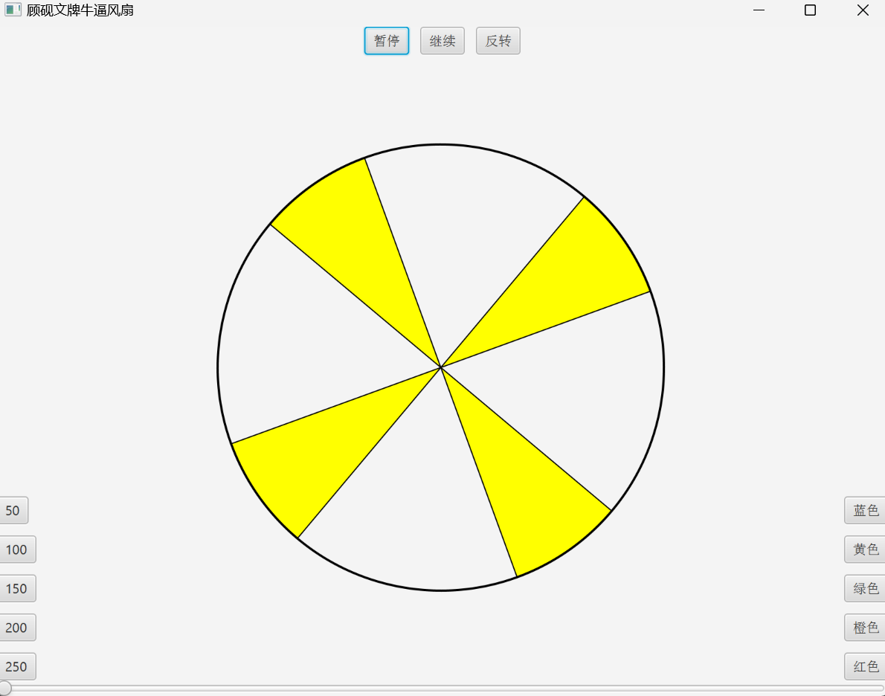

# 课程设计总结

在这次的程序设计中，我完成了人员管理系统和模拟风扇的设计开发，收获颇丰。这两个项目使我在实际应用中深入理解了JavaFX的核心组件和动画效果，并提升了编程能力和项目管理技能。

#### 人员管理:

首先，人员管理系统项目让我深入了解了JavaFX中的TableView、Button和TextField等基本组件的使用。TableView作为展示和管理表格数据的重要组件，在这个项目中发挥了核心作用。我学习并实践了如何通过ObservableList来动态更新表格数据，从而实现数据的增删改查功能。通过这些操作，我对数据绑定（data binding）有了更深的认识，并学会了如何有效地管理和更新界面上的数据。

在设计用户界面时，Button和TextField的结合使用让我掌握了响应用户输入的基本方法。例如，通过监听Button的点击事件，我能够触发相应的动作，如添加新人员、删除选定人员等。而TextField则用于接收用户的输入数据，通过设置合适的事件处理器，可以实现数据的验证和处理。这一过程不仅提高了我的事件处理能力，还让我理解了如何设计用户友好的交互界面。

#### 模拟风扇:

在模拟风扇项目中，我额外使用了Slider和KeyFrame等组件。Slider用于调节风扇速度，这使我对JavaFX的控件交互有了更深的理解。KeyFrame的使用则让我掌握了JavaFX的动画系统，通过设置关键帧和时间轴，我实现了风扇叶片的旋转效果。在这个过程中，我学会了如何创建平滑的动画效果，并理解了动画的性能优化问题。

#### 心得:

这两个项目还让我意识到了代码结构和模块化设计的重要性。在开发过程中，我逐渐养成了将代码分离成多个类和方法的习惯，使代码更加清晰易懂，也便于维护和扩展。此外，我还学会了使用Git进行版本控制。这对团队协作和项目管理非常有帮助。通过Git，我能够记录每次代码的修改历史，方便回溯和查看不同版本之间的变化。这一技能在实际开发中非常重要，尤其是在多人协作的项目中，可以有效避免代码冲突和版本混乱问题。

总的来说，通过这两个项目的开发，我不仅提高了JavaFX编程水平，还在实际应用中锻炼了逻辑思维和问题解决能力。理论知识在项目中的实践应用，使我更加理解了软件开发的全流程。从需求分析、设计实现到测试调优，每一个环节都充满了挑战与收获。这段经历为我未来的学习和工作打下了坚实的基础，也让我对软件开发充满了信心和热情。